# Lecture 13: Blueprints in Action 4

# Exercise 2

In this exercise, you will create an AI Blueprint based on the **ThirdPersonCharacter** Blueprint. It will move toward the player.

## Directions

1. Create a new project using the **Third Person** template, or use an existing one.
2. In the **Level Editor**, add a **Nav Mesh Bounds Volume**, which can be found in the **Volumes** section of the **Modes** panel. Resize the Nav Mesh to be the same size as the playable area.
3. In the **Game/ThirdPersonBP/Blueprints** folder, duplicate the **ThirdPersonCharacter** Blueprint and rename it “**BP_AI**”. Open **BP_AI** in the **Blueprint Editor**.
4. In the **Event Graph**, delete all the events and actions. Then add the events and actions shown in Figure 1. (**MoveToPlayer** is a custom event.)

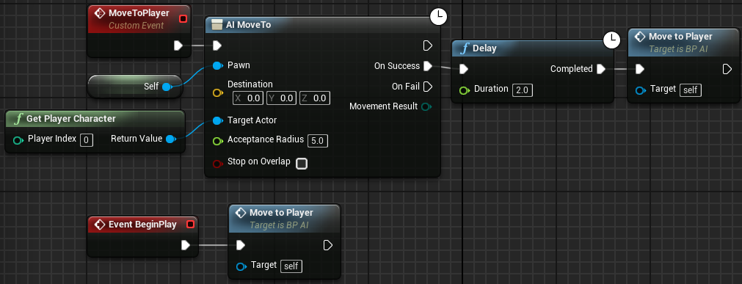

*Figure 1: AI MoveTo*

1. Compile the **BP_AI** Blueprint and add one instance of it to the Level. Play the Level.

## Outcome

After pressing **Play**, the AI character will move toward you. Move your character and the AI character will follow you. (See Figure 2.)

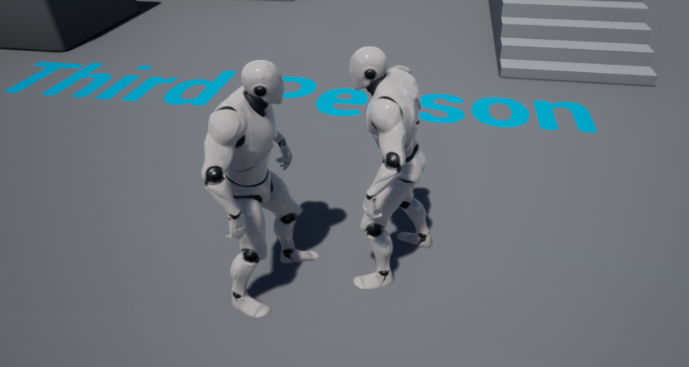

*Figure 2: The Player and the BP_AI*