Dear Authors,

We would like to congratulate you for the acceptance of your paper. Your contribution will be very important for the academic community. However, to formalize the publication of your document on IET editorial, you need to comply with 2 phases, and submit your final version by February 16, 2025:

1. Paper style adjustment according to the IET conference paper template
2. Final version submission to CMT platform

**Phase 1. Paper style adjustment according to the IET conference paper template**

1. At this stage it is needed to adjust the paper style according to the IET format: Title, Authors, Affiliation and Keywords, see Figure 1. Note that:
   * Both title and keywords and in CAPITAL LETTERS
   * Authors are in **bold letters** and*italic letters*
   * Affiliations are in *italic letters*

Figure 1. Header Template

1. Please, be attentive to the information of the authors and affiliations.
2. Use the IET reference style. Some examples are provided in the Word template. Users of Latex/Overleaf are strongly suggested to use the .bst file included in the Latex template, which is ready for using the \bibliographystyle environment. For example:

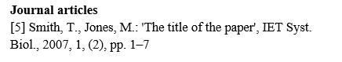

1. Consider that you must adhere to the **Page Length:**

The paper should be between **4 and 6** double-column pages. Beyond this length, a charge per additional page will be applied. The maximum number of pages allowed is **8**.

Please, go to the ICTIAIR 2025 web page on <https://ictiair.tiacon.org/> to download the paper templates in the Menu “For Authors/Templates”. Papers without following the required formatting will not be published in the conference proceedings.

**Phase 2. Final version submission on CMT platform**

1. Login to the submission center CMT throughthe ICTIAIR 2025 web page on <https://ictiair.tiacon.org/> in the Menu “For Authors/ Submit your paper”, or go directly on [**https://shorturl.at/5roLU**](https://shorturl.at/5roLU), see Figure 2**.**

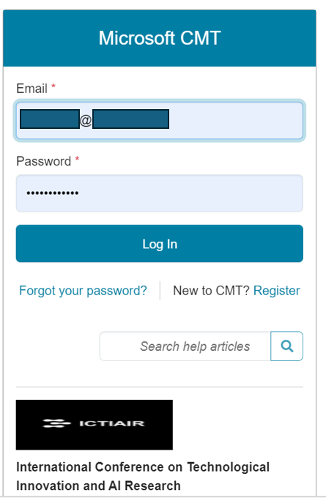

Figure 2. CMT login

1. Once the formatting issues are solved and the reviewers’ suggestions are included, if apply, click on the “create camera ready submission” button, as in Figure 3.

Figure 3. CMT author console

1. Update your author information in the space in Figure 4, if needed, such as title, abstract, author information. Note that on this point, only minor changes are allowed in this metadata.

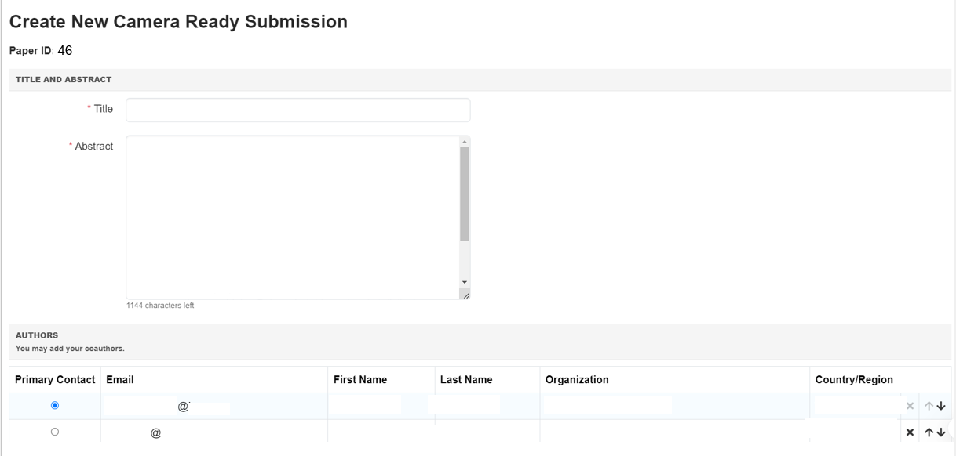

Figure 4. Camera ready submission

1. Finally, upload your final version and submit it, as indicated in Figure 5.

You can upload from 1 to 3 files. Maximum file size is 3 Mb. We accept **doc, docx, pdf** formats

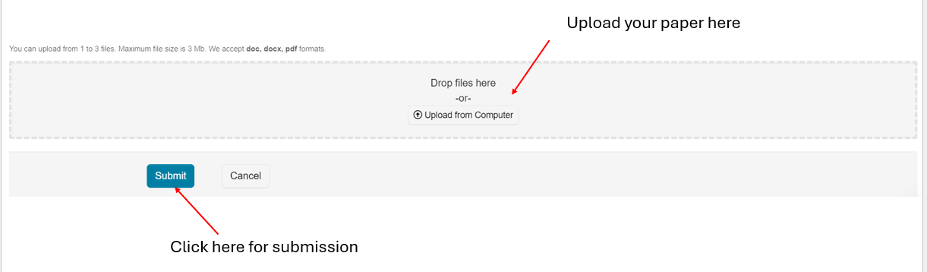

Figure 5. Paper submission space