Paper Title* (use style: paper title)
Muhammad Haider Khan Lodhi
Robotics Innovation Center
German Research Center for Artificial Intelligence (DFKI)
Bremen, Germany
mulo01@dfki.de
Muhammad Haider Khan Lodhi
Robotics Innovation Center
German Research Center for Artificial Intelligence (DFKI)
Bremen, Germany
mulo01@dfki.de
Muhammad Haider Khan Lodhi
Robotics Innovation Center
German Research Center for Artificial Intelligence (DFKI)
Bremen, Germany
mulo01@dfki.de

Abstract—Ground segmentation in point cloud data is the process of separating the points into ground and non-ground. Many good solutions have been published in literature. However, the majority of the solutions are targeted to solve the ground segmentation challenge for autonomous driving. There are very few solutions which are capable of performing in indoor and outdoor environments. Additionally, the solutions usually require hand tuning of parameters for optimal performance and are specific for certain type of LIDAR sensors and sensor configurations. There is a need to have a general purpose all-terrain capable ground segmentation solution which does not require tuning of parameters. Out of the many approaches, one approach to ground segmentation is to subdivide a large point cloud into smaller cells and analyze each cell. It is common practice to fit a planar model to the points. Although the existing solutions produce good results in certain scenarios based on assumptions about the robot environment, yet there is no solution which provides a general purpose solution for indoor and outdoor applications in mobile robotics. In this work, we provide such a solution for rough terrain indoor and outdoor mobile robot applications.
Keywords—LIDAR, Ground segmentation, Mobile Robotics, Rough Terrain

Introduction

The perception system of an autonomous system utilizes multiple sensors to capture salient features of the environment which help are used by various sub systems of e.g. navigation, control etc. A core sensor of the perception system is the LIDAR and given the advancements in sensor design and reduced costs, it has been a standard sensor in autonomous systems [X]. The LIDAR uses bands of laser beams to scan the surrounding environment and the time-of-flight information is to used to capture distance information at mm resolution. The result of the single scan is a point cloud sample which in today’s sensors may contain more than 1 million points. Evidently, the point cloud captures the points from the environment in the scanning region of interest. Depending on the sensor setting, it is usual that the point cloud has points from the 360 degree surrounding. At a basic level, the points can be divided into two categories. The points which belong to the ground surface are be called ground points and all other points are called non-ground points. The goal of the ground segmentation is to segment the input point cloud into ground and non-ground points. The ground segmentation has many applications:

- Ground Detection
- Obstacle Detection
- Object Detection
- Terrain Analysis
- Traversability Analysis
- Drivable Area Detection
- SLAM
The extraction of ground points from a pointcloud sample is a key step in the perception pipleine of an autonomous systems. There are a number of solutions which have been presented over the past few years. Our aim for this work was to focus on extraction of ground points with as few parameters as possible. We wanted to extract the ground points without the need to tune parameters to adapt to indoor and outdoor scenarios. Although our approach is not free of parameter tuning for best performance, however, we feel that the parameters only need to be tuned if the robot environment has major changes. We chose a model fitting approach for our solution because once broken down to smaller cells, it is a plausible to assume that the local cells are flat given that the cell size is very small. The smaller cell size ensures that the assumption holds more often than not but this increases the computation cost due to the increased number of cells in the grid. A large grid cell size improves performance and produces good results in indoor or autonomous driving scenario but flattens the natural curvature of ground in outdoor environments. Large grid size in highly uneven terrain produces poor results and this is to be expected because the planar model fit will ignore some points. What do we do with the points which were marked as outliers but are not really outliers? Another challenge with the grid representation is that based on the sparsity of points, we might have completely different point assignment to a grid cell. In one cell, we might have a line of points, in another, a few lines, and in some one of a few randomly scattered points.

Statement of Need
- Detection of ground points is a necessary precursor step for extraction of useful information from pointcloud data for downstream tasks in mobile robot navigation. [6,8]
- Object and obstacle detection algorithms detect ground points as false positives. The detection can be improved when ground points aredetected and removed. Additionally, the computational burden is reduced by processing only non-ground points. [9]
- Ground points can be used for traversability analysis, navigation, and static map generation.

Related work
The ground segmentation approaches use either a traditional or a learning-based approach. This claim is supported by the recent survey of ground segmentation approaches [X] which classifies the available state-of-the-art solutions.

Traditional Solutions
The traditional solutions to ground segmentation use geometric properties of the points to segment the ground and non-ground points. Usual approaches discretize the point cloud into grid cells and then process the points in each cell

individually. The grid cells may be purely 2D, 2.5D, or even 3D [X]. Some approaches extend the grid cell and analyze the points in neighboring cells for a better estimation of surface properties [X]. The modeling of the points in the grid cells using plane fitting and line extraction is a common approach in many solutions [X]. Region growing and clustering is used to combine individual grid cells into a larger region of connected cells [X]. Higher order inferences based on Conditional Random Field (CRF) and Markov Random Field (MRF) have been used [X].
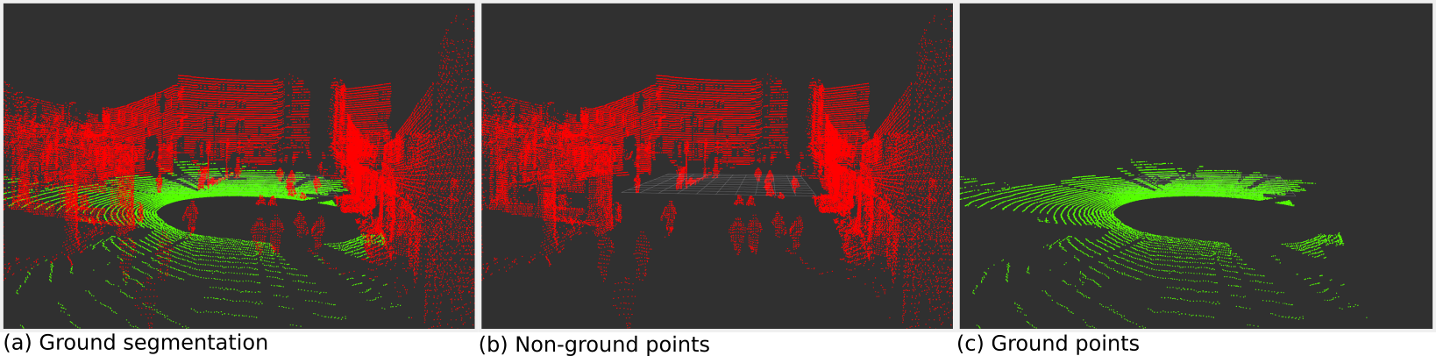Figure 1: Results of the ground segmentation pipeline.

Learning Solutions
The advancements in deep learning meant that some researchers used the existing CNN networks originally used for object detection for ground segmentation using range images generated from the point cloud data. The development of PointNet [X] and its successor PointNet++ [X] give a unified solution for various applications e.g. object and scene segmentation. Various other solutions like GndNet [X], PointPiller [X], JCP [X], SectorGSnet [X] showcase good results.

PROPOSED SOLUTION

Before we introduce our solution, let us discuss some common challenges faced with grid based approaches.
Based on our experience in this work and the literature review, we want to highlight some key challenges which researches try to solve in the ground segmentation approaches.

Roughness of the terrain
In principle, small grid cells are better suited for plane fitting algorithms but the size of grid cell has a direct impact on the computational performance of the algorithm. The selected size also depends on the gap of the scan lines. The scan lines in close proximity to the robot are dense and the distance between the lines increases based on the distance from the robot. Irrespective of the grid cell size, a cell close to the robot is more likely to have points from multiple scan lines assigned to it. This means that such cells are better suited to fit a plane model. As a concequence, it is possible to have an accurate slope estimate of the local point surface. On the contrary, cells which are assigned points far away from the robot are more likely to have only single scan lines assigned to them. A plane fitting algorithm can fit a plane to the line of points but the slope estimate is highly uncertain and is usually unreliable.
Small cell size is more sensitive to noise
Additionally, the size of the grid cells is also closely related to the type of application and environment. In indoor environments with flat surfaces, it is generally unproblamatic to have large grid cell size as compared to outdoor uneven terrain. To sum up, there is so one size fits all solution when it comes to selection of a suitable grid cell size for a ground segmentation algorithm.
In our solution, we make use of the known and reliable information and tried to find an algorithm which solves most of previously mentioned challenges. One challenge which remains unsolved is the computational performance related to the grid cell size. The type and amount of computational power available is robot platform dependent and therefore the grid cell size is coupled to the available resources. The user should select a grid cell size based on the runtime requirements of the algorithm.

Point Sparsity
As mentioned earlier, the point assignment to grid cells is non uniform and depends on various factors. It is not feasible to blindly fit a plane to all grid cells because some cells may have a single line of points or a random distribution of points. This is especially the case when using a fixed grid size and the distance of the cell from the pointcloud origin increases.

Polar & Square Coordinates
Literature review has shown that researchers prefer polar grid cells as compared to square cells. However, in our
experiments we found a square grid cell with a fixed grid size performs better than polar cells. The reason in our view is that as the distance from the sensor origin increases, the cells get bigger and as a concequence, results in the deterioration of the performance of the plane fitting based segmentation.

False positive flat surfaces other than ground e.g. table top, car roof etc.
The gradient of the fitting plane to a grid cell can not be used as the sole criteria for the segmentation. The reason is the existence of flat surfaced obstacles in the robot's environment.

False positive points at the junction of ground and obstacles
We perform a point wise check to remove as many false positives as possible at the junction of ground and non-ground points

Influence of grid cell height on the performance of segmentation
The height of the grid cell plays a key role in identification of obstacles in the point cloud. The key challenge here is to detect tall obstacles in the grid cells but without falsely detection the underlying ground points as obstacles as well. This challenge is evident in the tree canopy situation where the ground points in the grid cell are falsely identified as obstacle points because of the large height of the grid cell.

Outlier Correction
The plane fitting will produce false positive outliers because of the natual curvature of the ground surface. A correction step using the actual resultant normal of the points is used to correctly assign ground and non ground points.

Performance
The requirement for real-time operation of the ground segmentation is very evident for the application in the autonomous driving community. Therefore, solutions need to able to do a highly accurate segmentation within in stipulated time period. The exact time requirements may vary based on the industry.

Core Components

Pre-Processing
The input point cloud is cropped to a user defined region of interest. The region of interest is application specific, where a large region of interest is desirable in the autonomous driving situation and in mobile robotics applications a small to medium region of interest is usually enough.

3D Grid Representation
The points are assigned to cells into a euclidean space based 3D grid. The points are indiscriminately assigned to grid cells based on their 3D positions.

where cell size is a parameter. We explain our choice of parameters in the section H.

Local Eigen Analysis
The sparsity of points increases with the distance of the points from the sensor. As a consequence of this we can not except to get a reliable fit of a planar model to all the grid cells. Therefore, we perform a computationally inexpensive eigen analysis on each grid cell in order to get a rough estimation of the local spacial distribution of the points. The ratio of the largest eigen value to the sum of eigen values is computed.

We devise three possible conclusions based on the ratio and categorize the grid cells into three categories.

- Line: Ratio is close to 1 which means that the largest eigen value is the dominating value. This implies that the points have a linear spacial distribution.
- Plane: Ratio is close to 0.5 which implies that there is a planar spacial distribution of points.
- Unknown: Smaller values imply a random spread of points.

Largest eigen to the sum ratio
Cell Type | Threshold
Line | > 0.950
Plane | >= 0.40
Unknown | < 0.40

Each cell type is processed with a different algorithm.

1) Line Cell
If the largest eigen value is also the dominating value in all the values then the cell is categorized as Line. For such cells, we compute the angle between the largest eigen vector (shown green in Fig. 2) and the positive z-axis (upwards).

where threshold refers to the ground slope threshold.

Based on the angle of uprightness, it is possible classify cells with small angles as obstacles since we do not expect ground cells to have a upright spacial distribution. For the case where the points are not upright, the cell might be Obstacle or Ground. We can not be certain because this Line of points can also belong to a top of an obstacle e.g. car top, table etc. Therefore, we mark such cells as Unknown.

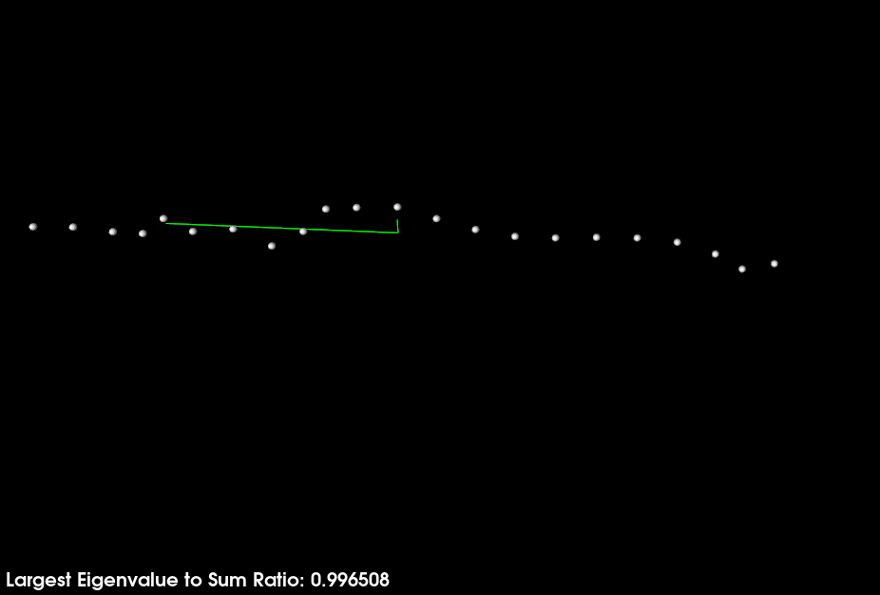Figure 2: Points (white) assigned to a grid cell and the corresponding eigen vectors (green) are shown. The eigen vector along the line of points is the single dominant eigen value. The cell is classified as Line based of the local eigen analysis.
2) Plane Cell
Cells with more than one scan lines are suitable candidates for plane fitting when the spacial distribution of the points has two dominant eigen values and the third eigen value is negligibly small or significantly smaller. If the largest eigen value to the sum of eigen values ratio is greater than 0.4 then the points are classified as Plane.
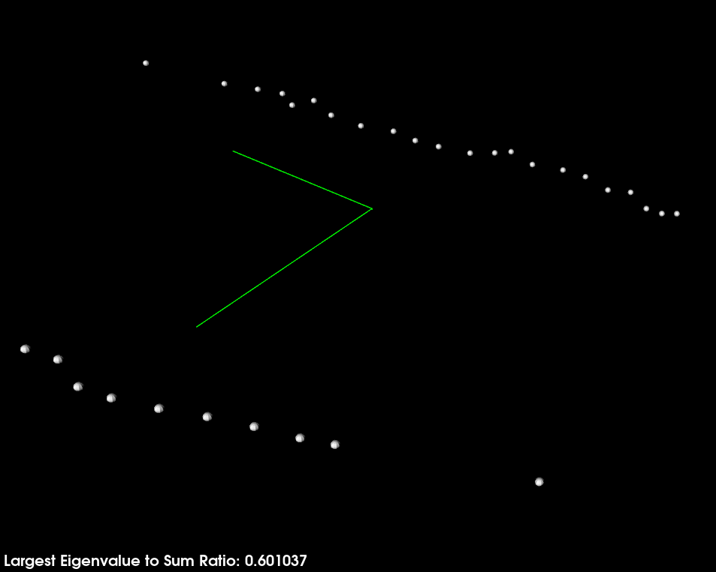Figure 3: Points (white) assigned to a grid cell and the corresponding eigen vectors (green) are shown. Two dominant eigen vectors and shown and the third vector is negligible in comparison. The cell is classified as Plane based on the local eigen analysis.

3) Unknown Cell
If the ratio is smaller than 0.4 then the points are classified as Unknown. In this case the points in the cell do not have two clearly dominant eigen values. It is true that the sharp cut off of 0.4 will result in some falsely classified Plane and Unknown cells but these false cases are automatically corrected at a later stage.

Each Unknown cell is individually processed in the segmentation stage.

Figure 4: Points (white) assigned to a grid cell and the corresponding eigen vectors (green) are shown. There is no dominance of a single or two eigen vectors. 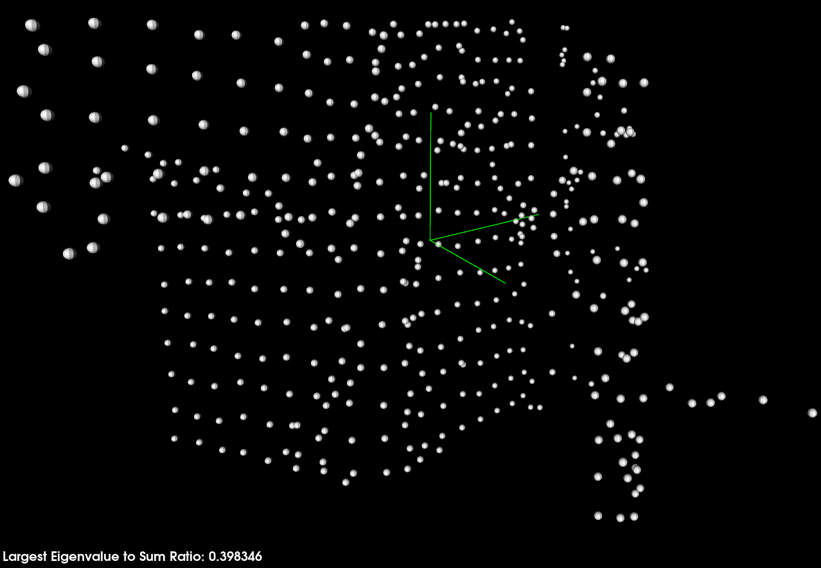The cell is classified as Unknown based on the local eigen analysis.

Planar Model Fitting
The plane model fitting is applied only to cells of type Plane. We compute the gradient of fitted plane and apply a slope threshold. The cells which fulfill the ground criteria are tentatively marked as a potential ground cells. Cells which fit the ground criteria are used to select the initial seeds for region growing. Cells which do not fit the ground criteria are marked as non-ground.

where threshold refers to the ground slope threshold.
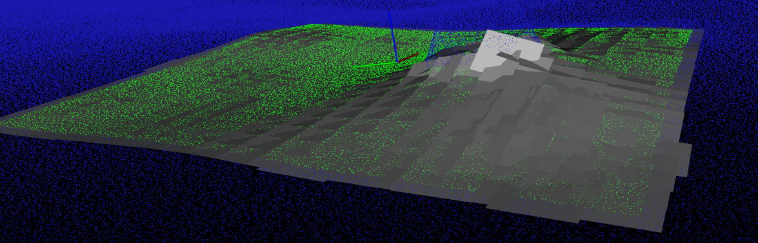Figure 5: Plane model fit for local surface gradient estimation.

Seed Selection
The seed cells are selected based on the following conditions:

1) High confidence of the cell belongs to ground. High confidence means that more than 95% of points in the grid cell are inlier of the planar model fit.

2) The centroid is within a user defined distance threshold. Far off cells are expected usually to have sparse points with large gaps in between points. These are not suitable candidates for the selection of initial seed cells. Therefore, we set a distance limit for the selection of seed cells so that only cells in close proximity the sensor are candidate seed cells.

3) Seed cells are selected from each of the four quadrants in the euclidean space. Large occlusions or gaps in the point cloud inhibit the region growth. If we select a single seed cell then there is a risk that the region growth will not be able to cover all the cells. Therefore, we select a seed cells as four groups. Each group belongs to a quadrant.

4) We compute the mean height of the selected cells in each group. We do this to minimize any adverse effects of a false positive seed cells. A group is only considered valid if there are at least a minimum number of selected seed cells.

5) A single seed cell is selected from all valid groups. The cell is selected based on neighborhood and closeness to the mean height.

The conditions for selection are:
- The cell has the highest number of ground neighbors compared to other cells in the group.
- It is closest to the mean height of the group.

6) At the end of seed selection, we have one seed cell selected from each quadrant.

Region Growth
We recursively expand all ground neighbors of the seed cells. The region wise growth ensures that false positive ground cells, which fulfilled the slope criteria, are not selected. When selecting neighbors of a cell, we check for 24 neighbors in its vicinity. We do not store empty cells in our 3D grid and to avoid far off neighbors to be selected, we apply a maximum distance threshold for the neighboring cell.

Each ground neighbor within the distance threshold is expanded and afterwards marked as expanded. The designation of cell as expanded ensures that no cell is expanded twice.

Point Segmentation
1) Ground Cells
The ground cells are the result of the expansion of the grid. The grid expansion is based on connectivity of ground cells, thus any falsely classified ground cells which merely fulfilled the slope criteria are rejected during expansion because there was no connectivity of such a cell to main body of the ground cells.After the region growing, we go over all the cells marked as ground and segment each cell's points into inliers and outliers. The segmentation uses the inliers from the plane fitting. The goal here is to detect small obstacles in the ground cells. Given that the real world ground has curvature, we are certain that the plane fit did indeed mark some ground points as outliers and they will be falsely assigned to non-ground points, resulting in poor quality of segmentation in very uneven terrain.
Outlier check:
1) Find the closest inlier point and compute the vector from the inlier to outlier
2) Compute the distance of vector's component along the ground normal
3) If the distance along the normal is
3.1) Less than or equal to the plane fit threshold then the outlier is marked as ground point
3.2) Greator than the plane fit theshold then the outlier marked as non-ground point
2) Unknown Cells
At this step, it is still not known whether the unknown cells are ground or non-ground. To solve this, we use the ground points from the previous step and compute the normals for all the points. Afterwards, we use the same algorithm used for the outlier check in the previous step to classify each unknown point as either ground or non-ground. It is not necessary that the closest ground point to an unknown point belong to the same or neighboring cells. The distance along the normal can only be used when the points are close to each other. To avoid far off unknown points from being falsly classified, we make sure that the distance between the unknown and the ground point is within a user-defined threshold.
3) Non-Ground Cells
Over segmentation of non-ground cells is very evident in the case of non-ground cells. We process each non-ground cell based on its neighborhood.
1) If the non-ground cell has no ground neighbors then we can safely assign all the points as non-ground.
2) If the non-ground cell has ground neighbors then we need to make sure which of these ground neighbors are actually ground and which were falsely assigned the ground label due to only slope criteria fulfillment.
3) To confirm the genuine ground neighbors, we explore its neighborhood via neighborhood expansion and the cell has a connectivity to 50% of the total ground cells, then we can be certain that this ground cell belongs to the main body of ground cells. Less than the threshold will mean that the cell might be false positive ground cell and not taken into consideration for the next step.
4) If the non-ground cell has ground neighbors belonging to the main body of the ground cells then we collect all ground points into a single collection of points
5) Afterwards, we use the same algorithm used in outlier check to classify segment ground and non-ground points.

Two Step Approach
Two phase segmentation of points based on local surface properties and neighborhood analysis First phase uses a large height for the grid cells. The large grid cell in the z direction ensures that we capture as many obstacles are possible. However, this also means that ground points in cases of the tree canopy will be falsely classified as non-ground points. We cater for these false detections at the later stage. Second phase uses a small height for the grid cells. The second phase uses a smaller grid cell height so that we can remove any false positive detections of ground points. All the false positive detections are later added back to the non-ground points during the post processing phase.

Post Processing
For highly challenging rough terrains an additional post-processing is used to improve the quality of the ground segmentation.

Experiments
We tested our ground segmentation on various indoor and outdoor scenarios on a number of different robotic systems.

Experimental Setup
We test the algorithm on a various indoor and outdoor datasets. The key point in these tests is that we do not change the parameters of the algorithm. This is done to support our initial claim that the algorithm can work in various types of indoor and outdoor environments without the need to manually tune parameters.

Datasets and Evaluation Metrics
We evaluate the work against the state-of-the-art method with the best performance Patchwork++. We limit the size of the point cloud to 80m and set the down-sample it to 0.1m.

Results and Discussion

Evaluation in Indoor Environment

Evaluation in Outdoor Environment
B1) ARTER
B2) RELLIES-3D

Evaluation of Public Datasets
C1) DOALS
C2) KITTI

conclusions

References
The template will number citations consecutively within brackets [1]. The sentence punctuation follows the bracket [2]. Refer simply to the reference number, as in [3]—do not use “Ref. [3]” or “reference [3]” except at the beginning of a sentence: “Reference [3] was the first ...”
Number footnotes separately in superscripts. Place the actual footnote at the bottom of the column in which it was cited. Do not put footnotes in the abstract or reference list. Use letters for table footnotes.
Unless there are six authors or more give all authors’ names; do not use “et al.”. Papers that have not been published, even if they have been submitted for publication, should be cited as “unpublished” [4]. Papers that have been accepted for publication should be cited as “in press” [5]. Capitalize only the first word in a paper title, except for proper nouns and element symbols.
For papers published in translation journals, please give the English citation first, followed by the original foreign-language citation [6].

- G. Eason, B. Noble, and I. N. Sneddon, “On certain integrals of Lipschitz-Hankel type involving products of Bessel functions,” Phil. Trans. Roy. Soc. London, vol. A247, pp. 529–551, April 1955. (references)
- J. Clerk Maxwell, A Treatise on Electricity and Magnetism, 3rd ed., vol. 2. Oxford: Clarendon, 1892, pp.68–73.
- I. S. Jacobs and C. P. Bean, “Fine particles, thin films and exchange anisotropy,” in Magnetism, vol. III, G. T. Rado and H. Suhl, Eds. New York: Academic, 1963, pp. 271–350.
- K. Elissa, “Title of paper if known,” unpublished.
- R. Nicole, “Title of paper with only first word capitalized,” J. Name Stand. Abbrev., in press.
- Y. Yorozu, M. Hirano, K. Oka, and Y. Tagawa, “Electron spectroscopy studies on magneto-optical media and plastic substrate interface,” IEEE Transl. J. Magn. Japan, vol. 2, pp. 740–741, August 1987 [Digests 9th Annual Conf. Magnetics Japan, p. 301, 1982].
- M. Young, The Technical Writer’s Handbook. Mill Valley, CA: University Science, 1989.

