Dartmouth Woodsmen's Meet 2012  Sponsored by the  CABIN AND TRAIL DIVISION  of the  DARTMOUTH OUTING CLUB    We welcome this year's competitors  to Dartmouth and Hanover.  Good Luck to All!  FTD TOR |  | 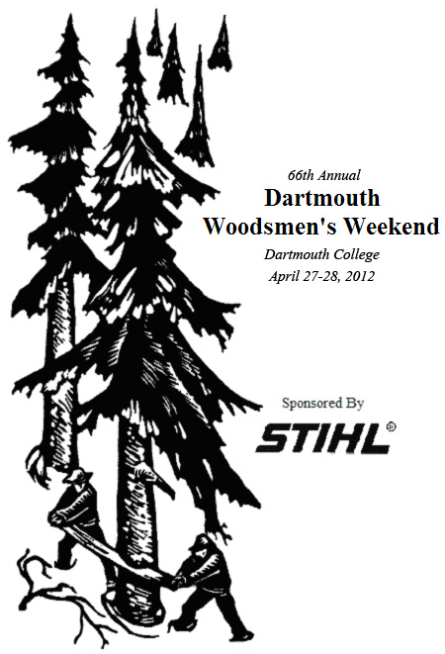
Schedule of Events  Friday, April 27  Dartmouth Organic Farm  8:00 am Opening Ceremony  8:15 am Singles Canoeing  Doubles Canoeing  Portage Canoeing  11:00 am Crosscut Sawing  Bow Sawing  1:00 pm Log Roll  Pulp Toss  Barrel Split  Scoot Load  3:00 pm Fire Build  4:30 pm Packboard Relay  Saturday, April 28  Hanover Green  8:00 am Single Buck  Obstacle Course  Chain Throw  Disk Stack  Birling  Axe Throw  Vertical Chop  12:00 pm Horizontal Chop  2:00 pm STIHL© Timbersports Northeast Collegiate Qualifier |  | Singles Events  Chain Throw: Coil and "throw" the unraveled chain. Scoring is by speed and appearance of the "thrown" chain.  Axe Throw: Throw an axe at the target from twenty feet away. Each competitor will get two practices before the five official throws.  Single Buck: A competitor must cut through a round log in the shortest time possible using crosscut saw.  Birling: Competitors balance on a cedar log in a pool of water. The ones with the longest times compete head-to-head.  Disk Stack: A competitor must make a stack of as many cookies as possible from a a piece of vertical wood by using a chainsaw.  Obstacle Course: The contestant completes an obstacle course for time consisting of pulp pile, choker set, dot split, and bucksawing while balancing on a log.  Doubles Events  Vertical Chop: Two contestants chop through a vertical square white pine cant in the fastest time possible.  Scoot Load: Load three logs onto a scoot for time using peaveys or cant dogs.  Fire Build: Using a bolt of dry firewood, three wooden matches, and a tin can, boil a given amount of soapy water.  Triples Events  Barrel Split: Each of three team members splits two hardwood logs for speed and accuracy.  Horizontal Chop: Each of three team members chop through a square white pine cant for time.  Canoeing Events  Singles Canoeing: Two contestants each canoe half of an obstacle course for a combined time.  Doubles Canoeing: Two contestants work together to canoe the course.  Portage Canoeing: First competitor paddles over a stretch of water, then carries the canoe and paddle over land. Partner returns.
Description of Events  The Cabin and Trail Division of the Dartmouth Outing Club expresses sincere thanks to  the EcoReps for real water to drink,  Collis Ray for real food to eat,  and Great Brook Forest Products for real wood to chop and saw.  Each event is worth 100 points. The team with the fastest time and/or greatest accuracy is awarded 100 points; scoring for the other teams is graded proportionately to these winning results. Women's and Men's teams will be scored separately.  While allowing legitimate innovations or technique improvements for the various events, the rules are intended to insure some similarity to the conditions under which the competitors must function.  Team Events  Crosscut Saw: Three pairs will each make three cuts on square white pine cants in the fastest time possible.  Team Buck: Each team member makes two cuts on square white pine cants for time.  Log Roll: Roll a log as quickly as possible using peaveys or cant hooks. Each of the three pairs will roll a log to the other end of the course, hit both stakes, and roll the log back to touch the starting stakes.  Pulp Toss: Throw pulpwood between two sets of stakes as quickly as possible. Three competitors will be at each end of the pit, and the pulp will be thrown back and forth until forty-eight sticks have landed between the stakes.  Packboard Relay: Lash a blanket, sandbag, and frying pan onto a packboard, and run a relay course. Each competitor will take a turn carrying the pack.  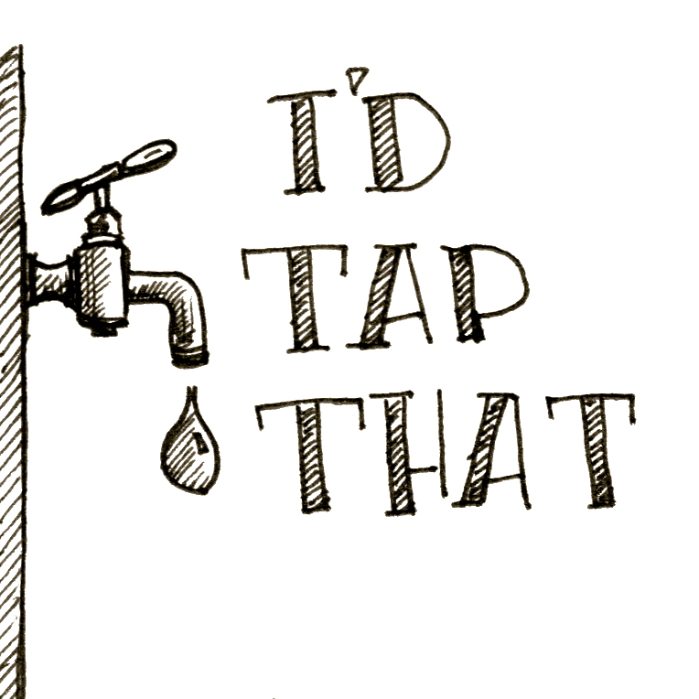 |  |   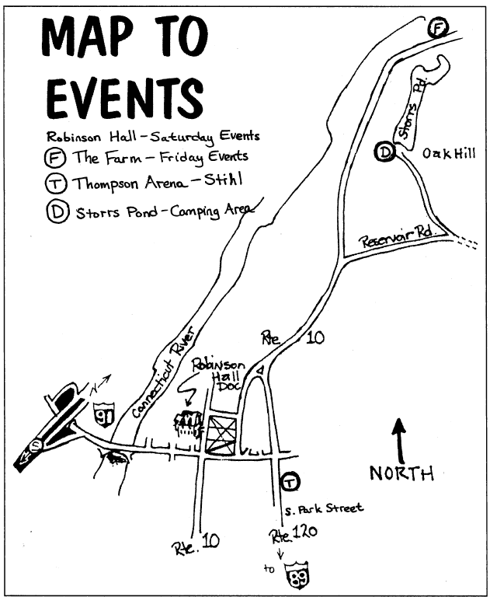
Background on Events  Many of the events at this weekend’s meet come from, or are meant to represent, tasks that loggers needed to perform in order to make a living. Not many people work in the woods with hand tools and horses anymore; consequently, not everyone knows where these events came from. Hopefully a bit of background will make the meet more interesting for competitors and spectators alike.  Some events are obvious – vertical chop, clearly, was needed for felling great trees before the days of chainsaws. As crosscut saws became more common, the procedure changed to include sawing into the tree and then finishing the “bird’s mouth” cut by taking chips out above the saw cut with the trusty axe. Then the back cut would be accomplished with the crosscut saw, leaving a guiding hinge just the way we would today with a chainsaw.  It was not uncommon for a logger or surveyor to be “spiked out” or working and camping alone a distance from the logging camp. Who was going to carry your equipment? You, that’s who, and a sturdy packboard was just the thing for carrying a heavy load. If you could get there by water, so much the better, in which case you’d better be able to canoe, and portage, or carry, the canoe from where one lake ended to where the next began.  Anyone who has worked hard in the outdoors will immediately see the usefulness in splitting and firebuild. After you finished your supper you may well find yourself bored and wondering if you could hit THAT tree from twenty feet away with your axe. The longer you were spiked out the better you got, and the more eager to show off your axe throw when you got back to camp.  Many people are curious about “chain throw.” They don’t throw it, and it’s not a chain. The “chain” is both a tool and a unit of measure – traditionally the surveyor’s chain was 66 feet long. Many chains, like the ones we are using at this meet, are 132 feet, |  | or two chains long. Conveniently, an acre is one chain by ten chains, and a mile is eighty chains long. Coiling the chain quickly in a neat package was the job of the surveyor’s assistant, who was generally being attacked by black flies and mocked by the surveyor while he was trying to accomplish the task. But when they were done, the area to be logged would be clearly marked off.  The crosscut saws you will see today are racing saws, much more delicate than one would see in the woods. They are light, sharp, fast, and expensive. Since the crosscut events involve cutting down through a horizontal piece of wood, they represent “bucking,” or cutting a felled tree into movable pieces. Bucking saws usually have a straight back and are thicker and stiffer than felling saws, which often have concave backs. If you think about the position in which they are used, this makes sense. Horizontal chop also represents bucking, when the logger was limited to his axe or was working alone.  “Pulp” was wood fit only for making into paper, rather than lumber. One would cut pulp wood if the price at the mill was attractive enough, or perhaps if one was clearing land for pasture. Pulp wood is generally softwood of a small diameter, and “pulp toss” represents being able to move the wood and also stack it neatly and accurately.  Log roll and scoot load are related events. A “scoot” is a low sled, generally just two heavy hardwood runners with cross bracing – sometimes with steering (a bobsled), sometimes without. It would be pulled by a team of patient horses with sharp caulks in their shoes. “Log roll” represents getting the log from where it was bucked to where the scoot was waiting. “Scoot load” represents rolling logs up onto a scoot, where they would be chained down and hauled out to the yard, or “yarded out.” It was common for horses to learn the route to and from the yard and to be trusted to go by themselves after a while.

