Ross McKenney 75th Annual Spring Meet 2023 Itinerary

Friday April 28th
7:00 pm: Captains meeting in Robinson Hall basement (building just off the Dartmouth Green)

-------------------------------------------------------------------------------------------------------------------------------Saturday April 29th

Morning session at Storr's Pond (59 Oak Hill Dr, Hanover)
8:00 am: Day 1 Opening Ceremonies
8:20 am: Canoeing Events (closes at 11:00 am)
Singles Canoeing, Doubles Canoeing, Portage

Afternoon session at the 16th hole of the Golf Course (22 Lyme Road, Hanover)
12:00 pm: Team Pulp Toss, Team Log Roll, Scoot Load (closes at 3:00 pm)
3:00 pm: Packboard relay (run in heats)

-------------------------------------------------------------------------------------------------------------------------------
Sunday April 30th

Morning session on the Dartmouth Green
8:00 am: Day 2 Opening Ceremonies
8:20 am: Singles events (closes at 11:00 am)
Pole Climb, Disk Stack, Single Buck, Birling, Axe Throw, Chain Throw
8:20 am: V-chop (run in heats)

Afternoon session on the Dartmouth Green):
12:00 pm: Team sawing events (run in heats)
Team Crosscut, Team Bow Saw
1:00 pm: Triples (run in heats)
H-Chop, Splitting
3:00 pm: Firebuild (run in heats)
4:00 pm: Awards

General Map
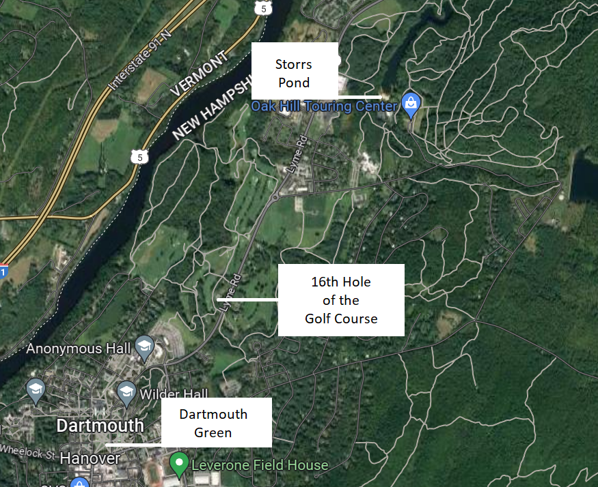

Parking for Spring Meet 2023

Captains Meeting in Robinson Hall
There are road spots that are free after 5pm near the green. You can also park in Dewey Lot or Observatory Lot.

Storrs Pond
There is limited parking right next to the main beach of Storr’s pond where we will be competing. We ask that each school only have one vehicle in this lot. There is plenty more parking by the entrance booth for other vehicles. The walk from this farther lot to the actual pond is 3-5 minutes.

The 16th Hole
There is limited parking at the 16th hole itself. We ask that each school only park one or two vehicles at the 16th hole. Every other vehicle should be parked in Dewey Lot. The walk over from Dewey to the 16th hole is 5-10 minutes. Schools camping at the 16th hole may have one or two additional vehicles if absolutely necessary

The Green
Surprise surprise, parking on campus is also limited. Each school is permitted to have one vehicle (with a trailer) parked on the green. There is limited parking available in Observatory Lot which is a 5 minute walk from the green. The majority of vehicles should be parked in Dewey Lot (where you parked on Saturday when you went to the 16th hole!) which is a 10-15 minute walk from the green. There is also limited street parking near the green but these spots should be avoided unless absolutely necessary so that people not attending the meet can still park in town.

Dartmouth Campus Map Highlights
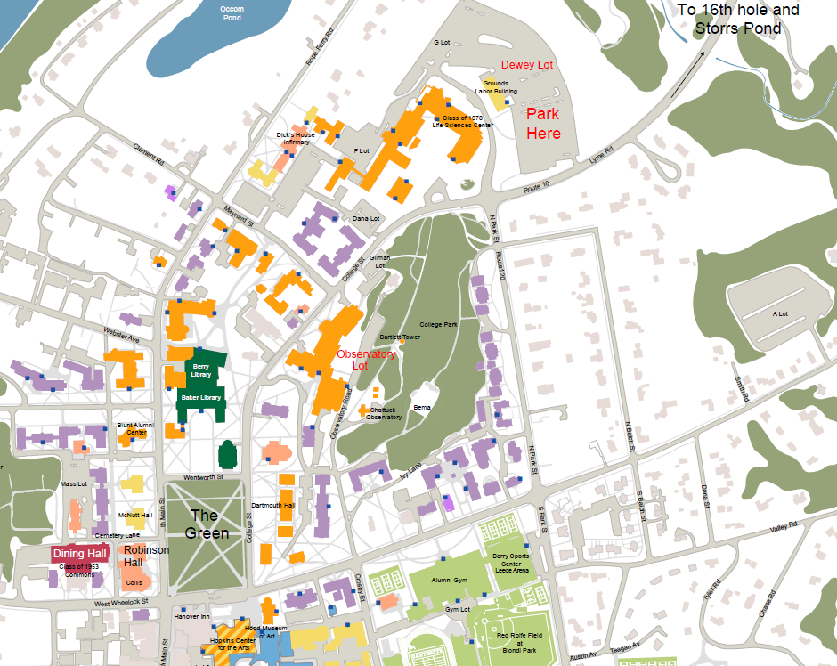

Storrs Pond Recreation Area Map (not to scale)

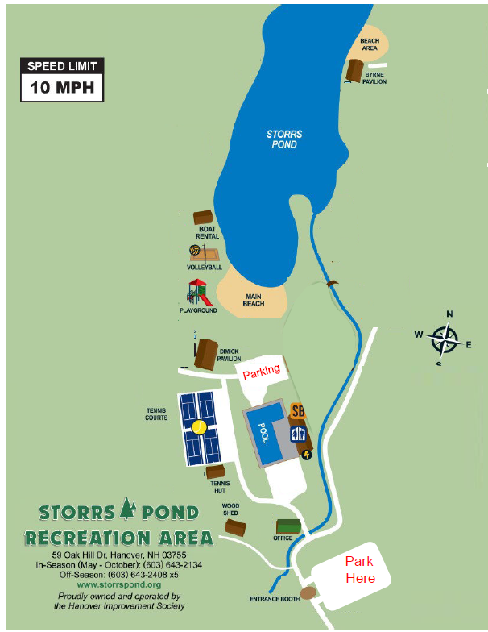
Golf Course
