001A — Medieval Church: Building, Community, and Sacramental Life
Name: Date:
AIM / EQ: What role did the Church play in medieval society?
LEARNING GOALS
• Explain how the local parish church, major churches, and cathedrals connected religious and community life.
• Distinguish the seven sacraments from devotions such as pilgrimage and relics.
• Use one visible detail from Sainte-Foy to explain how church art communicated judgment and a God-centered worldview.
DO NOW — RECALL + PREVIEW
1. RECALL FROM DANTE: In one sentence, what happens to souls after judgment in Inferno?
2. PREVIEW: Study the manor image below. First list 2–3 details you can actually see; then make one inference about where the church fits into community life.
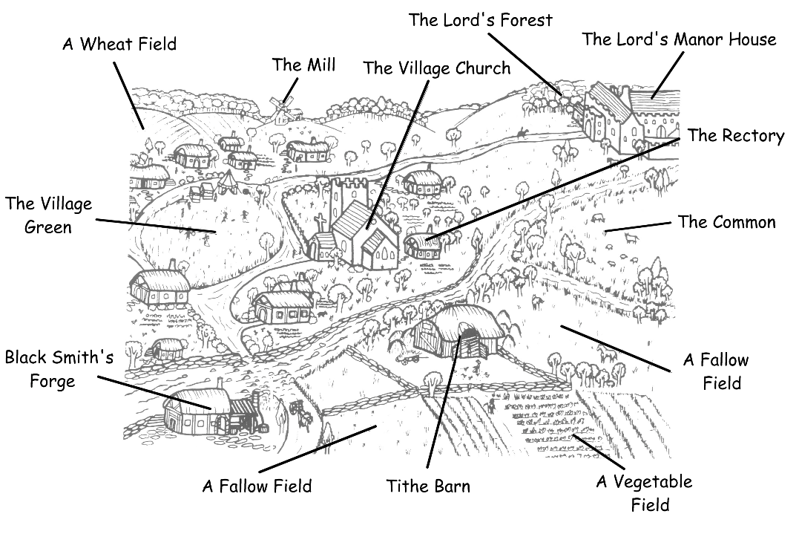
See  I notice…  (list 2-3 details you see in the diagram) | Think  What inferences can you draw about the role of the Church in medieval society? Write 2–3 sentences | Wonder  What question do you still have about this diagram?
2) Major Churches, Cathedrals, and Pilgrimage
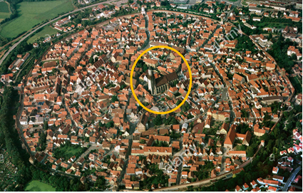
- Major Churches in Towns and Cities
Example: NOERDLINGEN, Germany
Main idea: A major church could serve as a religious, social, and economic center.
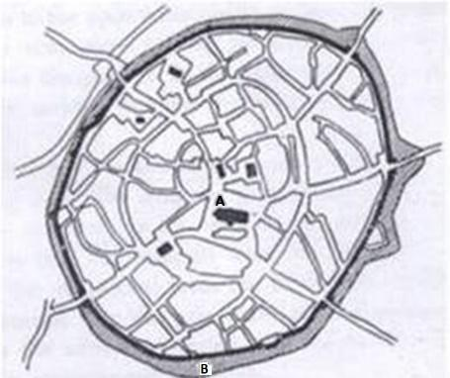
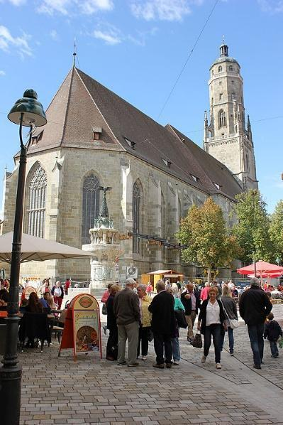
KEY TERM: What is a Cathedral? (+ notes)GUIDED NOTES — Church as a Community Institution
Use short phrases, not sentences. The cues are supplied; record only the details you would need to explain the role of the medieval Church later.
CUE / TOPIC | YOUR NOTES
Local church on the manor — location / visible role
Major church in a town — religious / social / economic roles
Cathedral — defining feature
One connection between church building and community life
A pilgrimage church: Church of Sainte‐Foy, Conques, France, c.1050–1130 C.E.
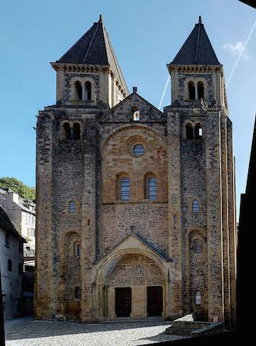
Pilgrims came to see the reliquary, or container holding the remains of Saint Foy [“Faith”]. St. Foy was a young Christian martyr from Agen in Roman Gaul, traditionally dated to about 303 CE during the persecution under Emperor Diocletian.
Conques became a major pilgrimage stop on the route to Santiago.

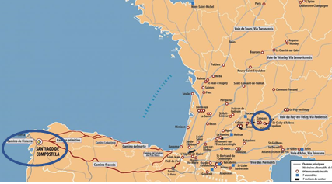
Q: Why did people in the Middle Ages take pilgrimages?
KEY TERMS:
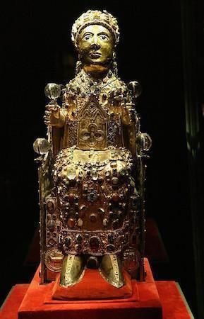
Pilgrimage Relic
For now, our interest is what the pilgrims would see before they walked in the front door (below):
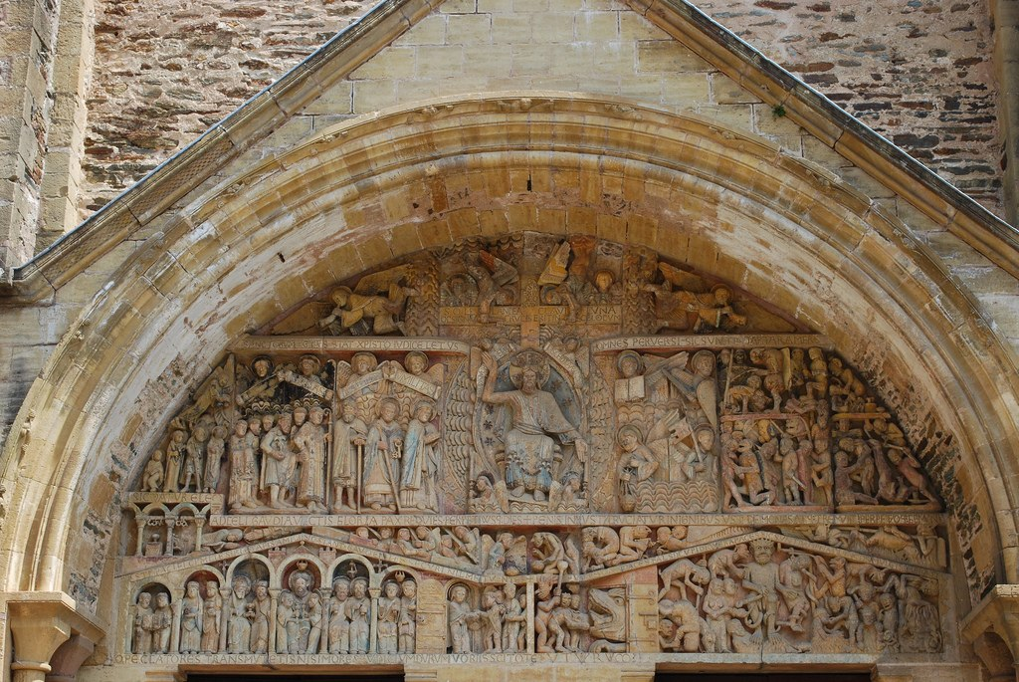
Tympanum, Church of Sainte‐Foy, Conques, France, c.1050–1130 C.E.
Who is at the center? What is he pointing to? What are the major symbols?

Looming over the front door, what is the overall effect and message of the sculpture?

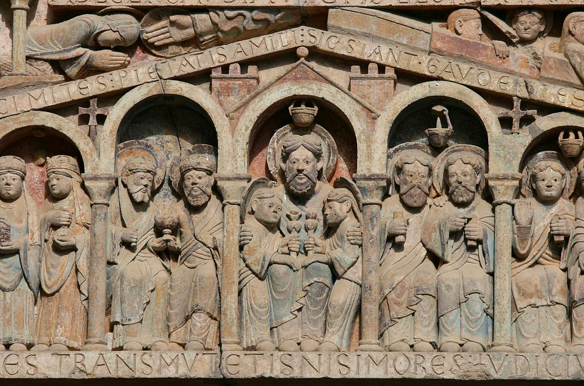
Jesus’s Right: The blessed in paradise, with the hand of God above beckoning Saint Foy (Saint Faith). Abraham sits enthroned in the center opposite the enthroned Devil below

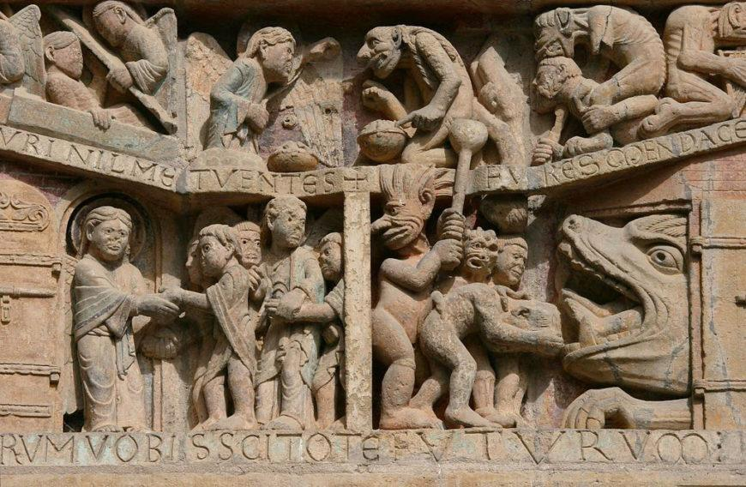
The resurrection of the dead; gates of heaven and the mouth of hell
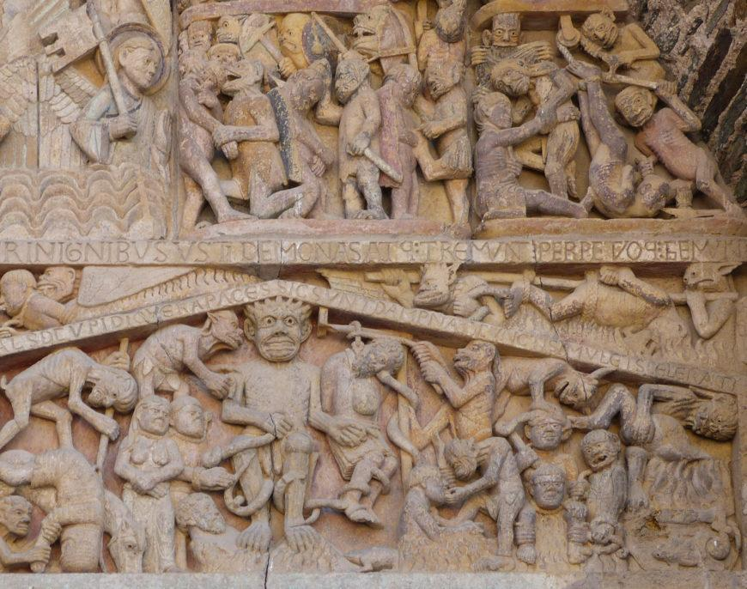
Hell. The devil, like Christ, is also an enthroned judge, determining the punishments that await the damned according to the severity of their sins. In particular, to the devil’s left is a hanged man. This man is a reference to Judas.
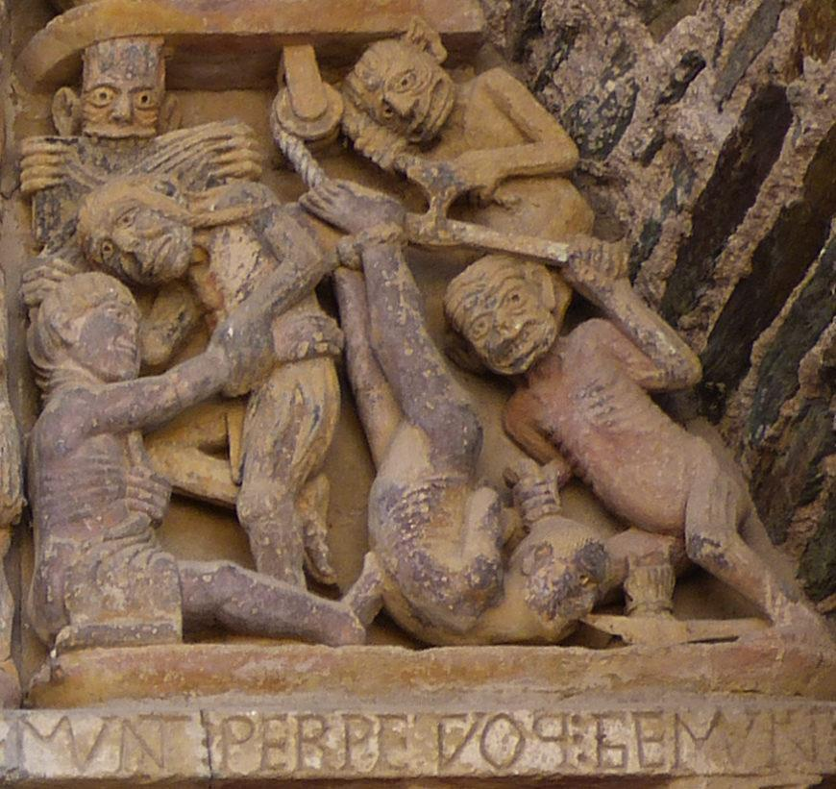

3) Inside the Church: Sacraments, Penance, and Devotions
- Q: What kinds of things went on inside a parish church? What was the role of the parish priest?
- Sacraments: how the medieval Church entered a Christian’s life
In medieval western Christianity, sacraments were sacred rites through which the Church taught that God gives grace. By the High Middle Ages, the Latin Church recognized seven. They connected major life stages and recurring worship to the Church and its clergy.
SACRAMENT | WHAT HAPPENS / WHAT IT MARKS | WHY IT MATTERS FOR THIS COURSE
Baptism | Water rite of Christian initiation; entry into the Church. | Beginning of sacramental Christian life.
Confirmation | The baptized person is sealed/strengthened with the Holy Spirit. | Completes/strengthens initiation.
Eucharist / Communion | At Mass, consecrated bread and wine are received. Catholic teaching: transubstantiation—their substance becomes Christ’s body and blood. | Later Luther and Calvin disagree with Catholic teaching about Communion.
Penance / Reconciliation / Confession | A repentant Christian confesses sins, receives priestly absolution, and performs assigned satisfaction/penance. | Central to Luther’s dispute about forgiveness, priestly mediation, and indulgences.
Anointing of the Sick | A seriously ill Christian is anointed with oil and prayed over. | Links illness and possible death to sacramental care.
Marriage | A Christian man and woman enter a sacramental marital union. | Places family formation within Church life.
Holy Orders | Ordination to clerical ministry (bishops, priests, deacons). | Creates the ordained ministry that celebrates or oversees many sacraments.
Historical baseline for later units: Palmer & Colton, 8th ed., p. 38 (sacraments and transubstantiation).

Sacraments are not the same thing as devotions.
Pilgrimage, relics, prayers to saints, fasting, and other devotions could be important parts of medieval Catholic religious life, but they were not themselves among the seven sacraments.
Penance, purgatory, and indulgences — the connection you will need for the Reformation
Medieval Catholic teaching distinguished forgiveness of sin from temporal punishment due to sin. Purgatory was understood as purification after death for souls destined for heaven but not yet fully purified. An indulgence remitted temporal punishment; it was not, in doctrine, the purchase of forgiveness. Late-medieval fundraising practices tied indulgences closely to donations, creating abuses and controversy that Martin Luther would attack.
Dante connection: Dante’s Commedia gives a poetic and imaginative picture of judgment and purgatory. Use Dante to deepen the worldview, but keep the poem’s geography and punishments distinct from the Church’s sacramental system.
GUIDED NOTES — Sacramental Life
After studying the seven-sacrament chart and the explanations above, record short phrases in the four rows below.
CUE / TOPIC | YOUR NOTES
Seven sacraments — definition / life-cycle role
Eucharist — Mass / transubstantiation
Penance → purgatory / indulgence
Sacraments vs. devotions — one example each
QUICK CHECK —
1. Name the seven sacraments.
2. Which sacrament is celebrated at Mass?
3. Why would recurring sacraments make the parish priest and the wider Church important in everyday life?

EXIT TICKET — Sainte-Foy: Image → Worldview
Explain how the Sainte-Foy tympanum communicates a God-centered worldview. Identify one visible symbol or placement/detail, then explain the effect it is intended to have on visitors’ emotions, beliefs, or behavior. Write 3–4 sentences. Today’s Vocabulary (check off when you can define & use the word)

- Cathedral ☐ Parish priest ☐ Sacrament ☐ Grace ☐ Eucharist ☐ Transubstantiation ☐ Penance/Reconciliation ☐ Purgatory ☐ Indulgence ☐ Pilgrimage ☐ Relic ☐ Tympanum ☐

HOMEWORK — FIRST TWO HISTORY NIGHTS
- FOR TUESDAY 9/15: Read Palmer & Colton pp. 39–42. Bring P&C and your History handouts.
- FOR WEDNESDAY 9/16: Read P&C pp. 22–26, from “The Church and the Rise of the Papacy” on p. 22 to just before “3. The High Middle Ages: Secular Civilization” on p. 26. Then read from “4. The High Middle Ages: The Church” on p. 35 through the short closing paragraph at the top of p. 39; stop before “Intellectual Life.” Include the seven-sacrament footnote and Eucharist/transubstantiation on p. 38. In 001B, read the Short Read and Image C caption; answer only the first Image C prompt. In 001E, everyone reads BOTH B and D, including the introductions. Underline one phrase in each that helps answer an existing question. No written source answers for homework; we will discuss the questions together in class. Review the seven sacrament names. Bring P&C, 001B, and 001E.
- Bring Palmer & Colton and 001B. The 001Q quiz remains Tuesday 9/22 after the full 001A sacramental framework has been taught.
QUIZ Tuesday 9/22 — 001Q: study the seven sacraments; Eucharist/transubstantiation; penance vs. indulgence; purgatory; pilgrimage and relics; clergy/Holy Orders; and Dante’s connection to judgment/purgatory in 001A. Church art and the new intellectual-life passage are not quiz scope.

