Calvin on predestination and the Christian community
003H05 | Wednesday, November 4, 2026 | Grade 10
HOMEWORK DUE WEDNESDAY, NOVEMBER 4
Read Palmer and Colton (P&C), pp. 80–83, and answer textbook questions T1 and T2 below in brief phrases. Read the full Calvin selection and underline his definition of predestination and one phrase about confidence.
Bring this handout on Wednesday. Questions C1–C3 and the comparison paragraph will be completed in class.
Name __________________________________
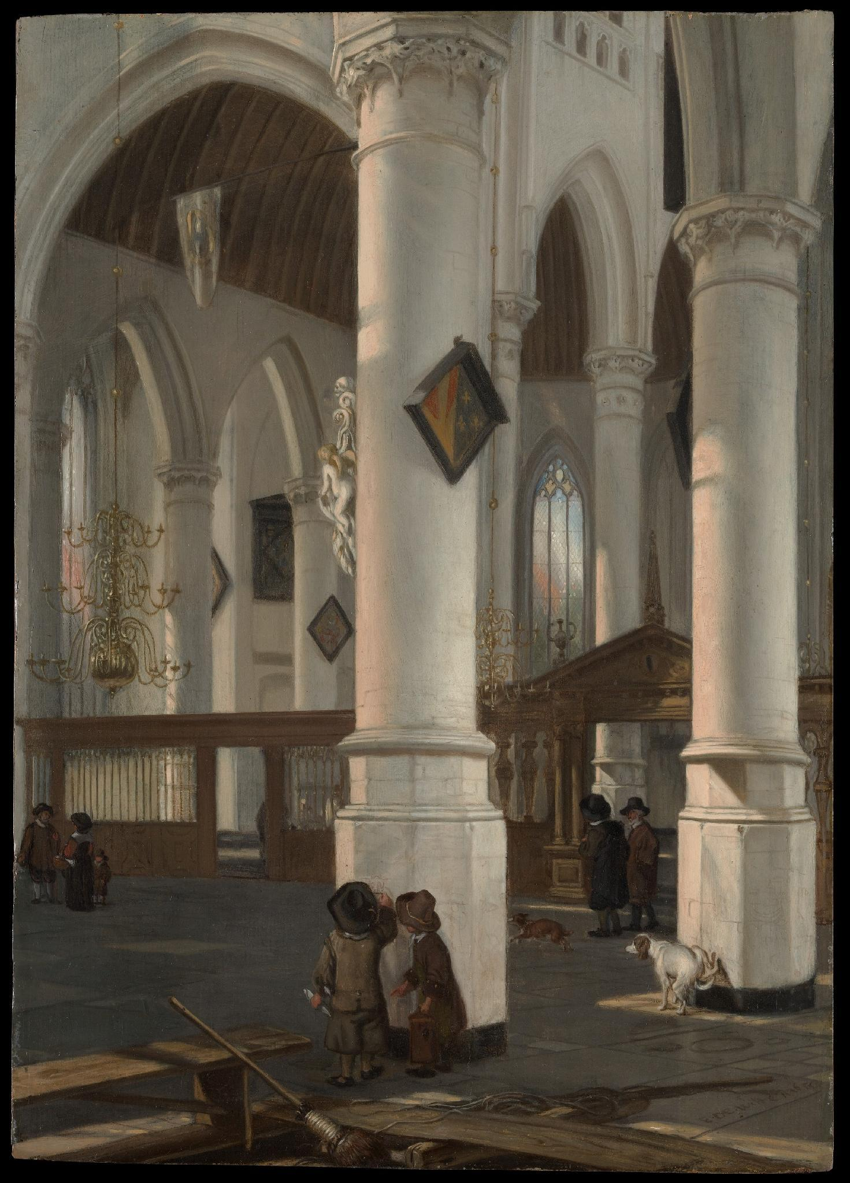
Emanuel de Witte, Interior of the Oude Kerk, Delft, probably 1650. The Met, 2001.403. Public domain. A later Dutch church, rather than Calvin’s Geneva. • Museum record

Look closely
Discuss the image: what do you notice/see? identify one visible feature of the interior and the position of the people. How might the arrangement shape worship? What cannot this later Dutch painting establish about Geneva?

Use the image with P&C pp. 81–82. Keep the later place and date in view: this painting cannot show whether all Reformed churches looked alike.

Textbook questions to complete before class

Class notes on Calvinist communities
Calvin believed in the formation of religious communities. Calvinists rejected bishops in favor of “presbyteries,” groups that included ministers and laymen. Presbyteries gave lay people authority over church governance. On the other hand, this was part of an effort to make everyone more religious. The formation of these presbyteries would play a role in American culture and political affairs.
Calvinist ideas also spread in England. Congregationalist churches each managed their own affairs, whereas Presbyterians organized clergy and laymen in networks of churches. These forms of local participation helped shape later American religious and political life.
T1. According to P&C pp. 81–82, what two institutions or practices enforced moral discipline in Calvinist cities?
T2. According to P&C pp. 81–82, how did ministers and laymen share authority in Calvinist church government?
Read the complete selection before class. Underline Calvin’s definition of predestination and one phrase explaining why believers can feel confident about salvation. We will discuss questions C1–C3 in class.

Primary source: John Calvin on predestination
John Calvin, Institutes of the Christian Religion, III.21. Edited by John T. McNeill; translated by Ford Lewis Battles. Selections; omissions marked […].
[…] We call predestination God’s eternal decree, by which he compacted with himself what he willed to become of each man. For all are not created in equal condition; rather, eternal life is foreordained for some, eternal damnation for others. Therefore, as any man has been created to one or the other of these ends, we speak of him as predestined to life or to death. […]
In actual fact, the covenant of life is not preached equally among all men, and among those to whom it is preached, it does not gain the same acceptance either constantly or in equal degree. In this diversity the wonderful depth of God’s judgment is made known. For there is no doubt that this variety also serves the decision of God’s eternal election. If it is plain that it comes to pass by God’s bidding that salvation is freely offered to some while others are barred from access to it, at once great and difficult questions spring up, explicable only when reverent minds regard as settled what they may suitably hold concerning election and predestination. A baffling question this seems to many. For they think nothing more inconsistent than that, out of the common multitude of men, some should be predestined to salvation, others to destruction. But how mistakenly they entangle themselves will become clear in the following discussion. Besides, in the very darkness that frightens them not only is the usefulness of this doctrine made known but also its very sweet fruit. We shall never be clearly persuaded, as we ought to be, that our salvation flows from the wellspring of God’s free mercy until we come to know his eternal election, which illumines God’s grace by this contrast: that he does not indiscriminately adopt all into the hope of salvation but gives to some what he denies to others. How much the ignorance of this principle detracts from God’s glory, how much it takes away from true humility, is well known. […]
And, as Christ teaches, here is our only ground for firmness and confidence: in order to free us of all fear and render us victorious amid so many dangers, snares, and mortal struggles, he promises that whatever the Father has entrusted to his keeping will be safe [John 10:28–29]. From this we infer that all those who do not know that they are God’s own will be miserable through constant fear.
[…] If this thought prevails with us—that the Word of the Lord is the sole way that can lead us in our search for all that it is lawful to hold concerning him, and is the sole light to illumine our vision of all that we should see of him—it will readily keep and restrain us from all rashness. For we shall know that the moment we exceed the bounds of the Word, our course is outside the pathway and in darkness, and that there we must repeatedly wander, slip, and stumble. Let this, therefore, first of all be before our eyes: to seek any other knowledge of predestination than what the Word of God discloses is no less insane than if one should purpose to walk in a pathless waste [cf. Job 12:24], or to see in darkness. And let us not be ashamed to be ignorant of something in this matter, wherein there is a certain learned ignorance. Rather, let us willingly refrain from inquiring into a kind of knowledge, the ardent desire for which is both foolish and dangerous—nay, even deadly. […] For there is good reason for us to be deterred from this insolence, which can only plunge us into ruin.
[…] Therefore, to hold to a proper limit in this regard also, we shall have to turn back to the Word of the Lord, in which we have a sure rule for understanding. For Scripture is the school of the Holy Spirit, in which, as nothing is omitted that is both necessary and useful to know, so nothing is taught but what is expedient to know. Therefore we must guard against depriving believers of anything disclosed about predestination in Scripture, lest we seem either wickedly to defraud them of the blessing of their God or to accuse and scoff at the Holy Spirit for having published what it is in any way profitable to suppress.
As Scripture, then, clearly shows, we say that God once established by his eternal and unchangeable plan those whom he long before determined once for all to receive into salvation, and those whom, on the other hand, he would devote to destruction. We assert that, with respect to the elect, this plan was founded upon his freely given mercy, without regard to human worth; but by his just and irreprehensible but incomprehensible judgment he has barred the door of life to those whom he has given over to damnation. Now among the elect we regard the call as a testimony of election. Then we hold justification another sign of its manifestation, until they come into the glory in which the fulfillment of that election lies. […]
For class discussion, return to the definition paragraph and the paragraph beginning “And, as Christ teaches.” In the paragraph beginning “In actual fact,” find the sentence beginning “We shall never be clearly persuaded.” Use these passages to explain Calvin’s argument.

Class discussion
C1. How does Calvin define predestination? Explain in your own words and include a three- to six-word quotation.
C2. Why does Calvin think election can produce humility and confidence? Use a phrase from the selection to explain each.
C3. How might confidence in salvation coexist with strict discipline in a religious community? Connect Calvin’s words to one Geneva practice from T1. Explain how the two sources support your answer.

Secondary source: Palmer and Colton on Luther
Palmer and Colton, A History of the Modern World, 8th ed., p. 76.
“Good works, Luther thought, were the consequence and external evidence of this inner grace, but in no way its cause. A man did not ‘earn’ grace by doing good; he did the good because he possessed the grace of God.”

Group comparison
Identify whose voice each passage represents. Each group should identify a passage to support its answer. Work in your usual groups.
Map/Door: identify what salvation depends on in both accounts. Hooks: explain the place of good works and religious discipline in these accounts. Window: compare what Calvin stresses about election with what P&C stresses about Luther’s good works.

Weekly History writing
Write independently after the class discussion. Submit your paragraph at the end of the period.
How do Luther’s and Calvin’s views of salvation compare?
- Explain one similarity and one difference in a developed paragraph.
- Use a short quotation from Calvin and evidence from P&C p. 76; explain both.

Optional reading
Additional Calvin passages and questions on economic life: Open full reference bank

Homework due Thursday, November 5
Read P&C pp. 83–93. Answer Questions 1, 2, 5, 7 and 8 on the 003H06 handout. For Questions 7–8, also reread pp. 79 and 81–82.
Questions 3, 4 and 6 on 003H06 are due Monday, November 9, using the same reading. No new History reading is assigned for Monday.

