Do Now Evidence from Binham Priory
003H06 | Thursday, November 5, 2026 | Grade 10
Name __________________________________ Date __________________
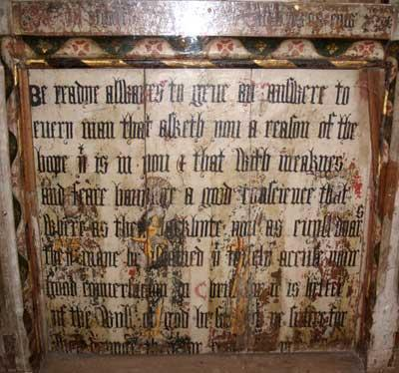 | 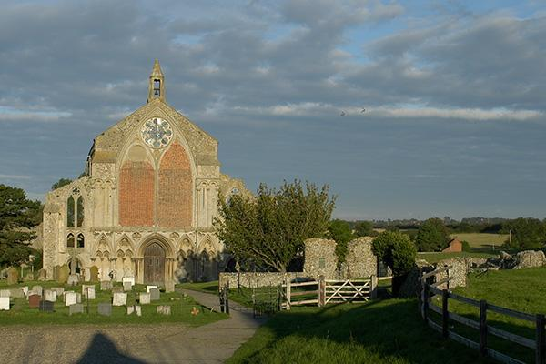
Look closely. Record two visible details about the painted figures and the writing.
Detail 1: _________________________ Detail 2: _________________________
Image A. Binham’s medieval screen separated the congregation from the altar area. During the Reformation, some saints’ faces were scratched out and the paintings covered with white paint and English Scripture. The older figures now show through.  Image B. Henry VIII closed Binham monastery in 1539 and granted it to Sir Thomas Paston. Much was dismantled, but part of the medieval church remained in parish use. | Congregation: assembly  Altar: worship table  Parish: local church
Elizabeth I’s Injunctions of 1559  VI. “Also, that they shall provide … one book of the whole Bible of the largest volume in English … and the same set up in some convenient place within the said church … whereas their parishioners may most commodiously resort unto the same, and read the same …”  XXIII. “Also, that they shall take away, utterly extinct, and destroy all shrines … pictures, paintings, and all other monuments of feigned miracles, pilgrimages, idolatry, and superstition … preserving nevertheless, or repairing both the walls and glass windows …” | Commodiously: conveniently  Extinct: abolish  Monuments: commemorative objects  Ellipses mark omissions.
XXIII — Remove: ____________________ Preserve: ____________________
A. How do the altered screen and the royal instructions show a change in religious practice? Cite one detail from each.

Henry VIII and royal supremacy
P&C pp. 83–85 — Read the complete “Reformation in England” section, including Ireland at the top of p. 85. Stop before “The Religious Situation by 1560.”
1. The Church of England became a national Protestant church, also called the Anglican Church. It combined Protestant teaching with much of the older church’s ritual and hierarchy.
2. Henry VIII ruled from 1509 to 1547. He belonged to the Tudor dynasty and was the son of Henry VII, its first king.
3. Henry began as a strong Catholic. His arguments against Lutheranism earned him the pope’s title Defender of the Faith. He did not initially want to change Catholic doctrine, but he came to demand control over the church in England.
4. England had experienced civil war and instability. Henry wanted a male heir to continue his dynasty and prevent rival families from fighting for the throne.
5. Henry’s marriage to Catherine of Aragon had produced a surviving daughter, Mary, but no surviving son. He wanted to marry another woman, but the Catholic Church did not permit divorce.
6. An annulment declared that a marriage had not been valid. Henry sought one from the pope.
7. The pope did not want to offend Emperor Charles V, Catherine’s nephew, who held great power in Germany and Italy. Catherine also opposed losing her position as queen.
8. Henry decided that he needed control over religion in England to obtain the marriage he wanted.
9. Parliament passed the Act of _________________ in 1534. It made the king supreme head of the Church of England in place of the pope.
A. Officials could be required to swear allegiance to the king as head of the church.
B. Sir Thomas More, the humanist author of Utopia, refused to accept royal supremacy. Henry had him executed for treason. More maintained that his loyalty to the king was limited by a higher loyalty to God.
10. In 1533 Henry married Anne Boleyn, and English church authorities annulled his marriage to Catherine. Anne bore Elizabeth. Henry later had Anne executed, married four more times, and had a son, Edward VI.
11. Opposition also took the form of a Catholic rebellion. Henry suppressed it by force.
12. Henry dissolved England’s monasteries, important centers of religious, intellectual and economic life. He seized their lands and distributed property to followers, building support among the nobility and landed gentry.
The new owners had a material reason to defend Tudor rule and the national church. Compare East Prussia, where Albert of Brandenburg turned the Teutonic Order’s territory into his hereditary secular duchy in 1525.
Henry retained major Catholic doctrines. His Six Articles of 1539 required transubstantiation, clerical celibacy and confession. The initial break with Rome changed authority before the later Protestant settlement changed worship and doctrine.

Edward VI Mary I and Elizabeth I
13. Edward VI ruled from 1547 to 1553 while still a boy, with adult advisers governing the country. They advanced Protestant reforms in the Church of England, including the English Book of Common Prayer.
14. Mary I, Henry and Catherine’s daughter, ruled from 1553 to 1558 and restored Catholicism and papal authority. She married Philip of Spain and burned nearly 300 Protestants as heretics, gaining the name Bloody Mary.
15. Elizabeth I, Henry and Anne Boleyn’s daughter, ruled from 1558 to 1603. Catholics who rejected Henry’s annulment also disputed her legitimacy.
A. Elizabeth was Protestant, but she sought to avoid unnecessary divisions among Protestants. The settlement of 1559 restored royal supremacy and prescribed a common form of worship.
B. The Church of England became an established national church. The monarch, acting through _________________, determined its legal position and doctrine. Elizabeth took the title Supreme Governor.
i. The Archbishop of Canterbury remained the leading church official. Archbishops, _________________, priests and deacons continued below the monarch. Church courts, parishes and tithes also survived. Tithes were payments to support the church.
ii. English replaced Latin in worship, clergy could marry, and the Book of Common Prayer prescribed an order of services. The Thirty-Nine Articles stated Anglican doctrine. The church retained a hierarchy rather than adopting Geneva’s system of ministers and lay elders.
Book of Common Prayer — Elizabethan edition
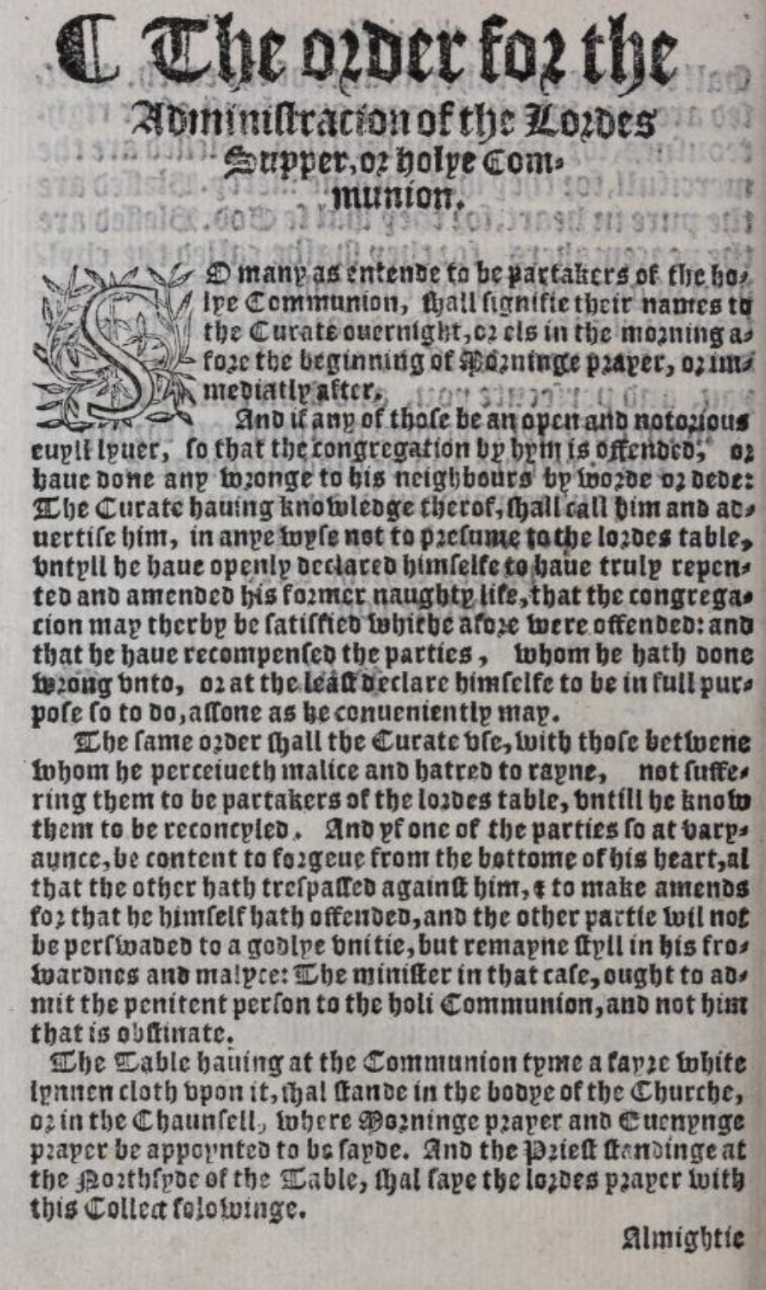
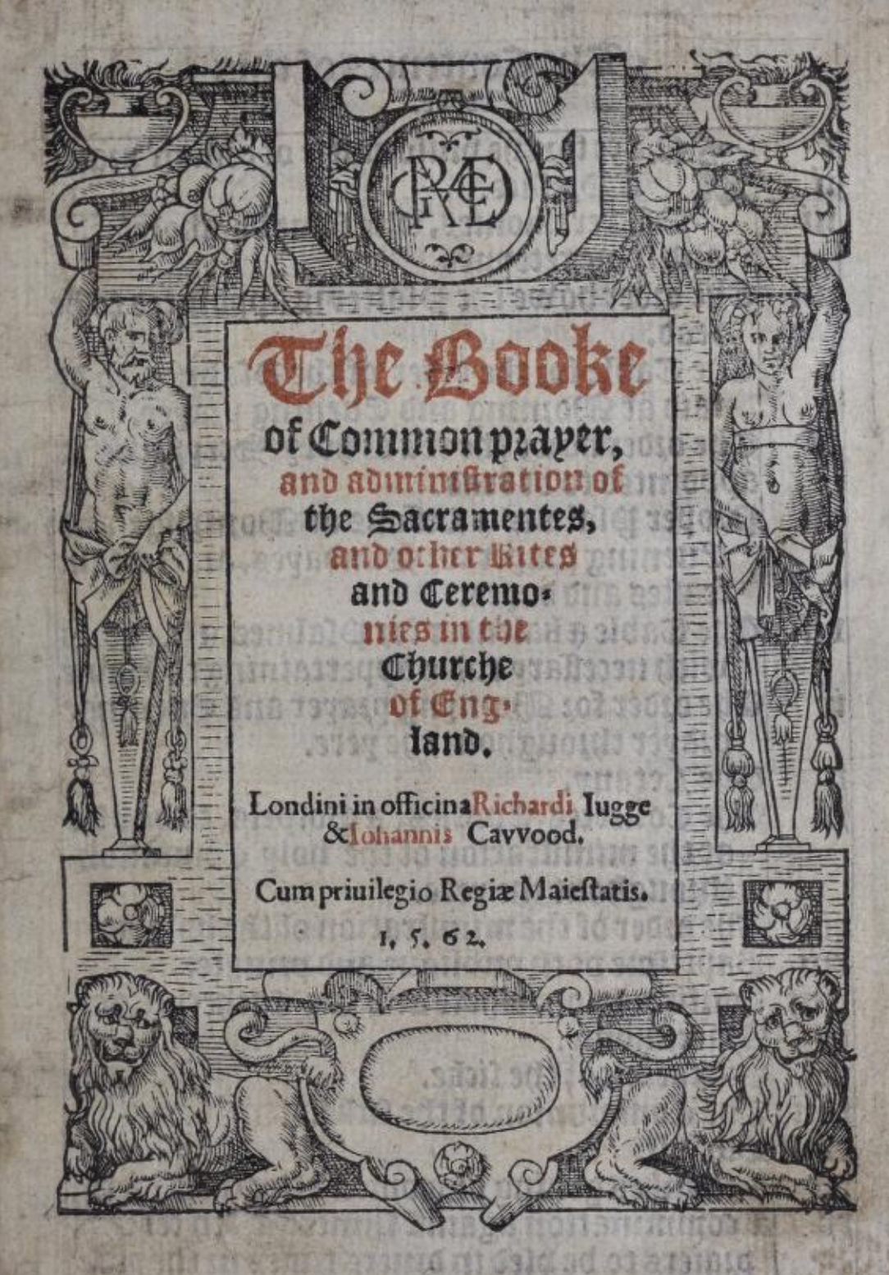
iii. Some Protestants, often called Puritans, wanted further changes in ceremonies and church government. Anglican worship preserved more traditional forms than many Calvinists wanted.
iv. Later Anglican usage called the emphasis on ritual and hierarchy High Church, and the stronger Protestant emphasis with less ritual Low Church. These were later labels, not formal parties established by Elizabeth.
Church decoration: removed and retained
Image C Ely, England  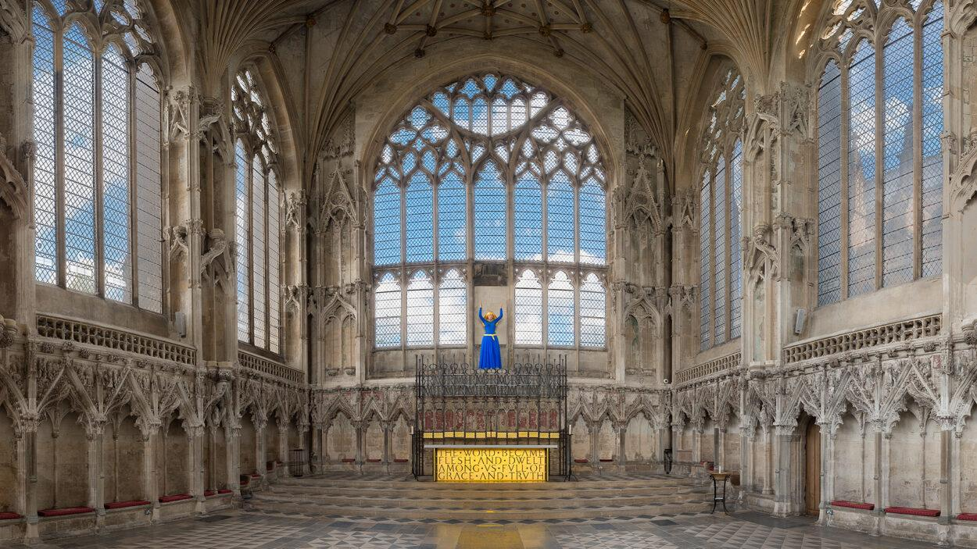  Detail below  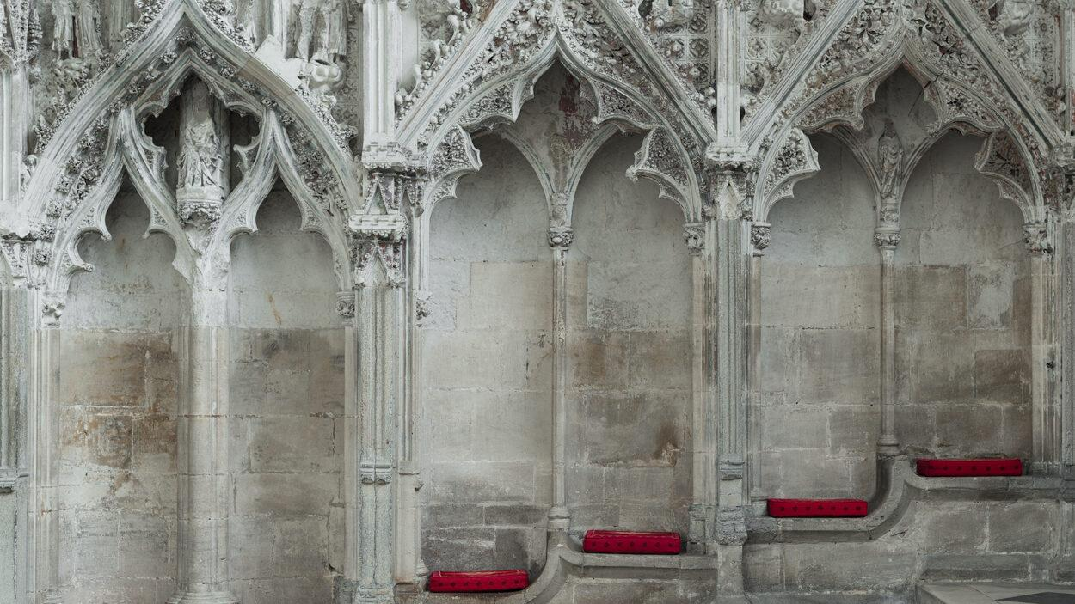 | Image D Albi, France  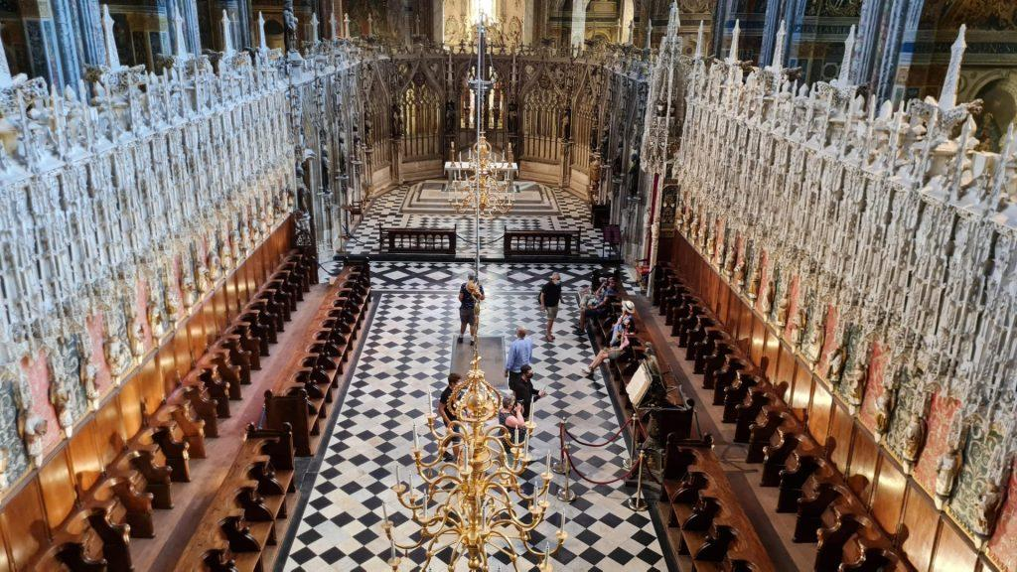  Detail below  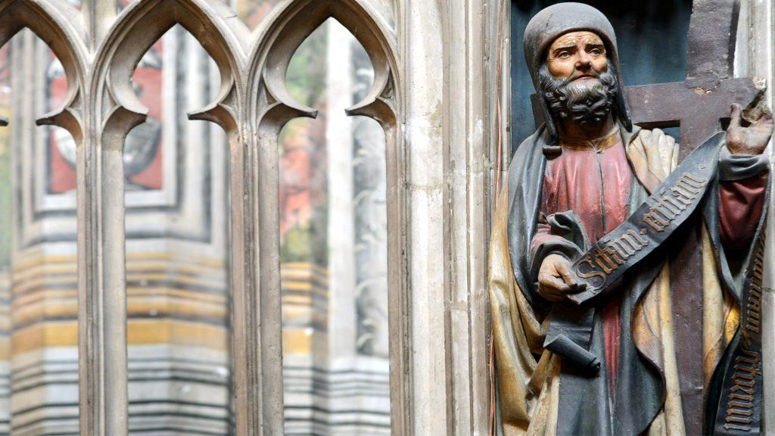
Image C. Ely Cathedral’s Lady Chapel was built in the fourteenth century. Ely became an Anglican cathedral during the Reformation. Its painted statues were removed and its lower carved figures defaced. The Gothic walls survived; empty niches remain. The blue statue in the overview is a modern addition, not a surviving medieval statue. | Image D. Albi Cathedral’s choir in Catholic France retains late medieval painted figures of biblical people. The detail shows a surviving figure within the carved screen. The screen was later damaged during the French Revolution and has been restored.  Niche: wall recess  Defaced: damaged  Choir: clergy’s area  Screen: partition
B1. Compare the two details. Identify one visible difference in the religious decoration, using a feature from each photograph.
______________________________________________________________________
______________________________________________________________________
B2. How does the treatment of religious images at Ely resemble the policy in XXIII? Use one detail from the caption and one from the instruction.
______________________________________________________________________
______________________________________________________________________
C. The settlement required subjects to attend Church of England services. People who refused were called _________________. Catholics faced fines and legal disadvantages; Protestant dissenters also faced restrictions. Bishops’ courts and the High Commission enforced conformity under royal authority.
D. Jews had been expelled from England in 1290 and were not openly readmitted under the Tudors. Open resettlement is conventionally dated to 1656, through toleration rather than a formal readmission law.
E. The English monarchy also established a Protestant Church of Ireland. Most Irish people remained Catholic and resented church taxes and English rule. Catholic identity became closely connected with resistance to English domination.
Final explanation
Why was England’s Reformation both a religious change and a transfer of power? Write three linked sentences using because and although. Include a change in worship, a change in authority or property, and one feature that survived.

Homework for Friday, November 6
- Read the complete P&C pp. 83–85 section, “The Reformation in England,” including the paragraph on Ireland.

For Monday, November 9
- Read P&C pp. 87–93, “Catholicism Reformed and Reorganized.”
- Bring this packet and your P&C reading.

