The Counter Reformation
003H07 | Monday, November 9, 2026 | Grade 10
Name: Date:

Complete the selected note blanks and write the final explanation.
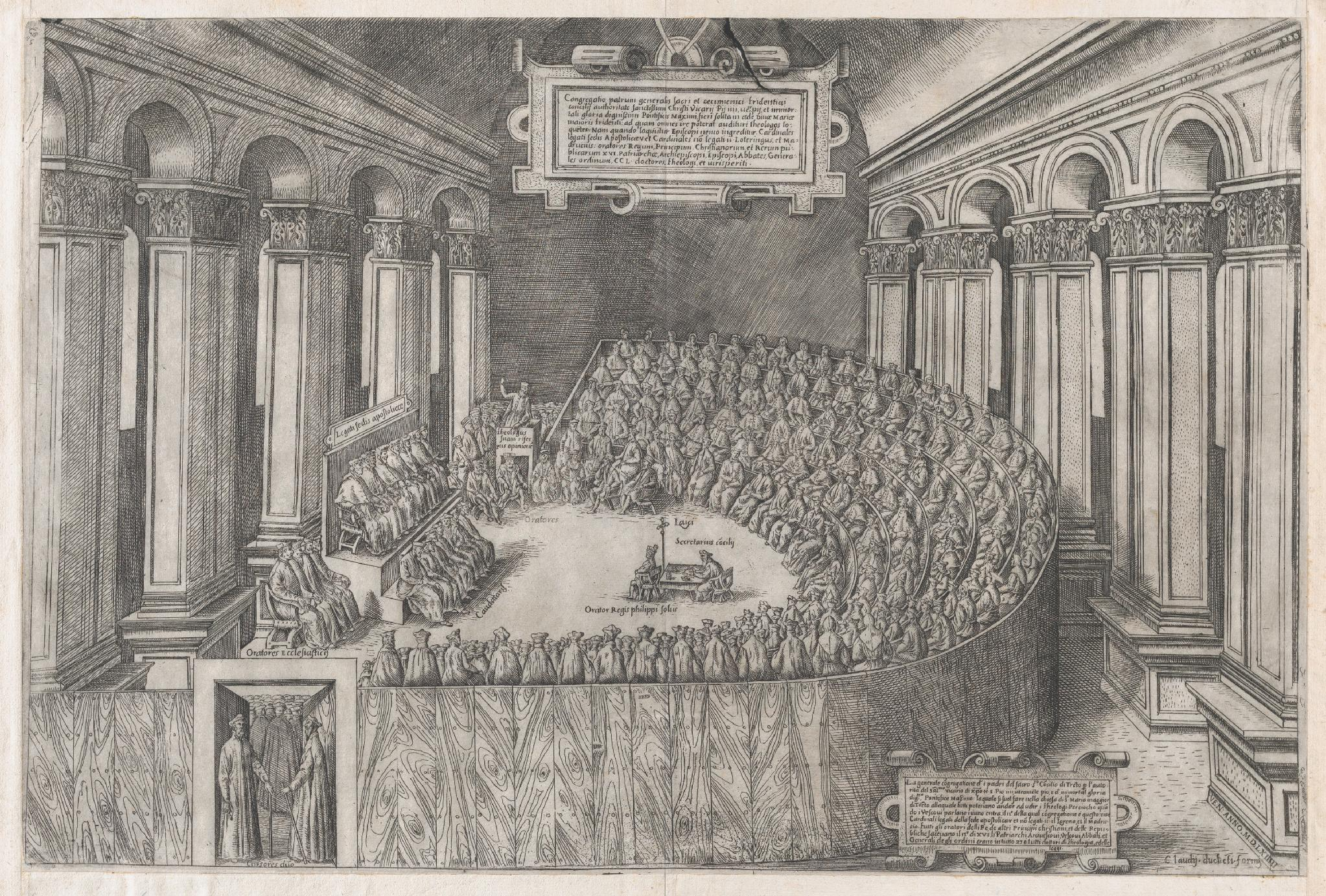
Council of Trent, 1565. Anonymous Italian artist; published by Claudio Duchetti. Etching and engraving. The Metropolitan Museum of Art, 41.72(3.70). Public domain. The print appeared two years after the council ended.
https://www.metmuseum.org/art/collection/search/403878
1. Which two details in the curved rows of seats and the figure addressing the assembly show how the clergy gathered to conduct the council?

The Council of Trent
1. Catholic reform answered longstanding complaints about abuses and responded to the Protestant challenge. The Catholic Church finally assembled the Council of Trent after years of delay caused by war, political rivalry and fears about a council’s power.
2. The council met in separate sessions between 1545 and 1563. Attendance was sometimes small, and bishops and rulers disagreed about how much authority a general council should have.
A. Some bishops argued that a council could be superior to the pope. Trent’s final rule required acceptance by the before its acts were valid. This preserved papal authority and helped prevent division into national churches.

The two tasks of Trent
P&C pp. 89–90. Doctrine is what the Church teaches; disciplinary reform changes how its clergy and institutions carry out their duties.
3. Trent clarified and reaffirmed Catholic doctrine and acted to reform abuses within the Church.

A Catholic doctrine reaffirmed
i. Justification: against Luther’s faith-alone position, Trent upheld faith and good works within a life made possible by God’s grace. It did not teach that people could save themselves without grace.
Trent on justification, 1547: “none of those things which precede justification—whether faith or works—merit the grace itself of justification.”
Council of Trent, Session VI, chapter VIII. J. Waterworth translation, 1848. Merit here means earn or deserve.
https://history.hanover.edu/texts/trent/ct06.html
ii. Indulgences: the Church retained the practice while condemning abuses. An indulgence concerned temporal punishment after guilt had been forgiven; it did not purchase forgiveness or permission to sin.
iii. Sacraments: Trent reaffirmed sacraments as means by which God gives grace: baptism, confirmation, Eucharist, penance, anointing of the sick, holy orders and matrimony. Their efficacy did not depend on the personal holiness of the minister.
iv. Priesthood: holy orders distinguished ordained clergy from laypeople and authorized their sacramental duties.
v. Clerical celibacy: the Latin Church retained its rule that priests must not marry.
vi. Monasticism: monks, nuns and their religious vows remained important parts of Catholic life.
vii. Worship: the Latin Mass was retained rather than replaced by services wholly in the vernacular, the language spoken by ordinary people.
viii. Interpretation: private judgment of Scripture could not override the Church’s authoritative teaching.
ix. Sources of faith: Scripture and apostolic were both authoritative. This rejected sola scriptura, the Protestant claim that Scripture is the final test of doctrine.
x. Bible: the Vulgate, the Latin translation associated with St. Jerome, was declared authoritative for public teaching and dispute in the Church.

Catholic worship and religious images
xi. Confession and penance: the council upheld the priest’s role in absolution, the declaration of forgiveness of sins, and clarified the practice of confession.
xii. Pilgrimages: journeys to holy places remained worthy religious activities.
xiii. Purgatory: the council reaffirmed a state of purification for those ultimately destined for heaven, and the value of prayers for the dead.
xiv. Transubstantiation: in the Eucharist, the substance of bread and wine becomes Christ’s body and blood while their outward appearances remain. Luther also affirmed Christ’s real presence, but rejected this explanation.
xv. Images and relics: pictures of Christ and saints, and physical remains or objects associated with saints, could aid devotion. Catholic teaching distinguished honoring the persons represented from treating the objects as gods.
xvi. Mary: devotion to the Virgin Mary remained part of Catholic worship and religious life.
xvii. Saints: the faithful could honor saints, imitate their lives and ask for their intercession, meaning their prayers to God. Many Protestant reformers rejected invoking saints as intermediaries.

Trent on religious images in 1563
“[T]he images of Christ, of the Virgin Mother of God, and of the other saints, are to be had and retained particularly in temples … not that any divinity, or virtue, is believed to be in them … but because the honour which is shown them is referred to the prototypes which those images represent …”
“[N]o one [shall] be allowed to place, or cause to be placed, any unusual image, in any place, or church … except that image have been approved of by the bishop …”
Council of Trent, Session XXV, December 1563. J. Waterworth translation, 1848, pp. 234–236. Prototypes means the persons represented. Temples means churches. Brackets mark changes; ellipses mark omissions.
https://history.hanover.edu/texts/trent/ct25.html
Elizabeth’s contrasting instruction, 1559: “take away, utterly extinct, and destroy all shrines … pictures, paintings, and all other monuments of feigned miracles, pilgrimages, idolatry, and superstition …”
Elizabeth I, Injunction XXIII. Gee and Hardy, 1896, p. 428. Extinct means abolish.
https://history.hanover.edu/texts/engref/er78.html
2. How do Trent’s instructions for religious images differ from Elizabeth’s? Explain what each orders and who approves unusual images under Trent’s rule.

B Reforming abuses
P&C p. 90
i. Indulgences: Trent acted against abuses while preserving the principle of indulgences.
ii. Clerical discipline: bishops were to live in their dioceses, attend to their duties and exercise closer supervision over clergy. The council checked pluralism, the holding of several church offices by one person, and reformed monastic discipline.
iii. Clerical education: each diocese was to establish a to train priests. Better instruction and closer supervision were intended to produce competent clergy.
3. Which two teachings did Trent reaffirm, and which two changes in clerical practice show how the council reformed abuses while rejecting Protestant doctrine?

4. The council’s influence grew gradually. Catholic rulers initially accepted some decrees selectively, but over time Trent helped shape a more closely regulated Catholic Church. Its decisions remained influential for centuries; later councils in 1870 and the 1960s addressed further questions and changes.

Catholic renewal missions and the Jesuits
P&C pp. 90–92
5. Catholic renewal included reforming popes, stricter bishops and renewed devotion to the Church and its sacraments. Catholic unity was increasingly defended through an international Church under the pope, while many Protestant churches operated within national or territorial states.
A. New orders devoted themselves to education, charity and missions. They included the Jesuits, the Oratorians for men and the Ursulines for women. St. Vincent de Paul worked among the poor in Paris.
B. Missionaries sought to reconvert Protestants in Europe and convert non-Christians in Asia and the Americas. P&C contrasts this Catholic missionary effort with the more limited activity it describes among established Protestant churches.
6. Catholic and Protestant authorities both tried to preserve their own churches and limit rival teaching. Religious renewal, persuasion and coercion could occur together.
7. Ignatius of Loyola founded the Society of Jesus, or , approved by Pope Paul III in 1540. Its members underwent rigorous spiritual training and discipline; fully professed members took a special vow of obedience to the pope concerning missions.
A. Jesuits taught in schools, preserved the study of Latin classics and trained boys from the ruling and middle classes. They also served as missionaries and as confessors to rulers, giving them opportunities for political influence. Catholic reform therefore remained involved in education, culture and politics.
4. How could Jesuit work in schools, missions and rulers’ courts strengthen the Catholic Church? Explain two examples from notes 5–7.

Enforcing belief and the European balance
P&C pp. 92–93
8. Book censorship and religious courts enforced conformity in both Catholic and Protestant territories. Protestant rulers feared the influence of Catholic clergy and rulers as well as religious disagreement itself.
A. The papal Index of Prohibited Books restricted Catholic reading. The Roman Inquisition, established in 1542 under the Holy Office, investigated heresy principally in Italy. The Spanish Inquisition was a separate institution closely controlled by the Spanish monarchy; its targets included converts suspected of continuing Jewish or Muslim practices and later Protestants.
B. Inquisitorial proceedings could involve torture and severe penalties; executions were carried out by secular authorities. In England, Elizabeth’s High Commission and bishops’ courts enforced Anglican conformity. Geneva’s consistory disciplined religious conduct, while civil magistrates imposed civil penalties.
C. P&C emphasizes the power of the in enforcing religion. Church rulings depended heavily on political authorities able to censor, fine, imprison or otherwise punish.
5. How did one Catholic means of enforcing belief compare with one English or Calvinist means? Identify each institution, the authority behind it and a consequence it could impose.
9. By about 1560, Protestantism had become a lasting part of Europe, but the religious division was not secure or peaceful. Catholic powers such as Spain, France and Austria were stronger than most individual Protestant states. Rivalries among Catholic rulers hindered a united campaign against Protestantism.
Catholic kingdoms and territories: Spain, Portugal, France, Austria and many southern German states. France retained special royal influence over its Church.
Protestant kingdoms and territories: England and Wales, Scotland, Scandinavia and many northern German states. Scotland was Calvinist; Scandinavia was Lutheran. These official churches did not mean that every inhabitant shared the ruler’s religion.

Final explanation
How did the Catholic Reformation reform the Church while preserving its authority? Write three linked sentences. Use although to explain one reform alongside one retained doctrine, then explain how papal approval or Jesuit work strengthened the Church.

Homework
- Review study-guide Questions 24–29 using this handout and P&C pp. 89–93; correct your existing answers in place.
- Bring the study guide, corrected Reformation notes and sources for Flippity review Tuesday, November 10, and Wednesday, November 11.
- Prepare for the Reformation test Thursday, November 12.
- No new History reading.

