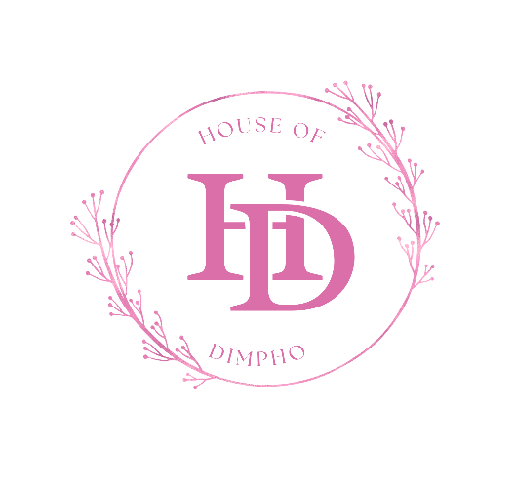
WEBSITE PROJECT PROPOSAL
House of Dimpho
Prepared by: Dimpho Flietoor
Student Number: ST10516381
Module: WEDE5020

Table of Contents
Table of Contents 2
Organisation overview 3
Mission Statement 3
Vision Statement 3
Target Audience 3
2. Website Goals and Objectives 3
Key Performance Indicators (KPIs) 4
3. Current Website Analysis 4
Strengths 4
Weaknesses 4
Areas for Improvement 4
4. Proposed Website Features and Functionality 4
5. Design and User Experience 5
User Experience Considerations 5
Home page wireframe 6
About us wireframe 7
Services wireframe 8

Organisation overview
Name: House Of Dimpho
House Of Dimpho is We are a beauty and hair care businesses the focuses on helping clients look and feel beautiful. We offer services such as braiding, nails and other beauty treatments. The business started from my passion for beauty and helping people feel good about themselves. House Of Dimpho was started in 2021 as a garage-based business in Rustenburg then moved to Pretoria in 2024, where it was still home based. Word of mouth and social media helped expose the businessework which helped it grow and relocate to a dedicated studio space, where if offers a full range of beauty services including braiding, nails and eyelashes. Today the business employs three braiders, one eyelash artist, two nail technicians and serves an average of 20 clients per week.

Mission Statement
The mission of House Of Dimpho is to help every client look and feel beautiful and confident through personalised and affordable beauty care in a warm and welcoming environment.

Vision Statement
Our vision as a business is to be successful and a trusted business that helps empower people to feel confident, beautiful and comfortable in their own skin. We aim to provide high quality and professional beauty services by creating a welcoming environment for every client.

Target Audience
- Women aged 7 and above or people working and living in and around
- Working professionals Working professionals seeking convenient, high-quality beauty treatments.
- Brides and bridal parties planning for their wedding day.
- Beauty social media influencers to expose the business more
- Existing clients who want an easier way to book appointments and repurchase retail products.

2. Website Goals and Objectives
The business is currently only on social pages like Instagram and Tik tok. We are currently working on creating a business website to formalise its online presence and Increase overall online visibility and attract new clients through organic search.
The goals of the website are:
- Enable clients to book appointments online to decrease WhatsApp booking traffic.
- To provide clear and up to date information on services and pricing.
- To also enable clients to see what products and services we provide

Key Performance Indicators (KPIs)
KPI | Target | Measurement Tool
Monthly website views | 200 withing 2 months of launching | Google Analytics
Online bookings made | 15% of visitors who view the Booking page | Booking system reports
Session duration | 2 minutes or more | Google Analytics
Bounce rate | Below 55% | Google Analytics

3. Current Website Analysis
House Of Dimpho does not currently have a dedicated website. Its online presence consists of an Instagram business page and a TikTok, which helps showcase work and communicate with clients

Strengths
- A hight number of following on social media with regular before and after posting.
- High-quality photo and video content already being produced for social media.

Weaknesses
- No central place for clients to view a full, up to date service menu with pricing.
- Booking are handles through WhatsApp and phone calls, which can be time consuming.
- The business does not appear when searched on Google.

Areas for Improvement
- Introduce a user friendly website.
- Introduce an online booking system.

4. Proposed Website Features and Functionality
Page / Feature | Functionality
Home Page | This is where the user/clients will be welcomed into to website by a welcome message
About Us | The business history and where a client can find us.
Services | Categorised service menu (skincare, makeup, nails, lashes & brows, bridal) with descriptions, duration, and pricing.
enquiries | This is the page where clients will be given to the opportunity to ask question and make appointment bookings.
contact | E-commerce store for retail skincare products with cart and secure checkout.

5. Design and User Experience
The design of the website will be made to be user friendly by having navigation where clients can click which page they want to go to. It will have small touches of pink to keep it feminine but still professional. The user will be able to make a booking and ask questions easily because the website will provide a platform easy to interpret and fill.

User Experience Considerations
- Website will be simple and not cluttered.
- Clear action buttons to make easy and hassle free
- There will clear images to show what services are provided to make it easy for the client to understand.

Home page wireframe
The below wireframe is intended to display the layout of the home page of the website.

LOGO

NAVIGATION

HEROSHOT

WELCOME MESSAGE AND SLOGAN

About us wireframe
The wireframe below shows the intended layout of the about us page

LOGO

NAVIGATION

Map image

Text about the business and the business location

Services wireframe
This is a wireframe to display the services page

LOGO

IMAGE

LIST OF SERVICES

IMAGE

NAVIGATION

