WEBSITE PROJECT PROPOSAL

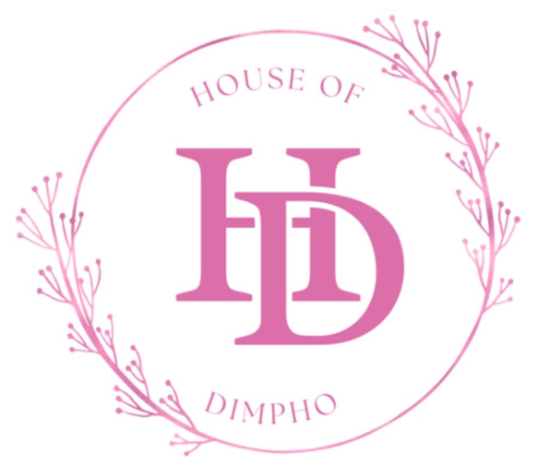
Prepared by: D FLIETOOR
Student Number: ST10516381
Module: Web Development
Date: 14 August 2026

Table of Contents
1. Organisation Overview 3
Business Name 3
Mission Statement 3
Vision Statement 3
Business Background 3
Target Audience 3
2. Website Goals and Objectives 3
3. Current Website Analysis 4
4. Proposed Website Features and Functionality 5
Home Page 5
Company Slogan 5
About Us Page 5
Services Page 5
Enquiries Page 5
Contact Us Page 5
5. Design and User Experience 6
Layout and Design Approach 6
Design Elements 6
Colour Scheme 6
User Experience Considerations 6

Organisation Overview

Business Name
House of Dimpho (HOD)

Mission Statement
To provide affordable, professional, and high-quality beauty services while ensuring that every client feels confident, valued, and satisfied.

Vision Statement
To become one of the most trusted beauty salons in South Africa by offering a variety of beauty services in a welcoming and professional environment.

Business Background
House of Dimpho was established in 2022 by a young entrepreneur from Rustenburg. The business started in her father's garage, where she braided the hair of close friends, family members, and people within her community at affordable prices. Her goal was to provide salon quality hairstyles at prices that were accessible to everyone. As the quality of her work became known, the business grew through word-of-mouth referrals, WhatsApp marketing, and Instagram promotions. Over time, House of Dimpho attracted more clients and built a loyal customer base. The business continues to grow.

Target Audience
The target audience for House of Dimpho includes:
- School and university students
- Working professionals
- Women looking for affordable beauty services
- Clients interested in hair, nail, and beauty treatments
- Residents of Pretoria and surrounding areas

2. Website Goals and Objectives
The purpose of the House of Dimpho website is to establish a professional online presence and make it easier for clients to learn about and access the business's services.

Goals:
- Promote the House of Dimpho brand online.
- Attract new clients.
- Provide information about services and prices.
- Allow customers to make enquiries and bookings.
- Increase customer engagement through social media integration.
- Build trust and credibility with potential clients.

Objectives:
- Create an easy-to-use website that is accessible on mobile phones and computers.
- Showcase the business's services using images and pricing information.
- Provide clear contact details and booking options.
- Improve communication between the business and its customers.
- Increase the number of appointments and enquiries received.

3. Current Website Analysis
Strengths:
- Clear and simple website structure.
- Important information is divided into dedicated pages.
- Online booking and enquiry functionality.
- Contact details and social media links are available.
- Services and pricing can easily be viewed by customers.
Weaknesses:
- As a growing business, the website may have limited content and customer reviews.
- Brand awareness is still developing.
- More service images may be needed to showcase completed work.
Areas for Improvement:
- Content Improvements
- Add customer testimonials and reviews.
- Include before-and-after images of hairstyles.
- Add frequently asked questions (FAQs).
- Marketing Improvements
- Improve social media integration.
- Increase online visibility through search engine optimisation (SEO).
- Add monthly promotions and special offers.
- Technical Improvements
- Improve website loading speed.
- Ensure full mobile responsiveness.
- Enable online appointment reminders.

4. Proposed Website Features and Functionality
The House of Dimpho website consists of five main pages:

Home Page
The Home Page serves as the introduction to the business.
Features include:
- Business logo
- Navigation menu
- Welcome message
- Business slogan
- Featured services
- Call-to-action buttons
- Professional images

Company Slogan
"Enhancing Beauty, Building Confidence."

About Us Page
This page provides visitors with information about the history and growth of the business.
Features include:
- Business background
- Mission and vision statement
- Founder story
- Business location
- Google Maps integration

Services Page
This page allows customers to view the different beauty services offered.
Services may include:
- Hair braiding
- Nail services
- Beauty treatments
Features include:
- Service descriptions
- Images
- Price lists

Enquiries Page
This page allows customers to communicate directly with the business.
Features include:
- Enquiry form
- Booking form

Contact Us Page
The Contact Page provides all necessary contact information.
Features include:
- Phone number
- Email address
- WhatsApp contact
- Instagram handle

5. Design and User Experience

Layout and Design Approach
The House of Dimpho website will have a modern beauty-salon design that reflects professionalism and style.

Design Elements
- Soft and welcoming colour palette
- High-quality service photographs
- Consistent branding across all pages
- Easy to use navigation system
- Clear booking and contact buttons

Colour Scheme
- White
- Light pink
These colours communicate elegance with simplicity, beauty, and professionalism.

User Experience Considerations
The website will be designed with the user in mind to ensure a smooth browsing experience.

Accessibility:
- Mobile-friendly design
- Responsive layouts
- Easy to read content
- Accessible navigation
Usability:
- Simple page structure
- Fast access to services and pricing
- Easy appointment booking process
- Clearly displayed contact information
Performance:
- Fast page loading speed
- Optimised images
- Secure website hosting
- Reliable functionality across devices

