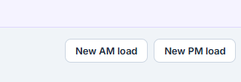
These probably need to be filters instead. The create new loads already exist when you select the shipments you want. Change these to filters and add the little filter icon along with a sun icon for morning and a moon icon for evening
Remove Live for now
Turn off Overview for now

Add Value and QTY on the shipment lines
What does suggested loads do and how can we improve it?
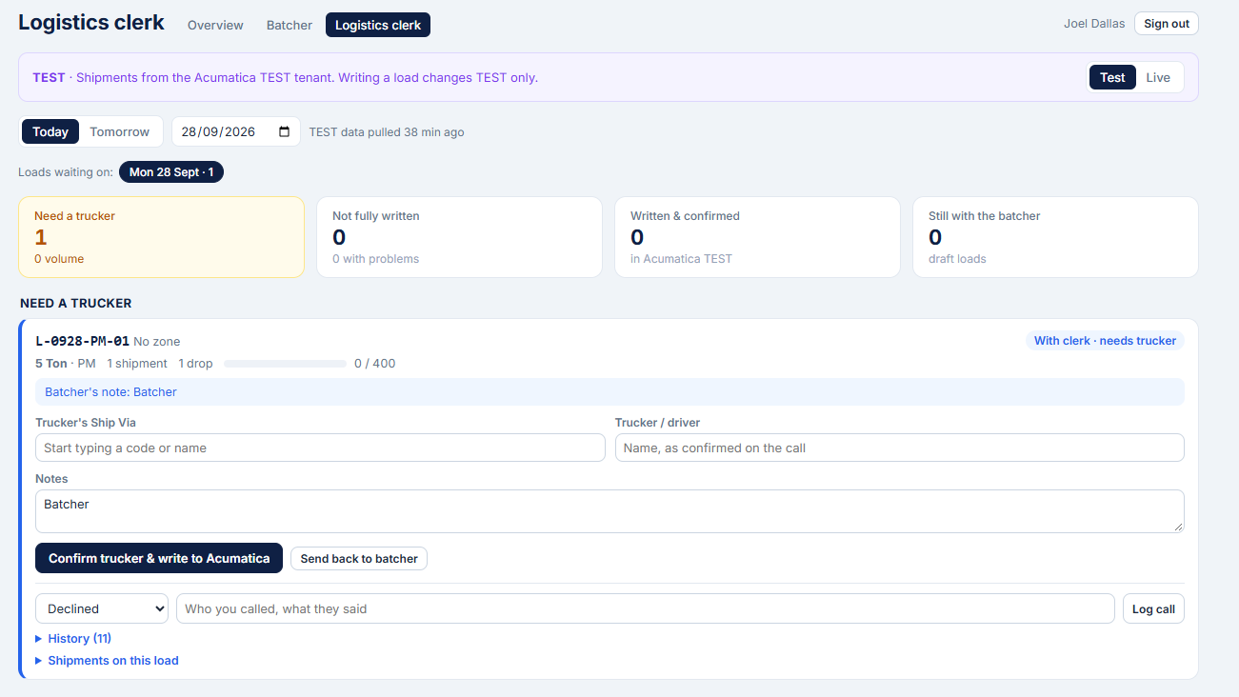
The load section in the logistics clerk view, needs to be collapsible so its easier to scroll through when you have 10+ loads sitting there. The collapsed view needs to show relevant information. Also could we make it two columns? No need for those dialogue boxes to be so wide? Also we can make more use of horizontal space because this will primarily be used on a Desktop.

