Dairy plant V1: cheese and mesost
Process data for mass and heat integration: rs and qt tables

1. Process
The plant receives fresh milk and produces cream and cheese. The whey separated in evaporation and cheese making is boiled down with part of the cream into mesost, a Scandinavian brown whey cheese.
Process steps and conditions:
- Reception: raw milk is cooled from 6 to 4 °C and stored.
- Pasteurisation: the milk is heated to 75 °C with regenerative heat exchange; the cream is separated by centrifugation at about 60 °C; the pasteurised skimmed milk is cooled back to 4 °C.
- Evaporation: the skimmed milk is preheated to 70 °C and concentrated in three effects boiling at about 70, 65 and 60 °C. Steam heats the first effect; the vapour of each effect heats the next one, and the vapour of the last effect is condensed. A diluted whey stream and a wastewater stream are also separated.
- Cheese making: the concentrated milk is heated to 56 °C and cultures are added; curd and whey are separated; the curd is cooled to 16 °C and brined with salt and water at about 13 °C.
- Cleaning in place (CIP): water is heated to 80 °C, circulated through the equipment and returned at 75 °C; about 70 % is reused and the rest is cooled to 30 °C and discharged.
- Wastewater treatment: brine, evaporator wastewater and product losses are treated; a sludge is separated.
- Mesost: the diluted and concentrated whey are mixed at about 21 °C, heated with cream to boiling at 100.6 °C, and part of their water is evaporated; the vapour is sent to the cleaning system. The mesost base is then cooled to 8 °C. It is an intermediate product: the dry matter is that of the model, before final concentration.

2. Basis and conventions
- Reference flow: 1 t/h of fresh milk. At this basis, a heat load in kW equals the specific energy in kWh per tonne of milk, and a mass flow in kg/h equals kg per tonne of milk.
- Reference plant: 28.8 t/h of fresh milk (about 28 m³/h), operated 8,760 h per year. Columns labelled "plant" are the 1 t/h values multiplied by 28.8.
- Heat integration: ΔTmin/2 = 5 K for liquid streams and 2 K for condensing and boiling streams, as given in Table 3 for each stream.
- Streams that change phase at constant temperature are given a span of 0.1 K. Very small mixing streams of the source model are lumped together.
- Utilities are not part of the process data: steam, hot water, refrigeration, cooling towers and cooling water are supplied by the utility system you design. Refrigeration demands appear as hot streams at the product temperature.
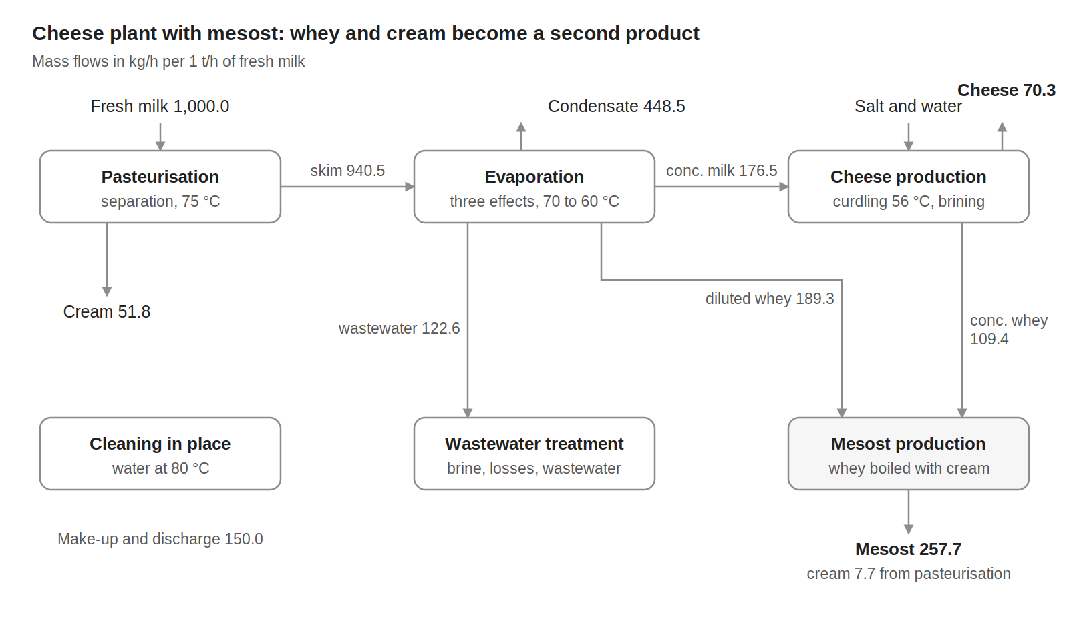
Figure 1. Block flow diagram of variant V1, mass flows in kg/h per 1 t/h of fresh milk.

3. rs: material flows
Table 1. Material flows, per 1 t/h of fresh milk.
Stream | Flow (kg/h) | T (°C)
Raw materials and inputs (in)
Fresh milk | 1,000.0 | 6
Salt | 6.1 | 25
Water for brining | 31.2 | 12
Water for cleaning (CIP) | 150.0 | 25
Total in | 1,187.3
Products, by-products and discharges (out)
Cream | 51.8 | 4
Cheese | 70.3 | 13
Mesost | 257.7 | 8
Water vapour from mesost boiling (to CIP) | 48.6 | 100
Evaporator condensate water | 448.5 | 65
Treated water discharge | 155.7 | 20
CIP water discharge | 150.0 | 30
Sludge from wastewater treatment | 4.8 | 20
Total out | 1,187.3
Internal flows
Skimmed milk to evaporation | 940.5 | 4
Concentrated milk to cheese making | 176.5 | 4
Concentrated milk losses to wastewater | 3.6 | 4
Brine to wastewater treatment | 34.2 | 13
Evaporator wastewater to treatment | 122.6 | 4
Cream to mesost | 7.7 | 8
Whey to mesost (diluted + concentrated) | 298.6 | 4 and 56
Inputs and outputs close at 1,187.3 kg/h. The concentrated-milk losses are the difference between the evaporator output and the cheese-making input; they are sent to wastewater treatment.

4. rs: process electricity
Table 2 lists the electricity that the cheese line consumes. It is derived from sector data for Dutch cheese dairies, because the process model gives no electricity use. Refrigeration is excluded: it is a utility, and its demand appears as hot streams in Table 3.
Table 2. Process electricity demand, per 1 t/h of fresh milk.
Item | kW at 1 t/h | Basis
Electric drives: separator, pumps, agitators, curd and cheese handling, CIP pumps | 5.37 | 16 % of the primary energy of cheese production
Compressed air | 1.68 | 5 % of the primary energy of cheese production
Total process electricity | 7.05 | 203 kW for the plant, 1,780 MWh/y
For comparison only: refrigeration compressors (not part of the process data) | 6.38 | 19 % of the primary energy of cheese production
Derivation: the reference specific energy use of cheese production is 4.3 GJ of primary energy per tonne of cheese (Ramírez et al., 2006, Table 7). Electricity is taken as 40 % of it, the sector-wide share stated by the same authors, and converted back to final electricity with their factor of 2.5: 191 kWh per tonne of cheese. Cooling (19 %) and compressed air (5 %) are the cheese-production shares given by Ramírez et al. (2006, Table 4) and are assumed to be entirely electric; the rest of the electricity is assigned to drives. With 70.3 kg of cheese per tonne of milk, the process electricity is 100 kWh/t of cheese, or 7.05 kWh/t of milk.
The refrigeration line is given for comparison only: it is the electricity that refrigeration (including cold storage) needed in the reference dairies, against which you can compare the refrigeration plant you design. The electricity of the mesost unit (pumps and stirring of the boiling kettle) is not covered by the reference and is not included.

5. qt: thermal streams
Table 3. Thermal streams of variant V1. Q and mCp per 1 t/h of fresh milk; operating time 8,760 h/y.
ID | Stream | Tin (°C) | Tout (°C) | Q, 1 t/h (kW) | mCp, 1 t/h (kW/K) | ΔTmin/2 (K) | Q, plant (kW)
Cold streams (to be heated)
C1 | Pasteurisation: Fresh milk heating to pasteurisation | 4 | 75 | 76.38 | 1.076 | 5 | 2,200
C2 | Evaporation: Skimmed milk preheating | 4 | 70.2 | 45.19 | 0.683 | 5 | 1,302
C3 | Evaporation: Effect 1, boiling (steam-heated) | 70.2 | 70.3 | 122.01 | 1,220 | 2 | 3,514
C4 | Evaporation: Effect 2, boiling | 65.3 | 65.6 | 102.32 | 341.065 | 2 | 2,947
C5 | Evaporation: Effect 3, boiling | 60.7 | 61.3 | 64.27 | 107.124 | 2 | 1,851
C6 | Cheese: Concentrated milk heating for curdling | 4 | 56 | 8.27 | 0.159 | 5 | 238
C7 | Cheese: Brining water warming | 12 | 15.2 | 0.11 | 0.036 | 5 | 3
C8 | CIP: Make-up water heating | 25 | 60 | 6.10 | 0.174 | 5 | 176
C9 | CIP: Cleaning water heating | 60 | 80 | 11.63 | 0.581 | 5 | 335
C10 | Mesost: Diluted whey warming (mixing) | 4 | 21.2 | 3.63 | 0.211 | 5 | 105
C11 | Mesost: Whey heating to boiling | 21.2 | 100.6 | 24.95 | 0.314 | 5 | 719
C12 | Mesost: Whey boiling, water evaporation | 100.6 | 100.7 | 32.11 | 321.070 | 2 | 925
C13 | Mesost: Cream heating | 8 | 100.6 | 0.71 | 0.008 | 5 | 20
 | Total cold streams |  |  | 497.7 |  |  | 14,334
Hot streams (to be cooled)
H1 | Pasteurisation: Raw milk cooling on reception | 6 | 4 | 2.18 | 1.092 | 5 | 63
H2 | Pasteurisation: Pasteurised milk cooling | 75 | 4 | 73.13 | 1.030 | 5 | 2,106
H3 | Evaporation: Effect 1 vapour, condensing | 70.2 | 69.1 | 122.15 | 111.042 | 2 | 3,518
H4 | Evaporation: Effect 2 vapour, condensing | 65.6 | 65 | 104.58 | 174.300 | 2 | 3,012
H5 | Evaporation: Effect 3 vapour, condensing | 61.3 | 60.1 | 65.61 | 54.673 | 2 | 1,890
H6 | Evaporation: Condensate cooling | 69.9 | 25 | 21.19 | 0.472 | 5 | 610
H7 | Evaporation: Concentrated milk cooling | 61.3 | 4 | 9.32 | 0.163 | 5 | 268
H8 | Cheese: Curd and whey cooling | 56 | 16 | 2.19 | 0.055 | 5 | 63
H9 | Cheese: Brining, cooling side (lumped) | 25 | 13 | 0.33 | 0.027 | 5 | 9
H10 | CIP: Cleaning circuits, cooling | 80 | 75 | 2.91 | 0.582 | 5 | 84
H11 | CIP: Returned water cooling before reuse | 75 | 60 | 6.11 | 0.407 | 5 | 176
H12 | CIP: Spent water cooling before discharge | 75 | 30 | 7.84 | 0.174 | 5 | 226
H13 | Mesost: Concentrated whey cooling (mixing) | 56 | 21.2 | 3.62 | 0.104 | 5 | 104
H14 | Mesost: Vapour, partial condensation | 100.6 | 100.5 | 0.91 | 9.074 | 2 | 26
H15 | Mesost: Mesost cooling | 100.6 | 8 | 24.60 | 0.266 | 5 | 709
 | Total hot streams |  |  | 446.7 |  |  | 12,864
mCp = Q / |Tout − Tin|. The evaporator is described effect by effect: each effect boils at one temperature and the vapour it produces condenses about 4 to 5 K higher in the next effect's heater, which is why phase-change streams use ΔTmin/2 = 2 K. Streams ending below about 20 °C need refrigeration unless another process stream absorbs their heat.

6. Reference targets
Check your own problem-table or composite-curve calculation against these targets for the 28 streams of Table 3.
Table 4. Minimum energy targets with the ΔTmin/2 values of Table 3.
Quantity | 1 t/h (kW) | Plant (kW) | Plant (MWh/y)
Total heating demand (cold streams) | 497.7 | 14,334 | 125,563
Total cooling demand (hot streams) | 446.7 | 12,864 | 112,685
Minimum hot utility | 182.5 | 5,256 | 46,041
Minimum cold utility | 131.4 | 3,786 | 33,163
of which below ambient (refrigeration) | 15.7 | 453 | 3,969
Maximum heat recovery | 315.2 | 9,078 | 79,522
Pinch temperature (shifted) | 67.3 °C | 67.3 °C
The pinch at 67.3 °C shifted lies in the evaporator, between the boiling of effect 1 and the condensation of its vapour. Plant annual energy = plant kW × 8,760 h. Refrigeration is the cold utility that must be supplied below 20 °C on hot streams when the rest of the cold utility is placed at the highest feasible temperature.

7. Data basis
Table 5. Origin of the data.
Data | Source
Stream temperatures, heat loads and mass flows of all units | IPESE dairy model (DWSIM simulation, ROSMOSE implementation), Dardor et al. (2024) and IETS Task XXIV dairy data set; values of the latest MER runs
Normalisation to 1 t/h of fresh milk | Plant values divided by 28.8 t/h of fresh milk
Evaporator effect by effect; ΔTmin/2 = 2 K on condensing and boiling streams | Source model, with the condensing vapour of each effect grouped by effect
Process electricity of the cheese line: 4.3 GJ primary energy per t of cheese; electricity 40 % of primary energy, converted with a factor of 2.5; cooling (19 %) and compressed air (5 %) shares assumed fully electric; refrigeration excluded | Ramírez et al. (2006), Tables 4 and 7 and Section 5; electricity share and allocation are assumptions of this handout
Lumped streams (pasteurisation heating and cooling, small mixing streams, condensate cooling) | Sums of the source-model streams over their combined temperature range; origin listed in the workbook
Skimmed milk = fresh milk minus cream; evaporator condensate closes the evaporator balance | Mass balance
Concentrated-milk losses (difference between evaporator output and cheese-making input) to wastewater treatment | Mass balance; this closes the wastewater treatment balance
Mesost unit scaled to the whey actually available (factor 0.9975) | Source model

References
- Dardor D., Flórez-Orrego D., Terrier C., Ribeiro Domingos M.E., Platteau C., da Silva J.C., Lopez M., Maréchal F. (2024). ROSMOSE: A web-based decision support tool for the design and optimization of industrial and urban energy systems. Energy 304, 132182. https://doi.org/10.1016/j.energy.2024.132182
- Flórez-Orrego D., Heringer R., Davi P. et al. (2025). Dairy process model, IETS Task XXIV gray-box data set (DWSIM, ROSMOSE). EPFL IPESE. https://gitlab.epfl.ch/ipese/pinchsmall/dairycasestudy
- Ramírez C.A., Patel M., Blok K. (2006). From fluid milk to milk powder: energy use and energy efficiency in the European dairy industry. Energy 31(12), 1984–2004. https://doi.org/10.1016/j.energy.2005.10.014

