Dairy plant V3: cheese and biogas from whey
Process data for mass and heat integration, compiled from process models and the literature
Sophia Wallerand, Daniel Flórez-Orrego, Pullah Bhatnagar, Oktay Boztas, Dareen Dardor
Industrial Process and Energy Systems Engineering (IPESE) group, EPFL, Sion, Switzerland
This case study describes the process data of the dairy model Dairy_V3 of the IETS Task XXIV database of ex-ante models: the material flows, the process electricity and the 27 thermal streams of a cheese dairy that digests its whey into biogas, with the options for the use of the biogas, per tonne of fresh milk. The stream data come from the IPESE dairy model, simulated in DWSIM and implemented in ROSMOSE (Dardor et al., 2024), and the process electricity from the energy use of European dairies reported by Ramírez et al. (2006); the biogas upgrading follows Bauer et al. (2013). Table 6 gives the source of each value.

1. Process description
The plant receives fresh milk and produces cream and cheese. The whey separated in evaporation and cheese making is digested anaerobically, together with the sludge of the wastewater treatment, to produce biogas and fertiliser.
Process steps and conditions:
- Reception: raw milk is cooled from 6 to 4 °C and stored.
- Pasteurisation: the milk is heated to 75 °C with regenerative heat exchange; the cream is separated by centrifugation at about 60 °C; the pasteurised skimmed milk is cooled back to 4 °C.
- Evaporation: the skimmed milk is preheated to 70 °C and concentrated in three effects boiling at about 70, 65 and 60 °C. Steam heats the first effect; the vapour of each effect heats the next one, and the vapour of the last effect is condensed. A diluted whey stream and a wastewater stream are also separated.
- Cheese making: the concentrated milk is heated to 56 °C and cultures are added; curd and whey are separated; the curd is cooled to 16 °C and brined with salt and water at about 13 °C.
- Cleaning in place (CIP): water is heated to 80 °C, circulated through the equipment and returned at 75 °C; about 70 % is reused and the rest is cooled to 30 °C and discharged.
- Wastewater treatment: brine, evaporator wastewater and product losses are treated; a sludge is separated.
- Anaerobic digestion: whey and sludge are heated to 55 °C and digested under thermophilic conditions, producing biogas with 55 vol % methane. The digestate is heated to 95 °C and dried with steam: its water evaporates at about 100 °C. The products are a liquid fertiliser and a dried digestate.

2. Basis and conventions
- Reference flow: 1 t/h of fresh milk. At this basis, a heat load in kW equals the specific energy in kWh per tonne of milk, and a mass flow in kg/h equals kg per tonne of milk.
- Reference plant: 28.8 t/h of fresh milk (about 28 m³/h), operated 8,760 h per year. Columns labelled "plant" are the 1 t/h values multiplied by 28.8.
- Heat integration: ΔTmin/2 = 5 K for liquid streams and 2 K for condensing and boiling streams, as given in Table 3 for each stream. The digestate dryer (2.5 K) keeps the value of the source model.
- Streams that change phase at constant temperature are given a span of 0.1 K. Very small mixing streams of the source model are lumped together.
- Utilities are not part of the process data: steam, hot water, refrigeration, cooling towers and cooling water belong to a utility system outside the model boundary. Refrigeration demands appear as hot streams at the product temperature.
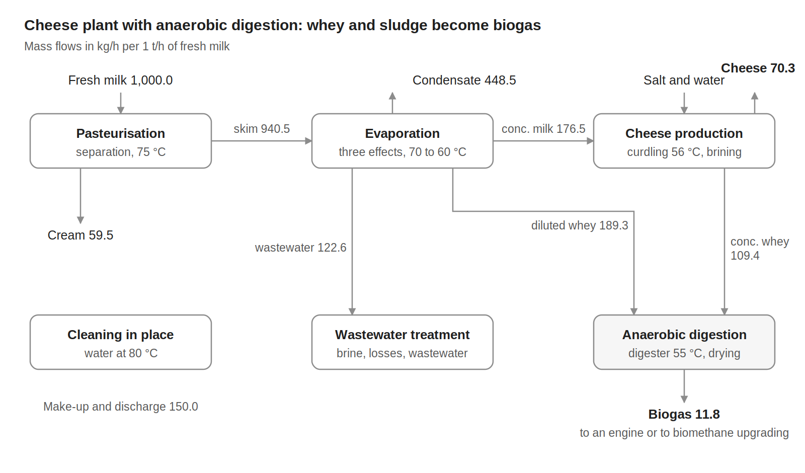
Figure 1. Block flow diagram of variant V3, mass flows in kg/h per 1 t/h of fresh milk.

3. Material flows
Table 1. Material flows, per 1 t/h of fresh milk.
Stream | Flow (kg/h) | T (°C)
Raw materials and inputs (in)
Fresh milk | 1,000.0 | 6
Salt | 6.1 | 25
Water for brining | 31.2 | 12
Water for cleaning (CIP) | 150.0 | 25
Total in | 1,187.3
Products, by-products and discharges (out)
Cream | 59.5 | 4
Cheese | 70.3 | 13
Biogas (55 vol % CH4) | 11.8 | 25
Liquid fertiliser (digestate liquor) | 63.9 | 95
Dried digestate | 65.8 | 100
Digester wastewater and drying condensate | 161.8 | 25
Evaporator condensate water | 448.5 | 65
Treated water discharge | 155.7 | 20
CIP water discharge | 150.0 | 30
Total out | 1,187.3
Internal flows
Skimmed milk to evaporation | 940.5 | 4
Concentrated milk to cheese making | 176.5 | 4
Concentrated milk losses to wastewater | 3.6 | 4
Brine to wastewater treatment | 34.2 | 13
Evaporator wastewater to treatment | 122.6 | 4
Whey to the digester (diluted + concentrated) | 298.6 | 20
Sludge to the digester | 4.8 | 20
Inputs and outputs close at 1,187.3 kg/h. The concentrated-milk losses are the difference between the evaporator output and the cheese-making input; they are sent to wastewater treatment.

4. Process electricity
Table 2 lists the electricity that the cheese line consumes. It is derived from sector data for Dutch cheese dairies, because the process model gives no electricity use. Refrigeration is excluded: it is a utility, and its demand appears as hot streams in Table 3.
Table 2. Process electricity demand, per 1 t/h of fresh milk.
Item | kW at 1 t/h | Basis
Electric drives: separator, pumps, agitators, curd and cheese handling, CIP pumps | 5.37 | 16 % of the primary energy of cheese production
Compressed air | 1.68 | 5 % of the primary energy of cheese production
Total process electricity | 7.05 | 203 kW for the plant, 1,780 MWh/y
For comparison only: refrigeration compressors (not part of the process data) | 6.38 | 19 % of the primary energy of cheese production
Derivation: the reference specific energy use of cheese production is 4.3 GJ of primary energy per tonne of cheese (Ramírez et al., 2006, Table 7). Electricity is taken as 40 % of it, the sector-wide share stated by the same authors, and converted back to final electricity with their factor of 2.5: 191 kWh per tonne of cheese. Cooling (19 %) and compressed air (5 %) are the cheese-production shares given by Ramírez et al. (2006, Table 4) and are assumed to be entirely electric; the rest of the electricity is assigned to drives. With 70.3 kg of cheese per tonne of milk, the process electricity is 100 kWh/t of cheese, or 7.05 kWh/t of milk.
The refrigeration line is given for comparison only: it is the electricity that refrigeration (including cold storage) needed in the reference dairies, for comparison with the electricity of a refrigeration plant. The electricity of the digestion unit (feed pumps and digester mixing) is not covered by the reference and is not included; the electricity of the biogas options is given in Table 4.

5. Thermal streams
Table 3. Thermal streams of variant V3. Q and mCp per 1 t/h of fresh milk; operating time 8,760 h/y.
ID | Stream | Tin (°C) | Tout (°C) | Q, 1 t/h (kW) | mCp, 1 t/h (kW/K) | ΔTmin/2 (K) | Q, plant (kW)
Cold streams (to be heated)
C1 | Pasteurisation: Fresh milk heating to pasteurisation | 4 | 75 | 76.38 | 1.076 | 5 | 2,200
C2 | Evaporation: Skimmed milk preheating | 4 | 70.2 | 45.19 | 0.683 | 5 | 1,302
C3 | Evaporation: Effect 1, boiling (steam-heated) | 70.2 | 70.3 | 122.01 | 1,220 | 2 | 3,514
C4 | Evaporation: Effect 2, boiling | 65.3 | 65.6 | 102.32 | 341.065 | 2 | 2,947
C5 | Evaporation: Effect 3, boiling | 60.7 | 61.3 | 64.27 | 107.124 | 2 | 1,851
C6 | Cheese: Concentrated milk heating for curdling | 4 | 56 | 8.27 | 0.159 | 5 | 238
C7 | Cheese: Brining water warming | 12 | 15.2 | 0.11 | 0.036 | 5 | 3
C8 | CIP: Make-up water heating | 25 | 60 | 6.10 | 0.174 | 5 | 176
C9 | CIP: Cleaning water heating | 60 | 80 | 11.63 | 0.581 | 5 | 335
C10 | Biogas: Digester feed heating | 20 | 55 | 11.19 | 0.320 | 5 | 322
C11 | Biogas: Digester at 55 °C (heat losses and reaction) | 55 | 55.1 | 5.73 | 57.257 | 5 | 165
C12 | Biogas: Digestate heating to drying | 55 | 95 | 4.72 | 0.118 | 5 | 136
C13 | Biogas: Digestate drying, water evaporation | 100 | 100.1 | 80.95 | 809.524 | 2.5 | 2,331
 | Total cold streams |  |  | 538.9 |  |  | 15,520
Hot streams (to be cooled)
H1 | Pasteurisation: Raw milk cooling on reception | 6 | 4 | 2.18 | 1.092 | 5 | 63
H2 | Pasteurisation: Pasteurised milk cooling | 75 | 4 | 73.13 | 1.030 | 5 | 2,106
H3 | Evaporation: Effect 1 vapour, condensing | 70.2 | 69.1 | 122.15 | 111.042 | 2 | 3,518
H4 | Evaporation: Effect 2 vapour, condensing | 65.6 | 65 | 104.58 | 174.300 | 2 | 3,012
H5 | Evaporation: Effect 3 vapour, condensing | 61.3 | 60.1 | 65.61 | 54.673 | 2 | 1,890
H6 | Evaporation: Condensate cooling | 69.9 | 25 | 21.19 | 0.472 | 5 | 610
H7 | Evaporation: Concentrated milk cooling | 61.3 | 4 | 9.32 | 0.163 | 5 | 268
H8 | Cheese: Curd and whey cooling | 56 | 16 | 2.19 | 0.055 | 5 | 63
H9 | Cheese: Brining, cooling side (lumped) | 25 | 13 | 0.33 | 0.027 | 5 | 9
H10 | CIP: Cleaning circuits, cooling | 80 | 75 | 2.91 | 0.582 | 5 | 84
H11 | CIP: Returned water cooling before reuse | 75 | 60 | 6.11 | 0.407 | 5 | 176
H12 | CIP: Spent water cooling before discharge | 75 | 30 | 7.84 | 0.174 | 5 | 226
H13 | Biogas: Drying vapour, condensation | 101 | 100 | 80.95 | 80.952 | 2.5 | 2,331
H14 | Biogas: Drying condensate cooling | 100 | 25 | 11.13 | 0.148 | 5 | 321
 | Total hot streams |  |  | 509.6 |  |  | 14,677
mCp = Q / |Tout − Tin|. The evaporator is described effect by effect: each effect boils at one temperature and the vapour it produces condenses about 4 to 5 K higher in the next effect's heater, which is why phase-change streams use ΔTmin/2 = 2 K. Streams ending below about 20 °C need refrigeration unless another process stream absorbs their heat.

6. Biogas use options
The biogas leaves the digester as a material stream. It can either be burnt in a cogeneration engine or upgraded to biomethane with membranes and exported to the gas grid. Both are utility options, to be compared with the other utilities of the site.
Table 4. Biogas use options, per 1 t/h of fresh milk.
Quantity | Cogeneration engine | Membrane upgrading and export
Biogas flow (kg/h) | 11.83 | 11.83
Biogas energy, LHV (kW) | 50.9 | 50.9
Electricity produced (+) or used (−) (kW) | 20.4 | −2.79
Heat in flue gas, 450 to 150 °C (kW) | 11.2 | 0
Heat in engine cooling water, 90 to 40 °C (kW) | 12.7 | 0
Biomethane exported (kW) | 0 | 50.9
Biogas with 55 vol % methane, that is 31 % methane by mass; LHV = 0.31 × 50 MJ/kg = 15.5 MJ/kg. Engine efficiencies: 40 % electricity, 22 % flue-gas heat and 25 % cooling-water heat. Membrane upgrading uses 0.21 kWh per m³ of biogas (density 0.89 kg/m³); the methane is assumed to be exported entirely.

7. Energy targets
The problem-table analysis of the 27 streams of Table 3, with the ΔTmin/2 contributions given there, gives the minimum energy targets of Table 5.
Table 5. Minimum energy targets with the ΔTmin/2 values of Table 3.
Quantity | 1 t/h (kW) | Plant (kW) | Plant (MWh/y)
Total heating demand (cold streams) | 538.9 | 15,520 | 135,953
Total cooling demand (hot streams) | 509.6 | 14,677 | 128,568
Minimum hot utility | 146.2 | 4,211 | 36,891
Minimum cold utility | 117.0 | 3,368 | 29,506
of which below ambient (refrigeration) | 14.1 | 407 | 3,567
Maximum heat recovery | 392.7 | 11,308 | 99,062
Pinch temperature (shifted) | 67.3 °C | 67.3 °C
The pinch at 67.3 °C shifted lies in the evaporator, between the boiling of effect 1 and the condensation of its vapour. Plant annual energy = plant kW × 8,760 h. Refrigeration is the cold utility that must be supplied below 20 °C on hot streams when the rest of the cold utility is placed at the highest feasible temperature.

8. Data basis
Table 6. Origin of the data.
Data | Source
Stream temperatures, heat loads and mass flows of all units | IPESE dairy model (DWSIM simulation, ROSMOSE implementation), Dardor et al. (2024) and IETS Task XXIV dairy data set; values of the latest MER runs
Normalisation to 1 t/h of fresh milk | Plant values divided by 28.8 t/h of fresh milk
Evaporator effect by effect; ΔTmin/2 = 2 K on condensing and boiling streams | Source model, with the condensing vapour of each effect grouped by effect
Process electricity of the cheese line: 4.3 GJ primary energy per t of cheese; electricity 40 % of primary energy, converted with a factor of 2.5; cooling (19 %) and compressed air (5 %) shares assumed fully electric; refrigeration excluded | Ramírez et al. (2006), Tables 4 and 7 and Section 5; electricity share and allocation are assumptions of this case study
Lumped streams (pasteurisation heating and cooling, small mixing streams, condensate cooling) | Sums of the source-model streams over their combined temperature range; origin listed in the workbook
Skimmed milk = fresh milk minus cream; evaporator condensate closes the evaporator balance | Mass balance
Concentrated-milk losses (difference between evaporator output and cheese-making input) to wastewater treatment | Mass balance; this closes the wastewater treatment balance
Digester wastewater closes the digester mass balance | Mass balance
Biogas 55 vol % CH4; engine efficiencies 40/22/25 %; membrane 0.21 kWh/m³ | Dardor et al. (2024); IPESE biogas utility model; Bauer et al. (2013)

References
- Bauer F., Hulteberg C., Persson T., Tamm D. (2013). Biogas upgrading: review of commercial technologies. SGC Rapport 270, Svenskt Gastekniskt Center. http://www.sgc.se/ckfinder/userfiles/files/SGC270.pdf
- Dardor D., Flórez-Orrego D., Terrier C., Ribeiro Domingos M.E., Platteau C., da Silva J.C., Lopez M., Maréchal F. (2024). ROSMOSE: A web-based decision support tool for the design and optimization of industrial and urban energy systems. Energy 304, 132182. https://doi.org/10.1016/j.energy.2024.132182
- Flórez-Orrego D., Heringer R., Davi P. et al. (2025). Dairy process model, IETS Task XXIV gray-box data set (DWSIM, ROSMOSE). EPFL IPESE. https://gitlab.epfl.ch/ipese/pinchsmall/dairycasestudy
- Ramírez C.A., Patel M., Blok K. (2006). From fluid milk to milk powder: energy use and energy efficiency in the European dairy industry. Energy 31(12), 1984–2004. https://doi.org/10.1016/j.energy.2005.10.014

