Assessment of CO₂ Abatement Potential of Heat Pumps using Pinch Analysis for the Swiss Chocolate Industry

Navdeep Bhadbhade^{a*}, Benjamin H. Y. Ong^{b}, Donald G. Olsen ª, Beat Wellig ª Martin K. Patelª

ª Chair for Energy Efficiency, Department F.-A. Forel for Environment and Aquatic Sciences, Institute for Environmental Sciences (ISE), University of Geneva, Switzerland
^{b} Lucerne University of Applied Sciences and Arts, Competence Center Thermal Energy Systems and Process Engineering, Technikumstrasse 21, 6048, Horw, Switzerland

Appendix 1: Cost-effectiveness analysis

$C_{lvl}=\frac{ANF×NPV}{ES}$ Eq. A1

Where,
C_{lvl,} = Levelized costs of saved energy by HP integration (CHF/kWh)
ANF = Annuity factor calculated by equation (A2)
NPV = Net present value of an EEM calculated by equation (A3) (CHF)
ES = Final energy saving achieved by HP integration (MWh)

$ANF=\frac{{(1+r)}^{L}×r}{{(1+r)}^{L}-1}$ Eq. A2
And

$NPV=\sum_{t=tr}^{L}{{CF}_{tr}}×{(1+r)}^{-tr+t}$ Eq. A3
Where,
CF_{tr} = Annual cash flow for year t calculated by equation (A4) (CHF)
r = Real discount rate (%)
L = Technological lifetime of HP (in years)
tr = running year (e.g., 2020)
t = year of implementation

${CF}_{tr}=I+O\&M-B$ Eq. A4
Where,
I = Initial investment for of HP integration
O&M = Annual operation and maintenance cost of HP
B = Annual net benefits generated by implementing HP integration calculated by equation (A5)

$B=\left(FS×P\right)-(ELS×P_{e})+(CA×P_{CO2})$ Eq. A5
Where,
ELS = Electricity consumed by HP integration estimated using COP_{real}
FS = Saving achieved for fuel by HP integration
P = Price of fuel (Since thermal demand is dominated by natural gas, fuel saved is assumed to be natural gas for all establishments)
P_{e} = Price of electricity e
P_{CO2} = CO₂ levy
CA = CO₂ abatement potential of HP integration calculated by equation A6

$CA=FS×EF$ Eq. A6
Where,
CA = carbon dioxide abatement achieved by HP integration (t-CO₂/year)
FS = Fuel savings estimated based on HP heating capacity
EF = CO₂ emission factor for fuel (t-CO₂/kWh)

Appendix 2 Electricity and natural gas prices for all industrial establishment categories and cantons in Switzerland

Table A1 presents the electricity and natural gas price paid by the industrial establishments of various size categories across different cantons. The economic feasibility analysis presented in section 3.3 is based on the ratio of average electricity price and average natural gas price for each category across the cantons. The sensitivity analysis presented in subsequent section 3.4 on the other hand, is based on the ratio of the energy prices for the canton with maximum electricity price and minimum electricity price identified from the following table.
Table A1. Natural gas and electricity prices for various sizes and cantons for the Swiss industry (Electricity prices (ElCom, 2023), Natural gas prices (DFE, 2023) )
Canton | Natural gas prices (CHF/kWh) |  |  | Electricity (CHF/kWh) |  |  | Ratio (Electricity/Gas)
 | Small (Type 8) | Medium (Type 9) | Large (Type 10) | Small (C3) | Medium (C5) | Large (C7) | Small (C3) | Medium (C5) | Large (C7)
Aargau | 0.16 | 0.16 | 0.16 | 0.17 | 0.13 | 0.12 | 1.06 | 0.81 | 0.75
Appenzell | 0.18 | 0.13 | 0.12 | 0.16 | 0.14 | 0.13 | 0.89 | 1.08 | 1.08
Bern | 0.16 | 0.16 | 0.16 | 0.21 | 0.18 | 0.16 | 1.31 | 1.13 | 1.00
Freiburg | 0.1 | 0.12 | 0.12 | 0.19 | 0.15 | 0.14 | 1.90 | 1.25 | 1.17
Geneva | 0.097 | 0.097 |  | 0.19 |  | 0.14 | 1.96 | - | -
Glarus | 0.17 | 0.1 | 0.1 | 0.18 | 0.14 | 0.13 | 1.06 | 1.40 | 1.30
Graubunden | 0.1 | 0.1 |  | 0.2 | 0.18 | 0.17 | 2.00 | 1.80 | -
Luzern | 0.13 |  |  | 0.18 | 0.14 | 0.13 | 1.38 | - | -
St. Gallen | 0.13 | 0.13 | 0.12 | 0.17 | 0.14 | 0.13 | 1.31 | 1.08 | 1.08
Schaffhausen | 0.06 |  |  | 0.17 | 0.14 | 0.12 | 2.83 | - | -
Solothurn | 0.17 | 0.17 | 0.17 | 0.19 | 0.16 | 0.15 | 1.12 | 0.94 | 0.88
Schwyz | 0.19 | 0.21 | 0.21 | 0.18 | 0.15 | 0.14 | 0.95 | 0.71 | 0.67
Thurgau | 0.13 | 0.08 | 0.08 | 0.18 | 0.15 | 0.14 | 1.38 | 1.88 | 1.75
Ticino | 0.1 | 0.07 | 0.07 |  |  |  | - | - | -
Vaud | 0.1 | 0.13 | 0.12 | 0.17 |  | 0.14 | 1.70 | - | 1.17
Valais | 0.07 | 0.101 | 0.1 | 0.18 | 0.15 | 0.14 | 2.57 | 1.49 | 1.40
Zug | 0.12 |  |  | 0.18 | 0.16 | 0.13 | 1.50 | - | -
Zurich | 0.15 | 0.15 | 0.15 | 0.16 | 0.12 | 0.12 | 1.07 | 0.80 | 0.80
Swiss average | 0.13 | 0.13 | 0.13 | 0.18 | 0.15 | 0.14 | 1.40 | 1.17 | 1.06

Appendix 3: Representative grand composite curves for company size categories

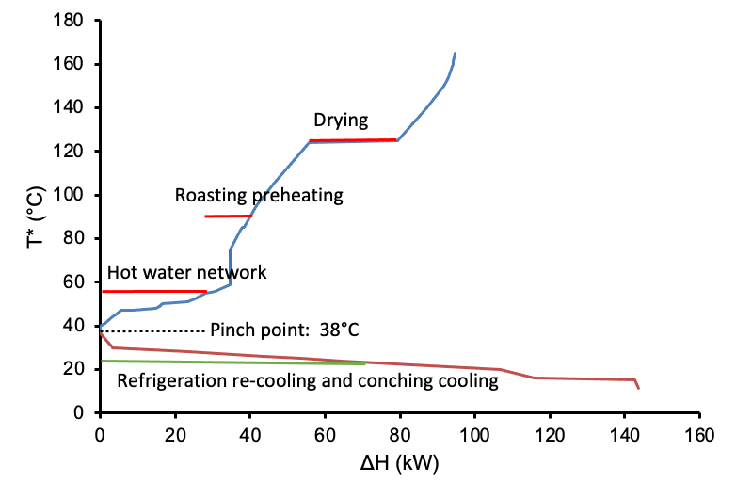  (A) | 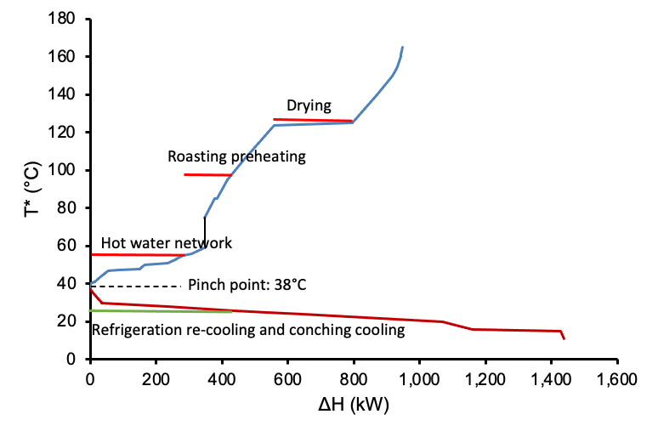  (B)
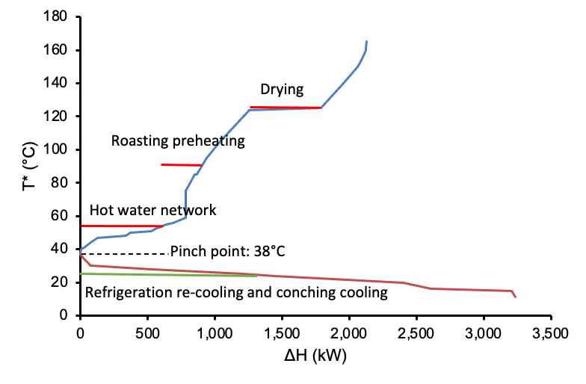  (C) | 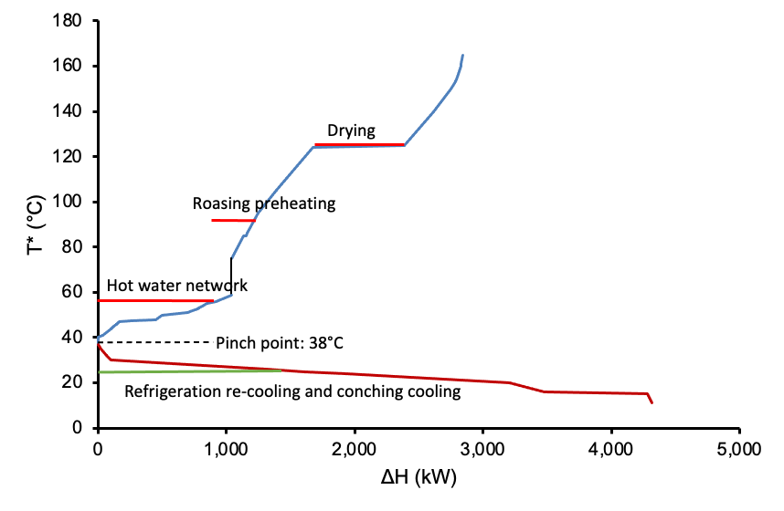  (D)

Figure A1. Representative GCC and possible heat sinks (red lines) and sources (green lines) for chocolate production in Switzerland: (A) category A1 (1000 tonnes/year), (B) category A2 (10,000 tonnes/year), (C) category A3 (20,000 tonnes/year), (D) category A4 (30,000 tonnes/year) (Pinch point at 38°C; global ∆T_{min} = 10°C)

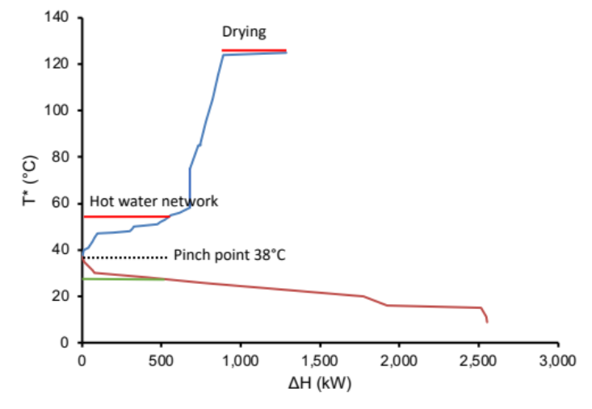
Figure A2. Representative grand composite curve for production route 2 (nibs roasting)

Appendix 4 Scaling factors and average values

Table A2. Scaling factors and other used of the Swiss chocolate industry

 | Size category 1 | Size category 2 | Size category 3 | Size category 4
Operating hours | 3600 | 4800 | 6000 | 6000
Scaling factor | 1.44 | 2.01 | 2.01 | 2.4
Average production (kt) | 850 | 8922 | 18,230 | 28,458
Average fuel demand (MWh/year) | 258 | 2576 | 8030 | 25,238
Average electricity demand (MWh/year) | 185 | 2055 | 6407 | 20,137

Appendix 5: Detailed levelized cost estimates for all heat pumps

Table A3. Annual potentials and Levelized costs of saved energy and CO₂ abatement for the establishment of category A1 (1000 tonne/year; results by row are mutually exclusive)

 |  | Levelized cost
Heat pump model | Arrangement | Saved energy (CHF/kWh saved) | CO₂ abatement (CHF/kWh abated)
SHP4 | AR1 | -0.09 | -284
SHP2 | AR1 | 0.01 | 29
SHP1 | AR1 | 0.02 | 83
SHP3 | AR1 | 0.32 | 307

Table A4. Levelized costs and annual saving potentials for the establishments of size category 2 (10,000 tonne/year, DR = 21%)
 |  | Levelized cost
Heat pump model | Arrangement | Saved energy (CHF/kWh saved) | CO₂ abatement (CHF/kWh abated)
SHP6 | AR1/AR3 | -0.04 | -146
SHP12 | AR1/AR3 | -0.05 | -155
SHP18 | AR1/AR3 | -0.10 | -412
SHP8 | AR1/AR3 | -0.11 | -404
SHP14 | AR1/AR3 | -0.11 | -373
SHP10 | AR1/AR3 | -0.11 | -418
SHP11 | AR1/AR3 | -0.12 | -428
SHP15 | AR1/AR3 | -0.12 | -386
SHP21 | AR1/AR3 | -0.12 | -457
SHP20 | AR1/AR3 | -0.12 | -483
SHP7 | AR1/AR3 | -0.12 | -400
SHP9 | AR1/AR3 | -0.12 | -461
SHP19 | AR1/AR3 | -0.12 | -446
SHP13 | AR1/AR3 | -0.12 | -473
SHP16 | AR1/AR3 | -0.13 | -479
SHP17 | AR1/AR3 | -0.13 | -547
HTHP1 | AR2/AR4 | 0.11 | 192
HTHP2 | AR2/AR4 | 0.08 | 100
HTHP3 | AR2/AR4 | 0.1 | 90

Table A5. Levelized costs and annual saving potentials for the establishments of category 3 (20,000 tonne/year, DR = 21%)
 |  | Levelized cost
Heat pump model | Arrangement | Saved energy (CHF/kWh saved) | CO₂ abatement (CHF/kWh abated)
SHP23 | AR1/AR3 | -0.11 | -394
SHP24 | AR1/AR3 | -0.14 | -543
HTHP2 | AR2/AR4 | 0.06 | 46

Table A6. Levelized costs and annual saving potentials for the establishments of category 4 (30,000 tonne/year, DR = 21%)
 |  | Levelized cost
Heat pump model | Arrangement | Saved energy (CHF/kWh saved) | CO₂ abatement (CHF/kWh abated)
SHP24 | AR1/AR3 | -0.13 | -523
SHP25 | AR1/AR3 | -0.05 | -31
HTHP3 | AR2/AR4 | 0.07 | 43

Appendix 6 Data for product-specific energy demand profile for chocolate production in Switzerland

Process | Process stream | Tin (°C) | Tout  (°C) | ΔH  (MWh)
Roasting | zone 1 hot air in | 20 | 145 | 12,380
Roasting | zone 1 hot air out | 30 | 20 | 4,767
Roasting | zone 2 hot air in | 20 | 155 | 14,688
Roasting | zone 2 hot air out | 46 | 20 | 7,064
Roasting | zone 3 hot air in | 20 | 160 | 19,181
Roasting | zone 3 hot air out | 110 | 20 | 12,462
Blending | pressb liq in | 43 | 50 | 100
Blending | pressb torteu out | 45 | 20 | 184
Blending | pressh in | 20 | 50 | 110
Blending | pressh tourteau | 50 | 20 | 223
CIP | Lauge | 80 | 80.1 | 600
CIP | Saure | 60 | 60.1 | 208
CIP | Spulwasser | 10 | 40 | 496
Compressor | WRG | 70 | 16.1 | 20,416
Conching | cfcaill phase 1 in | 40 | 55 | 1,252
Conching | cffonc phase 1 in | 35 | 80 | 1,688
Conching | cbmag phase 1 in | 35 | 42 | 93
Conching | cbfoncee phase 1 in | 35 | 42 | 148
Conching | cfcaill refroid in | 55 | 20 | 18,440
Conching | cffonc refroid in | 80 | 20 | 23,709
Conching | cbmag refroid in | 42 | 20 | 1,159
Conching | cbfoncee refroid in | 42 | 20 | 7,244
Debacterization | Debac_cocoa_in | 25.0 | 80.0 | 3,396
IR | Combustion Air_s | 30 | 70 | 2,807
IR | Combustion Air_w | 20 | 70 | 3,506
IR | Exhaust after cyclone | 150.0 | 25.0 | 8470.6
Mixer | Jacketed vessel | 164.0 | 165.0 | 9792.8
Moulding | lca mel in | 30 | 35 | 398
Moulding | lca mel latmg | 35 | 36 | 668
Moulding | lca mel mgfus | 36 | 39 | 292
Moulding | lca mel out | 39 | 41 | 220
Moulding | lca prebroy in | 41 | 48 | 624
Moulding | lca prebroy out | 48 | 49 | 96
Moulding | lfonc mel in | 30 | 42 | 782
Moulding | lfonc mel out | 42 | 43 | 74
Moulding | lfonc prebroy in | 43 | 54 | 795
Moulding | lfonc prebroy out | 54.0 | 55.0 | 87
Refrigeration | Industrial water | 35.0 | 25.0 | 73,110
Refrigeration | Industrial water (Desuperheater) | 60.0 | 25.0 | 12,332
Tamper | tankboyeuse in | 45 | 46 | 5,499
Tamper | tankmasses in | 42 | 43 | 8,651
Tamper | tankmass suite in | 42 | 43 | 737
Tamper | tankliqueur in | 45 | 46 | 191
Tamper | tankmout noisam in | 47 | 48 | 438
Tamper | tankhuil noisam in | 43 | 44 | 246
Tamper | tankbeur camion in | 50 | 51 | 1,098
Tamper | tankbeur in | 45 | 46 | 550
Tamper | tankconf in | 42 | 43 | 273
Tornado Roaster | Vapour Exhaust | 120 | 30 | 626
Tornado Roaster | FG Exhaust_s | 300 | 25 | 2,523
Tornado Roaster | FG Exhaust_w | 300 | 25 | 2,523
Tornado Roaster | Combustion Air_s | 30 | 70 | 216
Tornado Roaster | Combustion Air_w | 20.0 | 70.0 | 269
Tornado Roaster | Exhaust_Nibscooler_s | 60 | 25 | 2,096
Tornado Roaster | Exhaust_Nibscooler_w | 60 | 25 | 2,096
Tornado Roaster | Supply air_nibscooler_s | 30 | 14 | 958
Tornado Roaster | Beans | 70 | 120 | 18,371
Tracing circuits | Tracing water | 25 | 55 | 43,186

Appendix 7 Process equipment data

Equipment | Source
Roaster | (Buhler, 2022b), ((HDM), 2023), (Germán Giner Santonja, 2019)
Dryer | ((RDW), 2024), (Buhler, 2022a), (Germán Giner Santonja, 2019)
Refrigeration | (Germán Giner Santonja, 2019), (GEA, 2022), (Controls, 2022)

References:

(HDM), H. D. M. G. 2023. CONTINUOUS COCOA BEAN ROASTER FRV [Online]. https://www.h-d-m.com/en/products/cocoa-processing/roasting/continuous-cocoa-bean-roaster-frv/. [Accessed].
(RDW), R. D. W. 2024. Continuous Bean Dryer [Online]. https://duyviswiener.com/equipment/cocoa-processing/continuous-bean-dryer/. [Accessed].
BUHLER. 2022a. Infrared pre-treatment system [Online]. https://www.buhlergroup.com/global/en/products/barth_infra-red_dryer.html. [Accessed].
BUHLER. 2022b. Tornado roasting system [Online]. https://www.buhlergroup.com/global/en/products/barth_tornado_roastingsystem.html. [Accessed].
CONTROLS, J. 2022. Chillers based on Sabroe core technologies [Online]. https://www.johnsoncontrols.com/en_th/industrial-refrigeration/chillers-and-heat-pumps/chillpac. [Accessed].
DFE 2023. Surveillant des prix relatif aux prix du gaz naturel. In: L’ÉCONOMIE, D. F. D. (ed.). https://gaspreise.preisueberwacher.ch/web/index.asp?l=1.
ELCOM 2023. Prix de l’électricité en Suisse. https://www.strompreis.elcom.admin.ch: ElCom.
GEA. 2022. GEA chiller system [Online]. https://www.gea.com/en/products/chillers/. [Accessed].
GERMÁN GINER SANTONJA, P. K., KRISTINE RAUNKJÆR STUBDRUP, THOMAS BRINKMANN, SERGE ROUDIER 2019. Best Available Techniques (BAT) Reference Document for the Food, Drink and Milk Industries.

