Dairy plant V2: cheese and whey soft drink
Process data for mass and heat integration, compiled from process models and the literature
Sophia Wallerand, Daniel Flórez-Orrego, Pullah Bhatnagar, Oktay Boztas, Dareen Dardor
Industrial Process and Energy Systems Engineering (IPESE) group, EPFL, Sion, Switzerland
This case study describes the process data of the dairy model Dairy_V2 of the IETS Task XXIV database of ex-ante models: the material flows, the process electricity and the 30 thermal streams of a cheese dairy that turns its whey into a carbonated soft drink, per tonne of fresh milk. The stream data come from the DWSIM dairy model of Bhatnagar, Flórez-Orrego, Boztas and Dardor and from Dardor et al. (2024), and the process electricity from the energy use of European dairies reported by Ramírez et al. (2006). Table 5 gives the source of each value.

1. Process description
The plant receives fresh milk and produces cream and cheese. The whey separated in evaporation and cheese making is turned into a carbonated whey-based soft drink.
Process steps and conditions:
- Reception: raw milk is cooled from 6 to 4 °C and stored.
- Pasteurisation: the milk is heated to 75 °C with regenerative heat exchange; the cream is separated by centrifugation at about 60 °C; the pasteurised skimmed milk is cooled back to 4 °C.
- Evaporation: the skimmed milk is preheated to 70 °C and concentrated in three effects boiling at about 70, 65 and 60 °C. Steam heats the first effect; the vapour of each effect heats the next one, and the vapour of the last effect is condensed. A diluted whey stream and a wastewater stream are also separated.
- Cheese making: the concentrated milk is heated to 56 °C and cultures are added; curd and whey are separated; the curd is cooled to 16 °C and brined with salt and water at about 13 °C.
- Cleaning in place (CIP): water is heated to 80 °C, circulated through the equipment and returned at 75 °C; about 70 % is reused and the rest is cooled to 30 °C and discharged.
- Wastewater treatment: brine, evaporator wastewater and product losses are treated; a sludge is separated.
- Soft drink: the whey is heated to 97 °C and most of its water is evaporated at about 100 °C; the concentrate is cooled to 45 °C, blended with sugar, aroma and water, cooled to 10 °C and carbonated with CO2.

2. Basis and conventions
- Reference flow: 1 t/h of fresh milk. At this basis, a heat load in kW equals the specific energy in kWh per tonne of milk, and a mass flow in kg/h equals kg per tonne of milk.
- Reference plant: 28.8 t/h of fresh milk (about 28 m³/h), operated 8,760 h per year. Columns labelled "plant" are the 1 t/h values multiplied by 28.8.
- Heat integration: ΔTmin/2 = 5 K for liquid streams and 2 K for condensing and boiling streams, as given in Table 3 for each stream. The soft-drink evaporator (8 K) keeps the value of the source model.
- Streams that change phase at constant temperature are given a span of 0.1 K. Very small mixing streams of the source model are lumped together.
- Utilities are not part of the process data: steam, hot water, refrigeration, cooling towers and cooling water belong to a utility system outside the model boundary. Refrigeration demands appear as hot streams at the product temperature.
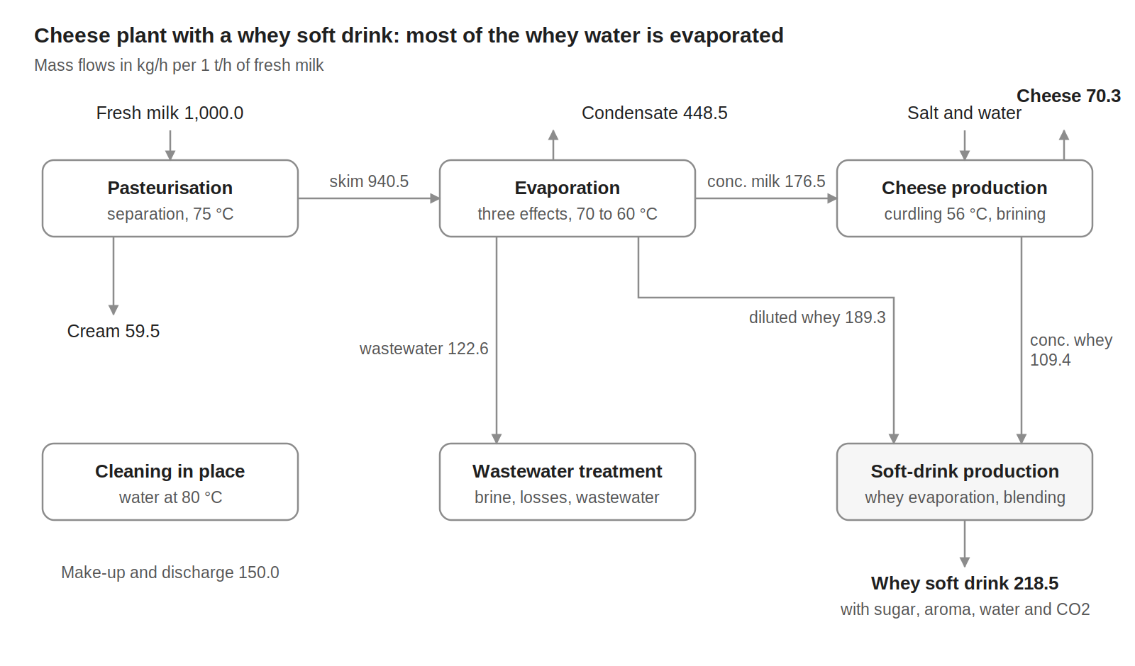
Figure 1. Block flow diagram of variant V2, mass flows in kg/h per 1 t/h of fresh milk.

3. Material flows
Table 1. Material flows, per 1 t/h of fresh milk.
Stream | Flow (kg/h) | T (°C)
Raw materials and inputs (in)
Fresh milk | 1,000.0 | 6
Salt | 6.1 | 25
Water for brining | 31.2 | 12
Water for cleaning (CIP) | 150.0 | 25
Sugar | 18.9 | 25
Aroma | 6.0 | 82
CO2 | 6.9 | 65
Water for the drink | 65.0 | 25
Total in | 1,284.1
Products, by-products and discharges (out)
Cream | 59.5 | 4
Cheese | 70.3 | 13
Whey soft drink | 218.5 | 10
Water vapour from whey evaporation | 176.9 | 100
Evaporator condensate water | 448.5 | 65
Treated water discharge | 155.7 | 20
CIP water discharge | 150.0 | 30
Sludge from wastewater treatment | 4.8 | 20
Total out | 1,284.1
Internal flows
Skimmed milk to evaporation | 940.5 | 4
Concentrated milk to cheese making | 176.5 | 4
Concentrated milk losses to wastewater | 3.6 | 4
Brine to wastewater treatment | 34.2 | 13
Evaporator wastewater to treatment | 122.6 | 4
Whey to the soft-drink line | 298.6 | 4 and 56
Inputs and outputs close at 1,284.1 kg/h. The concentrated-milk losses are the difference between the evaporator output and the cheese-making input; they are sent to wastewater treatment.

4. Process electricity
Table 2 lists the electricity that the cheese line consumes. It is derived from sector data for Dutch cheese dairies, because the process model gives no electricity use. Refrigeration is excluded: it is a utility, and its demand appears as hot streams in Table 3.
Table 2. Process electricity demand, per 1 t/h of fresh milk.
Item | kW at 1 t/h | Basis
Electric drives: separator, pumps, agitators, curd and cheese handling, CIP pumps | 5.37 | 16 % of the primary energy of cheese production
Compressed air | 1.68 | 5 % of the primary energy of cheese production
Total process electricity | 7.05 | 203 kW for the plant, 1,780 MWh/y
For comparison only: refrigeration compressors (not part of the process data) | 6.38 | 19 % of the primary energy of cheese production
Derivation: the reference specific energy use of cheese production is 4.3 GJ of primary energy per tonne of cheese (Ramírez et al., 2006, Table 7). Electricity is taken as 40 % of it, the sector-wide share stated by the same authors, and converted back to final electricity with their factor of 2.5: 191 kWh per tonne of cheese. Cooling (19 %) and compressed air (5 %) are the cheese-production shares given by Ramírez et al. (2006, Table 4) and are assumed to be entirely electric; the rest of the electricity is assigned to drives. With 70.3 kg of cheese per tonne of milk, the process electricity is 100 kWh/t of cheese, or 7.05 kWh/t of milk.
The refrigeration line is given for comparison only: it is the electricity that refrigeration (including cold storage) needed in the reference dairies, for comparison with the electricity of a refrigeration plant. The electricity of the soft-drink unit (pumps, blending, carbonation and filling) is not covered by the reference and is not included.

5. Thermal streams
Table 3. Thermal streams of variant V2. Q and mCp per 1 t/h of fresh milk; operating time 8,760 h/y.
ID | Stream | Tin (°C) | Tout (°C) | Q, 1 t/h (kW) | mCp, 1 t/h (kW/K) | ΔTmin/2 (K) | Q, plant (kW)
Cold streams (to be heated)
C1 | Pasteurisation: Fresh milk heating to pasteurisation | 4 | 75 | 76.38 | 1.076 | 5 | 2,200
C2 | Evaporation: Skimmed milk preheating | 4 | 70.2 | 45.19 | 0.683 | 5 | 1,302
C3 | Evaporation: Effect 1, boiling (steam-heated) | 70.2 | 70.3 | 122.01 | 1,220 | 2 | 3,514
C4 | Evaporation: Effect 2, boiling | 65.3 | 65.6 | 102.32 | 341.065 | 2 | 2,947
C5 | Evaporation: Effect 3, boiling | 60.7 | 61.3 | 64.27 | 107.124 | 2 | 1,851
C6 | Cheese: Concentrated milk heating for curdling | 4 | 56 | 8.27 | 0.159 | 5 | 238
C7 | Cheese: Brining water warming | 12 | 15.2 | 0.11 | 0.036 | 5 | 3
C8 | CIP: Make-up water heating | 25 | 60 | 6.10 | 0.174 | 5 | 176
C9 | CIP: Cleaning water heating | 60 | 80 | 11.63 | 0.581 | 5 | 335
C10 | Soft drink: Whey heating to boiling | 27.2 | 97.3 | 27.46 | 0.392 | 5 | 791
C11 | Soft drink: Whey boiling, water evaporation | 97.3 | 100 | 165.26 | 61.208 | 8 | 4,760
C12 | Soft drink: Blending, heating side (lumped) | 25 | 45.2 | 1.72 | 0.085 | 5 | 50
 | Total cold streams |  |  | 630.7 |  |  | 18,165
Hot streams (to be cooled)
H1 | Pasteurisation: Raw milk cooling on reception | 6 | 4 | 2.18 | 1.092 | 5 | 63
H2 | Pasteurisation: Pasteurised milk cooling | 75 | 4 | 73.13 | 1.030 | 5 | 2,106
H3 | Evaporation: Effect 1 vapour, condensing | 70.2 | 69.1 | 122.15 | 111.042 | 2 | 3,518
H4 | Evaporation: Effect 2 vapour, condensing | 65.6 | 65 | 104.58 | 174.300 | 2 | 3,012
H5 | Evaporation: Effect 3 vapour, condensing | 61.3 | 60.1 | 65.61 | 54.673 | 2 | 1,890
H6 | Evaporation: Condensate cooling | 69.9 | 25 | 21.19 | 0.472 | 5 | 610
H7 | Evaporation: Concentrated milk cooling | 61.3 | 4 | 9.32 | 0.163 | 5 | 268
H8 | Cheese: Curd and whey cooling | 56 | 16 | 2.19 | 0.055 | 5 | 63
H9 | Cheese: Brining, cooling side (lumped) | 25 | 13 | 0.33 | 0.027 | 5 | 9
H10 | CIP: Cleaning circuits, cooling | 80 | 75 | 2.91 | 0.582 | 5 | 84
H11 | CIP: Returned water cooling before reuse | 75 | 60 | 6.11 | 0.407 | 5 | 176
H12 | CIP: Spent water cooling before discharge | 75 | 30 | 7.84 | 0.174 | 5 | 226
H13 | Soft drink: Vapour, condensation | 100 | 99.9 | 41.19 | 411.884 | 2 | 1,186
H14 | Soft drink: Condensate cooling | 100 | 50 | 6.30 | 0.126 | 5 | 181
H15 | Soft drink: Vapour leaving the evaporator | 100 | 25 | 135.84 | 1.811 | 8 | 3,912
H16 | Soft drink: Whey concentrate and syrup cooling | 45.2 | 10 | 5.56 | 0.158 | 5 | 160
H17 | Soft drink: Aroma condensation and cooling (lumped) | 81.7 | 27.2 | 0.52 | 0.009 | 5 | 15
H18 | Soft drink: Blending, cooling side (lumped) | 50 | 9.7 | 1.00 | 0.025 | 5 | 29
 | Total hot streams |  |  | 607.9 |  |  | 17,508
mCp = Q / |Tout − Tin|. The evaporator is described effect by effect: each effect boils at one temperature and the vapour it produces condenses about 4 to 5 K higher in the next effect's heater, which is why phase-change streams use ΔTmin/2 = 2 K. Streams ending below about 20 °C need refrigeration unless another process stream absorbs their heat.

6. Energy targets
The problem-table analysis of the 30 streams of Table 3, with the ΔTmin/2 contributions given there, gives the minimum energy targets of Table 4.
Table 4. Minimum energy targets with the ΔTmin/2 values of Table 3.
Quantity | 1 t/h (kW) | Plant (kW) | Plant (MWh/y)
Total heating demand (cold streams) | 630.7 | 18,165 | 159,128
Total cooling demand (hot streams) | 607.9 | 17,508 | 153,371
Minimum hot utility | 236.0 | 6,795 | 59,527
Minimum cold utility | 213.1 | 6,138 | 53,771
of which below ambient (refrigeration) | 14.9 | 428 | 3,753
Maximum heat recovery | 394.8 | 11,370 | 99,600
Pinch temperature (shifted) | 67.3 °C | 67.3 °C
The pinch at 67.3 °C shifted lies in the evaporator, between the boiling of effect 1 and the condensation of its vapour. Plant annual energy = plant kW × 8,760 h. Refrigeration is the cold utility that must be supplied below 20 °C on hot streams when the rest of the cold utility is placed at the highest feasible temperature.

7. Data basis
Table 5. Origin of the data.
Data | Source
Stream temperatures, heat loads and mass flows of all units | DWSIM dairy model of Bhatnagar, Flórez-Orrego, Boztas and Dardor; Dardor et al. (2024); values of the latest MER runs
Normalisation to 1 t/h of fresh milk | Plant values divided by 28.8 t/h of fresh milk
Evaporator effect by effect; ΔTmin/2 = 2 K on condensing and boiling streams | Source model, with the condensing vapour of each effect grouped by effect
Process electricity of the cheese line: 4.3 GJ primary energy per t of cheese; electricity 40 % of primary energy, converted with a factor of 2.5; cooling (19 %) and compressed air (5 %) shares assumed fully electric; refrigeration excluded | Ramírez et al. (2006), Tables 4 and 7 and Section 5; electricity share and allocation are assumptions of this case study
Lumped streams (pasteurisation heating and cooling, small mixing streams, condensate cooling) | Sums of the source-model streams over their combined temperature range; origin listed in the workbook
Skimmed milk = fresh milk minus cream; evaporator condensate closes the evaporator balance | Mass balance
Concentrated-milk losses (difference between evaporator output and cheese-making input) to wastewater treatment | Mass balance; this closes the wastewater treatment balance
Soft-drink unit scaled to the whey actually available (factor 0.9975) | Source model
Sugar 9 g per 100 mL of drink, density 1.04 kg/L; the sugar removed from the source model is replaced by water | Typical whey soft drink (9 g of sugar per 100 mL); density assumed

References
- Dardor D., Flórez-Orrego D., Terrier C., Ribeiro Domingos M.E., Platteau C., da Silva J.C., Lopez M., Maréchal F. (2024). ROSMOSE: A web-based decision support tool for the design and optimization of industrial and urban energy systems. Energy 304, 132182. https://doi.org/10.1016/j.energy.2024.132182
- Ramírez C.A., Patel M., Blok K. (2006). From fluid milk to milk powder: energy use and energy efficiency in the European dairy industry. Energy 31(12), 1984–2004. https://doi.org/10.1016/j.energy.2005.10.014

