Integrated pork plant: slaughtering, cutting and cooked sausages
Process data for mass and heat integration, compiled from the literature
Daniel Flórez-Orrego, Meire Ribeiro Domingos, Pullah Bhatnagar, Oktay Boztas
Industrial Process and Energy Systems Engineering (IPESE) group, EPFL, Sion, Switzerland
This case study describes the process data of the integrated pork plant model (Meat_plant) of the IETS Task XXIV database of ex-ante models: the material flows, the process electricity and the 14 thermal streams of a plant that slaughters pigs, cuts the carcasses and produces cooked sausages, per tonne of hot carcass. The data are compiled from a review of the literature on the energy use of slaughterhouses and meat processing: the process integration studies of Fritzson and Berntsson (2006a, 2006b), the European reference document on best available techniques (Karlis et al., 2024), a Swiss pinch study of a meat plant (Meier, 2007) and sector statistics. Table 5 gives the source of each value.

1. Process description
The plant slaughters pigs, chills and cuts the carcasses, sells most of the meat as fresh cuts and turns the trimmings into cooked sausages of the cervelat type. Combining a slaughter line with meat processing on one site is typical of large plants (Fritzson and Berntsson, 2006a).
Process steps and conditions:
- Stunning and bleeding; the blood is collected and chilled to about 5 °C.
- Scalding in water at 58 to 65 °C for 3 to 6 min, with the tank held near 60 °C by steam, followed by mechanical dehairing.
- Singeing in a direct-fired oven at 900 to 1,000 °C to remove residual hair, then polishing, evisceration and splitting.
- Chilling of the carcasses from about 38 °C to 4 °C; EU rules require pig meat to reach at most 7 °C before cutting or transport.
- Cutting and deboning in chilled rooms; boneless meat is about 1/1.37 of the carcass mass.
- Mixing of trimmings with ice, salt and spices into a batter, filled into casings.
- Cooking with direct steam injection to a core temperature of 74 °C.
- Showering to about 45 °C and chilling to 2 °C.
- Chilled storage at about 2 °C and frozen storage at about −25 °C.
Three water networks serve the plant, all fed with mains water at 11 °C: hot water at 82 °C for knife sterilisers and disinfection, warm water at 55 °C for cleaning, and tap water at 40 °C for hand washing and personnel facilities.

2. Basis and conventions
- Reference flow: 1 t/h of hot carcass weight, that is 11.05 pigs/h at the Swiss average carcass of 90.5 kg. At this basis, a heat load in kW equals the specific energy in kWh per tonne of carcass, and a mass flow in kg/h equals kg per tonne.
- Reference plant: 700,000 pigs/y over 6,300 operating hours per year, that is 10.06 t/h of carcass (111 pigs/h). Columns labelled "ref. plant" are the 1 t/h values multiplied by 10.06.
- Heat integration: global ΔTmin = 10 K, applied as ΔTmin/2 = 5 K on every stream. Hot streams (H) must be cooled; cold streams (C) must be heated.
- Heat loads are time-averaged over the operating hours; batch steps (cooking, cleaning) are represented by their average load.
- Utilities are not part of the process data: steam, hot-water generation, refrigeration and cooling belong to a utility system outside the model boundary. Refrigeration demands appear as hot streams at the temperature of the product or of the room air.
- Singeing (C1) is a direct-fired duty at 900 to 1,000 °C; the burner and its flue gas belong to the utility system.
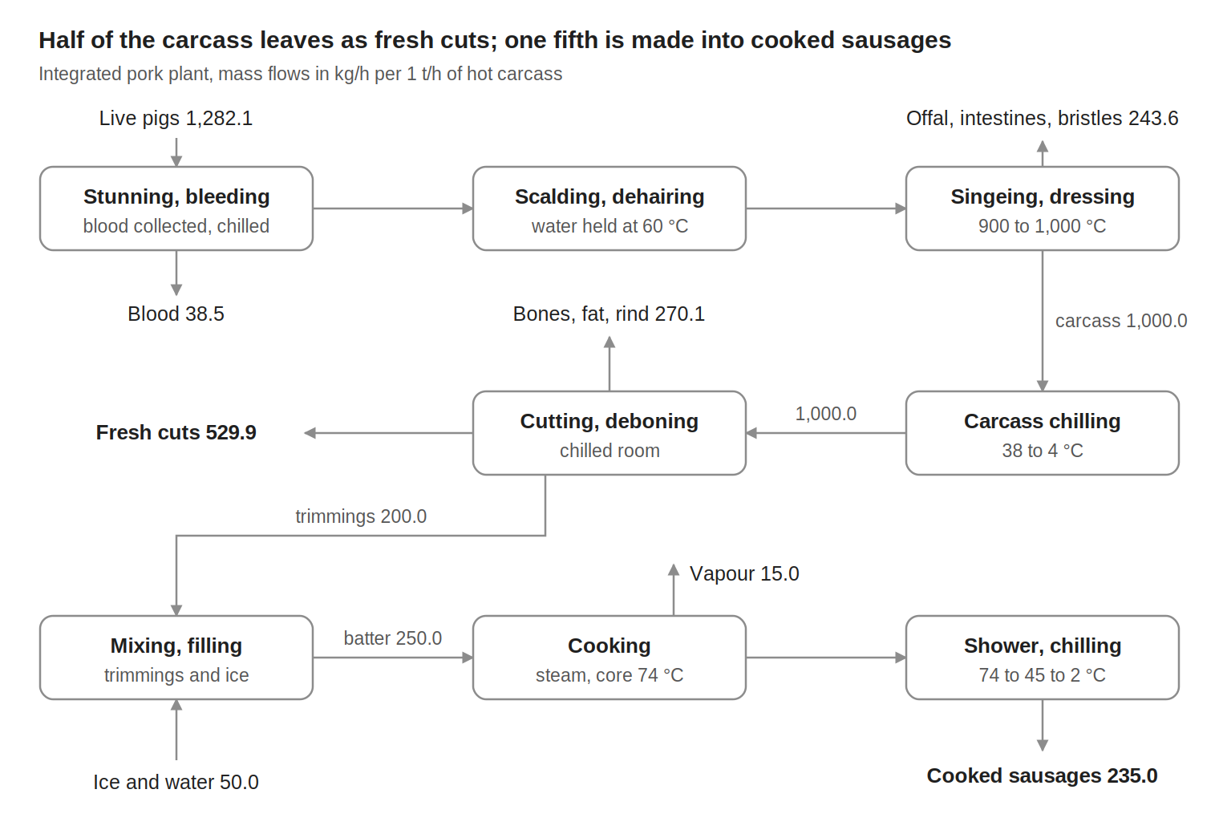
Figure 1. Block flow diagram of the integrated pork plant, mass flows in kg/h per 1 t/h of hot carcass.

3. Material flows
Table 1. Material and utility-medium flows, per 1 t/h of hot carcass.
Stream | Flow (kg/h) | T (°C) | Basis
Raw materials (in)
Live pigs | 1,282.1 | 38 | Carcass 90.5 kg per pig, dressing yield 78 %
Ice and water for the batter | 50.0 | 0 | 5 % of carcass mass
Total in | 1,332.1
Products and by-products (out)
Fresh cuts | 529.9 | 2 | Boneless meat minus trimmings
Cooked sausages | 235.0 | 2 | Batter minus 6 % cooking loss
Blood | 38.5 | 5 | 3 % of live weight
Offal, intestines, bristles | 243.6 | 38 | Live weight minus carcass minus blood
Bones, fat, rind | 270.1 | 4 | Carcass minus boneless meat
Vapour from cooking | 15.0 | up to 100 | 6 % of batter
Total out | 1,332.1
Internal flows
Hot carcass to chilling | 1,000.0 | 38 to 4 | Basis
Boneless meat | 729.9 | 4 | Carcass / 1.37
Trimmings to the sausage line | 200.0 | 4 | 20 % of carcass mass
Sausage batter | 250.0 | 4 to 74 | Trimmings plus ice and water
Utility media (mains water at 11 °C, discharged as wastewater)
Hot water | 497 | 82 | Knife sterilisers, disinfection
Warm water | 2,187 | 55 | Cleaning
Tap water | 696 | 40 | Hand washing, personnel
Product and raw-material flows close at 1,332.1 kg/h in and out. Water networks are utility media and are not part of this closure.

4. Process electricity
Table 2 lists only the electricity that the process itself consumes. Heat and refrigeration demands are not included: they are the thermal streams of Table 3, to be met by utilities such as boilers, heat pumps, a refrigeration plant and cooling water.
Table 2. Process electricity demand, per 1 t/h of hot carcass.
Item | kW at 1 t/h | Basis
Slaughter line (stunning, dehairing, polishing, conveyors, lighting) | 49 | Slaughterhouse electricity (149 kWh/t) minus cooling systems (100 kWh/t)
Cutting and deboning | 44 | 60 kWh per t of boneless meat × 0.730 t per t of carcass
Sausage line (cutting, mixing, filling, packing, lighting) | 99 | 660 kWh per t of raw material × 60 % non-cooling share × 0.25 t per t of carcass
Total process electricity | 192
Air compressors (about 18 kWh/t, 5 % of plant electricity) are included in the rows above; their recoverable heat is stream H3. For comparison only: a large Swedish slaughter and meat-processing plant of the reference size used about 490 kWh of electricity and 420 kWh of fuel per tonne of carcass, including refrigeration, boilers and comfort heating (Fritzson and Berntsson, 2006b).

5. Thermal streams
Table 3. Thermal streams of the integrated pork plant. Q and mCp at 1 t/h of carcass; ΔTmin/2 = 5 K for all streams.
ID | Stream | Tin (°C) | Tout (°C) | Q, 1 t/h (kW) | mCp, 1 t/h (kW/K) | Q, ref. plant (kW)
Cold streams (to be heated)
C1 | Singeing oven, direct-fired | 900 | 1000 | 28.00 | 0.280 | 281.7
C2 | Scalding tank, held at 60 °C | 60 | 61 | 40.00 | 40.000 | 402.4
C3 | Hot water 82 °C (sterilisers, disinfection) | 11 | 82 | 40.98 | 0.577 | 412.2
C4 | Warm water 55 °C (cleaning) | 11 | 55 | 111.73 | 2.539 | 1,124.0
C5 | Tap water 40 °C (hand washing, personnel) | 11 | 40 | 23.43 | 0.808 | 235.7
C6 | Sausage cooking, direct steam injection | 112 | 113 | 63.86 | 63.857 | 642.4
 | Total cold streams |  |  | 308.0 |  | 3,098.3
Hot streams (to be cooled)
H1 | Cooking-oven exhaust air | 70 | 35 | 20.21 | 0.577 | 203.3
H2 | Sausage shower cooling | 74 | 45 | 5.68 | 0.196 | 57.1
H3 | Air compressors, heat recovery | 70 | 25 | 17.89 | 0.398 | 180.0
H4 | Blood chilling | 38 | 5 | 1.27 | 0.038 | 12.8
H5 | Carcass chilling | 38 | 4 | 42.50 | 1.250 | 427.5
H6 | Sausage chilling | 45 | 2 | 8.42 | 0.196 | 84.7
H7 | Chilled rooms (cutting, storage), air at 2 °C | 3 | 2 | 150.23 | 150.231 | 1,511.3
H8 | Freezer rooms, air at −25 °C | −24 | −25 | 6.00 | 6.000 | 60.4
 | Total hot streams |  |  | 252.2 |  | 2,537.0
mCp = Q / |Tout − Tin|. Streams with a 1 K span are near-isothermal duties: the scalding tank, steam injection for cooking, and room air held at a set temperature. H4 to H8 are refrigeration demands at product or room-air temperature.

6. Energy targets
The problem-table analysis of the 14 streams of Table 3, with ΔTmin = 10 K, gives the minimum energy targets of Table 4.
Table 4. Minimum energy targets, ΔTmin = 10 K.
Quantity | 1 t/h (kW) | Ref. plant (kW) | Ref. plant (MWh/y)
Total heating demand (cold streams) | 308.0 | 3,098.3 | 19,519
Total cooling demand (hot streams) | 252.2 | 2,537.0 | 15,983
Minimum hot utility | 237.6 | 2,390.3 | 15,059
of which above 900 °C (singeing) | 28.0 | 281.7 | 1,775
Minimum cold utility | 181.8 | 1,829.0 | 11,523
of which at the freezer level (−25 °C) | 6.0 | 60.4 | 380
Maximum heat recovery | 70.4 | 708.0 | 4,461
Pinch temperature (shifted) | 16 °C | 16 °C
Reference-plant annual energy = kW at the reference plant × 6,300 h. The pinch at 16 °C shifted corresponds to 21 °C on hot streams and 11 °C on cold streams. Because the water networks start from mains water at 11 °C, they absorb the warm heat sources, and all of the minimum cold utility lies below ambient: it must be supplied by refrigeration.

7. Data basis
Table 5. Origin of the data.
Data | Source
Process steps and temperatures | Karlis et al. (2024): scalding 58 to 65 °C, singeing 900 to 1,000 °C, blood chilled to about 5 °C; COWI (2000): sterilisers at 82 °C; Meier (2007): steam injection at 113 °C, core 74 °C, shower to about 45 °C, chilling to 2 °C
Average carcass 90.5 kg per pig | Proviande (2025): 214,208 t of pig carcasses from 2,365,996 pigs
Dressing yield 78 % | Assumed general value (carcass / live weight)
Blood 3 % of live weight | COWI (2000), Table 2-2
Boneless meat = carcass / 1.37 | Ramírez et al. (2006)
Trimmings 20 % and ice 5 % of carcass; cp of sausages 3.0 and of blood 3.6 kJ/(kg K) | Assumed values
Cooking loss 6 %; cooking heat 255 kWh/t of batter; oven exhaust 70 to 35 °C, 81 kWh/t | Meier (2007), Bell AG Basel pinch study
Water networks: mains at 11 °C; 82, 55 and 40 °C at 5, 22 and 7 m³/h | Fritzson and Berntsson (2006a), Fig. 2, scaled from the reference plant to 1 t/h
Reference plant: 700,000 pigs/y, 6,300 h/y | Fritzson and Berntsson (2006b), Table 1
Scalding 40 kWh/t; singeing 28 kWh/t; cooling-system electricity 100 kWh/t | Karlis et al. (2024), Figs 3.39, 3.38 and 3.36: medians of reported pig slaughterhouses, read from the figures
Cold demand 200 kWh/t (H4, H5, H7, H8) | Cooling-system electricity × seasonal cooling COP 2.0 (Meier, 2007); carcass chilling 153 kJ/kg (Grimsby Institute); freezer share 3 % (Meier, 2007); chilled rooms take the remainder
Process electricity | Nunes et al. (2016): 149 kWh/t for slaughterhouses, 660 kWh/t of raw material for sausage plants; Ramírez et al. (2006): cutting 60 kWh/t, non-cooling share 60 %; COWI (2000), Table 2-12: compressed air 5 %

References
- COWI Consulting Engineers and Planners (2000). Cleaner Production Assessment in Meat Processing. Prepared for the United Nations Environment Programme, Division of Technology, Industry and Economics. https://wedocs.unep.org/handle/20.500.11822/9571
- Fritzson A., Berntsson T. (2006a). Efficient energy use in a slaughter and meat processing plant: opportunities for process integration. Journal of Food Engineering 76, 594–604. https://doi.org/10.1016/j.jfoodeng.2005.06.007
- Fritzson A., Berntsson T. (2006b). Energy efficiency in the slaughter and meat processing industry: opportunities for improvements in future energy markets. Journal of Food Engineering 77, 792–802. https://doi.org/10.1016/j.jfoodeng.2005.08.005
- Grimsby Institute (n.d.). Sector focus: carcass chilling. Project on reducing the energy inputs into the refrigeration of food. https://www.grimsby.ac.uk/documents/defra/sectrep-meatchill.pdf
- Karlis P., Presicce F., Giner-Santonja G., Brinkmann T., Roudier S. (2024). Best Available Techniques (BAT) Reference Document for the Slaughterhouses, Animal By-products and/or Edible Co-products Industries. JRC, EUR 31752 EN. https://doi.org/10.2760/18199
- Meier D. (2007). Pilotphase Pinch-Methodik 2006/07: Bell AG. Schlussbericht, Encontrol GmbH for the Swiss Federal Office of Energy. https://pubdb.bfe.admin.ch/de/publication/download/2976
- Nunes J., Dinho da Silva P., Andrade L.P., Domingues L., Gaspar P.D. (2016). Energy assessment of the Portuguese meat industry. Energy Efficiency 9, 1163–1178. https://doi.org/10.1007/s12053-015-9414-7
- Proviande (2025). Der Fleischmarkt im Überblick 2025. https://www.proviande.ch
- Ramírez C.A., Patel M., Blok K. (2006). How much energy to process one pound of meat? A comparison of energy use and specific energy consumption in the meat industry of four European countries. Energy 31, 2047–2063. https://doi.org/10.1016/j.energy.2005.08.007

Further reading
Swiss pinch studies of meat plants and sector-level data, for comparison with real sites:
- Ong B.H.Y., Bhadbhade N., Olsen D.G., Wellig B. (2023). Characterizing sector-wide thermal energy profiles for industrial sectors. Energy 282, 129028 (Swiss meat sector profile). https://doi.org/10.1016/j.energy.2023.129028
- DM Energieberatung (2016). Pinch-Analyse: Bell Schweiz AG, Oensingen. SFOE. https://pubdb.bfe.admin.ch/de/publication/download/8405
- DM Energieberatung (2018). Pinch-Analyse Bigler AG, Büren an der Aare. SFOE. https://pubdb.bfe.admin.ch/de/publication/download/9447
- DME Energieberatung (2011). Pinch-Analyse 2011: Rapelli SA, Stabio. SFOE. https://pubdb.bfe.admin.ch/de/publication/download/6447
- Wojdalski J. et al. (2013). Assessment of energy consumption in a meat-processing plant: a case study. Food and Bioprocess Technology 6, 2621–2629. https://doi.org/10.1007/s11947-012-0924-4
- World Bank Group (2007). Environmental, Health, and Safety Guidelines: Meat Processing. https://www.ifc.org/content/dam/ifc/doc/2000/2007-meat-processing-ehs-guidelines-en.pdf

