**Response to reviewers**

We thank the reviewers for their positive and constructive review of our report. The handful of spelling mistakes were corrected and the changes that were done on the document are presented below.

**Reviewer: Kevin Hedges**

Comment in the review form

The most important comment is that at various points the text implies that Andes is receiving navigational data from external instruments or the ship’s navigational computer (e.g. line 530), but I did not see an explicit mention about making a data collection or what might be required to do so. This addition is not essential to achieving the goal of the paper, but it would make it more complete.

We have clarified this point in the revised report. The capture of navigational data from external instrument and/or the ship’s navigational system is possible because these data streams can be sent to Andes through the local area network that is used by the application. These capabilities have evolved over the last few years of development. Initially, Andes existed independently of the ship’s navigation system since it raised security concerns from Coast Guard personnel. However, when the new offshore fisheries vessels were delivered, their modern networking infrastructure could be fully utilized by Andes, and this included having access to a number of data streams that are broadcast on the ship’s NMEA feed. The GPS feed is now captured at set intervals (we currently use 1 second intervals when fishing and 5 second intervals otherwise). The feed from the Scanmar sensors are also recorded directly by Andes and have been included in the fishing console to provide real-time trawl measurements. So these data can be stored within Andes and exported after a survey has been completed.

Comments in the annotated PDF

* Lines 139-140:
  + we rephrased that bullet to better distinguish between “prone to error” and “create an opportunity for error”
* Lines 246-251: Question “Would subsampling fall under 2.5?
  + The goal of this section is to communicate that sampling protocols are highly customizable, and not to detail all of the associated specifics. The shrimps section was revised to clarify the subsampling functionality that exists in Andes.
* Line 312:
  + This acronym is now spelled out in full on first use in the text and is defined in the acronyms and glossary section
* Lines 33-336:
  + We modified the sentence to identify “sporadic or slow connections”.
* Lines 358-363: Does the fishing console directly record sensor data or does it involve manual entry? The current wording suggests it is captured directly. Just want to make sure that is accurate”:
  + The fishing console offers both methods, some data is entered manually (e.g. weather, set result, etc.) and some are recorded automatically (GPS, trawl sensor data). This has been clarified in the text.
* Lines 386-389: Question “Could this module be reconfigured to record weight for additional species?”
  + Concerning subsampling: at the time of writing subsampling in ANDES was limited to the shrimp’s module. It has since been generalized to be an option for all species as part of continuing development on the project. This has been clarified in the revised report.
* Lines 434-435: Question “Would this module handle data from trawl-mounted sensors? These would not be vertical deployments but would have start and end coordinates.”
  + This should be resolved by the modifications in response to the comment on lines 358-363.
* Lines 528-532: Comment: “This must require connection to a navigation computer or GPS. There hasn’t been a clear overview of integration and connectivity with ship systems”
  + This is now clearly spelled out in the revised report, as discussed above. Figure 1 also shows how ship instruments can be integrated in Andes.
* Line 625:
  + We rephrased to “consistency and quality”

We also thank Kevin for touching base with us and for his interest in potentially using Andes to support some of his survey activities.

**Reviewer: Shelee Hamilton**

We thank Shelee for her review of our report and for her questions and suggestions.

The title page had a spelling mistake which was fixed (it said “pratical” instead of “practical”).

The entries for “Mission” and “Cruise” were cross-referencing each other, this was fixed in the revised document. The entry for “Mission” now contains a description and the entry for “Cruise” points to the other entry.

Comment in the review form

With the roll out of DFO’s data strategy, and the recent IMTS/CDOS reorg, there has been more of a focus on data management and governance lately. Other regions are actively looking into developing similar systems to reduce the data management burden on operational staff, while also benefiting the data custodians and stewards in reducing their QAQC workload.

Comment in the review form

Made a comment in the Glossary that Cruise and Mission refer to each other but neither has a definition. Didn’t define CUPS, UPD, UDP on Figure 1.

The acronyms appearing in the figures were added to the acronyms and glossary section. These include CUPS, UDP, and UPD which appear in Figure 1. The figure was also improved by better defining terms in the caption.

We address her following three questions.

1. How did you standardize data entry to be able to export into various systems? Report just said it was difficult. Did you develop a framework for data collection and for importing into other systems? Did you develop a training guide for staff for the new process? Or do users get referred to [andes | Andes (A New Data Entry System) (dfo-gulf-science.github.io)](https://dfo-gulf-science.github.io/andes/) to figure out on their own?

Andes provides a centralized reporting module that allows users to export data that was captured by the application. The reporting is tailored to the needs of the users and can be modified to better integrate into existing systems. We haven’t developed a training guide per se but have been keeping notes to support users in the repository Wiki pages.

1. Did ANDES result in reduced data management workload for staff collecting data, as well as for those reviewing (QAQC) and maintaining it? If yes, can you give an estimate of workload saved, such as 3 days per survey or whatever time frame works.

Initially, Andes lead to an increase in data management workload since the resulting data coming from Andes was different from those coming from previous systems. As such, new procedures had to be developed to support the transfer of data from Andes to existing databases. However, once the script have been developed, the data management workload is greatly reduced. Additionally, Andes captures a lot more data than the previous systems did. For example, we now store the GPS track from the vessel as well as a multitude of instrument readings such as trawl sensors.

1. Related to #1: It seems to be focussed for use/expansion only in the currently supported regions. Is it possible to expand it to another region since it was built to be agile and uses open-source? Would other regions need their own developer and just need to follow the links/info on GitHub?

Our hope with this report is to make the data entry system available to all regions. The software development framework used was chosen for supporting collaboration and we hope to continue expanding the use of Andes. In terms of what is required from other regions in order to start using Andes, we have been developing onboarding “how-to” documents that have evolved as more regions started using the application. We felt that these topics were beyond the scope of the report and are currently being captured on the repository used for Andes development.

We thank Shelee for her positive comments and encourage her to contact us if she feels like Andes could be used for freshwater surveys in the Pacific Region.

**Summary of changes to the revised report**

The changes in the revised report can best be viewed by comparing the PDF file of the initial submission to the file for this resubmission. Below is a summary of these changes.

**Abstract**

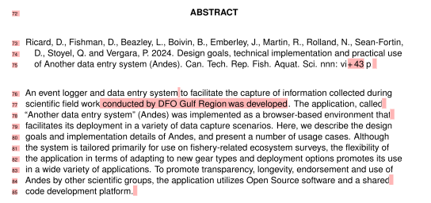

the sentence in red above was modified to the green sentence here:

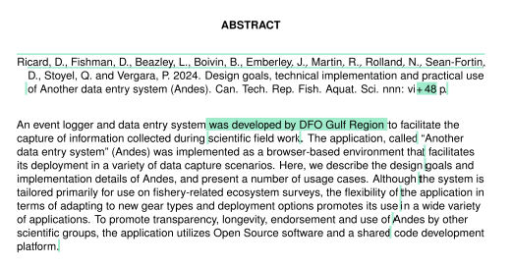

**Results**

Section 3.1 was slightly modified to better describe the architecture differences between Andes and previous data entry systems:

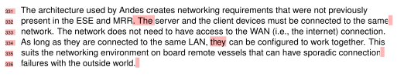

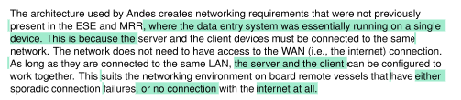

The following paragraph was added to section 3.2, it pertains to some improvements made in Andes version 3:

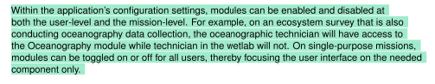

Section 3.2.1 about the Bridge module was modified from this (also pertains to some improvements made in Andes version 3):

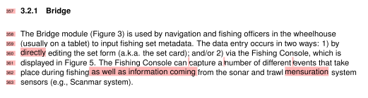

to this:

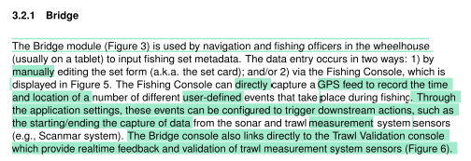

To address one of the reviewers’ comments about species, the following changes were made in section 3.2.4

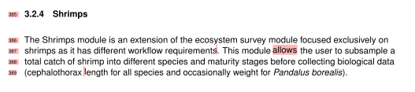

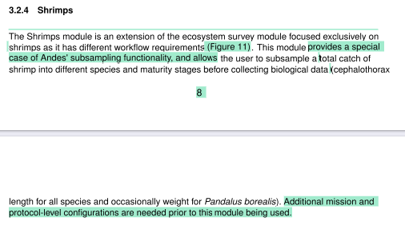

The Oceanography module was modified in version 3, hence these changes in section 3.2.6:

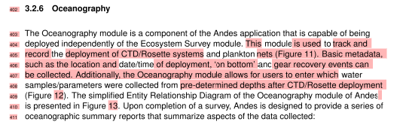

changed to this:

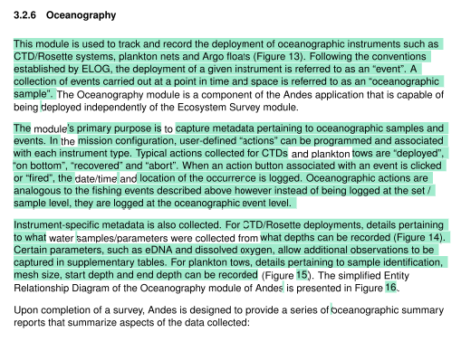

Similarly, section 3.2.9 was modified from this:

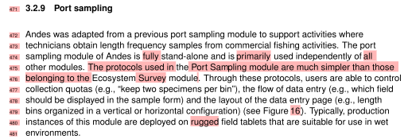

to this:

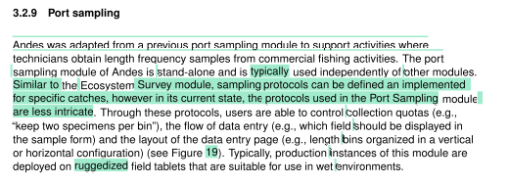

Section 3.3.3 was modified to capture changes in the way that images are included in the backup.

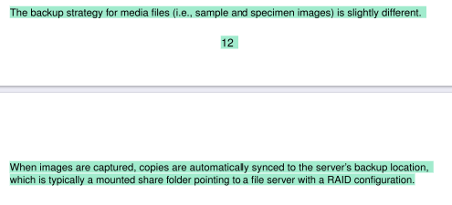

**Discussion**

The first part of the Discussion was slightly modified to nuance the roles of reports in Andes and to better explain the tradeoffs of connecting the system to the internet.

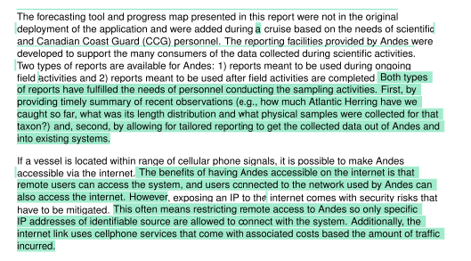

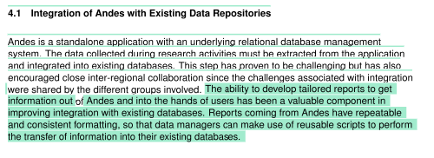

The discussion was also modified to capture the many advancements made in the use of Andes as part of the Atlantic Zone Monitoring Program, so things that appeared in Future Directions now appear as a separate subsection:

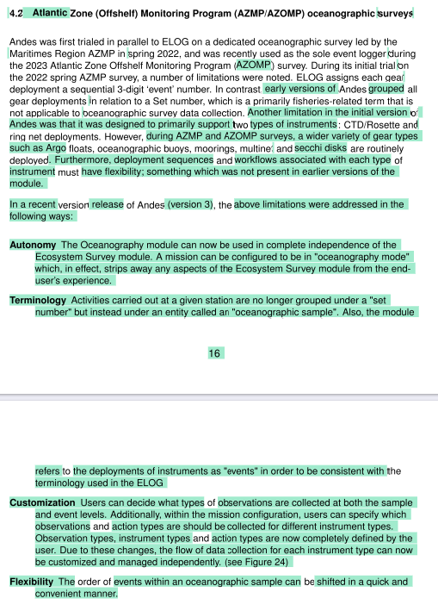

A new figure (Figure 6) showing the trawl measurements console added in Andes version 3 was added to the report.

The figure captions were revised to ensure that they completely described the contents of each figure.

We also found a few acronyms that were not present in the Acronyms and Glossary sections, these were correctly added to these sections.