Get DataScraping App setup on a DFO machine
If you get stuck for more than five minutes at any point, feel free to reach out to Quentin.

- Install software from software center:
- GitHub account (send the username to Quentin can add you to the Datascraping repo (https://github.com/dfo-mar-odis/saraDataScraping) if not done already (optional))
- PyCharm
- Git: download and install from https://gitforwindows.org/
- Python: grab the latest version of python 3. If you have a good reason to use Python 2.7, you can install that as well.
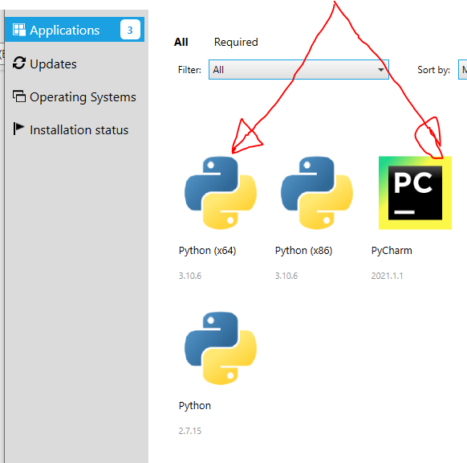
- Clone the repo: (https://github.com/dfo-mar-odis/saraDataScraping)
Open Pycharm and clone the repo (make a copy of it on your local machine). To do this, select clone from the Git dropdown menu:
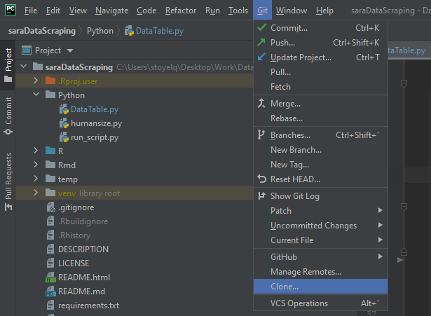
Add the repo link + where you want to stick it:
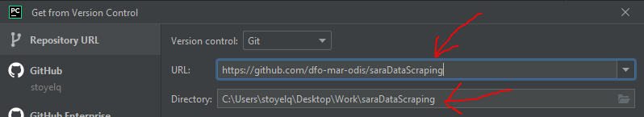

At this point, PyCharm should prompt you to create a venv for the project. The default location and dependencies fields are good, but double check the Base Interpreter to make sure that it is the version of Python 3 you installed from the software center:
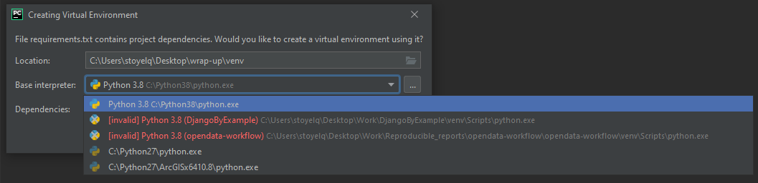
In my case, it is Python 3.8 installed to C:\Python38\pythone.exe. Yours may be a little different due to having a later version, this should not matter a whole ton. The main thing is to avoid using a version of python 2, or some other installed version.
After clicking okay, give PyCharm enough time to create the venv, you can see the status of this at the bottom right of the window:
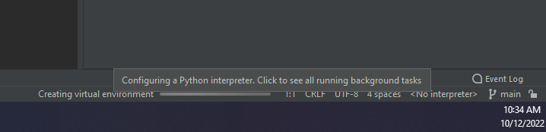
Your directory tree should look something like this now:
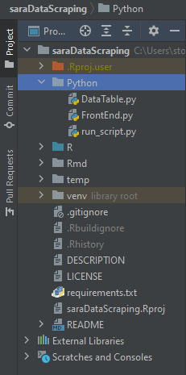
Once that is done, test your python installation by importing Pandas in the Python Console, this should run without any errors:
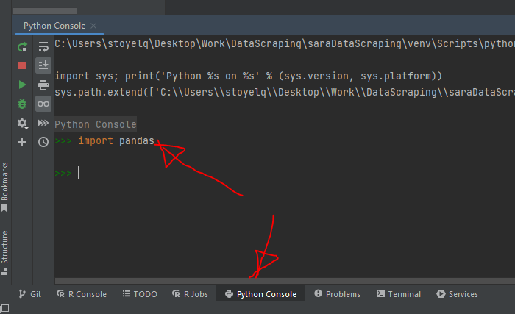
- Link PyCharm to GitHub (Optional):
To make changes and push to the GitHub repo PyCharm needs your GitHub credentials. To set these up open settings and go to version control -> GitHub:
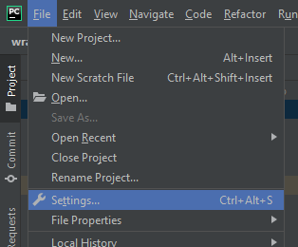
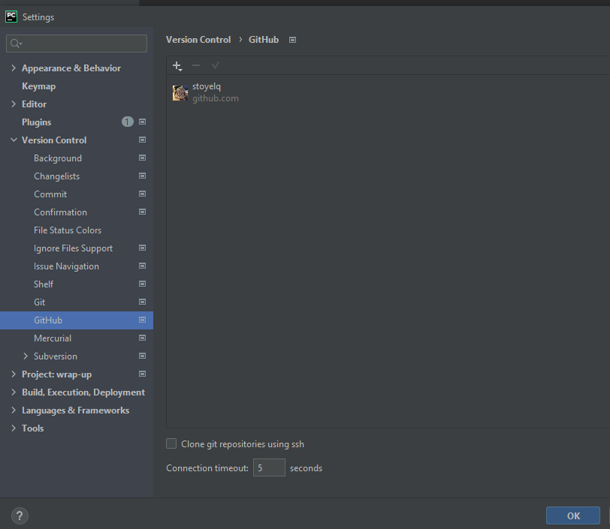

Then login to your account with a token:
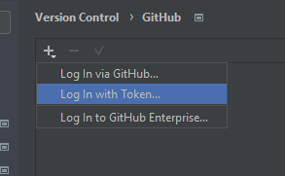
Generate the token through GitHub:
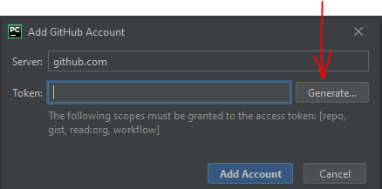
Make sure to tick all the boxes listed on PyCharm and set the expiration length: I set my token for my main DFO machine to never expire, if I were using a temporary workstation, I would pick a shorter limit.
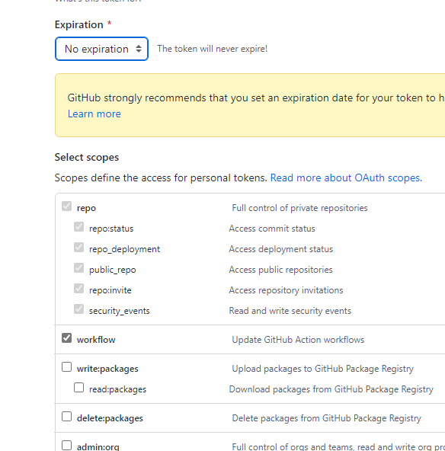
Copy the token and paste it into PyCharm:
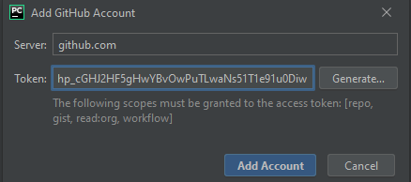

- Add the run_script configuration:
To run the app, you will need to run the python/run_script.py file:
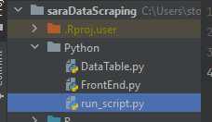
You can do this by adding a configuration:
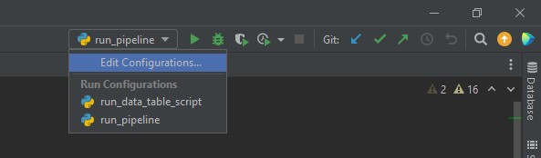

Once the configurations window opens, add a new python configuration:
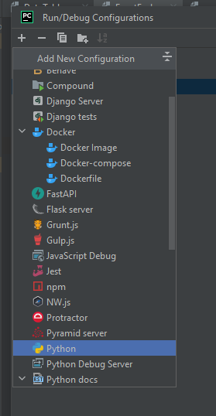

Then give the configuration a name and point it to Python/run_script.py, leave the other fields as is:
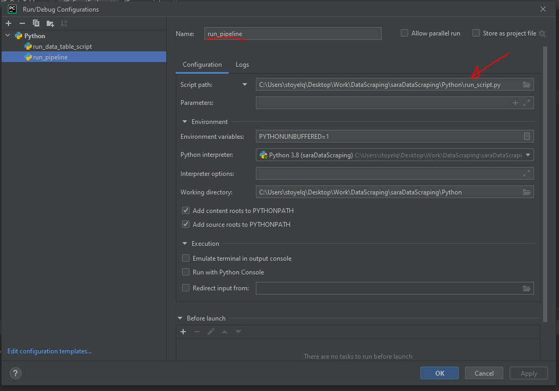
To test the configuration, click on the green “run” triangle in pycharm, and the interface should appear:
