Proposed
Species at Risk Act
Recovery Strategy Series

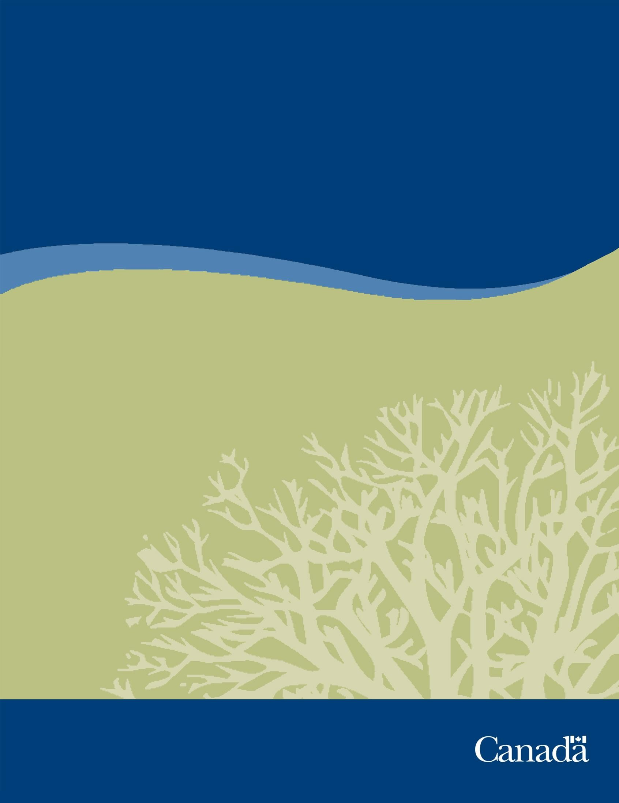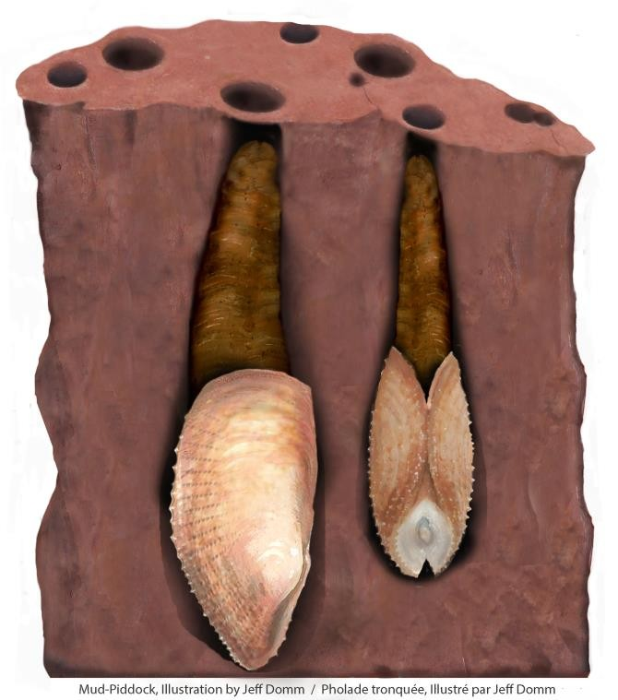

Recovery Strategy for the Atlantic Mud- piddock (Barnea truncata) in Canada

Atlantic Mud-piddock

2022

Recommended citation:
Fisheries and Oceans Canada. 2022. Recovery Strategy for the Atlantic Mud-piddock (Barnea truncata) in Canada [Proposed]. Species at Risk Act Recovery Strategy Series. Fisheries and Oceans Canada, Ottawa. vi+ 50pp.

For copies of the recovery strategy, or for additional information on species at risk, including Committee on the Status of Endangered Wildlife in Canada (COSEWIC) status reports, residence descriptions, action plans, and other related recovery documents, please visit the Species at Risk Public Registry.

Cover illustration: Jeff Domm

Également disponible en français sous le titre
« Programme de rétablissement de la pholade tronquée de l’Atlantique (Barnea truncata) au Canada »

© Her Majesty the Queen in Right of Canada, represented by the Minister of Fisheries and Oceans, 2022. All rights reserved.
ISBN ISBN to come
Catalogue no. Catalogue no. to come

Content (excluding the illustrations) may be used without permission, with appropriate credit to the source.

Preface
The federal, provincial, and territorial government signatories under the Accord for the Protection of Species at Risk (1996) agreed to establish complementary legislation and programs that provide for the protection of species at risk throughout Canada. Under the Species at Risk Act (S.C. 2002, c.29) (SARA), the federal competent ministers are responsible for the preparation of a recovery strategy for species listed as extirpated, endangered, or threatened and are required to report on progress five years after the publication of the final document on the Species at Risk Public Registry, and every subsequent five years.

The Minister of Fisheries and Oceans is the competent minister under SARA for the Atlantic Mud-piddock and has prepared this strategy, as per section 37 of SARA. In preparing this recovery strategy, the competent minister has considered, as per section 38 of SARA, the commitment of the Government of Canada to conserving biological diversity and to the principle that, if there are threats of serious or irreversible damage to the listed species, cost-effective measures to prevent the reduction or loss of the species should not be postponed for a lack of full scientific certainty. To the extent possible, this recovery strategy has been prepared in cooperation with other federal government departments, provincial governments, Indigenous organizations, and others as per section 39(1) of SARA.

As stated in the preamble to SARA, success in the recovery of this species depends on the commitment and cooperation of many different groups that will be involved in implementing the directions set out in this strategy and will not be achieved by Fisheries and Oceans Canada (DFO), or any other jurisdiction, alone. The cost of conserving species at risk is shared amongst different groups. All Canadians are invited to join in supporting and implementing this strategy for the benefit of the Atlantic Mud-piddock and Canadian society as a whole.

This recovery strategy will be followed by one or more action plans that will provide information on recovery measures to be taken by DFO and other jurisdictions and/or organizations involved in the conservation of the species. Implementation of this strategy is subject to appropriations, priorities, and budgetary constraints of the participating jurisdictions and organizations.

Acknowledgments
DFO wishes to acknowledge the many individuals who provided valuable input into the development of this recovery strategy. In particular, Andrew Hebda, retired Curator of Zoology at the Nova Scotia Museum, has played a significant role in recovery planning and implementation by sharing his expertise on the species.

Executive summary
The Atlantic Mud-piddock (Barnea truncata) was listed as threatened under the Species at Risk Act (SARA) in 2017. This recovery strategy is considered one in a series of documents for this species that are linked and should be taken into consideration together, including the Committee on the Status of Endangered Wildlife in Canada (COSEWIC) status report (COSEWIC 2009), a recovery potential assessment (DFO 2010), a threat assessment (DFO 2019), and one or more action plan(s). Recovery of the Atlantic Mud-piddock has been determined to be biologically and technically feasible.

The Atlantic Mud-piddock is an intertidal bivalve mollusc. In Canada, this species is distributed in the Minas Basin, within the inner Bay of Fundy. The Atlantic Mud-piddock has a planktonic larval phase followed by an adult form that burrows into the red mudstone substrate present in the Minas Basin. The Atlantic Mud-piddock becomes entrapped in its burrow as it grows, and it remains there for its lifetime. Also referred to as “fallen angelwing”, the Atlantic Mud-piddock possesses a thin, delicate, ridged shell that is greyish-white in colour and 3 to 5 cm long. There are no visible differences between males and females.

Section 33 of SARA prohibits the damage or destruction of a species’ residence. A detailed description of Atlantic Mud-piddock residence is provided in section 4 and is also available on the Species at Risk Public Registry.

Current and potential threats facing Atlantic Mud-piddock are described in section 5 and include: climate change, alteration of shoreline or water control structures, mineral exploration or extraction activities in the Minas Basin, large-scale tidal energy extraction, release of petroleum products in the Gulf of Maine, other sources of pollution including non-point source pollution, and recreation and adventure sport activities.

The population and distribution objectives (section 6) for the Atlantic Mud-piddock are:
- population objective: maintain a stable population
- distribution objective: maintain suitable habitat

A description of the broad strategies to be taken to address threats to the species’ survival and recovery, as well as research and management approaches needed to meet the population and distribution objectives are included in section 7. These will help inform the development of specific recovery measures in one or more action plans.

For the Atlantic Mud-piddock, critical habitat is identified to the extent possible, using the best available information (section 8). Critical habitat provides the functions and features necessary to support the species’ life-cycle processes and to achieve the species’ population and distribution objectives. This recovery strategy identifies critical habitat for Atlantic Mud-piddock as nine discrete substrate locations within the Minas Basin as well as the waters of the Minas Basin below the high tide mark. The nine substrate locations are situated in the intertidal zone and contain red mudstone. A schedule of studies is included, which outlines the research needed to further identify and refine critical habitat for the species as more information becomes available.

An action plan will be completed within five years of posting the final recovery strategy.

Recovery feasibility summary
Section 40 of the Species at Risk Act states:

“In preparing the recovery strategy, the competent minister must determine whether the recovery of the listed wildlife species is technically and biologically feasible. The determination must be based on the best available information, including information provided by COSEWIC.”

Recovery of the Atlantic Mud-piddock is considered technically and biologically feasible because the following four criteria are met (Government of Canada 2009):

Are individuals of the wildlife species that are capable of reproduction available now or in the foreseeable future to sustain the population or improve its abundance?

Yes. Atlantic Mud-piddock abundance has not been quantitatively estimated, but the Canadian population appears stable with local variability, based on the number of live individuals observed, the amount and location of available habitat, and observed habitat quality. This population is not expected to increase beyond current levels given the limited available habitat.

Is sufficient suitable habitat available to support the species or could it be made available through habitat management or restoration?

Yes. The Canadian population of Atlantic Mud-piddock burrows exclusively into red mudstone in the intertidal zone of the Minas Basin. Although habitat availability is a limiting factor for population growth, there is sufficient habitat to support the existing population.

Can significant threats to the species or its habitat be avoided or mitigated?

Unknown. The primary threat to Atlantic Mud-piddock in Canada is climate change, which could result in habitat destruction through increased sedimentation, ice scouring, sea level rise, and an increase in the frequency of major storm events. The actual impacts of climate change on the population are uncertain due to the spatial and temporal variability in the expected effects of climate change. Climate change may also result in the creation of new habitat; however, the effects of climate change on Atlantic Mud-piddock are expected to be broadly distributed and generally negative. Available measures to prevent or mitigate the local-scale impacts of climate change on Atlantic Mud-piddock are unknown and thought to be limited. Mitigation of climate change on a global scale is still possible and could prevent or mitigate the negative impacts predicted for the Atlantic Mud-piddock; however, this is beyond the scope of this recovery strategy.

Other threats include: alteration of shoreline or water control structures, mineral exploration or extraction activities in the Minas Basin, large-scale tidal energy extraction, release of petroleum products in the Gulf of Maine, other sources of pollution including non-point source pollution, and recreation and adventure sport activities. These threats can be avoided or mitigated through compliance with existing legislation and regulatory review of development proposals.

Do recovery techniques exist to achieve the population and distribution objectives or can they be expected to be developed within a reasonable timeframe?

Unknown. There is some uncertainty about the recovery techniques that could be used to ensure population stability under various climate change scenarios. Shoreline protection measures can be taken to reduce coastal erosion. However, ice scour of intertidal habitat cannot be controlled. Mitigating the effects of increased storms, such as increased riverine input to the Minas Basin or altered depositional characteristics in the Minas Basin, could be achieved to a degree through adoption of flood mitigation measures, but would be difficult. Long-term achievement of the population and distribution objectives will likely depend on which global emissions scenario is realized.

For all other threats, recovery techniques exist to ensure human-induced harm and mortality rates do not exceed levels that would impede the survival or recovery of the Canadian population of Atlantic Mud-piddock. These techniques include, but are not limited to: working with local parks and enforcement officers to promote awareness and compliance, regulatory review of activities, and habitat monitoring.

Table of contents
Preface ii
Acknowledgments ii
Executive summary iii
Recovery feasibility summary iv
Background 1
- Introduction 1
- COSEWIC species assessment information 2
- Species status information 2
- Species information 3
Description 3
Population abundance and distribution 5
Needs of the species 7
Residence of the species 8
Location of the species’ residence 8
Structure, form and investment 10
Occupancy and life-cycle function 11
- Threats 11
Threat assessment 11
Description of threats 15
Climate change 15
Alteration of shoreline or water control structures 15
Mineral exploration or extraction activities in Minas Basin and nearby rivers 15
Large-scale tidal energy extraction 15
Other sources of pollution, including non-point source pollution 16
Release of petroleum products in the Gulf of Maine and Bay of Fundy 16
Recreation and adventure sport activities 16
Recovery 16
- Population and distribution objectives 16
- Broad strategies and general approaches to meet objectives 17
Actions already completed or currently underway 18
Strategic direction for recovery 20
Narrative to support the recovery planning table 22
- Critical habitat 24
Identification of the species’ critical habitat 24
General description of the species’ critical habitat 24
Information and methods used to identify critical habitat 24
Identification of critical habitat 25
Schedule of studies to identify critical habitat 33
Activities likely to result in the destruction of critical habitat 34
- Measuring progress 40
- Statement on action plans 40
References 41
Appendix A: effects on the environment and other species 43
Appendix B: record of cooperation and consultation 44
Appendix C: threat assessment categories 45
Appendix D: water column critical habitat coordinates 46
Appendix E: glossary 49

Background

Introduction
The Atlantic Mud-piddock (Barnea truncata) was listed as threatened¹ under the Species at Risk Act (SARA) in 2017.

This recovery strategy is part of a series of documents regarding Atlantic Mud-piddock that should be taken into consideration together, including the Committee on the Status of Endangered Wildlife in Canada (COSEWIC) status report (COSEWIC 2009), the recovery potential assessment (RPA) (DFO 2010), a threat assessment (DFO 2019), and the subsequent action plan(s). A recovery strategy is a planning document that identifies what needs to be done to arrest or reverse the decline of a species. It sets objectives and identifies the main areas of activities to be undertaken. Detailed planning is done at the subsequent action plan stage.

The RPA is a process undertaken by Fisheries and Oceans Canada (DFO) to provide the information and scientific advice required to implement SARA, relying on the best available scientific information, data analyses and modelling, and expert opinions. The outcome of this process informed many sections of the recovery strategy.

1 See appendix E, glossary

COSEWIC species assessment information
Date of assessment: November 2009²

Species’ common name (population): Atlantic Mud-piddock

Scientific name: Barnea truncata

Status: Threatened

Reason(s) for designation: This intertidal marine bivalve species is restricted to a single population in the Minas Basin, Nova Scotia. Although this species is adapted to boring into hard clay and soft rock, in Canada it is entirely dependent on a single geological formation, the red mudstone facies within the basin. The total available habitat for this species is <0.6 km². This species settles on and bores into the mudstone, and once settled, is immobile.
Any changes in deposition of sediments can smother individuals or cover entire areas of habitat. Disturbances that change the sediment depositional regime are considered the main threat. Most serious is the increased frequency and severity of storms, due to climate change, which have the potential to rapidly bury habitat and smother individuals. It is expected that erosion from rising sea levels (storm surges) and increased rainfall (floods), would also contribute to habitat loss by sediment deposition. Proposed development in the basin could also alter or add to sediment deposition. The Canadian population is clearly disjunct from the nearest population, 350 km south, in Maine, and rescue is very unlikely.

Canadian occurrence: Atlantic Ocean

Status history: Designated threatened in November 2009

Note: This section is taken from the 2009 COSEWIC assessment and status report
on the Atlantic Mud-piddock, and reflects the information provided at that time. The assessment cited the total available habitat for Atlantic Mud-piddock in the Minas Basin as <0.6 km², based on unpublished data. Subsequent foot surveys (Clark et al. 2019) led to a revised estimate of
<1.84 km². In addition, Clark et al. (2019) identified the nearest Atlantic Mud-piddock population as being 475 km away.

Species status information
The Atlantic Mud-piddock has not received any additional protection beyond SARA. NatureServe ranks the global status of the species as G5 (secure) and the status in Nova Scotia as S1 (critically imperiled) (NatureServe 2021).

2 The status of Atlantic Mud-piddock was re-examined and confirmed in May 2021; however, the COSEWIC assessment and status report has not been published yet.

Upon listing as a threatened species, the Atlantic Mud-piddock became protected wherever it is found by section 32 of SARA:

“No person shall kill, harm, harass, capture or take an individual of a wildlife species that is listed as an extirpated species, an endangered species or a threatened species.” [subsection 32(1)]

“No person shall possess, collect, buy, sell or trade an individual of a wildlife species that is listed as an extirpated species, an endangered species or a threatened species, or any part or derivative of such an individual.” [subsection 32(2)]

Under section 73 of SARA, the competent minister may enter into an agreement or issue a permit authorizing a person to engage in an activity affecting a listed wildlife species, any part of its critical habitat, or its residences.

Species information

Description
Globally, there are 16 species in the Barnea genus (MolluscaBase 2019). Table 1 describes the taxonomy of the Atlantic Mud-piddock.

Table 1. Taxonomic classification of the Atlantic Mud-piddock (Turner 1954). The most inclusive (broadest) taxonomic rank is on the far left of the table, and the least inclusive (most specific) rank is on the far right.

Kingdom | Phylum | Class | Order | Family | Genus | Species
Animalia | Mollusca | Bivalva | Myida | Pholadidae | Barnea | Barnea truncata
Animals | Clams, snails, octopuses, squid, scallops, oysters, and  chitons | Marine and freshwater molluscs with a two- part hinged  shell | Burrowing salt water clams | Piddocks | Distinguished from other Pholadidae by morphological characteristics | Atlantic Mud- piddock

The Atlantic Mud-piddock possesses a delicate, thin, greyish-white shell that typically ranges from 3 to 5 cm in length (figure 1). While there is no visible difference between males and females, sexes are separate and internal organs are distinct.

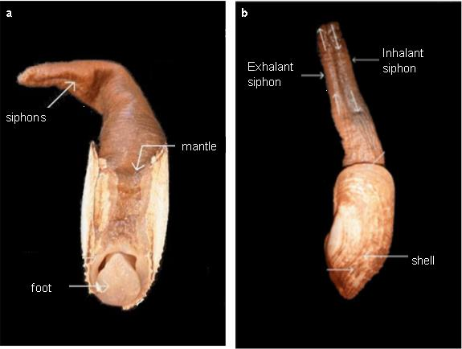
Figure 1. Adult Atlantic Mud-piddock specimen: a) ventral view and b) lateral view (left side) (adapted from COSEWIC 2009).

Spawning is thought to be temperature-driven; fertilization is external, and occurs once ova and sperm are released into the water (DFO 2010). Chanley (1965) noted that females can release up to 11 million eggs in one spawning. Fertilization and recruitment rates have not been studied; however, while it is expected that the rate of fertilization is high, recruitment is likely limited due to factors including predation, the availability of suitable substrate, and tidal flushing (Hebda pers. comm. 2019).

After fertilization, the eggs develop through larval stages, feeding on plankton. The larvae grow from approximately 18 μm to 315 μm (COSEWIC 2009). Evidence from laboratory experiments suggests that larvae may settle on substrate after approximately 35 days during high slack tide (Chanley 1965). Many substrates are not suitable for Atlantic Mud-piddock settlement and boring; however, their larval foot and still-functional velum (swimming appendage) may enable limited movement onto suitable substrate. Once settled, the larva undergoes metamorphosis and initiates boring by making longitudinal movements facilitated by the foot (figure 1). As the Atlantic Mud-piddock grows, the size of the burrow grows, resulting in a conical-shaped hole where the adult remains entrapped for the remainder of its life. Atlantic Mud-piddock are estimated to have a lifespan of approximately 11 years, with relatively continuous growth throughout (Roddick and Clark 2019).

Population abundance and distribution

Globally, Atlantic Mud-piddock are distributed intermittently along the eastern and western continental margins of the Atlantic Ocean and occupy substrates including marine peats, firm muds, and, rarely, wood (COSEWIC 2009). In the east, Atlantic Mud-piddock have an intermittent distribution from South Africa to the Republic of Congo, and a more continuous distribution from Gabon to Senegal. In the west, Atlantic Mud-piddock have a patchy distribution from southeastern Brazil to the Gulf of Mexico, and a more continuous distribution from Florida to southern Maine. The only known population north of Maine is located in the Minas Basin, Canada (figure 2) (COSEWIC 2009). This population, persisting in the warmer waters of the Minas Basin, is considered a relic from the last post-glacial warm period (~3000 years ago) (DFO 2010).

According to COSEWIC, the Atlantic Mud-piddock is not thought to be of particular significance to Indigenous Peoples in Canada, and there is no evidence of it being consumed by humans (COSEWIC 2009).
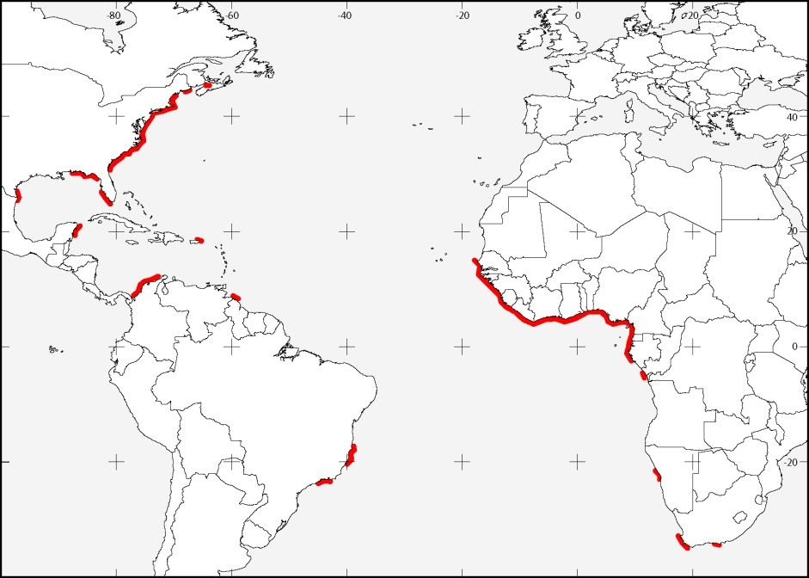
Figure 2. Global distribution of Atlantic Mud-piddock (adapted from COSEWIC 2009).

There are 13 sites in the Minas Basin and within Cobequid Bay³, that are known to contain suitable Atlantic Mud-piddock habitat (figure 3). The total known suitable habitat area is less than 1.84 km² (Clark et al. 2019). All 13 sites are associated with Triassic-age red mudstone facies and occur in the mid to low intertidal zones (DFO 2010; Clark et al. 2019). Live Atlantic Mud-piddock were observed at all 13 sites during 2017 to 2018 surveys.

Atlantic Mud-piddock population abundance in the Minas Basin is unknown. Population estimates are difficult to obtain due to the containment of individuals in hard substrate, which

3 Cobequid Bay is the innermost portion of the Minas Basin. In this document, unless specified, “Minas Basin” should be interpreted as also including Cobequid Bay.

would require destructive methods to assess abundance, and the challenging nature of conducting foot surveys in the low tide zone (COSEWIC 2009). However, qualitative comparisons of visual observations have allowed for the assessment of habitat site stability and overall population status over time (Clark et al. 2019). These comparisons are based on the number of live individuals observed, the amount and location of available habitat, and habitat quality (for example, sedimentation regime, presence of protective features such as cobbles, boulders, and resistant caprock). Available habitat area and quality of habitat were maintained over a ten-year survey period (2008 to 2018) at eight sites (table 2). These sites are considered stable and account for more than 90% of the total available habitat as described in Clark et al. (2019). The five remaining sites (table 2) are not considered stable, as they are either declining in available habitat area and quality of habitat, or are small and increasing in habitat area and quality.

The 13 sites containing suitable habitat are characterized as either “core” or “peripheral”, based on their relative size, proximity to each other, and apparent stability (table 2) (Clark et al. 2019):

- core sites are concentrated between Tennycape and Mungo Brook, contain the majority of available Atlantic Mud-piddock habitat in the Minas Basin, appear to be stable over time, and are more resilient to ice scouring effects due to the presence of protective features such as capstones, large cobbles, boulders, and reefs
- peripheral sites contain suitable habitat but are smaller than the core sites and are more distant and spread out (Hebda pers. comm. 2019)

Table 2. Stability classification of the 13 extant Atlantic Mud-piddock sites within the Minas Basin, based on Clark et al. 2019.

 | Stable sites | Unstable sites
Core sites | Tennycape, Burntcoat Head, Noel Bay, Sloop Rocks, Shad Creek, and Mungo  Brook | N/A
Peripheral sites | Spencer Point and Port Williams | Parrsboro, Kingsport, Evangeline Beach, Economy Point, and Five Islands

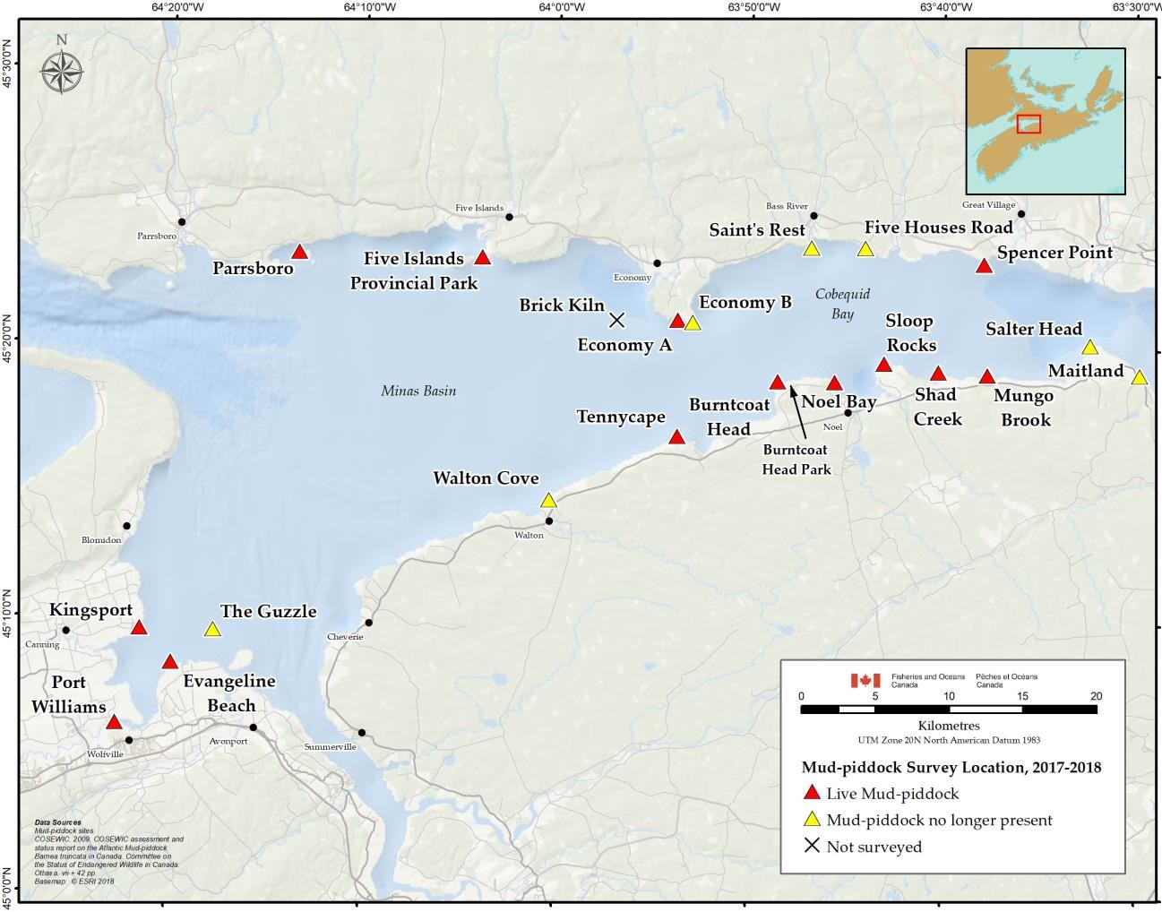
Figure 3. Canadian distribution of Atlantic Mud-piddock based on 2017 to 2018 field surveys (Clark et al. 2019). Coordinates for live Atlantic Mud-piddock sites can be found in Clark et al. (2019).

Needs of the species

Habitat

The Minas Basin is approximately 80 km long and 30 km wide (DFO 2018). It is a highly productive part of the Bay of Fundy with a tidal range of up to 19 m that results in highly oxygenated waters and abundant particulate food resources (COSEWIC 2009).

Atlantic Mud-piddock are adapted to boring into firm muds, mudstones, or peats (Hebda 2011; Clark et al. 2019). Within Canada, they burrow exclusively in red mudstone facies found within the Minas Basin, which are limited sub-tidally by the presence of stable masses of sands and fine gravels. In the Minas Basin, Atlantic Mud-piddock occur in five different habitat types associated with red mudstone: tidal pools, boulders, capstones, rivulets, and patches (Hebda 2011; Clark et al. 2019). The use of these habitat types by Atlantic Mud-piddock is summarized in table 3 and described further in section 4.4.

Optimal water temperature and oxygen levels are unknown for Atlantic Mud-piddock; however, in the Minas Basin, they tolerate water temperatures ranging from 0°C in the winter to 21°C in the summer, and oxygen levels within the natural range of variation (~5 mg/L) (DFO 2019).
Atlantic Mud-piddock have also been observed in a wide range of salinities, from 5 to 25 ppt, in the Minas Basin (COSEWIC 2009; DFO 2010).

Table 3. The five habitat types associated with Atlantic Mud-piddock burrows in red mudstone facies as described in Clark et al. (2019).

Habitat type | Habitat use
Tidal pools | In the bottom of tidal pools with water >0.5 cm deep and an area greater than a patch (>1.0 m2)
Boulders | Around the base of large cobbles or boulders where tidal scour causes sediment flushing
Capstone | Adjacent to or under resistant capstone that protects underlying mudstone against scour from ice and other materials
Rivulets | In rivulets or channels where freshwater runoff or the tide causes sediment flushing
Patches | In patches in the intertidal zone covered by water <0.5 cm deep and an area smaller than a tidal pool (<1.0 m2)

Limiting factors

Because of their association with red mudstone facies in the Minas Basin, Atlantic Mud-piddock are limited by the availability of suitable habitat in the intertidal zone.

Atlantic Mud-piddock are also limited by their intolerance of rapid or significant sediment accumulation. Because they remain immobile in their burrow after larval settlement, sediment accumulation and in-filling of burrows results in smothering (COSEWIC 2009).

The cooler waters of the outer Bay of Fundy may be a factor in the isolation of the population from populations outside of the Minas Basin (COSEWIC 2009).

Residence of the species

Location of the species’ residence

SARA states that “No person shall damage or destroy the residence of one or more individuals of a wildlife species that is listed as an endangered species or a threatened species, or that is listed as an extirpated species if a recovery strategy has recommended the reintroduction of the species into the wild in Canada.” [section 33]

Also, SARA defines “residence” as: “a dwelling-place, such as a den, nest or other similar area or place, that is occupied or habitually occupied by one or more individuals during all or part of their life cycles, including breeding, rearing, staging, wintering, feeding or hibernating.” [subsection 2(1)]

The following (the residence statement) is a description of a residence for Atlantic Mud-piddock.
The Atlantic Mud-piddock’s burrow is its residence. Once an Atlantic Mud-piddock larva settles on its preferred red mudstone substrate, it invests energy in creating a burrow that is essential to its survival. The Atlantic Mud-piddock grows and matures in its burrow. It feeds and releases spawn from within its burrow where it remains for the duration of its adult life stage.

Atlantic Mud-piddock are found in five red mudstone habitat types (table 3 and figure 4). There is a one-to-one correspondence between each Atlantic Mud-piddock and its burrow. This means that the distribution of residences (burrows) precisely matches the distribution of the adult population, and is not a sub-area of the distribution.

Atlantic Mud-piddock require habitat that is not subject to rapid or significant sediment accumulation, which would result in smothering. The burrows must be located where adequate currents prevent accumulation of sediment over top of or in the burrows, and allow the animals to filter feed organic matter from the water. Atlantic Mud-piddock also require well oxygenated waters, due to confinement in the burrows. The species is completely reliant on environmental conditions remaining suitable outside of the burrows, given they are unable to relocate if conditions deteriorate and become unsuitable.

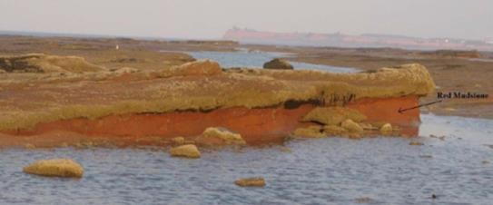
1
G. Jones

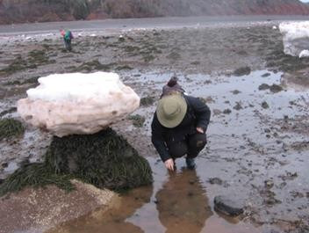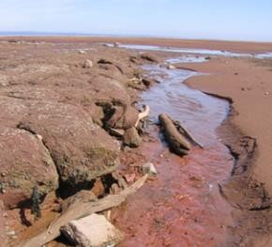
2
A. Hebda
3
G. Jones

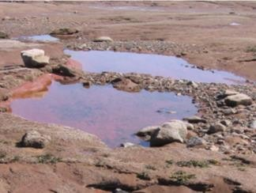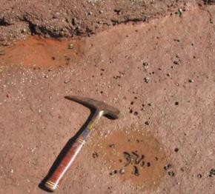
4
G. Jones
5
A. Hebda
Figure 4: Atlantic Mud-piddock burrows may be found (1) embedded under resistant capstone substrate; (2) associated with more resistant bedrock features, such as a boulder, pictured here, or large cobbles or other exposed rock material; and in exposed surfaces created by erosion of resistant rock, for example, in (3) rivulets, (4) tidal pools, and (5) patches in the intertidal zone.

Structure, form and investment

The process of constructing a residence begins when the larva settles and actively burrows into the substrate. The presence of a functional foot and a still-functional velum (membrane) in the larval stage suggests mobility allowing for some substrate selection after the larva settles and

makes contact with the substrate. As the Atlantic Mud-piddock grows and burrows deeper, the size of the burrow increases in diameter resulting in a conical hole that traps the animal inside (figure 5). The adult Atlantic Mud-piddock is unable to fully enclose itself in its shell, and protection is provided by the burrow (COSEWIC 2009).

The Atlantic Mud-piddock's burrow starts at the surface of the substrate and continues to a point below the lower end of the valves (shells) (figure 5). The burrow ends below the valves where the Atlantic Mud-piddock’s foot temporarily anchors to the substrate, enabling the rotation of the shell for the reaming of the burrow (COSEWIC 2009).

The structure and form of the burrow is the residence of the Atlantic Mud-piddock. Their investment is the act of burrowing into the substrate, entering the space and creating the burrow that will be occupied for the lifespan of the individual.
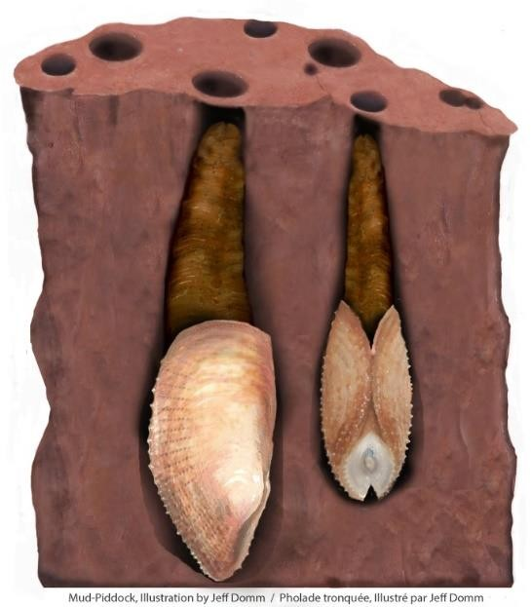
Figure 5. Cross section of Atlantic Mud-piddock in their burrows, illustrating the entrapment of adults within the substrate.

Occupancy and life-cycle function

The Atlantic Mud-piddock occupies its burrow year-round for its entire post-larval lifespan. Life cycle functions including growth, maturation, spawning, and feeding all occur from within the burrow (COSEWIC 2009).

Once created, the burrow of an individual Atlantic Mud-piddock is considered its residence year round for its entire adult lifespan.

Threats

Threat assessment

An assessment and prioritization of threats to the survival and recovery of Atlantic Mud-piddock was undertaken (DFO 2019). A threat is defined as any human activity or process that has

caused, is causing, or may cause harm, death, or behavioural changes to the Atlantic Mud- piddock, or the destruction, degradation, and/or impairment of its habitat, to the extent that population-level effects occur (DFO 2014). Threats to the Atlantic Mud-piddock in Canadian waters are summarized in table 4, and described in more detail in section 5.2 and DFO (2019). The specific assessment categories and associated rankings used in table 4 are provided in appendix C. Assessment category definitions are provided in appendix E. For more details on the threat assessment process, refer to the Guidance on Assessing Threats, Ecological Risk and Ecological Impacts for Species at Risk.

Table 4. Population-level threat assessment for Atlantic Mud-piddock in Canadian waters, adapted from DFO 2019⁴.

Threat | Geographic scale | Likelihood of occurrence | Level of impact | Causal certainty | Threat risk | Threat occurrence | Threat frequency | Threat extent
Climate change | Minas Basin/ Cobequid Bay | Known | High | Low | High | Current | Continuous | Extensive
Alteration of shoreline or water control structures | Cobequid Bay (with no consideration for potential far-field effects) | Likely | Low | Very Low | Low | Anticipatory | Recurrent | Narrow
Mineral exploration or extraction activities in Minas Basin and nearby rivers | Minas Basin/ Cobequid Bay | Unlikely | Unknown | Low | Unknown | Anticipatory | Continuous | Restricted
Large-scale tidal energy extraction | Minas Basin | Unlikely | Unknown | Medium | Unknown | Anticipatory | Continuous | Broad
Other sources of pollution, including non-point source pollution | Minas Basin/ Cobequid Bay | Remote | Unknown | Low | Unknown | Anticipatory | Single | Narrow
Release of petroleum products in Gulf of Maine and Bay of Fundy | Minas Basin/ Cobequid Bay | Remote | Extreme | Medium | Low | Anticipatory | Recurrent | Extensive

4 DFO (2019) assessed an underground gas storage project as a potential threat to Atlantic Mud-piddock due to uncertainties associated with the diffusion of brine into Cobequid Bay and the toxicity of salts to the Pholadidae family. In October 2021, it was announced that this project would not proceed and so it has not been included in Table 4.

Threat | Geographic scale | Likelihood of occurrence | Level of impact | Causal certainty | Threat risk | Threat occurrence | Threat frequency | Threat extent
Recreation and adventure sport activities | Minas Basin/ Cobequid Bay | Known | Low | Medium | Low | Current | Recurrent | Restricted

Description of threats

Threats to the Atlantic Mud-piddock are described in DFO (2019) and briefly summarized below.

Climate change

Climate change poses the greatest risk to the Canadian population of Atlantic Mud-piddock, the effects of which are likely to be complex and broadly distributed (COSEWIC 2009; DFO 2010; DFO 2019). Although the impacts of this threat could be significant, the level of causal certainty is low.

The impacts of climate change could both create and destroy Atlantic Mud-piddock habitat (DFO 2019). An increase in the frequency, length, and severity of storms and rainfall may disrupt sediment deposition and smother Atlantic Mud-piddock or cover available habitat. In the Minas Basin, sea level rise may destroy Atlantic Mud-piddock habitat due to increased shore erosion and beach migration (Forbes et al. 1997; Ashmore and Church 2001; NRCAN 2009; DFO 2019). However, sea level rise could also result in the settlement of new areas if new red mudstone habitat becomes exposed. Water temperatures in the Minas Basin during the winter are colder than those experienced by any other known population of Atlantic Mud-piddock. If water temperature is limiting, greater temperature fluctuations around annual means or colder winter temperatures may negatively impact the persistence of the population (COSEWIC 2009). An increase in the volume and persistence of ice rafting in late winter and/or early spring could cause habitat destruction through scouring of exposed red mudstone, or the collapse of protective capstone under the weight of ice after ebb tides (COSEWIC 2009; DFO 2010; 2019).

Alteration of shoreline or water control structures

The construction, modification, or removal of shoreline or water-crossing structures such as dams, causeways, wharves, boat slips, and aboiteaux may cause water current alteration, habitat destruction, and smothering through associated sedimentation events. Harbour and/or waterway dredging is also included in this category (DFO 2019).

Mineral exploration or extraction activities in Minas Basin and nearby rivers

Potential mineral exploration or extraction activities in nearby rivers may disturb sediments and destroy habitat, and may also introduce heavy metals or other potential toxins. For example, an experimental titanium mining project proposed to take place between 1997 and 2002 resulted in the exploratory dredging of a lower portion (102 km²) of the Shubenacadie River, which drains into the Minas Basin upstream of Atlantic Mud-piddock habitat. Though this project proved to be uneconomical, similar future activities could negatively affect Atlantic Mud-piddock through sedimentation of habitat, smothering, and introduction of toxins (DFO 2019).

Large-scale tidal energy extraction

The impacts of large-scale tidal energy extraction in the Minas Passage and Minas Channel on Atlantic Mud-piddock are largely unknown. However, this activity may pose a risk to Atlantic Mud-piddock in the Minas Basin by altering tidal regimes (DFO 2019). Experimental small-scale turbine deployments have been ongoing in the area since 2009, and research on environmental impacts has been limited to a small pilot site. Impacts of large-scale tidal development or incremental and/or cumulative effects of small-scale tidal development have not been

evaluated. Additionally, deployment of the experimental turbines has been intermittent, so long- term data associated with those deployments is not available. Overall, small-scale tidal development is not expected to have a measurable effect on tidal regimes in the Minas Basin. However, effects from large-scale tidal development are identified as a potential threat to Atlantic Mud-piddock (DFO 2019).

Other sources of pollution, including non-point source pollution

Five major rivers drain into the Minas Basin: Shubenacadie, Cornwallis, Avon, Gaspereau, and Salmon. Non-point source pollution resulting from agriculture and urban run-off may decrease water quality, with potential impacts on Atlantic Mud-piddock health (DFO 2019). There could also be point sources of pollution, such as an incident in 1986 when a fire at a pesticide and agrichemical warehouse resulted in the release of both fertilizers and pesticides into the Avon Estuary of the Minas Basin.

Release of petroleum products in the Gulf of Maine and Bay of Fundy

The bulk movement of petroleum products via ocean transport in the Gulf of Maine and Bay of Fundy to four seaports with oil refineries in Maine and New Brunswick could result in an accidental oil spill. Such an event could affect Atlantic Mud-piddock though smothering of adults, or toxicity to adults or larvae. Resultant cleanup procedures could also be physically and chemically destructive to Atlantic Mud-piddock and its habitat (DFO 2019). While the risk of an oil spill is low and few vessels enter the Minas Basin, spilled oil could enter from the lower reaches of the Bay of Fundy via an incoming tide, significantly impacting intertidal habitats. For instance, the Port of Saint John, on the northern shore of the Bay of Fundy, is considered to have the highest risk of an oil spill of any port in Canada, the results of which could impact the Minas Basin shoreline (Ryan et al. 2019) The complex shoreline of the Bay of Fundy may make cleanup difficult, and variable environmental factors such as wind, salinity, and temperature can increase the complexity of cleanup (Owens 1977; Ryan et al. 2019).

Recreation and adventure sport activities

Known recreational and adventure sport activities that occur in Atlantic Mud-piddock habitat during low tide include running, biking, and all-terrain vehicle (ATV) use. Individual recreational activities are not likely to have a major impact on the population; however, impacts are expected to increase with the frequency and intensity of site use. Situations that could cause such an influx of visitors to a specific site include large group activities such as running and bicycle races (DFO 2019).

Recovery

Population and distribution objectives
Population and distribution objectives establish, to the extent possible, the number of individuals and/or populations, and their geographic distribution, that is necessary for the recovery of the species. The population and distribution objectives for Atlantic Mud-piddock are:

  - population objective: maintain a stable population
  - distribution objective: maintain suitable habitat

There are no historical or current population abundance estimates for Atlantic Mud-piddock in the Minas Basin. It is unlikely that a population estimate could be obtained, as this would require the removal of capstone at selected sites and cutting cross-sections through burrow assemblages (Hebda 2011). This process would significantly damage or destroy Atlantic Mud- piddock habitat, including their residences, and could kill or harm individuals at those sites. Non- destructive methods for reliably estimating Atlantic Mud-piddock abundance in capstone habitat are not currently known. It is therefore not possible to set a quantitative population objective at this time.

Without a reliable quantitative population estimate, a qualitative population objective has been set. Qualitative comparisons of habitat, based on foot surveys conducted in 2007 to 2008 (Hebda 2011) and 2017 to 2018 (Clark et al. 2019), indicate that the Atlantic Mud-piddock population appears to be stable over time. The overall extent and quality of habitat, as well as observed occurrences of live Atlantic Mud-piddock, appear stable, and there is no evidence to suggest that the population has declined (Clark et al. 2019; DFO 2010). However, variability between the size of the sites and the local conditions at the site means that some sites may be more likely to persist than others (Clark et al. 2019). Due to the limited availability of red mudstone within the Minas Basin, population abundance and distribution of Atlantic Mud- piddock are not expected to increase beyond current levels (DFO 2010).

Setting a distribution objective for Atlantic Mud-piddock is also challenging. The dynamic nature of the Minas Basin causes red mudstone to be covered and uncovered by sediment, or altered by events such as ice scouring, resulting in shifting habitat availability. For example, in 2007 and 2008, a previously documented sub-population at Evangeline Beach was deemed extirpated, but re-settlement was observed during the 2017 to 2018 field surveys (Clark et al. 2019).
Conversely, during the 2017 to 2018 field surveys the Bass River sub-population (Saints Rest) was deemed extirpated, with no available red mudstone due to cobble deposition (Clark et al. 2019). The current understanding of natural variation for the population is based on a relatively short time scale. The total available habitat has remained relatively stable between the 2007 to 2008 survey and the 2017 to 2018 survey, in spite of local variability, and the distribution objective aims to maintain suitable habitat such that a stable population is supported.

Long-term achievement of the population and distribution objectives may be affected by the impacts of global climate change. Though expected to be generally negative, the exact extent and magnitude of the potential effects of climate change on Atlantic Mud-piddock are unknown, but are expected to depend in part on which global emissions scenario is realized, and the resultant local effects.

Broad strategies and general approaches to meet objectives
Research and management approaches required to meet the population and distribution objectives, including actions already completed or underway, are described in this section and grouped under the following broad strategies:

Broad strategy 1: research and monitoring Broad strategy 2: management and protection
Broad strategy 3: engagement, stewardship, and public outreach

Actions already completed or currently underway

Broad strategy 1: research and monitoring Habitat mapping
DFO, in partnership with the Geological Survey of Canada, conducted a pilot study in 2018 and 2019 to assess the feasibility of mapping red mudstone habitat using an unmanned aerial vehicle (UAV) and high accuracy, survey-grade GPS technology. The pilot project was completed at Burntcoat Head Park. Work is underway to produce detailed 3D maps and habitat boundaries. This will provide baseline data that could help in monitoring future habitat change and implementing recovery measures. Depending on the outcomes of the pilot study, this work may be expanded to other sites in the Minas Basin. This work could help refine pre-existing habitat maps created using a hand-held GPS, and create habitat maps in previously unmapped areas with limited accessibility to traditional foot survey methods.

Further work has been carried out within the Minas Basin at Five Islands, Economy, and Kingsport to map Atlantic Mud-piddock habitat and to collect data to characterize sediment grain size within the area. The proposed extension of this work would utilize UAV sampling and modelling to help inform understanding of threats from sedimentation and possible changing bottom sediment substrate in Atlantic Mud-piddock habitat areas.

Ageing

Roddick and Clark (2019) examined Atlantic Mud-piddock ageing and growth. They established protocols for ageing individuals, and produced a growth curve used to estimate the lifespan of Atlantic Mud-piddock. This, combined with future work in this area, may help to further the understanding of life history and population dynamics for the species.

Larval distribution

Work is underway to model Atlantic Mud-piddock larval dispersal and habitat connectivity within the Minas Basin to inform understanding of larval dispersal dynamics and the relative importance of each habitat site in maintaining the population.

Genetics

The Marine Gene Probe Laboratory at Dalhousie University, in collaboration with DFO, conducted initial genetic analyses of Atlantic Mud-piddock samples from the Minas Basin to support the assessment of genetic connectivity between the Canadian population and those nearby. Further analysis is required to complete this assessment.

Broad strategy 2: management and protection Habitat protection
DFO has worked with the organizers of intertidal running and bicycle race events held at Burntcoat Head Park and Five Island Provincial Park to ensure race routes avoid known Atlantic Mud-piddock habitat.

Broad strategy 3: engagement, stewardship, and public outreach Public outreach
Atlantic Mud-piddock interpretive signage has been installed at Burntcoat Head Park and Five Islands Provincial Park. These signs inform park visitors about the species and its habitat, as well as how to avoid contravening the SARA prohibitions.

DFO also promotes awareness of the species, its status, habitat, and threats at public events, such as Oceans Day (Halifax) and Explore Your Own Backyard (Burntcoat Head Park). Staff at Burntcoat Head Park also conduct outreach and education with visitors on the species and its presence in the park.

Targeted engagement

Local soft shell clam and marine worm harvesters were given presentations and handouts about Atlantic Mud-piddock, its habitat, and threats at advisory committee meetings in 2016, prior to the species’ listing under SARA. While these fisheries do not interact directly with Atlantic Mud- piddock, the use of all-terrain vehicles to reach fishing areas could impact habitat.

DFO representatives have attended running and bicycle races at Burntcoat Head Park and Five Islands Provincial Park. These site visits promoted awareness of the species and its habitat through verbal briefings and distribution of information sheets to recreational users and the Nova Scotia Department of Lands and Forestry.

Strategic direction for recovery

The research and management approaches needed to meet population and distribution objectives are presented in table 5, and further described in section 7.3. These will help inform the development of specific recovery measures in one or more action plans.

Table 5. Recovery planning table.
General description of research and management approaches | Priority⁵ | Broad strategy | Threat or concern addressed
1. Monitor, and refine knowledge of, threats to the species | Medium | 1 | All threats
2. Research and monitor sedimentation regimes in the Minas Basin and at Atlantic Mud-piddock habitat sites, including establishing baselines and developing predictive models for various climate change scenarios | Medium | 1 | Sedimentation, climate change
3. Establish and implement a monitoring program to survey distribution of available habitat and live individuals to monitor changes over time (see also table 7) | Medium | 1 | Habitat availability, population abundance and distribution
4. Increase understanding of life history characteristics (for example, age structure, recruitment, mortality) | Low | 1 | Knowledge gaps
5. Conduct research on spawning to determine correlation between timing and concurrent water temperature, as well as larval distribution, mobility, and settlement preference (see also table 7) | Low | 1 | Knowledge gaps
6. Determine genetic connectivity between the Atlantic Mud-piddock populations in Canada and the United States | Low | 1 | Potential for rescue effect

5 “Priority” reflects the degree to which the approach contributes directly to the recovery of the species or is an essential precursor to an approach that contributes to the recovery of the species:
  - "high" priority approaches are considered likely to have an immediate and/or direct influence on the recovery of the species
  - "medium" priority approaches are important but considered to have an indirect or less immediate influence on the recovery of the species
  - "low" priority approaches are considered important contributions to the knowledge base about the species and mitigation of threats

General description of research and management approaches | Priority⁵ | Broad strategy | Threat or concern addressed
7. Develop and implement a multi-jurisdictional compliance and enforcement strategy for Atlantic Mud- piddock | High | 2 | All threats
8. Ensure the Atlantic Mud-piddock is considered in all relevant regulatory review processes | High | 2 | All threats
9. Explore and implement measures to prevent habitat loss due to human activities | High | 2 | All threats
10. Promote public awareness of Atlantic Mud-piddock at relevant events, education centres, museums, and parks | Medium | 3 | All threats

Narrative to support the recovery planning table

Broad strategy 1: research and monitoring

Six research and monitoring approaches are included in table 5. These approaches are expected to improve understanding of Atlantic Mud-piddock life history and threats. They are also expected to provide information on species distribution and habitat use.

Establishing a sedimentation baseline in the Minas Basin is necessary to effectively monitor threats that may affect sedimentation rates (for example, climate change, large-scale tidal energy extraction). Additionally, predictive sedimentation modelling could be performed to identify scenarios (for example, naturally occurring events, climate change impacts, coastal developments and activities) that could destroy or increase available habitat. Overall, there is limited information on the effects of all identified threats (table 4) on Atlantic Mud-piddock, and further research is needed to effectively monitor and mitigate these threats.

The main threat to Atlantic Mud-piddock is habitat loss due to climate change. Monitoring for changes in species distribution and habitat availability over time is essential to understand the impact of this threat. A monitoring program will be established, which will include a combination of foot surveys, UAV surveys, and potentially other novel methods. Foot surveys can be used to map the distribution of Atlantic Mud-piddock live occurrences and available habitat. UAV and GPS technology can be used to create and refine detailed 3D maps of known Atlantic Mud- piddock habitat. This may provide estimates of the amount and type of habitat at each site and indicate whether they are considered stable, increasing, or declining. Such survey and mapping techniques could also be used to monitor changes (for example, erosion, siltation) in suitable habitat over time. Furthermore, 3D map products could be used to inform regulatory review processes to aid in the assessment of potential impacts to Atlantic Mud-piddock habitat.

Within the Minas Basin, Atlantic Mud-piddock may be found near Brick Kiln Island; however, further surveys would be required to confirm Atlantic Mud-piddock presence in this location, or elsewhere (Clark et al. 2019). UAV technology could facilitate surveys in areas where traditional foot survey methods are constrained by accessibility considerations. Encouraging and facilitating citizen science monitoring could supplement other survey methods by providing further information on Atlantic Mud-piddock distribution, habitat use, and habitat availability. This could be accomplished using methods such as directed monitoring or opportunistic reporting.

The protocols developed by Roddick and Clark (2019) for ageing Atlantic Mud-piddock could be used in studies on population structure (for example, mean age, year class, length at age, and age at maturity) or population dynamics (for example, larval and juvenile abundance, recruitment, growth, and mortality). This information could be used to determine population structure and provide population estimates.

Research underway to model Atlantic Mud-piddock larval dispersal could be expanded to increase understanding of recruitment and settlement dynamics. Field and laboratory research could expand upon existing knowledge of spawning and larval development and settlement (Chanley 1965), and increase understanding of movement within the water column.

There are no published data on the genetic structure of Atlantic Mud-piddock in the Northwest Atlantic. The degree of genetic connectivity between the Canadian Atlantic Mud-piddock population and the Maine population is unknown. Though it is assumed that the Canadian

population is genetically isolated, genetic transfer may occur given the large volume of water exchange between the Bay of Fundy and the greater Gulf of Maine. A genetic linkage could enable the rescue and survival of the Canadian population if its status declined. This would apply if it were determined that larvae disperse from the Maine population to the Canadian population. Conversely, if it is determined that United States populations are partially reliant on the Canadian population, greater emphasis on Atlantic Mud-piddock recovery in Canada may be required.

Broad strategy 2: management and protection

Three management and protection approaches are included in table 5, all of which are considered high priority. These approaches are intended to mitigate the effects of threats described in the threat assessment, and ensure that Atlantic Mud-piddock is considered in regulatory processes (DFO 2019).

Broad management measures implemented as part of climate change mitigation or adaptation strategies, such as shoreline protection or erosion and run-off controls, could positively impact the species by preventing sedimentation and smothering of Atlantic Mud-piddock, or toxicity from agricultural or urban run-off.

Other anthropogenic threats causing habitat destruction can be more directly prevented and mitigated. For example, preventing habitat destruction from ATVs and heavy foot traffic (for example, running and bicycle races) is possible through an enforcement plan and continued collaboration with municipal (Burntcoat Head) and provincial (Five Islands) parks. Consideration of Atlantic Mud-piddock in relevant regulatory reviews, under the Fisheries Act, Species at Risk Act, and Impact Assessment Act, for example, is also necessary to protect the species and its habitat.

Broad strategy 3: engagement, stewardship, and public outreach

The Atlantic Mud-piddock is cryptic in its habitat use, and has not been traditionally harvested for consumption, or for its shells. As a result, the species has not garnered much public attention. While geographic and tidal constraints render public access difficult at many sites, important habitat areas are readily accessible in Burntcoat Head Park and Five Islands Provincial Park. Because of the relative obscurity of the species and the public access to potentially sensitive habitat areas, public outreach will continue to be an important component of recovery efforts to prevent harm to Atlantic Mud-piddock habitat or individuals.

Outreach to relevant provincial government departments, Indigenous groups, municipalities, non-government organizations, and private industry is also needed to increase awareness and consideration of the species and its habitat. This could be accomplished through public events, social media, and targeted engagement, for example, and focus on Atlantic Mud-piddock biology, known locations, habitat use, and threats. Increasing awareness of Atlantic Mud- piddock may help to prevent habitat destruction. Public outreach may also contribute to long- term monitoring, through the establishment of citizen science efforts, as described above.

Critical habitat

Identification of the species’ critical habitat

General description of the species’ critical habitat

Critical habitat is defined in SARA as “…the habitat that is necessary for the survival or recovery of a listed wildlife species and that is identified as the species’ critical habitat in the recovery strategy or in an action plan for the species.” [subsection 2(1)]

Also, SARA defines habitat for aquatic species as “… spawning grounds and nursery, rearing, food supply, migration and any other areas on which aquatic species depend directly or indirectly in order to carry out their life processes, or areas where aquatic species formerly occurred and have the potential to be reintroduced.” [subsection 2(1)]

For the Atlantic Mud-piddock, critical habitat is identified to the extent possible, using the best available information, and provides the functions and features necessary to support the species’ life-cycle processes and to achieve the species’ population and distribution objectives. This includes red mudstone habitat, as well as the waters of the Minas Basin.
Red mudstone: This recovery strategy identifies critical habitat for Atlantic Mud-piddock as the substrate at nine discrete sites within the Minas Basin (figures 6 to 15). These intertidal sites contain areas of red mudstone in association with tide pools, rivulets, resistant capstone, boulders/large cobbles, and patches. All habitat types except for capstone have water present at high and low tide. Capstone habitat retains moisture and provides shade to allow for Atlantic Mud-piddock persistence.

Waters of the Minas Basin: This recovery strategy identifies critical habitat for Atlantic Mud- piddock as the waters of the Minas Basin below the high tide mark along the contiguous shoreline, crossing each river at the coordinates identified in appendix D, and bounded at the western extent by the coordinates identified in appendix D (figure 16).

The critical habitat identified in this recovery strategy is considered sufficient to achieve the species’ population and distribution objectives; however, given the dynamic nature of Atlantic Mud-piddock habitat, critical habitat areas may change over time. The schedule of studies outlines the research required to identify new critical habitat and refine existing areas.

Information and methods used to identify critical habitat

The delineation of Atlantic Mud-piddock red mudstone critical habitat (figures 6 to 15) was informed by foot surveys documented in COSEWIC (2009) and Clark et al. (2019). All of the sites considered stable (section 4.2) were identified as critical habitat, as well as one of the larger unstable sites on the northwestern shore of the Minas Basin (Five Islands). The delineation of critical habitat boundaries for the waters of the Minas Basin (figure 16; appendix D) was informed by Clark et al. (2019) and by previous work to delineate boundaries for the Minas Basin in relation to important marine habitat for Atlantic Salmon (inner Bay of Fundy population) (DFO 2013; Canadian Hydrographic Service 2014).

Identification of critical habitat

Geographic information

For the Atlantic Mud-piddock, red mudstone critical habitat is identified at nine sites within the Minas Basin: Port Williams, Spencer Point, Five Islands, Tennycape, Burntcoat Head, Noel Bay, Sloop Rocks, Shad Creek, and Mungo Brook (figures 6 to 15). Critical habitat is also identified in the water column of the Minas Basin (figure 16; appendix D). The critical habitat identified in this recovery strategy contains the functions, features, and attributes (table 6) necessary for the species’ survival and recovery.
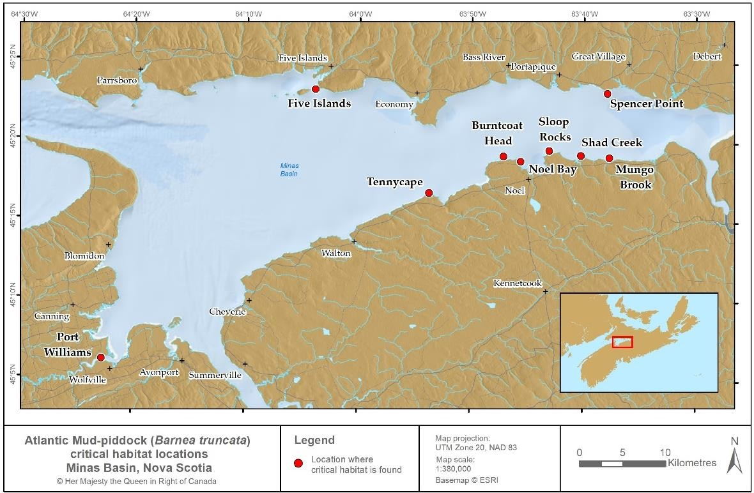
Figure 6. Location of sites containing red mudstone critical habitat for Atlantic Mud-piddock.

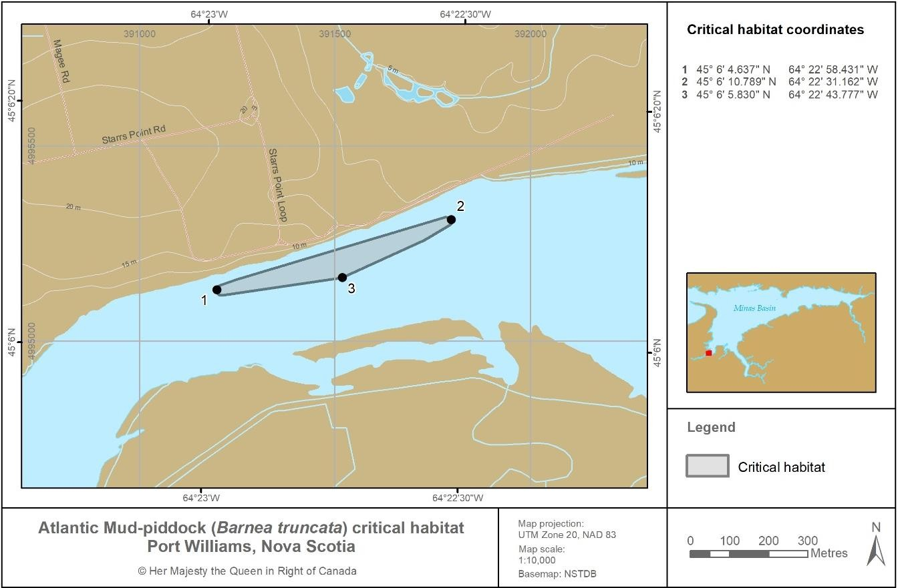
Figure 7. Red mudstone critical habitat at the Port Williams site.

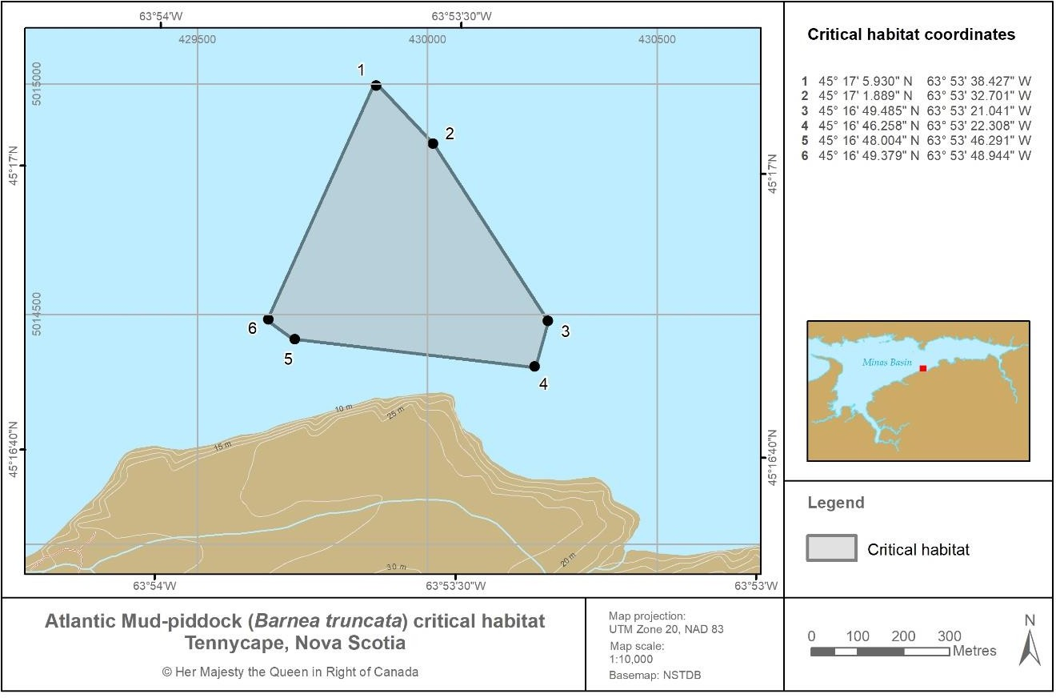
Figure 8. Red mudstone critical habitat at the Tennycape site.

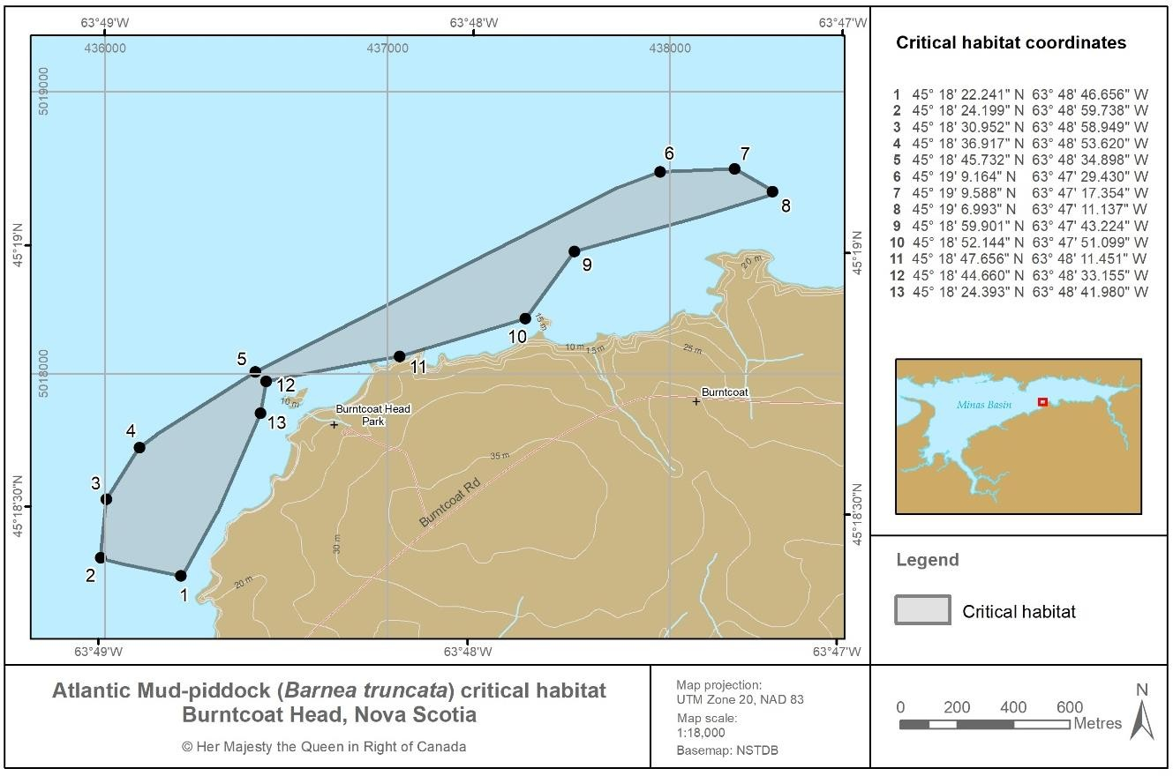
Figure 9. Red mudstone critical habitat at the Burntcoat Head site.
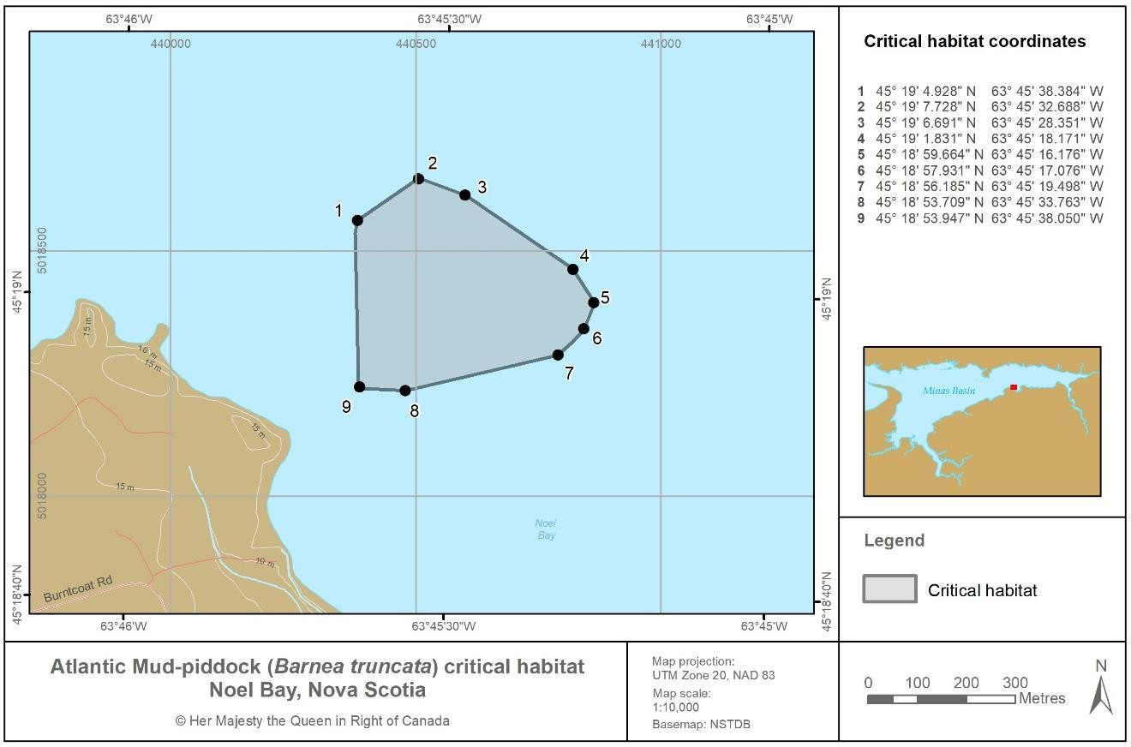
Figure 10. Red mudstone critical habitat at the Noel Bay site.

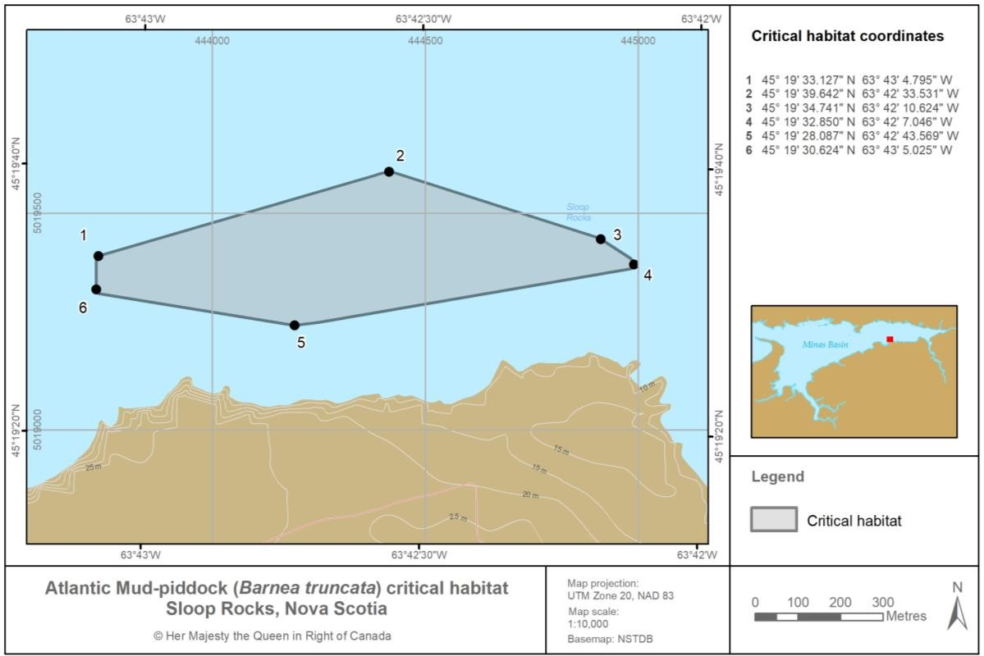
Figure 11. Red mudstone critical habitat at the Sloop Rocks site.
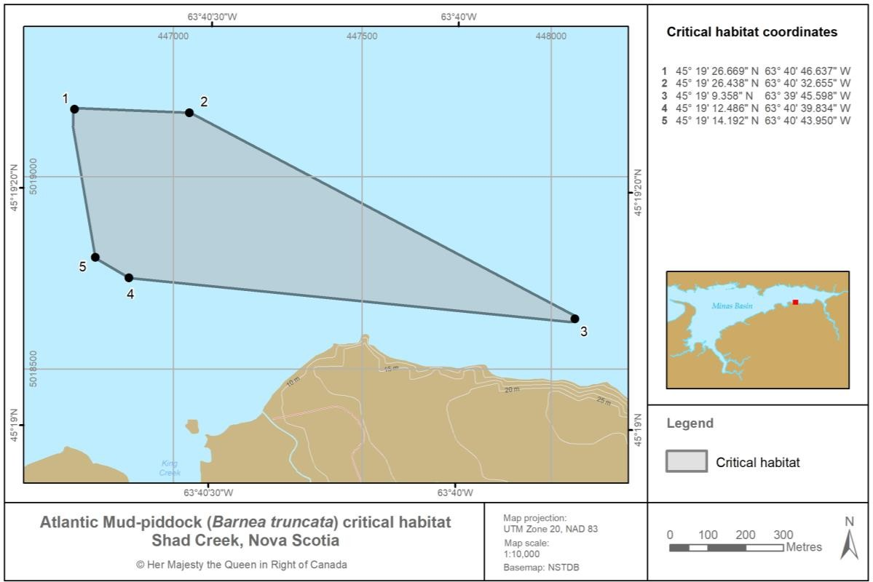
Figure 12. Red mudstone critical habitat at the Shad Creek site.

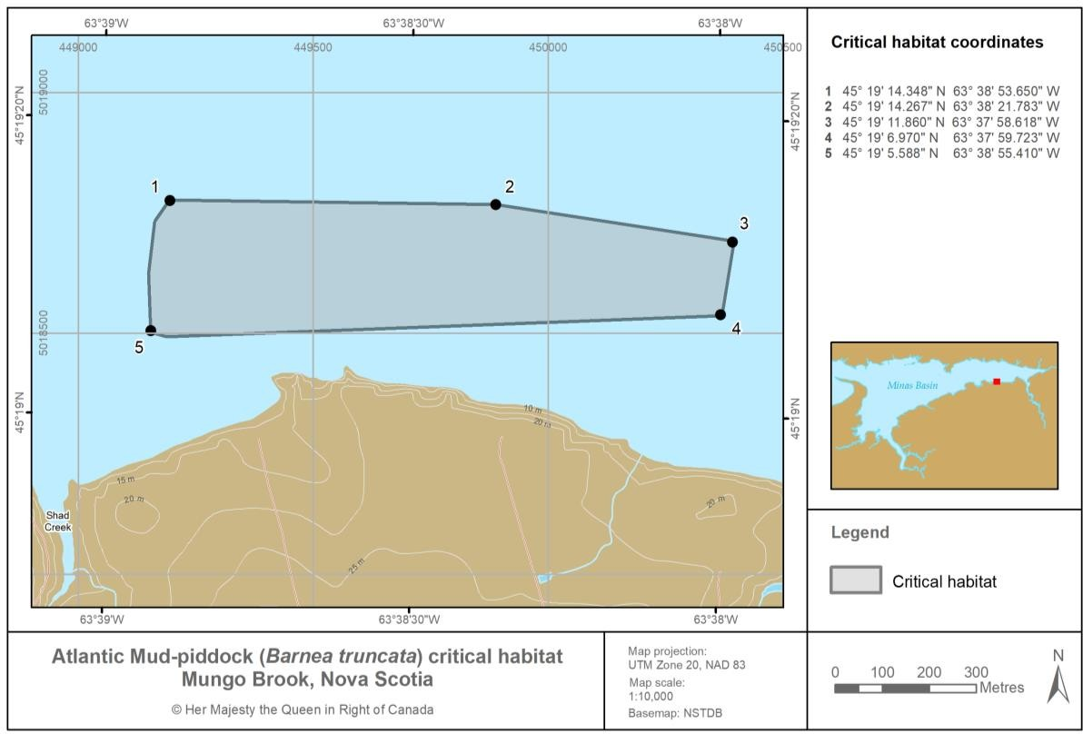
Figure 13. Red mudstone critical habitat at the Mungo Brook site.
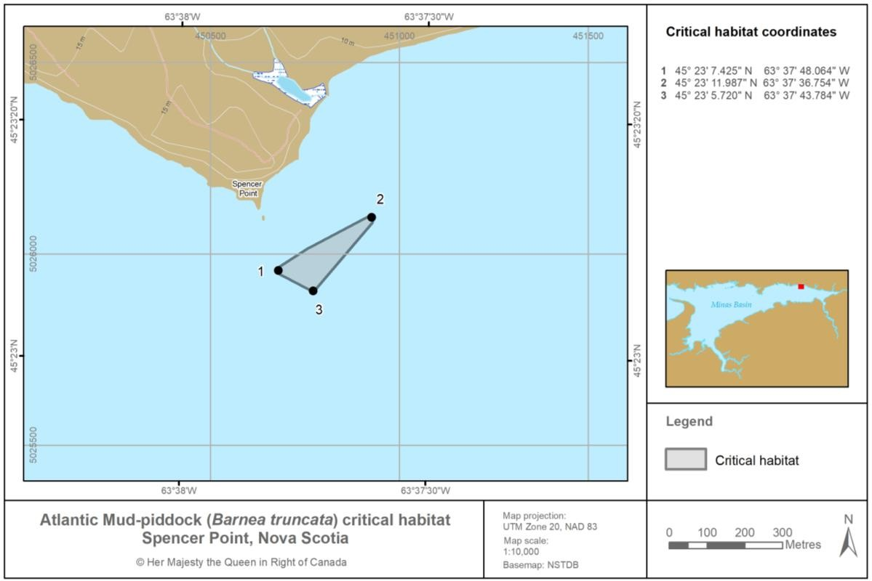
Figure 14. Red mudstone critical habitat at the Spencer Point site.

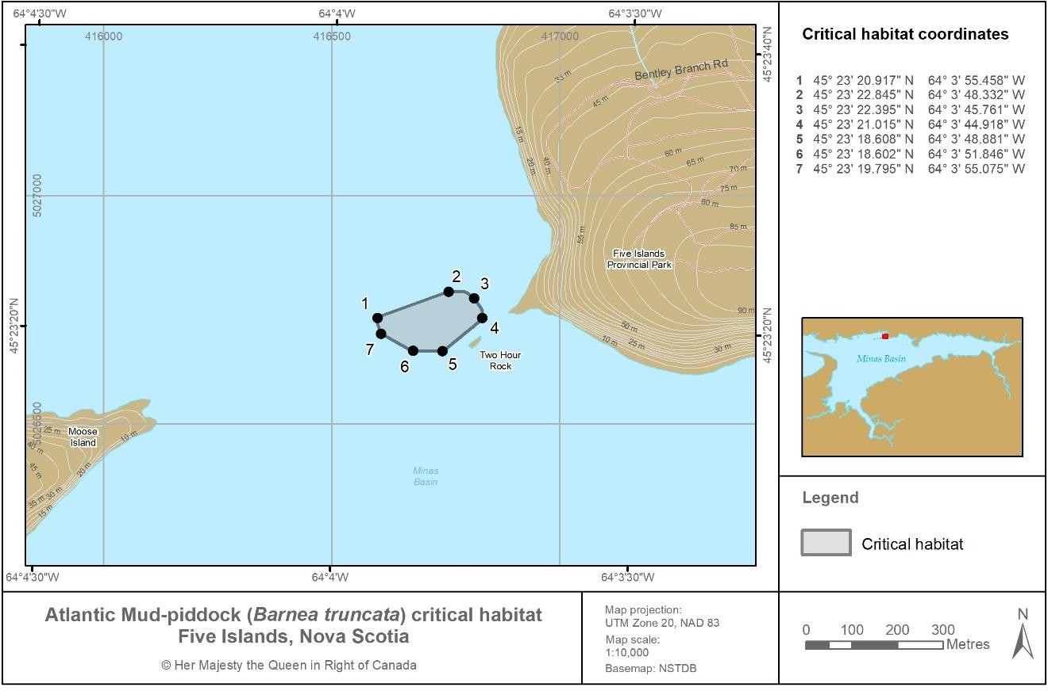
Figure 15. Red mudstone critical habitat at the Five Islands site.
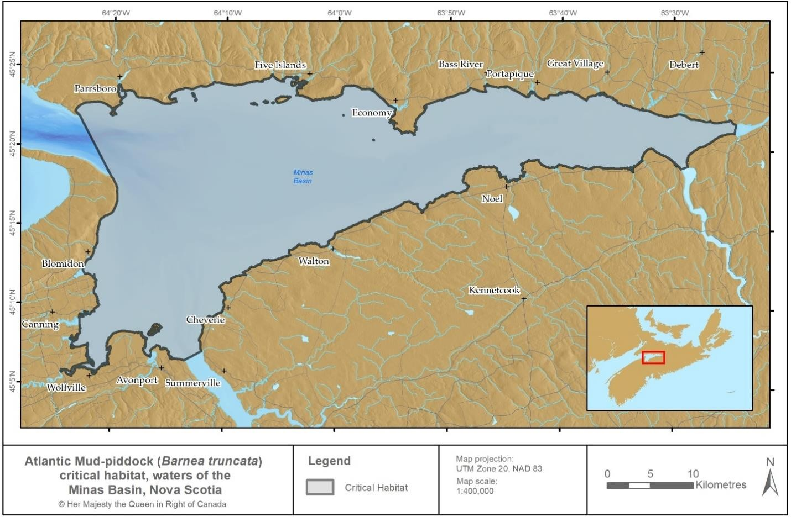
Figure 16. Water column critical habitat within the Minas Basin. See Appendix D for a list of coordinates.

Biophysical functions, features and attributes

Table 6 summarizes the best available knowledge of the functions, features, and attributes of critical habitat for each life stage of the Atlantic Mud-piddock. Note that not all attributes in table 6 must be present for a feature to be identified as critical habitat. If the features as described in table 6 are present and capable of supporting the associated function(s), the feature is considered critical habitat for the species, even though some of the associated attributes might be outside of the range indicated in the table.

Table 6. General summary of the biophysical functions, features, and attributes of critical habitat necessary for a species’ survival or recovery (adapted from Clark et al. 2019).
Life stage | Function⁶ | Feature(s)⁷ | Attribute(s)⁸
Egg | Egg development and growth | Water column in intertidal and subtidal zones | - Salinity in intertidal zone: 5 to 25 ppt  - Salinity in subtidal zone9: 20.0 to  29.5 ppt  - Temperature and oxygen levels within natural range of variation (0° to 21°C and ~5 mg/L)  - Sufficient water quality
Trochophore larva | Growth | Water column in intertidal and subtidal zones | - Salinity in intertidal zone: 5 to 25 ppt  - Salinity in subtidal zone: 20.0 to  29.5 ppt  - Temperature and oxygen levels within natural range of variation (0° to 21°C and ~5 mg/L)  - Sufficient water quality
Veliger larva | Settlement | Water column in intertidal and subtidal zones | - Salinity in intertidal zone: 5 to 25 ppt  - Salinity in subtidal zone: 20.0 to  29.5 ppt  - Temperature and oxygen levels within natural range of variation (0° to 21°C and ~5 mg/L)  - Sufficient water quality

6Function: a life-cycle process of the listed species taking place in critical habitat (for example, spawning, nursery, rearing, feeding and migration).
7Feature: the essential structural component that provides the requisite function(s) to meet the species’ needs. Features may change over time and usually consist of more than one part, or attribute. A change or disruption to the feature or any of its attributes may affect the function and its ability to meet the biological needs of the species.
8Attribute: measurable properties or characteristics of a feature. Attributes describe how the identified features support the identified functions necessary for the species’ life processes.
9 Salinity values for water in the subtidal zone are not specified in Clark et al. (2019), and are instead based upon DFO (2013).

Life stage | Function⁶ | Feature(s)⁷ | Attribute(s)⁸
 |  |  | - High slack tide for settlement
Veliger larva | Settlement | Red mudstone in the intertidal zone associated with the following habitat types: tide pools, rivulets, boulders/cobbles, and patches (water is present at high and low tide for these habitat types), and resistant capstone | - Available red mudstone surfaces to settle upon
Sub-adult | Boring and growth | Red mudstone in the intertidal zone associated with the following habitat types: tide pools, rivulets, boulders/cobbles, and patches (water is present at high and low tide for these habitat types), and resistant capstone | - Available red mudstone of sufficient depth (~5 cm) within which to bore and mature  - No rapid or significant accumulation of sediments
Sub-adult | Boring and growth | Water column in the intertidal zone | - Salinity: 5 to 25 ppt  - Temperature and oxygen levels within natural range of variation (0° to 21°C and ~5 mg/L)  - Sufficient water flushing to remove waste  - Sufficient water quality  - No rapid or significant accumulation of sediments
Adult | Growth | Red mudstone in the intertidal zone associated with the following habitat types: tide pools, rivulets, boulders/cobbles, and patches (water is present at high and low tide for these habitat types), and resistant capstone | - Red mudstone of sufficient depth (~5 cm) in which to grow  - No rapid or significant accumulation of sediments

Life stage | Function⁶ | Feature(s)⁷ | Attribute(s)⁸
 |  | Water column in the intertidal zone | - Salinity: 5 to 25 ppt  - Temperature and oxygen levels within natural range of variation (0° to 21°C and ~5 mg/L)  - No rapid or significant accumulation of sediments  - Sufficient water flushing to remove waste  - Sufficient water quality
Adult | Reproduction | Red mudstone in the intertidal zone associated with the following habitat types: tide pools, rivulets, boulders/cobbles, and patches (water is present at high and low tide for these habitat types), and resistant capstone | - Available mudstone from which adults can release eggs and sperm  - No rapid or significant accumulation of sediments
Adult | Reproduction | Water column in the intertidal zone | - Salinity: 5 to 25 ppt  - Oxygen levels within natural range of variation (~5 mg/L)  - Suitable temperature for external fertilization (exact temperature unknown)  - No rapid or significant accumulation of sediments  - Sufficient water quality  - Tidal flushing to allow egg fertilization and distribution
All (except egg) | Feeding | Food supply | - Sufficient quality and quantity of food (plankton and particulates)

Summary of critical habitat relative to population and distribution objectives

Based on the best available information, these are areas that the Minister of Fisheries and Oceans considers necessary to achieve the species’ population and distribution objectives required for the survival or recovery of the species.

Schedule of studies to identify critical habitat
Further research is required to identify critical habitat and refine the boundaries of the currently identified critical habitat. This additional work includes the studies in table 7.

Table 7. Schedule of studies to identify and refine critical habitat.

Description of study | Rationale | Timeline¹⁰
Habitat mapping via foot surveys to determine the amount of available and occupied habitat at inhabited and extirpated sites. | This will allow for comparisons of the extent of available and occupied habitat at known Atlantic Mud- piddock sites over time to characterize sites as either stable, increasing, or declining. | 5 years and ongoing
Habitat mapping using unmanned aerial vehicle (UAV) and high accuracy survey-grade GPS technology to identify potential suitable Atlantic Mud-piddock habitat. | This work will supplement foot surveys to inform characterization of habitat availability as either stable, increasing, or declining. This work will also help guide foot surveys.  Survey areas that have not previously been accurately assessed due to time and tidal constraints can also be mapped using UAV. | 5 years and ongoing
Conduct research on spawning to determine timing, concurrent water temperature, and other environmental determinants. | The habitat attributes required for spawning are unknown. This study is expected to improve understanding of habitat requirements and habitat use at the time of reproduction. | 5 years
Conduct research and modelling to refine understanding of temporal, spatial, and environmental features and attributes of critical habitat for the larval life stages. | Little is known about the habitat requirements and movement of larvae in the Minas Basin. Modelling larval distribution and mobility is expected to improve understanding of habitat use by larval life stages, as well as larval transfer between habitat sites throughout the Minas Basin. | 5 years

Activities likely to result in the destruction of critical habitat
Under SARA, critical habitat must be legally protected from destruction within 180 days of being identified in a recovery strategy or action plan and included in the Species at Risk Public Registry. Atlantic Mud-piddock critical habitat, once identified in a final recovery strategy, will be protected through a SARA Critical Habitat Order made under subsections 58(4) and (5), which will invoke the prohibition in subsection 58(1) against the destruction of any part of the identified critical habitat.

The following examples of activities likely to result in the destruction¹¹ of critical habitat (table 8) are based on known human activities that are likely to occur in and around critical habitat and

10 Timeline reflects the amount of time required for the study to be completed from the time the recovery strategy is published as final on the Species at Risk Public Registry.
11 Destruction occurs when there is a temporary or permanent loss of a function of critical habitat at a time when it is required by the species.

would result in the destruction of critical habitat if unmitigated. The list of activities is neither exhaustive nor exclusive and has been guided by the threats described in section 5. The absence of a specific human activity from this table does not preclude or restrict the Department’s ability to regulate that activity under SARA. Furthermore, the inclusion of an activity does not result in its automatic prohibition, and does not mean the activity will inevitably result in destruction of critical habitat. Every proposed activity must be assessed on a case-by- case basis and site-specific mitigation will be applied where it is reliable and available. Where information is available, thresholds and limits have been developed for critical habitat attributes to better inform management and regulatory decision making. However, in many cases knowledge of a species and its critical habitat’s thresholds of tolerance to disturbance from human activities is lacking and must be acquired.

Table 8. Examples of activities likely to result in the destruction of critical habitat.

Threat | Activity | Effect- pathway | Function(s) affected | Feature(s) affected | Attribute(s) affected
Climate change | - Global greenhouse gas emissions from human activities | - Increase in the frequency, length, and severity of storms and rainfall, causing disruption to sediment deposition, smothering of individuals, or reduced red mudstone availability  - Sea level rise causing reduced red mudstone availability due to increased shore erosion and beach migration  Greater fluctuations around annual means or colder winter temperatures negatively impacting Atlantic Mud-piddock persistence  - Increase in the volume and persistence of ice rafting in late winter and/or early spring causing reduced red mudstone availability through scouring of exposed red mudstone, or the collapse of protective capstone under the weight of ice  after ebb tides | - Egg development and growth  - Trochophore larva growth  - Veliger larva settlement  - Sub-adult boring and growth  - Adult growth  - Adult reproduction  - Larval, sub-adult, and adult feeding | - Water in intertidal and subtidal zones  - Red mudstone in the intertidal zone where water is present at high and low tide and is associated with the following habitat types: tide pools, rivulets, resistant capstones, boulders/cobbles, patches  - Food supply | - Temperature and oxygen levels within natural range of variation (0° to 21°C and ~5 mg/L)  - Suitable temperature for external fertilization  - Available red mudstone surfaces upon which to settle, and within which to bore, mature, and reproduce  - Red mudstone of sufficient depth (~5 cm) in which to grow  - No rapid or significant accumulation of sediments  - Sufficient quality and quantity of food  - Salinity in intertidal zone: 5 to 25 ppt  - Salinity in subtidal zone: 20.0 to 29.5 ppt  - Sufficient water quality

Threat | Activity | Effect- pathway | Function(s) affected | Feature(s) affected | Attribute(s) affected
Alteration of shoreline or water control structures | - Dredging  - Construction of coastal infrastructure (for example, marina, wharf)  - Installation of shoreline- modifying structures (for example, breakwater, stone rip-rap)  - Construction, alteration, or removal of water-control or water-crossing structures (for example, causeways,  dams, aboiteaux) | - Current alteration, causing reduced red mudstone availability or smothering through siltation events | - Veliger larva settlement  - Sub-adult boring and growth  - Adult growth  - Adult reproduction | - Red mudstone in the intertidal zone where water is present at high and low tide and is associated with the following habitat types: tide pools, rivulets, resistant capstones, boulders/cobbles, patches | - Available red mudstone surfaces upon which to settle, and within which to bore, mature, and reproduce  - No rapid or significant accumulation of sediments  - Sufficient water flushing to remove waste
Mineral exploration or extraction activities in Minas Basin and nearby rivers | - Dredging | - Disruption of sediments, causing reduced red mudstone availability or smothering through sedimentation events | - Veliger larva settlement  - Sub-adult boring and growth  - Adult growth  - Adult reproduction | - Red mudstone in the intertidal zone where water is present at high and low tide and is associated with the following habitat types: tide pools, rivulets, resistant capstones, boulders/cobbles, patches | - Available red mudstone surfaces upon which to settle, and within which to bore, mature, and reproduce  - No rapid or significant accumulation of sediments  - Sufficient water  flushing to remove waste

Threat | Activity | Effect- pathway | Function(s) affected | Feature(s) affected | Attribute(s) affected
Large-scale tidal energy extraction | - Deployment and operation of tidal power turbines within the Minas Basin for energy extraction | - Alteration of tidal, and thus sedimentation regimes within the Minas Basin, reducing red mudstone availability and altering tidal flushing | - Veliger larva settlement  - Sub-adult boring and growth  - Adult growth  - Adult reproduction  - Larval, sub-adult, and adult feeding | - Red mudstone in the intertidal zone where water is present at high and low tide and is associated with the following habitat types: tide pools, rivulets, resistant capstones, boulders/cobbles, patches  - Water in intertidal and subtidal zones  - Food supply | - No rapid or significant accumulation of sediments  - Available red mudstone surfaces upon which to settle, and within which to bore, mature, and reproduce  - Sufficient water flushing to remove waste  - Tidal flushing to allow egg fertilization and distribution
Sources of pollution, including point and non-point source pollution | - Agricultural activities leading to run- off (for example, pesticides, animal waste)  - Urban activities leading to run- off  - Industrial activities with point source pollution | - Introduction of pollutants, resulting in reduction in water quality and food availability | - Egg development and growth  - Trochophore larva growth  - Veliger larva settlement  - Sub-adult boring and growth  - Adult growth  - Adult reproduction  - Larval, sub-adult, and adult feeding | - Water in intertidal and subtidal zones | - Oxygen levels within natural range of variation (0° to 21°C and ~5 mg/L)  - Sufficient water quality  - Sufficient quality and quantity of food  - Salinity in intertidal zone: 5 to 25 ppt Salinity in subtidal zone: 20.0 to 29.5 ppt

Threat | Activity | Effect- pathway | Function(s) affected | Feature(s) affected | Attribute(s) affected
Recreation and adventure sport activities | - Running events  - Biking events  - All terrain- vehicle use | - Frequent or intense site use resulting in degradation of substrate and reduced red mudstone availability | - Veliger larva settlement  - Sub-adult growth and boring  - Adult growth  - Adult reproduction | - Red mudstone in the intertidal zone where water is present at high and low tide and is associated with the following habitat types: tide pools, rivulets, resistant capstones, boulders/cobbles,  patches | - Available red mudstone surfaces upon which to settle, bore, mature, and reproduce  - Red mudstone of sufficient depth (~5 cm) in which to grow

Measuring progress
The performance indicators presented below provide a way to define and measure progress toward achieving the population and distribution objectives.

- The amount of live observations, or evidence of live occupation, is maintained overtime
- The total area and distribution of suitable habitat is maintained over time

A successful recovery program will achieve the overall aim of maintaining both a stable population and suitable habitat in the Minas Basin. Progress towards meeting these objectives will be reported on in the Report on the Progress of Recovery Strategy Implementation.

Statement on action plans
The federal government’s approach to recovery planning is a two-part approach, the first part being the recovery strategy and the second part being the action plan. An action plan contains specific recovery measures or activities required to meet the objectives outlined in the recovery strategy.

An action plan for Atlantic Mud-piddock will be completed within five years of posting the final recovery strategy.

References

Ashmore, P., and M. Church. 2001. The impact of climate change on rivers and river processes in Canada. Geological Survey of Canada, Bulletin 555:58 pp.

Canadian Hydrographic Service. April 30, 2014. Inner Bay of Fundy, critical salmon habitat: Areas 2 and 8 delimitation. Canadian Hydrographic Service, Hydrography. Internal report by Serge Lévesque. 14pp.

Chanley, P.E. 1965. Larval development of a boring clam, Barnea truncata. Chesapeake Science 6(3):162-166.

Clark, C.M., A. Hebda, G. Jones, S. Butler, and G. Pardy. 2019. Identification of Atlantic Mud- piddock Habitat in Canadian Waters. DFO Can. Tech. Rep. Fish. Aquat. Sci. 3295. iv + 42 p.

COSEWIC. 2009. COSEWIC assessment and status report on the Atlantic Mud-piddock Barnea truncata in Canada. Committee on the Status of Endangered Wildlife in Canada. Ottawa. vii + 42 pp.

DFO. 2019. Threat Assessment for Atlantic Mud-piddock (Barnea truncata), Canadian Population. DFO Can. Sci. Advis. Sec. Sci. Resp. 2019/033.

DFO. 2018. Delineating Important Ecological Features of the Evangeline-Cape Blomidon-Minas Basin Ecologically and Biologically Significant Area (EBSA). DFO Can. Sci. Advis. Sec. Sci. Resp. 2018/005.

DFO. 2016. Review of a method for Identifying a Window of Principle Striped Bass (Morone saxatilis) Spawning in the Shubenacadie River Estuary. Can. Sci. Advi. Sec. Sci. Resp. 2016/026.

DFO. 2015. Support for Delineation of Inner Bay of Fundy Salmon Marine Critical Habitat Boundaries in Minas Basin and Chignecto Bay. DFO Can. Sci. Advis. Sec. Sci. Resp. 2015/035.

DFO. 2014. Guidance on Assessing Threats, Ecological Risk and Ecological Impacts for Species at Risk. DFO Can. Sci. Advis. Sec. Sci. Advis. Rep. 2014/013. (Erratum: June 2016).

DFO. 2013. Important Marine and Estuarine Habitat of Inner Bay of Fundy Atlantic Salmon.
DFO Can. Sci. Advis. Sec. Sci. Advis. Rep. 2013/054.

DFO. 2010. Recovery Potential Assessment for Atlantic Mud-piddock (Barnea truncata). DFO Can. Sci. Advis. Sec. Sci. Advis. Rep. 2010/068.

Forbes, D.L., J. Shaw, and R.B. Taylor. 1997. Climate change impacts in the coastal zone of Atlantic Canada. Climate Change and Climate Variability in Atlantic Canada, Occasional Report of Environment Canada 9:37-58.

Government of Canada. 2009. Species at Risk Act Policies [Draft]. Species at Risk Act, Policies and Guidelines Series. Ottawa, Ontario. Environment Canada. 48 pp.

Hebda, A., pers. comm, 2019. Email correspondence with Katherine Hastings. March 2019.
Zoology Curator. Museum of Natural History. Halifax, Nova Scotia.

Hebda, A. 2011. Information in Support of a Recovery Potential Assessment of Atlantic Mud- piddock (Barnea truncata) in Canada. DFO Can. Sci. Advis. Sec. Res. Doc. 2010/117: vi
+ 30 p.

MolluscaBase. 2019. MolluscaBase. Barnea Risso, 1826. Accessed through: World Register of Marine Species. Accessed July 2019.

NatureServe. 2021. NatureServe Explorer [web application]. NatureServe, Arlington, Virginia. (Accessed: February 15, 2021).

NRCAN (Natural Resources Canada). 2009. The atlas of Canada. Coastal sensitivity to sea- level rise.

Owens, E.H. 1977. Coastal Environments, Oil Spills and Clean-up Programs in the Bay of Fundy. Economic and Technical Review Report EPS 3-EC-77-9, Environment Canada, Ottawa, 175 p.

Roddick, D., and C.M. Clark. 2019. Initial Methods for Ageing Atlantic Mud-piddock (Barnea truncata). DFO Can. Tech. Rep. Fish. Aquat. Sci. 3312. iv + 26 p.

Ryan, S.A., G. Wohlgeschaffen, N. Jahan, H. Niu, A.C. Ortmann, T.N. Brown, T.L. King, and J. Clyburne. 2019. State of Knowledge on Fate and Behaviour of Ship-Source Petroleum Product Spills: Volume 2, Saint John and Bay of Fundy, New Brunswick. Can. Manuscr. Rep. Fish. Aquat. Sci. 3176: x + 67 p

Turner, R.D. 1954. The family Pholadidae in the Western Atlantic and the Eastern Pacific. Part 1: Pholadinae. Johnsonia 3: 1–64.

Appendix A: effects on the environment and other species
In accordance with the Cabinet Directive on the Environmental Assessment of Policy, Plan and Program Proposals (2010), Species at Risk Act (SARA) recovery planning documents incorporate strategic environmental assessment (SEA) considerations throughout the document. The purpose of a SEA is to incorporate environmental considerations into the development of public policies, plans, and program proposals to support environmentally sound decision-making and to evaluate whether the outcomes of a recovery planning document could affect any component of the environment or achievement of any of the Federal Sustainable Development Strategy’s (FSDS) goals and targets.

Recovery planning is intended to benefit species at risk and biodiversity in general. However, it is recognized that strategies and critical habitat identified may also inadvertently lead to environmental effects beyond the intended benefits. The planning process based on national guidelines directly incorporates consideration of all environmental effects, with a particular focus on possible impacts upon non-target species or habitats. The results of the SEA are incorporated directly into the strategy itself, but are also summarized below.

This recovery strategy will benefit the environment by promoting the survival of Atlantic Mud- piddock and the preservation of a unique piece of Canadian biodiversity. Other aquatic organisms in the Minas Basin are also expected to benefit from the measures taken to mitigate threats to Atlantic Mud-piddock, especially threats to water quality and habitat. Conserving biodiversity within Canadian waters helps to encourage the resiliency of various North Atlantic Ocean ecosystems.

Implementation of this recovery strategy is expected to contribute to achieving the following 2019 to 2022 FSDS goals:

- Healthy Coasts And Oceans: Coasts and oceans support healthy, resilient and productive ecosystems
- Healthy Wildlife Populations: All species have healthy and viable populations
- Connecting Canadians With Nature: Canadians are informed about the value of nature, experience nature first hand, and actively engage in its stewardship

The potential for this recovery strategy to inadvertently lead to adverse effects on other species was considered, and it was determined such effects are unlikely.

Appendix B: record of cooperation and consultation
Recovery strategies are to be prepared in cooperation and consultation with other jurisdictions, organizations, affected parties, and others as outlined in the Species at Risk Act (SARA) section
39. An early engagement workshop was held at the Bedford Institute of Oceanography in Dartmouth, Nova Scotia on June 15, 2018. The purpose of the workshop was to collaborate on setting the recovery direction for the Atlantic Mud-piddock and provide a forum for sharing ideas on potential research and management approaches to achieve recovery. Input from this workshop has been considered in the development of this recovery strategy. Invitations to attend the workshop were extended to government departments, First Nations and other Indigenous organizations, industry, and non-government organizations. Workshop participants included representatives from the following groups:

Bird Studies Canada Burntcoat Head Park
Fundy United Federation / Weir fish harvesters Maritime Aboriginal Peoples Council
Mi’kmaw Conservation Group Nova Scotia Department of Energy Nova Scotia Museum
Saint Mary’s University
University of New Brunswick, Saint John

A draft version of the recovery strategy was sent to relevant government departments (federal and provincial), Indigenous organizations, and stakeholders for a targeted external review period held from July 28, 2021 to September 13, 2021. Feedback from this external review period was considered and incorporated into the proposed recovery strategy where appropriate.

Additional stakeholder, Indigenous, and public comments will be sought through the publication of the proposed document on the Species at Risk Public Registry for a 60-day public comment period. Comments received will inform the final document.

Appendix C: threat assessment categories

Likelihood of occurrence | Definition
Known or very likely to occur | This threat has been recorded to occur 91 to 100%
Likely to occur | There is 51 to 90% chance that this threat is or will be occurring.
Unlikely | There is 11 to 50% chance that this threat is or will be occurring
Remote | There is 1 to 10% or less chance that this threat is or will be occurring.
Unknown | There are no data or prior knowledge of this threat occurring now or in the future.

Level of impact | Definition
Extreme | Severe population decline (for example, 71 to 100%) with the potential for extirpation.
High | Substantial loss of population (31 to 70%) or  Threat would jeopardize the survival or recovery of the population.
Medium | Moderate loss of population (11 to 30%) or  Threat is likely to jeopardize the survival or recovery of the population.
Low | Little change in population (1 to 10%) or  Threat is unlikely to jeopardize the survival or recovery of the population.
Unknown | No prior knowledge, literature or data to guide the assessment of threat severity on population.

Causal certainty | Definition
Very high | Very strong evidence that threat is occurring and the magnitude of the impact to the population can be quantified.
High | Substantial evidence of a causal link between threat and population decline or jeopardy to survival or recovery
Medium | There is some evidence linking the threat to population decline or jeopardy to survival or recovery
Low | There is a theoretical link with limited evidence that threat is leading to a population decline or jeopardy to survival or recovery
Very low | There is a plausible link with no evidence that the threat is leading to a population decline or jeopardy to survival or recovery

Threat occurrence | Definition
Historical | A threat that is known to have occurred in the past and negatively impacted the population.
Current | A threat that is ongoing, and is currently negatively impacting the population.
Anticipatory | A threat that is anticipated to occur in the future, and will negatively impact the population.

Threat frequency | Definition
Single | The threat occurs once.
Recurrent | The threat occurs periodically, or repeatedly.
Continuous | The threat occurs without interruption.

Threat extent | Definition
Extensive | 71 to 100% of the population is affected by the threat.
Broad | 31 to 70% of the population is affected by the threat.
Narrow | 11 to 30% of the population is affected by the threat.
Restricted | 1 to 10% of the population is affected by the threat.

Appendix D: water column critical habitat coordinates
The coordinates below indicate critical habitat boundaries for the waters of the Minas Basin at major waterways, as well as bounding points for the western extent of the Minas Basin. For each pair of coordinates, critical habitat is bounded by a straight line drawn between the coordinates.

Water feature name | Latitude | Longitude
Avon River | 45° 6' 31.324" N | 64° 13' 26.971" W
Avon River | 45° 7' 7.156" N | 64° 11' 55.178" W
Bass Creek (Cambridge) | 45° 11' 57.748" N | 64° 8' 3.999" W
Bass Creek (Cambridge) | 45° 11' 57.000" N | 64° 8' 2.953" W
Bass Creek (Medford) | 45° 10' 44.611" N | 64° 21' 34.723" W
Bass Creek (Medford) | 45° 10' 39.623" N | 64° 21' 32.904" W
Bass River | 45° 24' 4.768" N | 63° 46' 56.677" W
Bass River | 45° 24' 3.943" N | 63° 46' 52.171" W
Bass River of Five Islands | 45° 24' 29.231" N | 64° 3' 40.511" W
Bass River of Five Islands | 45° 24' 30.056" N | 64° 3' 44.828" W
Bear Brook | 45° 17' 26.884" N | 63° 48' 27.648" W
Bear Brook | 45° 17' 28.140" N | 63° 48' 26.588" W
Big Creek | 45° 9' 21.799" N | 64° 22' 22.273" W
Big Creek | 45° 9' 20.831" N | 64° 22' 26.761" W
Cambridge Creek | 45° 12' 38.154" N | 64° 6' 46.724" W
Cambridge Creek | 45° 12' 39.504" N | 64° 6' 44.491" W
Canard River | 45° 7' 28.609" N | 64° 23' 27.964" W
Canard River | 45° 7' 34.920" N | 64° 23' 24.382" W
Cornwallis River | 45° 5' 44.820" N | 64° 24' 25.596" W
Cor Cornwallis River nwallis River | 45° 5' 41.505" N | 64° 24' 22.126" W
Doyle Brook | 45° 12' 49.066" N | 64° 22' 3.175" W
Doyle Brook | 45° 12' 49.498" N | 64° 21' 58.671" W
East Branch Moose River | 45° 24' 3.086" N | 64° 11' 12.053" W
East Branch Moose River | 45° 24' 4.638" N | 64° 11' 11.492" W
East Noel River | 45° 18' 23.516" N | 63° 43' 21.349" W
East Noel River | 45° 18' 21.245" N | 63° 43' 25.835" W
East River | 45° 24' 13.014" N | 64° 2' 53.729" W
East River | 45° 24' 14.985" N | 64° 3' 1.024" W
Economy River | 45° 22' 34.778" N | 63° 54' 52.620" W
Economy River | 45° 22' 43.659" N | 63° 55' 24.977" W
Folly River | 45° 22' 34.883" N | 63° 32' 26.542" W
Folly River | 45° 22' 33.038" N | 63° 32' 15.706" W
Gaspereau River | 45° 6' 42.702" N | 64° 16' 27.636" W
Gaspereau River | 45° 7' 2.000" N | 64° 16' 22.710" W
Great Village River | 45° 23' 39.705" N | 63° 36' 42.932" W

Water feature name | Latitude | Longitude
Gr Great Village River eat Village River | 45° 23' 40.765" N | 63° 36' 37.443" W
Habitant Creek | 45° 9' 3.393" N | 64° 22' 49.369" W
Habitant Creek | 45° 8' 41.817" N | 64° 22' 47.492" W
Harrington River | 45° 24' 38.152" N | 64° 5' 56.519" W
Harrington River | 45° 24' 36.683" N | 64° 5' 53.323" W
Johnson Cove | 45° 10' 27.971" N | 64° 9' 48.953" W
Johnson Cove | 45° 10' 28.316" N | 64° 9' 48.823" W
King Creek | 45° 18' 55.361" N | 63° 40' 39.569" W
King Creek | 45° 18' 59.313" N | 63° 40' 30.467" W
Little Bass River | 45° 23' 54.929" N | 63° 48' 15.603" W
Little Bass River | 45° 23' 55.664" N | 63° 48' 15.100" W
Little Rainy Brook | 45° 13' 0.819" N | 64° 5' 3.184" W
Little Rainy Brook | 45° 13' 1.366" N | 64° 5' 1.418" W
Mill Brook | 45° 23' 34.251" N | 63° 40' 21.367" W
Mill Brook | 45° 23' 35.633" N | 63° 40' 19.967" W
Mill Creek Brook | 45° 13' 33.396" N | 64° 21' 36.687" W
Mill Creek Brook | 45° 13' 33.788" N | 64° 21' 32.622" W
Minas Basin (western extent) | 45° 18' 0.050" N | 64° 20' 8.272" W
Minas Basin (western extent) | 45° 21' 53.526" N | 64° 23' 6.780" W
Moose Brook | 45° 17' 16.828" N | 63° 49' 3.295" W
Moose Brook | 45° 17' 17.637" N | 63° 49' 8.746" W
Mungo Brook | 45° 18' 51.844" N | 63° 37' 46.382" W
Mungo Brook | 45° 18' 51.663" N | 63° 37' 43.938" W
Noel Bay 1 | 45° 18' 6.582" N | 63° 44' 0.876" W
Noel Bay 1 | 45° 18' 7.054" N | 63° 43' 58.940" W
Noel Bay 2 | 45° 18' 12.833" N | 63° 43' 46.240" W
Noel Bay 2 | 45° 18' 13.478" N | 63° 43' 45.679" W
Noel River 1 | 45° 18' 3.268" N | 63° 44' 53.111" W
Noel River 1 | 45° 18' 2.313" N | 63° 44' 52.570" W
Noel River 2 | 45° 17' 59.702" N | 63° 44' 47.834" W
Noel River 2 | 45° 17' 59.556" N | 63° 44' 45.449" W
Noel River 3 | 45° 18' 1.052" N | 63° 44' 41.207" W
Noel River 3 | 45° 18' 0.333" N | 63° 44' 40.574" W
Noel River 4 | 45° 18' 0.036" N | 63° 44' 37.153" W
Noel River 4 | 45° 18' 2.958" N | 63° 44' 35.580" W
North River | 45° 24' 19.963" N | 64° 4' 57.934" W
North River | 45° 24' 24.011" N | 64° 4' 48.618" W
Parrsboro Harbour | 45° 23' 51.168" N | 64° 19' 31.712" W
Parrsboro Harbour | 45° 23' 50.511" N | 64° 19' 26.614" W
Pereaux Creek | 45° 12' 8.671" N | 64° 22' 35.450" W
Pereaux Creek | 45° 11' 51.534" N | 64° 22' 23.040" W

Water feature name | Latitude | Longitude
Portapique River 1 | 45° 23' 35.228" N | 63° 42' 25.630" W
Portapique River 1 | 45° 23' 38.577" N | 63° 42' 27.379" W
Portapique River 2 | 45° 23' 37.432" N | 63° 42' 53.690" W
Portapique River 2 | 45° 23' 39.398" N | 63° 42' 52.239" W
Rainy Cove Brook | 45° 13' 14.118" N | 64° 4' 6.524" W
Rainy Cove Brook | 45° 13' 13.927" N | 64° 4' 7.213" W
Salmon River | 45° 21' 7.917" N | 63° 24' 34.921" W
Salmon River | 45° 21' 42.891" N | 63° 24' 26.986" W
Selma Brook | 45° 19' 27.235" N | 63° 32' 47.899" W
Selma Brook | 45° 19' 25.155" N | 63° 32' 47.153" W
Shad Creek | 45° 24' 26.230" N | 64° 4' 0.402" W
Shad Creek | 45° 24' 24.906" N | 64° 4' 2.296" W
Shad Creek Brook | 45° 18' 55.760" N | 63° 39' 7.642" W
Shad Creek Brook | 45° 18' 55.627" N | 63° 39' 3.006" W
Shubenacadie River | 45° 18' 53.975" N | 63° 29' 21.933" W
Shubenacadie River | 45° 19' 1.941" N | 63° 28' 44.963" W
Swan Creek | 45° 23' 9.304" N | 64° 15' 8.190" W
Swan Creek | 45° 23' 9.312" N | 64° 15' 9.522" W
Unamed Watercourse - Oak Point | 45° 9' 21.512" N | 64° 21' 58.372" W
Unamed Watercourse - Oak Point | 45° 9' 22.418" N | 64° 21' 56.813" W
Unnamed Watercourse - Economy Point | 45° 21' 39.202" N | 63° 54' 54.845" W
Unnamed Watercourse - Economy Point | 45° 21' 39.817" N | 63° 54' 54.975" W
Walton River | 45° 13' 52.297" N | 64° 0' 49.367" W
Walton River | 45° 14' 0.559" N | 64° 0' 41.914" W

Appendix E: glossary
Aboiteaux: found in the bases of dykes and constructed of wooden sluices fitted with swinging doors that allow excess fresh water to drain from newly claimed land, but shut to prevent re- entry of salt water at high tide.

Age structure: a summary of the number of individuals of each age in a population.

Anthropogenic: relating to or resulting from the influence of humans.

Attribute: in reference to critical habitat, attributes are measurable properties or characteristics of a feature. Attributes describe how the identified features support the identified functions necessary for the species’ life processes.

Brine: a highly concentrated solution of salt in water.

Causal certainty: the strength of evidence linking the threat to the survival and recovery of the population.

Disjunct: disjoined and distinct from one another.

Ebb tide: the period between high tide and low tide during which water flows away from the shore.

Extirpated: a wildlife species that no longer exists in the wild in Canada, but continues to exist elsewhere in the wild.

Facies: the character of a rock expressed by its formation, composition, and fossil content.

Feature: in reference to critical habitat, features describe the essential structural component that provides the requisite function(s) to meet the species’ needs. Features may change over time and are usually comprised of more than one part, or attribute. A change or disruption to the feature or any of its attributes may affect the function and its ability to meet the biological needs of the species.

Function: in reference to critical habitat , function refers to a life-cycle process of the listed species taking place in critical habitat (for example, spawning, nursery, rearing, feeding and migration).

Level of impact: the magnitude of the impact caused by a given threat, and the level to which it affects the survival or recovery of the population.

Likelihood of occurrence: the probability of a specific threat occurring over 10 years or 3 generations, whichever is shorter.

Non-point source pollution: pollution resulting from many diffuse sources.
Population dynamics: the study of the age and size of populations and the factors involved in their maintenance, decline, and expansion.

Recruitment: the increase in a natural population as progeny grow and immigrants arrive.

Rescue effect: the immigration of gametes or individuals that have a high probability of reproducing successfully, such that extirpation or decline of a wildlife species can be mitigated.

Slack tide: the short period in a body of tidal water when there is no movement either way in the tidal stream, and which occurs before the direction of the tidal stream reverses.

Sub-adult: an individual who has passed through the juvenile period but has not yet attained typical adult characteristics.

Threat: any activity or process (both natural and anthropogenic) that has caused, is causing, or may cause harm, death, or behavioural changes to a species at risk or the destruction, degradation, and/or impairment of its habitat to the extent that population-level effects occur.

Threatened: a wildlife species that is likely to become an endangered species if nothing is done to reverse the factors leading to its extirpation or extinction.

Threat extent: the proportion of the population affected by the threat.

Threat frequency: the temporal extent of the threat over the next 10 years or three generations, whichever is shorter.

Threat occurrence: refers to the timing of the occurrence of the threat, and describes whether a threat is historical, current and/or anticipatory.

Threat risk: the product of likelihood and level of impact as determined using a risk matrix approach.

Triassic-age: pertaining to the period of the Mesozoic Era, occurring from 230 to 190 million years ago.

Trochophore: the planktonic larva of certain invertebrates, including some molluscs and polychaete worms, having a roughly spherical body, a band of cilia, and a spinning motion.

Veliger: larva typical of certain molluscs such as marine snails and bivalves and a few freshwater bivalves. The veliger develops from the trochophore larva and has large, ciliated lobes (velum).

Year class: all the young of a given species produced during one year.

