“Updated Escapement Estimate Type Classification Guidance”
Abstract
NuSEDS (New Salmon Escapement Database System) estimate Types 1–6 are used throughout the Pacific Region as a concise indicator of estimate interpretability for downstream uses (e.g., stock assessment and Wild Salmon Policy status workflows). In practice, Type assignment has varied across programs because historical guidance does not explicitly address several common complications such as incomplete run-window coverage, outages and missed observation, breach/bypass at counting sites, visibility constraints, and incomplete documentation. This technical report updates the Type 1–6 guidance by operationalizing the intent of Kim Hyatt’s 1997 classification key as a property-first decision sequence. The updated key separates enumeration (field) methods from estimation (analysis) methods, defines method families, and records standardized qualifier codes that explain conservative downgrades related to timing, coverage/uptime, breach/bypass, visibility, documentation, and quantified uncertainty (e.g., CV/SE). The report also identifies a minimal set of metadata elements needed for interpretable Type assignment in NuSEDS, with an emphasis on Stream Escapement Narratives (SENs) and controlled vocabularies for downgrade criteria and uncertainty metrics. Adoption of this guidance is expected to improve cross-program consistency, increase transparency of classification decisions, and support more defensible downstream use of escapement estimates.

Introduction
The New Salmon Escapement Database System (NuSEDS) stores salmon spawner survey records, spawner abundance estimates, and linkages between them for Pacific Region salmon populations (Fisheries and Oceans Canada 2016). In NuSEDS, estimate Types 1–6 are used as a shorthand indicator of interpretability for downstream uses such as stock assessment and Wild Salmon Policy workflows.
In practice, Type assignment has varied across programs and areas because the historical table-only guidance does not fully specify how to treat incomplete coverage, uncertain methods, and other recurring real-world complications.
This update was prompted by inconsistent application across operational teams, which leads to inconsistent reporting in NuSEDS and increases the risk of downstream misinterpretation—especially near screening thresholds used in rapid status workflows (Holt et al. 2009).

Purpose and scope
The purpose of this technical report is to provide forward, implementation-ready guidance for assigning NuSEDS estimate Types 1–6 in a way that is reproducible and interpretable to downstream data users.
This report:
- documents the decision logic for assigning Types 1–6 (including explicit conservative qualifier codes);
- clarifies evidence expectations for common operational complications;
- identifies a minimal set of metadata elements needed for interpretable Type assignment, with an emphasis on Stream Escapement Narratives (SENs) used to support NuSEDS uploads and review; and
- provides canonical roll-ups and mapping guidance for enumeration and estimate methods (including legacy-to-canonical term reconciliation) to support consistent use in NuSEDS (Appendix 8).
This report does not re-estimate escapement, evaluate biological status, or replace program-specific expert judgement.

Hyatt (1997) intent and foundation
Hyatt (1997) developed a draft, hierarchical escapement classification key intended to be “unambiguous, easy to apply and reliable” for both field personnel and informed data users (Hyatt 1997). Hyatt emphasized that the key should support:
- Repeatability: classifications should be repeatable among users given the same information;
- Planning and review: use both before surveys (planning) and after surveys (reporting/quality control); and
- Retrospective use: application to historic estimates stored in the regional database to differentiate mixtures of unqualified estimates with unknown utility (Hyatt 1997).
Hyatt framed classification around three linked dimensions: (i) properties of the survey and analytical methods used, (ii) statistical properties of the resulting estimate (units, accuracy, and precision), and (iii) the level of documentation supporting interpretation (Hyatt 1997). The NuSEDS estimate-type table is derived from this foundation. This report does not reproduce Hyatt’s original draft key verbatim; instead, it operationalizes Hyatt’s intent as a property-first decision sequence that can be applied consistently to contemporary workflows.

Estimate type summary (Types 1–6)
Table summarizes Types 1–6 for orientation. Types summarize interpretability given method properties, uncertainty evidence, and documentation; they do not guarantee unbiasedness.
Table 1: High-level summary of estimate Types 1–6 for orientation.
Type | Label | Units | Interpretation
1 | Census / near-census (high resolution) | Absolute abundance | A direct count (or near-census) with high confidence that missed fish are negligible or well constrained.
2 | Absolute abundance estimate (qualified) | Absolute abundance (often with uncertainty) | A standardized estimation method producing absolute abundance with qualified accuracy and, where available, quantified precision.
3 | Relative abundance index (high resolution) | Relative units (index; within-series) | A consistent, high-effort index that supports within-series comparisons; absolute abundance and uncertainty may not be fully quantified.
4 | Relative abundance index (medium resolution) | Relative units (index; within-series) | A lower-effort index where comparability is more sensitive to timing, visibility, and coverage.
5 | Relative abundance / estimate (low evidence) | Relative units (uncertain) | A numeric estimate where method information, documentation, or key qualifiers are insufficient to support stronger interpretation.
6 | Presence / not detected | + / - | A non-numeric record indicating adults present or not detected with reliable species identification.

Why an update is needed
In operational datasets, the same nominal estimate Type can be assigned to methodologically different estimates, and the historical table-only guidance does not encode several recurring qualifiers that affect interpretation. Key drivers include:
- Modern method coverage: hydroacoustic imaging sonar approaches (e.g., DIDSON/ARIS) are increasingly used, but are not always clearly represented in table-only guidance (Holmes et al. 2005).
- Coverage/uptime and breach/bypass: device outages, incomplete run-window coverage, and breach/bypass events can materially affect interpretability unless magnitude and correction methods are documented (See et al. 2021).
- Timing, visibility, and effort standardization: for survey-based indices, timing relative to run timing, observer efficiency, and visibility often govern comparability (Jones et al. 1998; Korman et al. 2002; Holt and Cox 2008).
- Combined-method workflows: multi-component estimates require explicit component recording to avoid concealing a weaker component (Parsons and Skalski 2010).
- Downstream screening sensitivity: estimate Types are used as data-quality filters in Wild Salmon Policy rapid status workflows; inconsistent assignment can create discontinuities near threshold cutoffs (Holt et al. 2009).

How this guidance should be used when uploading to NuSEDS
This update is intended to support consistent Type assignment during data entry and review by making key qualifiers explicit.
In practice:
- Record methods explicitly (enumeration and estimation). If methods are unknown, the guidance assigns a conservative Type 5 and records a method-unknown qualifier.
- Record key qualifiers that affect interpretation (run-window coverage, uptime, breach/bypass context, timing/visibility constraints, and any infilling/interpolation method).
- Provide documentation evidence sufficient for independent interpretation (e.g., field logs, methods/QA notes). Where evidence is missing, the guidance applies conservative downgrades.
- Report quantitative uncertainty when available (e.g., CV or SE) to support qualified precision for Type 2 where appropriate (e.g., AUC and mark–recapture uncertainty reporting) (English et al. 1992; Schwarz et al. 1993; Hilborn et al. 1999; Parken et al. 2003).

What this report provides
Relative to table-only interpretation, the updated guidance:
- Separates enumeration from estimation. Enumeration methods (field data collection) are recorded distinctly from estimation methods (analysis and modelling), so eligibility rules and qualifiers are applied transparently.
- Defines method families. The many enumeration and estimation methods observed in NuSEDS are grouped into a small set of method families to support consistent property-based checks (Section 2.7).
- Implements a property-first decision sequence. In plain language: confirm record type (numeric vs presence/not detected), confirm methods are known, select a method family, apply method-family checks, and then apply final documentation/uncertainty gates (Section 2.2).
- Makes downgrade reasons explicit. Conservative qualifiers (e.g., coverage/uptime, breach/bypass context, timing/visibility constraints, missing documentation, and quantified uncertainty when available) are recorded as explicit qualifier codes rather than as implicit judgement.
- Recommends minimal metadata for interpretability. The guidance identifies a minimal set of metadata elements that must be captured for Type assignment to remain interpretable to downstream users (Section 2.6).

Methods

Design principles (Hyatt-aligned)
Hyatt (1997) intended estimate-type assignment to reflect (i) method properties, (ii) statistical properties, and (iii) documentation (Hyatt 1997). This report makes those dimensions explicit as decision gates, method-family checks, and final evidence requirements.
Practically, classification depends on two method layers:
- Enumeration method (field data collection)
- Estimation method (analysis/model that turns observations into an estimate)
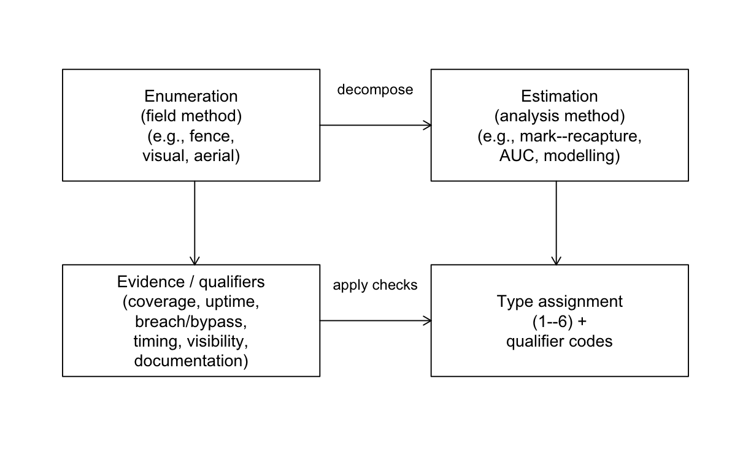
Figure . Conceptual decomposition of enumeration (field) methods and estimation (analysis) methods used to assign estimate Types and qualifiers.

Decision key design
The classification follows a property-first sequence:
- Data format gate: non-numeric presence/not-detected is classified as Type 6.
- Method known gate: if survey and analytical methods are not identified, the estimate is provisionally Type 5 and flagged as method-unknown.
- Method family selection: a primary method family scopes the applicable questions.
- Method-family checks: coverage, effort, visibility, timing, and related criteria drive conservative downgrades.
- Final checks: documentation and uncertainty evidence are evaluated; where evidence is missing, conservative downgrades apply.
This structure reduces subjective table interpretation by turning common qualifiers into explicit questions and recorded qualifier codes.

Escapement Estimate Type Toolkit (informative)
The Escapement Estimate Type Toolkit (R Shiny application) applies this decision logic and returns both (i) a final estimate Type (1–6) and (ii) qualifier codes explaining any conservative downgrades. The toolkit is a practical companion tool; it is not the primary output of this report.

Guidance-to-implementation outlook
Implementation should align with the guidance and method-family checks in this report. Priorities are to:
- capture complete enumeration and estimation methods for each estimate;
- apply mandatory qualifiers where applicable; and
- track unresolved policy/specification items (e.g., mixed-method combination handling and ambiguity thresholds) through a controlled revision cycle.

Handling common operational complications
The guidance treats several recurring complications as explicit qualifiers rather than implicit judgement calls.

Breaches/bypass and infilling
Breach/bypass events at counting sites, and periods of missing observation due to outages or missed visits, can materially affect interpretability unless magnitude and correction methods are documented. The updated guidance treats breach/bypass risk and incomplete coverage as explicit downgrade triggers and records whether defensible infilling/interpolation was required (Holmes et al. 2005; Vélez-Espino et al. 2010; See et al. 2021). For example, run-window coverage below 95% of season days or device uptime below 95% are treated as explicit qualifiers, and any interpolation used to fill missing data should be recorded.

Survey timing relative to run timing
For survey-based indices, visit count alone is not sufficient: surveys must bracket the period when fish are present, and visibility constraints and observer effects can govern bias and comparability (Hill 1997; Jones et al. 1998; Korman et al. 2002; Holt and Cox 2008). The updated guidance includes timing and visibility checks within method families where these factors are primary drivers of interpretability.

Combined-method estimates
Combined-method workflows (e.g., system-wide sonar with tributary visual apportionment, or fences supplemented during breach periods) should be recorded as explicit components. The updated guidance applies a conservative rule: where multiple components contribute to the final estimate, the assigned Type should not exceed that implied by the weakest component unless a documented integration method supports a higher classification (Parsons and Skalski 2010).

Calibration and historical revisions
Where historical values have been recalibrated or revised, the updated guidance treats calibration as an analysis layer that should be captured in metadata (calibration source, diagnostics, and revision history) rather than as a new estimate Type. This supports interpretation of time-series values by downstream users.

Quantitative uncertainty (CV/SE)
Hyatt (1997) distinguished higher-quality absolute-abundance estimates in part by qualified precision (variance evidence) (Hyatt 1997). Where available, reporting quantitative uncertainty (e.g., CV or SE) improves interpretability for downstream use. For example, AUC and peak-count approaches have established approaches for incorporating uncertainty and evaluating sensitivity to survey timing and frequency (English et al. 1992; Hill 1997; Hilborn et al. 1999; Parken et al. 2003; Millar et al. 2012). The updated guidance includes a final precision/accuracy check and recommends capturing quantitative uncertainty when available.

Recommended metadata elements for NuSEDS
Most of the guidance can be expressed using existing NuSEDS fields, but several high-value metadata elements are needed to make estimate Types interpretable and reproducible for downstream users.
The table below lists guidance-level metadata elements and the typical qualifier codes they support; detailed software rollout and database-change logistics are treated as implementation work outside the scope of this technical report.
Table 2: Recommended metadata elements for NuSEDS uploads to support transparent Type 1–6 assignment and interpretation.
Metadata element | Why it matters for interpretation | Typical qualifier code(s) | Priority for upload
Enumeration method (field) | Scopes which property checks apply. | METHOD_UNKNOWN (if missing) | Required
Estimation method (analysis) | Distinguishes analysis pathways (e.g., mark–recapture, AUC, modelling). | METHOD_UNKNOWN (if missing) | Required
Primary method family (FS/V/A/S/T/R/P/M) | Controls eligibility rules and the set of required qualifiers. | METHOD_UNKNOWN (if missing) | Required
Run-window coverage evidence | Explains conservative downgrades due to missed start/end of run. | RUN_COVERAGE | Recommended
Device/site uptime evidence | Explains conservative downgrades due to outages/unobserved intervals. | UPTIME | Recommended
Breach/bypass context | Explains conservative downgrades where missed fish are plausible. | BREACH_BYPASS | Recommended
Infilling/interpolation method | Distinguishes defensible correction from undocumented gap-filling. | INFILL_METHOD | Recommended
Survey timing relative to run timing | A core driver of bias and comparability for survey indices. | TIMING | Recommended
Visibility/conditions | Affects detectability and comparability (especially for visual methods). | VISIBILITY / ENV_COND | Recommended
Documentation evidence | Determines whether a downstream user can independently interpret the estimate. | DOC | Required
Quantitative uncertainty (CV/SE) | Supports qualified precision for Type 2 and more transparent uncertainty. | PRECISION_ACCURACY | Recommended
Combined-method components | Prevents concealment of a weaker component within an overall estimate. | (varies; conservative component rule) | Recommended
Calibration source + diagnostics | Supports interpretation of recalibrated time series. | (varies) | Recommended
Revision history (what changed/when) | Supports transparency when historical values have been revised. | (varies) | Recommended

Method families
Table 3: Method families encoded in the property-first guidance and the best attainable Type before conservative downgrades.
Code | Method family | Best attainable type
FS | Fixed site census (manual or electronic) | 1
V | Visual ground or snorkel count | 2
A | Aerial survey count | 3
S | Hydroacoustic sonar count (modelled) | 2
T | Trap model (non-spanning) | 2
R | Redd survey | 2
P | Electrofishing CPUE index | 3
M | Mark-recapture program | 2

DFO Salmon Data Standards and Controlled Vocabularies linkages for methods and downgrade criteria
To support consistent interpretation (including cross-program interoperability), these NuSEDS elements can be linked to the DFO Salmon Data Standards and Controlled Vocabularies (DFO Salmon Ontology) term browser and concept schemes:
- https://w3id.org/gcdfo/salmon
Table 4: Ontology concept-scheme linkages for NuSEDS enumeration methods, estimate methods, and downgrade criteria.
NuSEDS element | Ontology scheme term | Ontology IRI | WIDOCO term page
ENUMERATION_METHODS | gcdfo:EnumerationMethodScheme | https://w3id.org/gcdfo/salmon#EnumerationMethodScheme | https://dfo-pacific-science.github.io/dfo-salmon-ontology/#EnumerationMethodScheme
ESTIMATE_METHOD | gcdfo:EstimateMethodScheme | https://w3id.org/gcdfo/salmon#EstimateMethodScheme | https://dfo-pacific-science.github.io/dfo-salmon-ontology/#EstimateMethodScheme
DOWNGRADE_CRITERIA | gcdfo:DowngradeCriteriaScheme | https://w3id.org/gcdfo/salmon#DowngradeCriteriaScheme | https://dfo-pacific-science.github.io/dfo-salmon-ontology/#DowngradeCriteriaScheme
Detailed term-level crosswalks are provided in Appendix B (downgrade criteria) and Appendix C (enumeration and estimate methods), and equivalent lookup helpers are also exposed in the metasalmon package (nuseds_enumeration_method_crosswalk() and nuseds_estimate_method_crosswalk()) (DFO Pacific Science 2026).
Legacy values are not dropped; where a legacy term does not cleanly align to a current method family, it can be represented as inherited contextual guidance via ontology metadata (for example via rdfs:comment) while remaining traceable in source records. ## NuSEDS data dictionary alignment
The NuSEDS data dictionary defines the database fields used to store enumeration methods, estimation methods, estimate classification (Types 1–6), and supporting metadata (e.g., inspections/effort and timing fields) (Fisheries and Oceans Canada 2025). The updated guidance is designed to be expressible using existing NuSEDS fields where possible, and to clearly identify gaps where additional metadata would improve interpretation and reproducibility.
Table 5: NuSEDS fields relevant to estimate-type classification and how they relate to the updated guidance (see the NuSEDS data dictionary in docs/context/).
 | Field Name | Role in updated guidance
3 | ESTIMATE_CLASSIFICATION | Stores Type 1–6 estimate classification (including legacy non-Type labels where present)
2 | ENUMERATION_METHODS | Primary field method (enumeration) used to scope method-family checks
4 | ESTIMATE_METHOD | Primary analysis method (estimation), including combined or calibrated special cases
7 | NO_INSPECTIONS_USED | Supports effort/visit thresholds (VISITS and related downgrades)
6 | INDEX_YN | Flags index (partial-coverage) estimates (relative-abundance context)
1 | ACCURACY | Legacy qualitative uncertainty field; not a substitute for quantified metadata
8 | PRECISION | Legacy qualitative uncertainty field; not a substitute for quantified metadata
9 | RELIABILITY | Legacy/import field (historical); not consistently present
5 | ESTIMATE_STAGE | QA/workflow stage (preliminary/near final/final); not a type determinant

Guidance updates for forward implementation
Next we summarize the substantive updates to the Type 1–6 guidance and how it should be applied during NuSEDS data entry and review.

What is new in this guidance
Compared to table-only interpretation, the updated guidance:
- Uses a property-first decision sequence (rather than a table lookup).
- Separates enumeration methods (field) from estimation methods (analysis).
- Applies explicit qualifier codes for conservative downgrades (coverage, timing, visibility, documentation, and method-known gaps).
- Treats combined-method estimates as component-based workflows so weaker components are not concealed.
- Encourages recording quantitative uncertainty (CV/SE) where available.

How to apply the guidance moving forward
For most users, the simplest way to apply this guidance is through the Escapement Estimate Type Toolkit (R Shiny application):
- https://dfo-pac-sci-dev.shinyapps.io/smn-escapement-toolkit/
The toolkit guides users through the same decision sequence described in this report and produces (i) a final estimate Type (1–6) and (ii) explicit qualifier/downgrade codes. Users should copy the toolkit outputs (Type and qualifiers) into their SEN and into the NuSEDS bulk upload tool fields used to store estimate-type classification and justification.

Authoritative decision-key logic and change requests
The authoritative decision-key logic is maintained as a version-controlled YAML file in the toolkit repository:
- https://github.com/dfo-pacific-science/smn-escapement-estimates-toolkit/blob/main/matrix_key/structured_dichotomous_key.yaml
Requests to update the logic (new method terms, revised thresholds, clarified combination rules, etc.) should be submitted as a GitHub issue in that repository (preferred) or emailed to FADSDataStewardship-GestiondesdonneesSFDA@dfo-mpo.gc.ca.

What must be recorded
Uploads should include enough method and evidence context that downstream users can interpret both the assigned Type and any conservative qualifiers. In practice, this means recording:
- the primary enumeration and estimation methods;
- key qualifiers (coverage, uptime, breach/bypass, timing, visibility, and any infilling/interpolation context);
- documentation evidence sufficient for independent interpretation; and
- quantitative uncertainty where available.
A compact, single-table rule summary is provided in Appendix A.

Discussion

Intended use (NuSEDS data entry and review)
This guidance supports consistent estimate-type assignment during data entry and review by:
- making method and evidence expectations explicit (not implicit in table lookups);
- recording conservative qualifier codes that explain why a candidate Type is not supported; and
- improving interpretability by separating enumeration (field) methods from estimation (analysis) methods.
Estimate Types are not a binary “usable/unusable” label. Lower Types may still be fit for specific purposes (e.g., presence/absence, qualitative local context, or within-program indices), but they are not interchangeable with census-like or fully qualified absolute-abundance estimates.

Implications for downstream assessments
Estimate Types are often used as screening filters in downstream workflows (including WSP rapid status assessments) (Fisheries and Oceans Canada 2005; Holt et al. 2009). When Type assignment is inconsistent, threshold-based decisions can become sensitive to classification noise, particularly near cutoffs (e.g., around the Type 4 boundary). More broadly, measurement error in spawner abundance can distort stock–recruit inference and downstream decisions, reinforcing the value of recording uncertainty and detectability-related metadata where available (Walters and Ludwig 1981).
Because qualifier codes are explicit (e.g., missing method identification, timing/coverage gaps, insufficient documentation), conservative classifications become interpretable and metadata improvements can be targeted.

Recommended metadata additions (schema) and implementation status
A central finding of this update is that the Type table alone cannot communicate the information required for consistent interpretation of real-world estimates. Several recurring qualifiers are better represented as explicit metadata elements rather than as new public estimate Types.
Based on working-group implementation notes, near-term rollout is best framed as SEN-first with controlled vocabularies.

SEN fields prioritized for implementation
The following SEN fields are the clearest priorities for aligning NuSEDS uploads with the updated guidance:
- ESTIMATE_TYPE_CLASS_JUSTIFICATION: basis for the Type assignment.
- DOWNGRADE_CRITERIA: which downgrade trigger(s) were applied.
- UNCERTAINTY_VALUE_TYPE: uncertainty metric class (e.g., CV, SE, CI, SD).
- UNCERTAINTY_VALUE: corresponding numeric uncertainty value.
- ANALYSIS_EXPLANATION: analysis details, including modified or combined methods.
Together, these fields operationalize core qualifiers in the decision key: method clarity, downgrade rationale, and uncertainty transparency.

Supporting lookup tables and naming updates
Supporting structures already partway through rollout include:
- DOWNGRADE_CRITERIA_BASE_TABLE: controlled values for downgrade criteria.
- UNCERTAINTY_VALUE_TYPE_BASE_TABLE: controlled values/definitions for uncertainty metric types.
- DOWNGRADE_CRITERIA_IMPACT renamed to DOWNGRADE_CRITERIA_COMMENT to support broader explanatory context.
Controlled values reduce ambiguity and help keep entries consistent across areas and programs.

Items still under discussion
Several metadata items remain valuable but require further specification/governance:
- WSP_RAPID_STATUS_YN (candidate SEN field): potentially useful for screening workflows, but requires clearer governance for interpretation and maintenance.
- SIL additions: less mature than SEN additions and require further prioritization.
- ENHANCEMENT_RANK, POP_CATEGORY, and CUMatchVerifiedYN: follow-on site/CU context fields discussed for WSP-oriented interpretation.
For this report, the implementation priority is therefore: finalize SEN metadata first, keep SIL/CU extensions explicit as backlog, and maintain a transparent mapping from stored fields to decision-key qualifiers.

Escapement Estimate Type Toolkit: unresolved policy/specification gaps
The Escapement Estimate Type Toolkit (R Shiny application) surfaces policy/specification gaps that can still affect cross-program consistency if left implicit. The most material items are:
- Mixed-method estimates: explicit combination policy is needed (e.g., conservative minimum-component rule vs. weighted integration with evidence requirements).
- Ambiguous threshold language: terms such as “negligible”, “adequate”, “fair”, and “defensible” still need agreed quantitative thresholds.
- Breach severity interpretation: clearer rules are needed for how breach magnitude/timing (e.g., peak vs early/late-season) should influence downgrades.
- Calibration diagnostics standards: calibrated time-series pathways need explicit minimum diagnostics/validation expectations.
- Documentation standardization: documentation labels are functionally similar but still inconsistently phrased across method pathways.
- Type-5 pathway clarity: low-resolution relative-estimate pathways should remain explicit to avoid ad hoc interpretation.
This backlog reflects remaining work for the Regional Escapement Task Team. Perfect cross-program consistency and zero ambiguity may not be feasible given the diversity of operational contexts; the goal is to keep the most consequential rules explicit, versioned, and reviewable.

Limitations
This guidance summarizes interpretability given recorded methods and evidence. It does not correct biased inputs, replace program expertise, or guarantee biological accuracy. The most common practical limitation is incomplete metadata: when critical qualifiers are not recorded, the guidance applies conservative classification (often Type 5) to avoid overstating interpretability.

Governance and change control
Because estimate Types are used as screening tools and can influence downstream inference, changes to method families, thresholds, or qualifier rules should be versioned and reviewed. Updates should be accompanied by worked examples and regression/path tests in the Escapement Estimate Type Toolkit so behavior changes are deliberate and transparent.

Conclusion
This report retains the familiar Type 1–6 structure but replaces table-only interpretation with explicit, auditable decision logic grounded in Hyatt (1997): method properties, statistical properties, and documentation (Hyatt 1997).
For NuSEDS users, the practical change is simple: record methods and key qualifiers at upload time so Types remain interpretable downstream. Run-window coverage, uptime, breach/bypass context, timing/visibility constraints, documentation evidence, and (where available) quantitative uncertainty (CV/SE) affect how an estimate can be used.
For downstream analysts, the main benefit is transparency: conservative downgrades are accompanied by explicit qualifier codes, making it clear why a stronger Type is not supported and which metadata gaps matter most.

Next steps
- Finalize a minimal, public-facing metadata schema for NuSEDS that supports the guidance (including quantitative uncertainty fields where available).
- Maintain a small set of worked examples (anonymized as needed) to demonstrate expected behavior on representative cases.

Appendix

Appendix A: Classification rule summary
Table 6: Single-table summary of the NuSEDS estimate-type classification rules used for forward implementation.
Rule stage | Decision / trigger | Classification effect | Primary qualifier code(s)
1. Data format gate | Record is non-numeric (presence or not-detected) | Assign Type 6 | (none)
2. Method known gate | Enumeration and/or estimation method not identified | Assign provisional Type 5 | METHOD_UNKNOWN
3. Method family assignment | Primary method family selected (FS, V, A, S, T, R, P, M) | Select applicable rule path | (path selection step)
4. Family-specific checks (counting systems) | Coverage, uptime, bypass/breach, cross-section, and related counting-system checks fail or are incomplete | Apply conservative downgrades within selected path | RUN_COVERAGE, UPTIME, BREACH_BYPASS, XSEC_COVERAGE, DEVICE_CONFIG
5. Family-specific checks (survey indices) | Visit effort, timing relative to run, visibility, reach coverage, or related survey checks fail or are incomplete | Apply conservative downgrades within selected path | VISITS, TIMING, VISIBILITY, REACH_COVERAGE, EFF_STD, DETECTABILITY
6. Combined-method integration rule | Multiple components contribute to final estimate | Final Type cannot exceed weakest component unless integration method supports stronger classification | INFILL_METHOD (as relevant), component-level qualifiers
7. Documentation gate | Evidence package insufficient for independent interpretation | Apply conservative downgrade | DOC
8. Precision/accuracy gate | Candidate Type requires uncertainty/accuracy evidence that is missing or weak | Apply conservative downgrade | PRECISION_ACCURACY
9. Final assignment | All gates evaluated | Return final Type plus explicit qualifier codes | All triggered qualifiers retained as audit trail

Appendix B: Downgrade criteria codes
Table 7: Downgrade criteria codes used by the classification key, with linkages to published DFO Salmon Ontology terms.
Code | Description | Ontology term | Ontology IRI
RUN_COVERAGE | Run window coverage gaps (e.g., <95% of season days). | gcdfo:RunCoverage | https://w3id.org/gcdfo/salmon#RunCoverage
VISITS | Too few site visits for the claimed precision tier. | gcdfo:NumberOfVisits | https://w3id.org/gcdfo/salmon#NumberOfVisits
BREACH_BYPASS | Bypass or breach risk at a counting site. | gcdfo:BreachBypass | https://w3id.org/gcdfo/salmon#BreachBypass
UPTIME | Device outages or unobserved intervals (e.g., uptime <95%). | gcdfo:Uptime | https://w3id.org/gcdfo/salmon#Uptime
REVIEW_QA | Insufficient review of automated events. | gcdfo:ReviewQA | https://w3id.org/gcdfo/salmon#ReviewQA
VISIBILITY | Poor visibility or lighting limits detection. | gcdfo:Visibility | https://w3id.org/gcdfo/salmon#Visibility
REACH_COVERAGE | Intended reaches or segments not surveyed. | gcdfo:ReachCoverage | https://w3id.org/gcdfo/salmon#ReachCoverage
TIMING | Visits not aligned with migration peak or plateau. | gcdfo:Timing | https://w3id.org/gcdfo/salmon#Timing
EFF_STD | Inconsistent effort standardization. | gcdfo:EffortStandardization | https://w3id.org/gcdfo/salmon#EffortStandardization
XSEC_COVERAGE | Partial cross-section coverage. | gcdfo:CrossSectionCoverage | https://w3id.org/gcdfo/salmon#CrossSectionCoverage
CLASSIFICATION | Species or target classification error. | gcdfo:Classification | https://w3id.org/gcdfo/salmon#Classification
TRAP_EFF | Unmeasured or uncertain trap efficiency. | gcdfo:TrapEfficiency | https://w3id.org/gcdfo/salmon#TrapEfficiency
DETECTABILITY | Redd or carcass detectability bias. | gcdfo:Detectability | https://w3id.org/gcdfo/salmon#Detectability
DEVICE_CONFIG | Device settings not documented or unstable. | gcdfo:DeviceConfiguration | https://w3id.org/gcdfo/salmon#DeviceConfiguration
ENV_COND | Environmental conditions bias detection. | gcdfo:EnvironmentalConditions | https://w3id.org/gcdfo/salmon#EnvironmentalConditions
MR_ASSUMP | Mark-recapture assumption violations. | gcdfo:MarkRecaptureAssumptions | https://w3id.org/gcdfo/salmon#MarkRecaptureAssumptions
INFILL_METHOD | Interpolation or infilling used; defensibility must be documented. | gcdfo:InfillMethod | https://w3id.org/gcdfo/salmon#InfillMethod
DOC | Documentation or evidence missing. | gcdfo:Documentation | https://w3id.org/gcdfo/salmon#Documentation
PRECISION_ACCURACY | Precision or accuracy weaker than candidate Type. | gcdfo:PrecisionAccuracy | https://w3id.org/gcdfo/salmon#PrecisionAccuracy
METHOD_UNKNOWN | Survey or analysis method not identified. | gcdfo:MethodUnknown | https://w3id.org/gcdfo/salmon#MethodUnknown

Appendix C: NuSEDS data dictionary crosswalk
This appendix documents how the updated guidance relates to NuSEDS fields and controlled vocabularies (see docs/context/Data_Dictionary_NuSEDS_EN.csv).

C.1 Enumeration method values (ENUMERATION_METHODS)
Table 8: Suggested mapping from NuSEDS enumeration method values to the updated key method families (FS, V, A, S, T, R, P, M), with ontology term and WIDOCO linkages.
NuSEDS ENUMERATION_METHODS value | Suggested method family | Ontology term | WIDOCO term page | Notes
Bank Walk | V | gcdfo:VisualGroundCount | https://dfo-pacific-science.github.io/dfo-salmon-ontology/#VisualGroundCount
Based on Angling Catch | P | gcdfo:EnumerationMethod | https://dfo-pacific-science.github.io/dfo-salmon-ontology/#EnumerationMethod | Catch-based index; treat as a CPUE-style index unless more detail is provided; ontology linkage is provisional at scheme level.
Biologist/Working Group | unknown | NA | NA | Not a method; treat as method-unknown unless a specific field/analysis method is documented elsewhere.
Boat | V | gcdfo:VisualGroundCount | https://dfo-pacific-science.github.io/dfo-salmon-ontology/#VisualGroundCount
Broodstock Removal | FS | gcdfo:FixedSiteCensusManual | https://dfo-pacific-science.github.io/dfo-salmon-ontology/#FixedSiteCensusManual
Dead Pitch | V | gcdfo:VisualGroundCount | https://dfo-pacific-science.github.io/dfo-salmon-ontology/#VisualGroundCount | Carcass-based visual surveys; often paired with peak/cumulative dead estimation methods.
Electronic Counters | FS | gcdfo:FixedSiteCensusElectronic | https://dfo-pacific-science.github.io/dfo-salmon-ontology/#FixedSiteCensusElectronic
Electroshocking | P | gcdfo:ElectrofishingCount | https://dfo-pacific-science.github.io/dfo-salmon-ontology/#ElectrofishingCount
Enumeration by Hatchery | FS | gcdfo:FixedSiteCensusManual | https://dfo-pacific-science.github.io/dfo-salmon-ontology/#FixedSiteCensusManual
Fence | FS | gcdfo:FixedSiteCensusManual | https://dfo-pacific-science.github.io/dfo-salmon-ontology/#FixedSiteCensusManual
Fixed Wing Aircraft | A | gcdfo:AerialSurveyCount | https://dfo-pacific-science.github.io/dfo-salmon-ontology/#AerialSurveyCount
Float | V | gcdfo:VisualGroundCount | https://dfo-pacific-science.github.io/dfo-salmon-ontology/#VisualGroundCount
Helicopter | A | gcdfo:AerialSurveyCount | https://dfo-pacific-science.github.io/dfo-salmon-ontology/#AerialSurveyCount
Hydroacoustic Station | S | gcdfo:HydroacousticSonarCount | https://dfo-pacific-science.github.io/dfo-salmon-ontology/#HydroacousticSonarCount
Other | unknown | NA | NA | Treat as method-unknown unless a specific field/analysis method is documented elsewhere.
Peak Live and Dead Count | V | gcdfo:VisualGroundCount | https://dfo-pacific-science.github.io/dfo-salmon-ontology/#VisualGroundCount | Value is analysis-like; prefer capturing peak/cumulative variants under ESTIMATE_METHOD.
Redd Counts | R | gcdfo:ReddCount | https://dfo-pacific-science.github.io/dfo-salmon-ontology/#ReddCount
Snorkel | V | gcdfo:VisualSnorkelCount | https://dfo-pacific-science.github.io/dfo-salmon-ontology/#VisualSnorkelCount
Spot Checks | V | gcdfo:VisualGroundCount | https://dfo-pacific-science.github.io/dfo-salmon-ontology/#VisualGroundCount
Stream Walk | V | gcdfo:VisualGroundCount | https://dfo-pacific-science.github.io/dfo-salmon-ontology/#VisualGroundCount
Strip Counts | V | gcdfo:VisualGroundCount | https://dfo-pacific-science.github.io/dfo-salmon-ontology/#VisualGroundCount
Tag Recovery | M | gcdfo:MarkRecaptureFieldProgram | https://dfo-pacific-science.github.io/dfo-salmon-ontology/#MarkRecaptureFieldProgram
Trap | T | gcdfo:TrapCount | https://dfo-pacific-science.github.io/dfo-salmon-ontology/#TrapCount | If trap is non-spanning or efficiency-corrected, use T; fully constraining traps may behave more like fixed-site counting.
Walk | V | gcdfo:VisualGroundCount | https://dfo-pacific-science.github.io/dfo-salmon-ontology/#VisualGroundCount
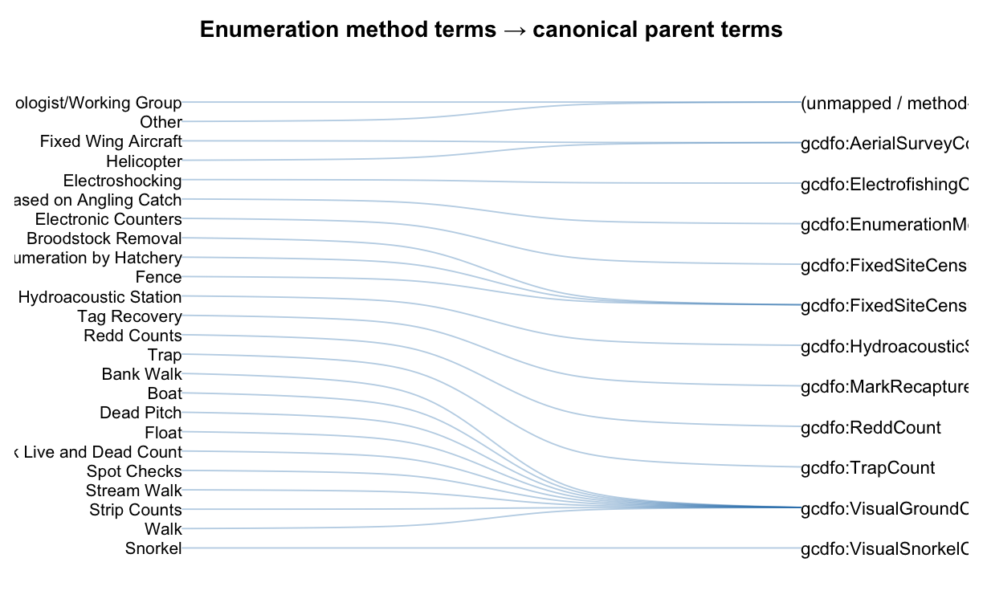
Figure . Sankey-style summary of how legacy NuSEDS enumeration-method terms converge to canonical parent terms used by the updated guidance.

C.2 Estimate method values (ESTIMATE_METHOD)
Table 9: Suggested interpretation of NuSEDS estimate method values under the updated guidance, with ontology term and WIDOCO linkages. Where ‘depends’ appears, additional method metadata are required to apply the key cleanly.
NuSEDS ESTIMATE_METHOD value | Guidance interpretation | Suggested method family | Ontology term | WIDOCO term page | Notes
Cumulative CPUE | CPUE index | P | gcdfo:EstimateMethod | https://dfo-pacific-science.github.io/dfo-salmon-ontology/#EstimateMethod | No specific CPUE estimate concept is currently defined in this scheme; linked at EstimateMethod scheme level.
Fixed Site Census | Enumeration device/mode (often stored as estimate method) | FS | gcdfo:FixedStationTally | https://dfo-pacific-science.github.io/dfo-salmon-ontology/#FixedStationTally
Cumulative New | Method unknown/administrative label | unknown | gcdfo:PeakCountAnalysis | https://dfo-pacific-science.github.io/dfo-salmon-ontology/#PeakCountAnalysis | Legacy dictionary label with no method definition in the source description; mapped to PeakCountAnalysis pending local confirmation.
Peak Live + Dead | Visual-series estimation (AUC/peak variants and expansions) | V | gcdfo:PeakCountAnalysis | https://dfo-pacific-science.github.io/dfo-salmon-ontology/#PeakCountAnalysis
Area Under the Curve | Visual-series estimation (AUC/peak variants and expansions) | V | gcdfo:AreaUnderTheCurve | https://dfo-pacific-science.github.io/dfo-salmon-ontology/#AreaUnderTheCurve
Mark & Recapture: Jolly-Seber | Mark-recapture estimation | M | gcdfo:MarkRecaptureAnalysis | https://dfo-pacific-science.github.io/dfo-salmon-ontology/#MarkRecaptureAnalysis
Addition/Subtraction | Math/expansion operations (depends on base method) | depends | gcdfo:ExpansionMathematicalOperations | https://dfo-pacific-science.github.io/dfo-salmon-ontology/#ExpansionMathematicalOperations
Multiplication/Division | Math/expansion operations (depends on base method) | depends | gcdfo:ExpansionMathematicalOperations | https://dfo-pacific-science.github.io/dfo-salmon-ontology/#ExpansionMathematicalOperations
Mark & Recapture: Petersen | Mark-recapture estimation | M | gcdfo:MarkRecaptureAnalysis | https://dfo-pacific-science.github.io/dfo-salmon-ontology/#MarkRecaptureAnalysis
Redd Count | Redd-based estimation (often requires spawners-per-redd conversion) | R | gcdfo:ReddExpansionAnalysis | https://dfo-pacific-science.github.io/dfo-salmon-ontology/#ReddExpansionAnalysis
Peak Live + Cumulative Dead | Visual-series estimation (AUC/peak variants and expansions) | V | gcdfo:PeakCountAnalysis | https://dfo-pacific-science.github.io/dfo-salmon-ontology/#PeakCountAnalysis
Lake Expansion | Math/expansion operations (depends on base method) | depends | gcdfo:ExpansionMathematicalOperations | https://dfo-pacific-science.github.io/dfo-salmon-ontology/#ExpansionMathematicalOperations
Insufficient Information | Method unknown/administrative label | unknown | NA | NA
Peak Live * Expansion | Visual-series estimation (AUC/peak variants and expansions) | V | gcdfo:ExpansionMathematicalOperations | https://dfo-pacific-science.github.io/dfo-salmon-ontology/#ExpansionMathematicalOperations
Unknown Estimate Method | Method unknown/administrative label | unknown | NA | NA
Not Applicable | Method unknown/administrative label | unknown | NA | NA
Expert Opinion | Method unknown/administrative label | unknown | NA | NA
Mark & Recapture: Bayesian | Mark-recapture estimation | M | gcdfo:MarkRecaptureAnalysis | https://dfo-pacific-science.github.io/dfo-salmon-ontology/#MarkRecaptureAnalysis
Other Estimate Method | Method unknown/administrative label | unknown | NA | NA
Sonar-DIDSON | Hydroacoustic modelling pipeline | S | gcdfo:HydroacousticModelling | https://dfo-pacific-science.github.io/dfo-salmon-ontology/#HydroacousticModelling
Calibrated Time Series | Calibrated time series (requires calibration source + diagnostics) | depends | gcdfo:CalibratedTimeSeries | https://dfo-pacific-science.github.io/dfo-salmon-ontology/#CalibratedTimeSeries | For interpretability, record calibration source years, diagnostics, and revision history.
Resistivity Counter | Enumeration device/mode (often stored as estimate method) | FS | gcdfo:FixedStationTally | https://dfo-pacific-science.github.io/dfo-salmon-ontology/#FixedStationTally | Enumerated as a device/mode; ensure bypass/coverage/QA metadata are captured to support Type 1/2 eligibility.
Sonar-ARIS | Hydroacoustic modelling pipeline | S | gcdfo:HydroacousticModelling | https://dfo-pacific-science.github.io/dfo-salmon-ontology/#HydroacousticModelling
Mark & Recapture: Open Model | Mark-recapture estimation | M | gcdfo:MarkRecaptureAnalysis | https://dfo-pacific-science.github.io/dfo-salmon-ontology/#MarkRecaptureAnalysis
Combined Methods | Combined-method workflow (requires explicit component listing) | depends | gcdfo:EstimateMethod | https://dfo-pacific-science.github.io/dfo-salmon-ontology/#EstimateMethod | Decompose into components (e.g., sonar + visual apportionment; fence + visual during breach) and apply conservative classification.
Video Counter | Enumeration device/mode (often stored as estimate method) | FS | gcdfo:FixedStationTally | https://dfo-pacific-science.github.io/dfo-salmon-ontology/#FixedStationTally | Enumerated as a device/mode; ensure QA review rate and uptime/coverage metadata are captured.
(Peak Live+Cum Dead)*Expansion | Visual-series estimation (AUC/peak variants and expansions) | V | gcdfo:ExpansionMathematicalOperations | https://dfo-pacific-science.github.io/dfo-salmon-ontology/#ExpansionMathematicalOperations
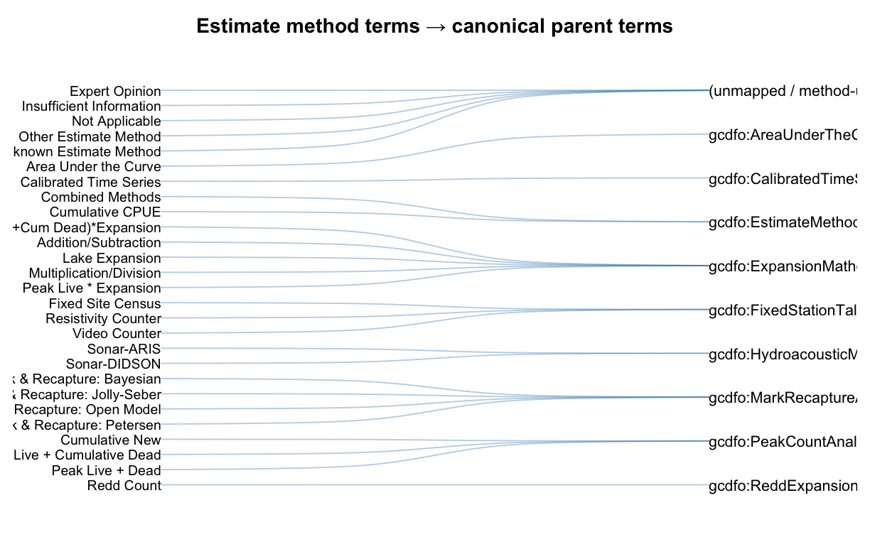
Figure . Sankey-style summary of how legacy NuSEDS estimate-method terms converge to canonical parent terms used by the updated guidance.

C.3 Type-to-accuracy/precision lookup used in the Escapement Estimate Type Toolkit
The Escapement Estimate Type Toolkit includes a compact lookup that can be used when populating legacy-style accuracy/precision class fields alongside estimate Type.
Table 10: Escapement Estimate Type Toolkit lookup from estimate Type to legacy-style accuracy/precision class labels.
Estimate Type | accuracy_class | precision_class
1 | actual_very_high | plus_minus_zero
2 | actual_or_assigned_high | high_to_moderate
3 | assigned_range_med_high | assigned_med_high
4 | unknown_assumed_constant | unknown_assumed_constant
5 | unknown_assumed_highly_variable | unknown_assumed_highly_variable
6 | medium_to_high | unknown

Appendix D: NuSEDS method-term summary (SEN exploratory)
This appendix reports a quick exploratory check of method terminology in historical NuSEDS SEN records (from the shared All AREA SEN_Survey_method (1).csv dataset) and the resulting rollups used to support the method mapping in this guidance.
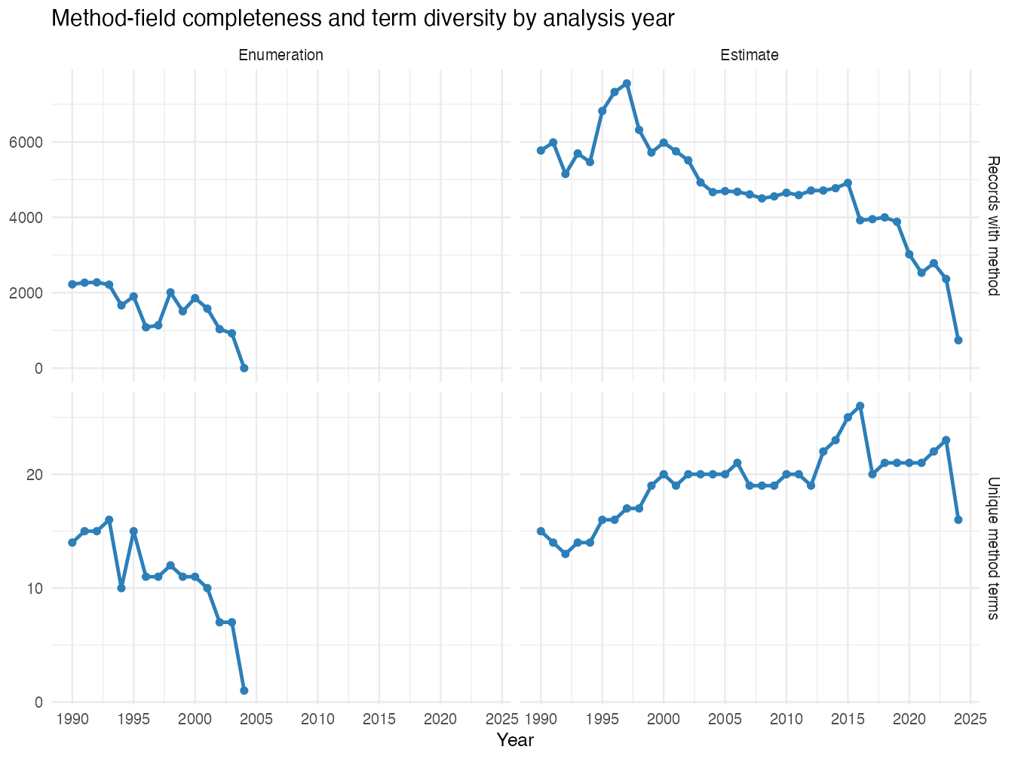
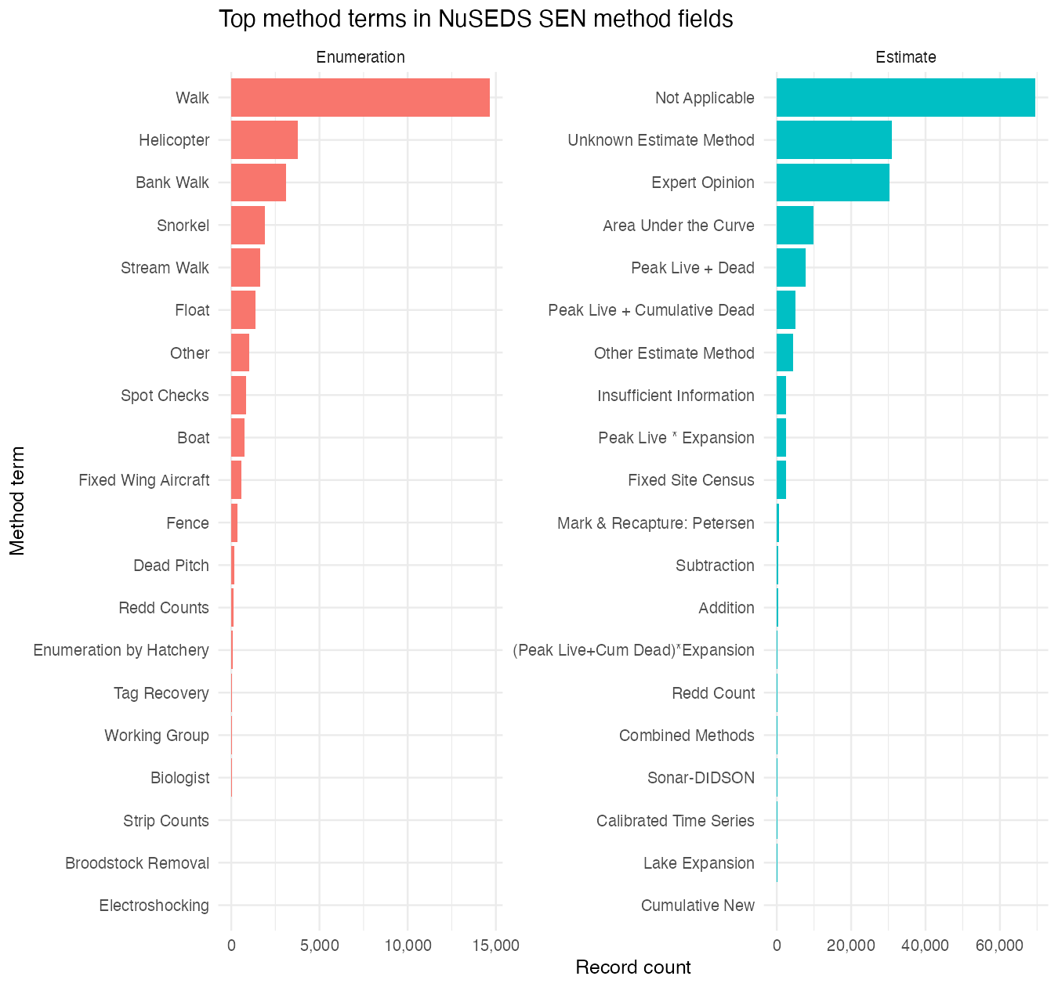

References
DFO Pacific Science. 2026. Metasalmon: Tools for salmon ontology and NuSEDS method workflows. R package.
English, K.K., Bocking, R.C., and Irvine, J.R. 1992. A robust procedure for estimating salmon escapement based on the area-under-the-curve method. Canadian Journal of Fisheries and Aquatic Sciences 49(10): 1982–1989.
Fisheries and Oceans Canada. 2005. Canada’s policy for conservation of wild pacific salmon. Fisheries; Oceans Canada.
Fisheries and Oceans Canada. 2016. NuSEDS–new salmon escapement database system. Open Government Portal dataset.
Fisheries and Oceans Canada. 2025. NuSEDS (new salmon escapement database system) data dictionary (english).
Hilborn, R., Bue, B.G., and Sharr, S. 1999. Estimating spawning escapements from periodic counts: A comparison of methods. Canadian Journal of Fisheries and Aquatic Sciences 56(5): 888–896.
Hill, R.A. 1997. Optimizing aerial count frequency for the area-under-the-curve method of estimating escapement. North American Journal of Fisheries Management 17(2): 461–466.
Holmes, J.A., Cronkite, G., and Enzenhofer, H.J. 2005. Feasibility of deploying a dual-frequency identification sonar (DIDSON) system to estimate salmon spawning ground escapement in major tributary systems of the fraser river, british columbia. Canadian technical report of fisheries and aquatic sciences 2592. Fisheries; Oceans Canada.
Holt, C.A., Cass, A., Holtby, B., and Riddell, B. 2009. Can. Sci. Advis. Sec. Res. Doc. 2009/058. Fisheries; Oceans Canada.
Holt, K.R., and Cox, S.P. 2008. Evaluation of visual survey methods for monitoring pacific salmon (oncorhynchus spp.) escapement in relation to conservation guidelines. Canadian Journal of Fisheries and Aquatic Sciences 65(2): 212–226.
Hyatt, K.D. 1997. Salmon escapement classification key. Internal memo, Fisheries and Oceans Canada, Pacific Biological Station.
Jones, E.L., Quinn, T.J., and Van Alen, B.W. 1998. Observer accuracy and precision in aerial and foot survey counts of pink salmon in a southeast alaska stream. North American Journal of Fisheries Management 18(4): 832–846.
Korman, J., Ahrens, R.N.M., Higgins, P.S., and Walters, C.J. 2002. Effects of observer efficiency, arrival timing, and survey life on estimates of escapement for steelhead trout (oncorhynchus mykiss) derived from repeat mark-recapture experiments. Canadian Journal of Fisheries and Aquatic Sciences 59(7): 1116–1131.
Millar, R.B., McKechnie, S., and Jordan, C.E. 2012. Simple estimators of salmonid escapement and its variance using a new area-under-the-curve method. Canadian Journal of Fisheries and Aquatic Sciences 69(6).
Parken, C.K., Bailey, R.E., and Irvine, J.R. 2003. Incorporating uncertainty into area-under-the-curve and peak count salmon escapement estimation. North American Journal of Fisheries Management 23(1): 78–90.
Parsons, A.L., and Skalski, J.R. 2010. Quantitative assessment of salmonid escapement techniques. Reviews in Fisheries Science 18(4): 301–314.
Schwarz, C.J., Bailey, R.E., Irvine, J.R., and Dalziel, F.C. 1993. Estimating salmon spawning escapement using capture–recapture methods. Canadian Journal of Fisheries and Aquatic Sciences 50(6): 1181–1197.
See, K.E., Kinzer, R.N., and Ackerman, M.W. 2021. State-space model to estimate salmon escapement using multiple data sources. North American Journal of Fisheries Management 41(5): 1360–1374.
Vélez-Espino, L.A., and others. 2010. Mark-recapture experiment for the 2009 chinook salmon spawning escapement in the atnarko river. Canadian manuscript report of fisheries and aquatic sciences 2930. Fisheries; Oceans Canada.
Walters, C.J., and Ludwig, D. 1981. Effects of measurement errors on the assessment of stock–recruitment relationships. Canadian Journal of Fisheries and Aquatic Sciences 38(6): 704–710.

