David Forystek

SI 339

SI 339 Portfolio Project

1. I chose to create a media query to make the images on the ‘Projects’ page smaller and centered when on mobile view in order to make the page more readable and look more organized.
2. I decided to use Grid on the ‘About Me’ page because it was the easiest way to incorporate having text one on side and images on the other side of the page. I decided to use Flexbox on the gallery of images on the ‘Projects’ page.
3. While running my pages through the W3 validator, it gives me an error of illegal character in the line that imports two Google fonts, but the fonts still work on the pages. Aside from that one error, the code on all of my pages passed the W3 validator. The WAVE validator comes up with no contrast errors. The AxE validator only came up with contrast errors, but no other errors.

Images:

W3 Validator:

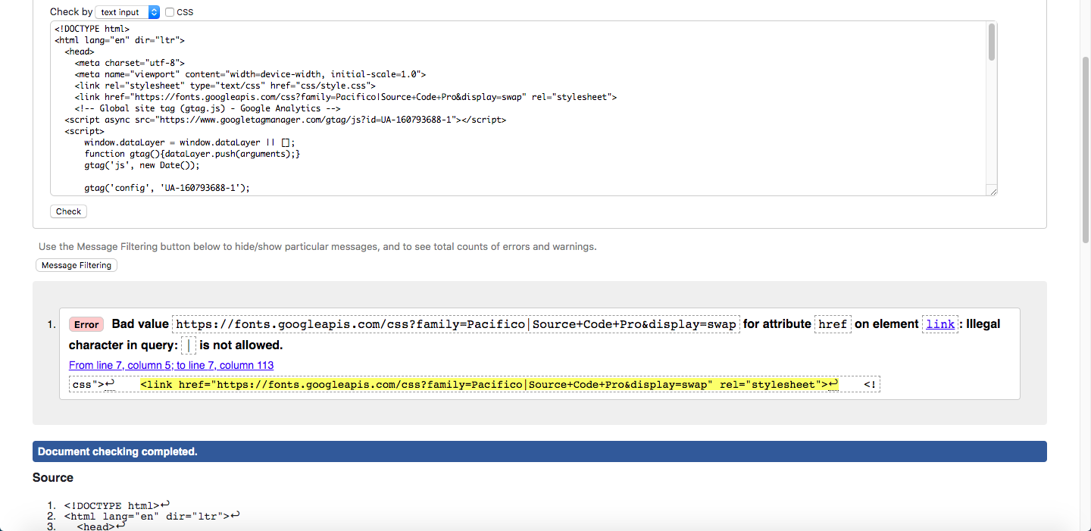

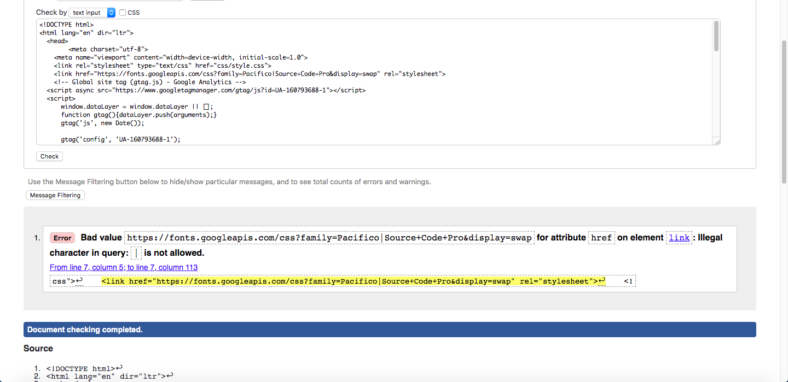

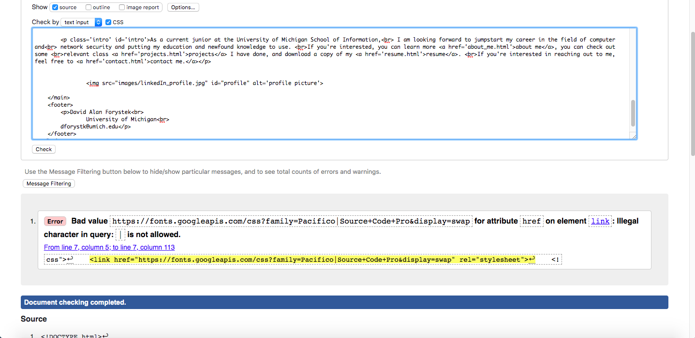

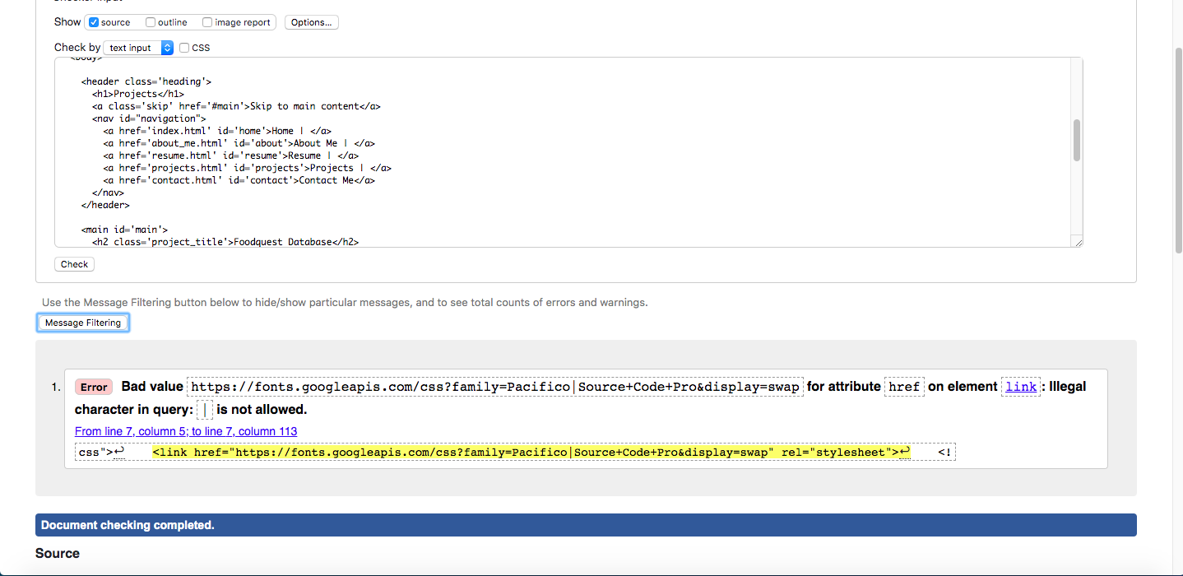

AXE validator:

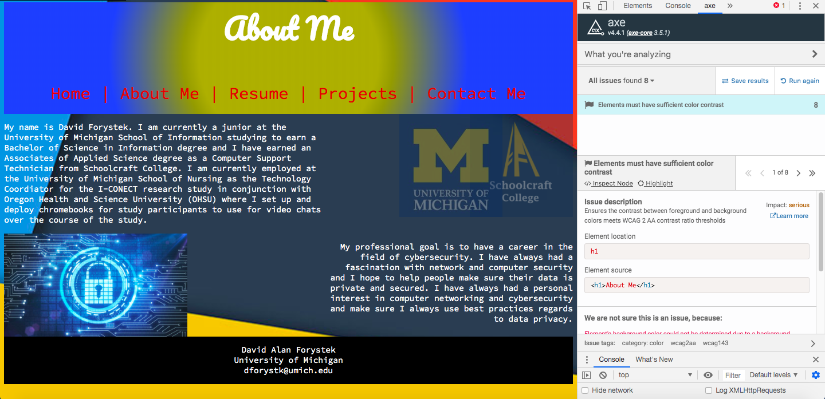

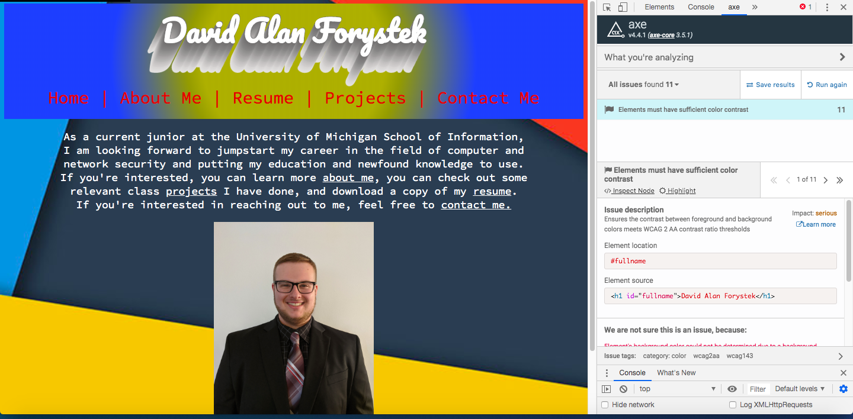

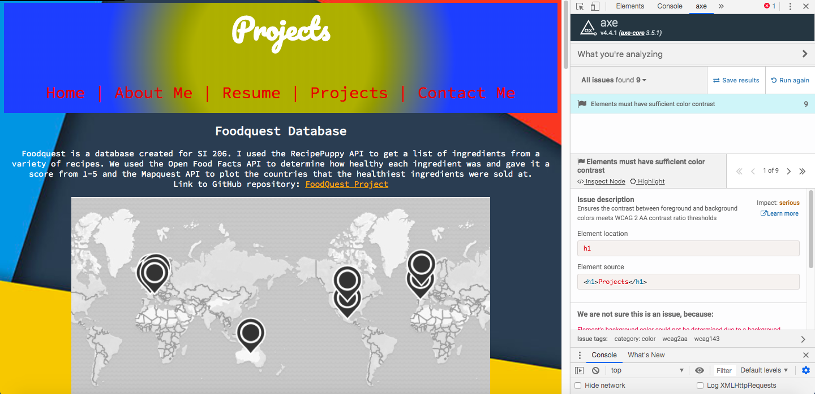

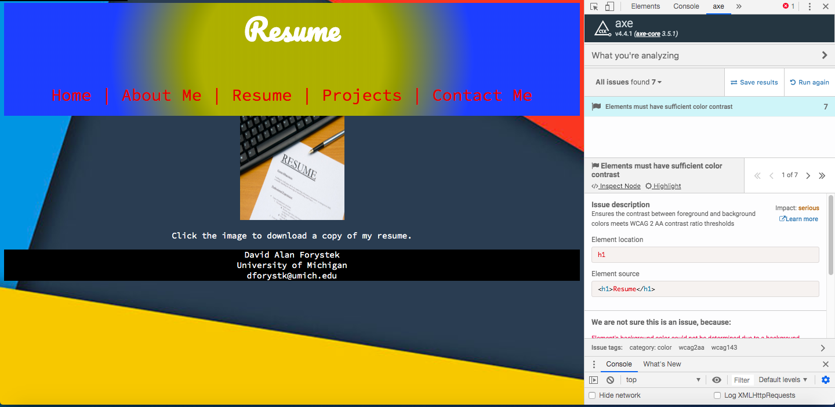

WAVE validator:

