CE640 / OC512 – Week 3 Assignment
Functions and Program Control

Write a function, called multGauss, to compute the sum of multiple Gaussian (normal distribution) profiles. See the figure here to illustrate what Gaussians of different locations, amplitudes and ‘widths’ (standard deviations) look like. Also, here is a sample plot showing you what the sum of a few Gaussians looks like:

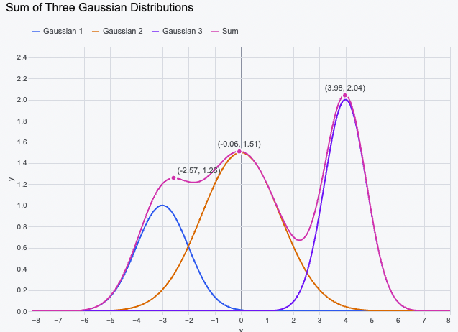

Your function should accept, as input, a matrix with three columns, and a vector x. The three columns should be the amplitude, the width, and the location of the individual Gaussian profiles. The rows of the matrix contain these parameters for each of the Gaussian profiles that you wish to compute. Your function should return, as output, the SUM of the individual Gaussian profiles. In other words, the individual profiles will be y1(x), y2(x), y3(x), and so on. What you want to return is y = y1+ y2 + y3 +…Please set up your function to perform ‘error checking’ to ensure that the input matrix has the needed three columns. HINT: This is a great place for an ‘if’ statement. If it does not, you should report an error to the command window and terminate the function call. Also set up your function so that it will work no matter how many Gaussians are requested. For example, the user might wish to compute the sum of 2 profiles, or 5, or 10. Your code needs to be flexible and be able to handle an arbitrary number of rows in the input matrix. HINT: this is a great place for a ‘for’ statement.

Next, to accomplish its goal, your function should call the function gaussmf (built-in matlab function) to do the basic calculation of a single gaussian profile. If you look at the help for this function, you will see that gaussmf accepts only width and location, not amplitude. Thus, gaussmf always returns Gaussians with an amplitude of 1, and your function will have to scale them with the desired amplitudes before computing the sum. Note: the use of gaussmf will make your life easier. But, another option is to program in the actual formula for the gaussian distribution. Your call. Do what is easiest.

Great, now that you have written your function, write an m-file called week3hw.m that we will use to ‘test’ your function. Your m-file will specify the input variables, issue a call to your function multGauss and plot the result. For your test, let the domain range from 0 to 20. Let there be four Gaussians. The amplitudes are to be 0.1, 0.5, 1, and 2. The standard deviations (sigma) are to be 0.5, 1, 2 and 3. The positions are to be 2, 4, 6, and 8. Since your function returns the SUM of the gaussians, your m-file should plot this output, i.e. the sum.

NOTE: you can, as discussed in class, have two separate files…the main script, and the function. OR…you can place the function at the bottom of your main script.

This homework assignment is fairly involved, since it uses functions, if statements, for statements, and so on. These are all critically important core components to coding. Spend the time to learn them and don’t resort to full AI which won’t teach you anything. Use the discussion forum on Canvas to pose questions, or come see me for help.

