Devin Fowler

09/21/2017

Lab 1 Report

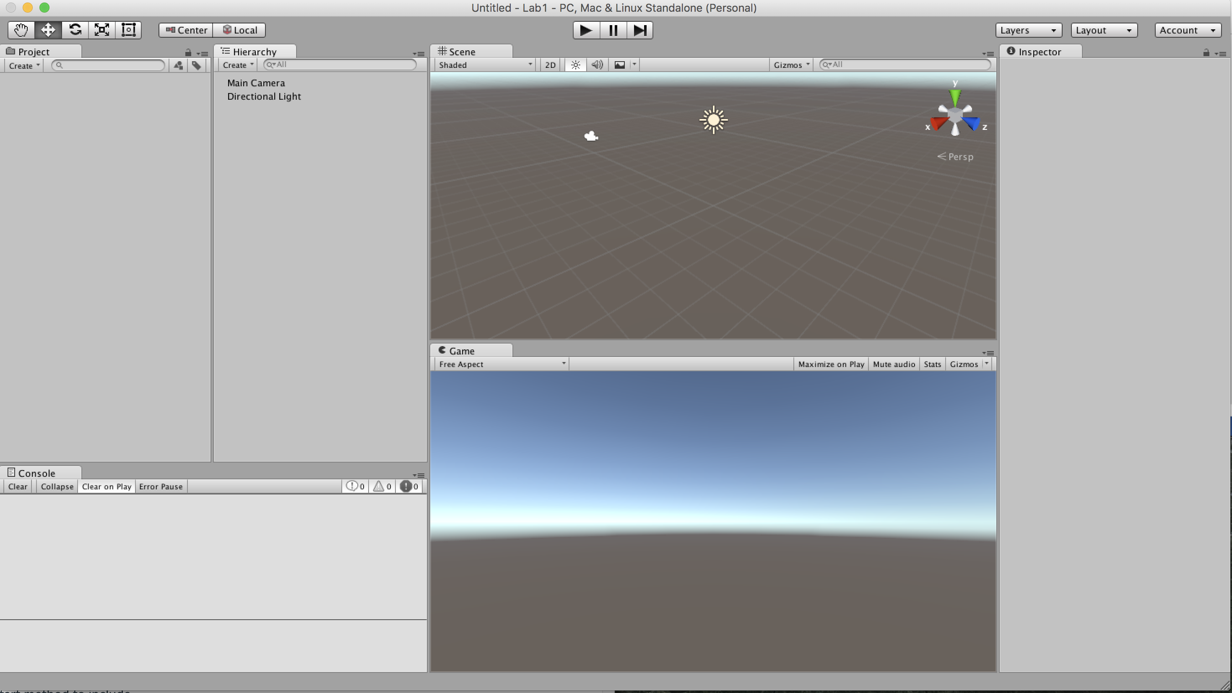

Step 7: “Hello, World!” keeps printing to the output until the program is paused or exited from.

Step 11: Cube 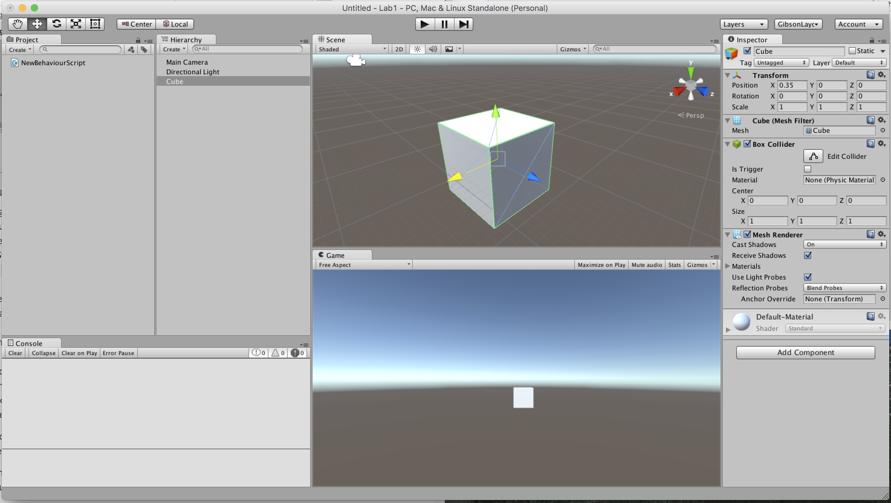

Step 12: Transform is used to control the position, rotation, or overall size of the cube

The mesh filter controls the shape of the object.

The collider is used to show the points at which something would collide with the object on screen.

The (Mesh)Renderer makes it so the axis aren’t shown on screen, the texture of the object is rendered on screen.

Rigibody controls the physics of the object.

Step 22: one cube 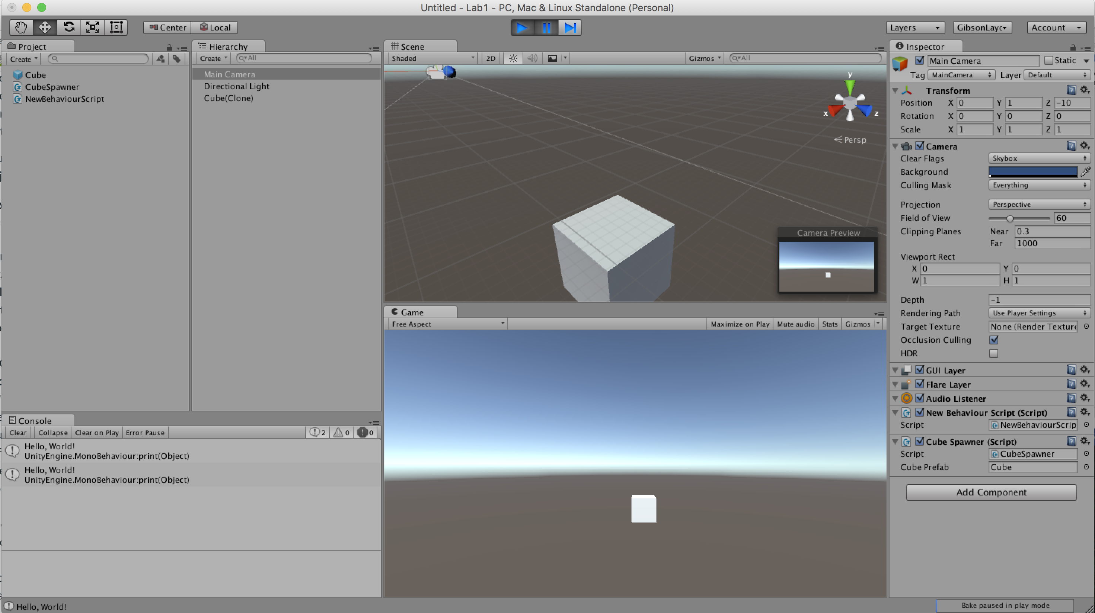

Step 24: Many Cubes 