Notes

Look into using NLTK stopwords as the first word filter (Probrably not as includes words like ‘A’)

Use cookbook to work out how to tag and chunk into a good parse tree

Use characterising stylistic elements to analyse tree using algorithm 2

N statements imply conclusion

When I was shopping in the town yesterday, I saw Mike

Look for statements like ‘I saw Mike’ or ‘Sarah will be in charge next week’ and then check if they are at the end rather than the beginning

Final statement is always conclusive and the ones before are not conclusive

So conclusive detection and then check positioning

“she still managed to find time to read.” Could be a problem – maybe say that the final statement is always conclusive if there are statements before it?

“paid attention to what the professor was saying” – Only makes sense with the previous statements



A periodic sentence is a stylistic device employed at the sentence level, described as one that is not complete grammatically or semantically before the final clause or phrase.

Algorithm 2 translation

Note that Algorithm 1 & 2 rely on the use of Berkeley parser (Petrov and Klein, 2007)

We check whether sentence S has the following structure

SBAR is used to identify dependent clauses (also known as subordinate clauses)

For independent/incomplete clauses, we look at the sequence of nodes under the root

Ltop represents the sequence of nodes under the root and Lktop represents the sequence of nodes from k to the top (?)

λ means |Ltop| *which I think means length of Ltop but unclear*

t(Nr) represents the tree rooted at Nr and is theinput for the algorithm

Ω(Nr) represents the set of nodes in t(Nr) => Ω(Lktop) represents the set of nodes in t(Lktop)

k is an index (aka counting variable) and is used to go through each layer of the tree

∈ is used to see if an item is in a set. Eg S: {a, b, c, d}. Then a ∈ S, b ∈ S, c ∈ S, and d ∈ S are all true.

K = 1

While k is less than the amount of nodes in Ltop

If Lktop is not a verb phrase then

If Sentence or SBAR can be found in the Lktop set of nodes then

Return periodic

If Lktop IS a verb phrase then

If Sentence or SBAR can be found in the Lktop set of nodes then

Return loose

(End while)

Return other

Check amount of subtrees on either side, if lobsided, periodic?

SBAR high up here

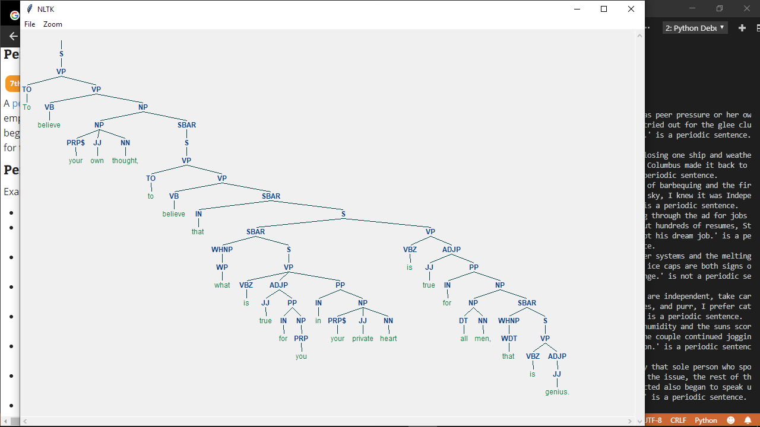

Argument mining investigation

<https://github.com/vene/marseille> looks interesting but potentially very complex?

* <http://arg.napier.ac.uk/page/admin/studentprojects/> Specifically “Developing an algorithm to automatically detect periodic sentences, classify them as argument or non-argument, and convert them into argumentation structures that are saved using the [SADFace](http://arg.napier.ac.uk/page/project/sadface)format (developed at ENU). NB. Periodic sentences often encapsulate an entire argument, including premises and conclusion, into a single sentence, e.g. “The beach, with white sand, crystal clear water, and palm trees, is a favorite hangout for the locals.” but they are problematic because they may have various forms, and sometimes the same form can express an argument and at other times the sentence does not contain an argument.

”

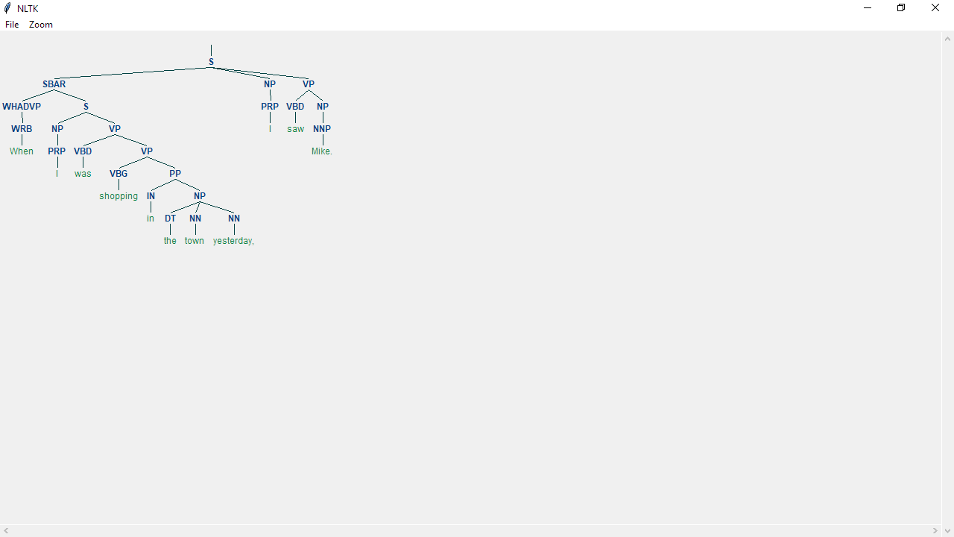

In SadFace:

Arguments are claims/atoms linked with relationship atoms describing the relationship – eg supportive, conflicting