Agentic Health Interoperability
Requirements and User Stories

Version 1.0 | May 2026 | InterSystems AI Hub

Table of Contents
1. Introduction
2. Developer Experience
3. Builder Experience - Admin UI
4. Builder Experience - Chatbot
5. End-to-End Scenario
6. Non-Functional Requirements

1. Introduction
This document defines the end-to-end requirements and user stories for the Agentic Health Interoperability project. The system enables two distinct personas to build, configure, and operate AI-powered agents for healthcare interoperability tasks inside InterSystems IRIS for Health.
Product vision: A configuration-driven AI Copilot that helps integration engineers build Productions, create Transformations, test HL7/FHIR messages, and explore the IRIS class catalog -- entirely through natural-language conversation or a structured admin UI.

1.1 Personas
Persona | Role | Primary Interface | Security Scope
Developer | Builds agent infrastructure, writes custom tools, deploys packages | VS Code + ObjectScript extension + terminal | Full %DB access, %Dictionary write, source control, IPM packaging
Builder | Configures agents, skills, connections, reviews mappings, operates the chatbot | IRIS Management Portal (admin UI + chatbot) | Restricted to /api/agentic/ endpoints, no direct SQL or class compilation

2. Developer Experience
Developers work exclusively through VS Code with the InterSystems ObjectScript extension. They write classes (Agent, MCP, ToolSet, Tool, Skill), compile them, and deploy via IPM. The admin UI is not their primary interface -- their deliverable is code that the Builder configures.

2.1 Security Requirements
Requirement | Implementation
Authentication | IRIS native users with role-based access (%Developer role)
Source control | Git integration via VS Code; all classes under src/cls/
Secret management | IRIS Secured Wallet (collection: AgenticInteropConnections). No plaintext secrets in code, tables, or globals
API key isolation | Runtime LLM credentials are separate from development LLM. Agent's Bedrock/Anthropic key stored in Wallet, never in source
Namespace isolation | Code is namespace-agnostic ($namespace resolved at request time). No hardcoded namespace references
IPM packaging | zpm load on a clean instance produces a working system. Shipped classes survive upgrades; user customizations survive in override tables

2.2 User Stories

US-D01: Create a New Tool
As a Developer, I want to write an ObjectScript class that extends %AI.Tool with defined parameters (NAME, DESCRIPTION, INPUT, OUTPUT), so that the tool appears in the agent's catalog and can be invoked during chat conversations.
- Acceptance criteria:
- Tool class compiles without errors
- Tool appears in the admin UI Tools tab after compilation
- Tool description follows the contract format: imperative verb, scope, side effects
- Tool input/output schemas are valid JSON Schema
- Tool includes at least one happy-path unit test

US-D02: Create a New Skill
As a Developer, I want to write a Skill class with INSTRUCTIONS content (markdown text up to 32K characters), so that the agent can delegate domain-specific questions to a specialist sub-agent.
- Acceptance criteria:
- Skill class extends AgenticInterop.Skill.Base (not %AI.Agent.Skill directly)
- INSTRUCTIONS parameter contains domain knowledge in plain prose
- Skill registers automatically via SkillLoader at agent build time
- Builder can override INSTRUCTIONS content in the admin UI without code changes

US-D03: Create a New MCP Server
As a Developer, I want to write an MCP Server class that groups related ToolSets under a named service, so that Builders can enable/disable entire capability domains from the admin UI.
- Acceptance criteria:
- MCP class extends AgenticInterop.MCP.Base (which extends %AI.MCP.Service)
- Parameters: NAME, DESCRIPTION, TOOLSETS (comma-separated list)
- MCP appears in the admin UI MCPs tab after compilation

US-D04: Deploy via IPM
As a Developer, I want to package the entire project as an IPM module (agentic-interop), so that a Builder can install it on any IRIS for Health 2026.2+ instance.
- Acceptance criteria:
- module.xml defines all sources, CSP applications, seed data, and install hooks
- zpm load on a clean HSCUSTOM namespace produces a working system
- Install hooks: CSP timeout patch applied, Interop Editor patched with AI buttons
- Uninstall hooks: Interop Editor reverted to original state

US-D05: Write Custom Tool Implementations
As a Developer, I want to implement tools using SQL statements, ObjectScript class methods, or Embedded Python, so that I can leverage the best language for each task.
- Acceptance criteria:
- SQL tools execute parameterized queries (no string concatenation)
- ObjectScript tools use $namespace for namespace-agnostic operation
- Python tools use ##class(%SYS.Python).Import() for LLM/MCP glue
- All tools handle errors gracefully and return structured error objects

US-D06: Build and Maintain Vector Catalogs
As a Developer, I want to rebuild the Ens.* and HS.* vector catalogs from %Dictionary, so that the agent can semantically search for Business Hosts and transformation classes.
- Acceptance criteria:
- AgenticInterop.Catalog.Builder walks %Dictionary.ClassDefinition for relevant superclasses
- Embeddings use FastEmbed (384-dim HNSW vectors) via %AI.RAG.KnowledgeBase
- Curated prose descriptions (not auto-generated accessor signatures) feed the embeddings
- Catalog rebuild can be triggered from admin UI or scheduled

3. Builder Experience - Admin UI
Builders work through the IRIS Management Portal. They configure agents, manage LLM connections, review transformation mappings, tune skills, and operate the chatbot. No code editing required.
The admin UI is a vanilla JavaScript SPA served at /agentic/admin/. It communicates with /api/agentic/ REST endpoints using JWT or Basic authentication.

3.1 Security Requirements
Requirement | Implementation
Authentication | IRIS native auth (Basic or JWT). No UI element visible before login
Authorization | Role-based: %ISCMgtPortal group membership required
Audit | Every REST request logged with username, namespace, session, job, path, method, status, duration
Secret handling | API keys entered in masked input, stored in IRIS Secured Wallet. Never displayed back, never logged
Session isolation | UseSession=0 on all REST classes. No CSRF cookies. Bearer token per request

3.2 US-B01: Configure an LLM Connection
As a Builder, I want to create an LLM connection (provider, model, region, API key) and test it, so that the agent can communicate with the LLM provider.
The Connections tab shows all configured LLM connections with status indicators:
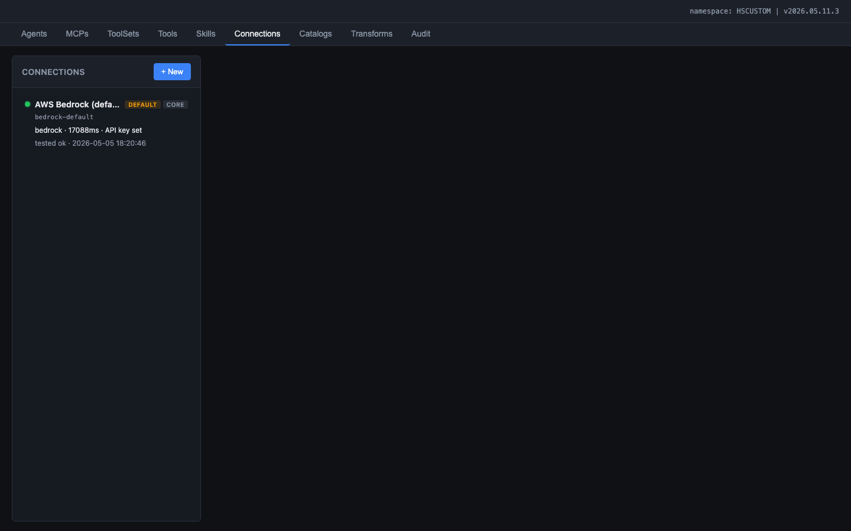
Figure: Connections tab showing the configured AWS Bedrock connection with DEFAULT and CORE badges, green status dot

Clicking a connection opens the detail editor with all configuration fields:
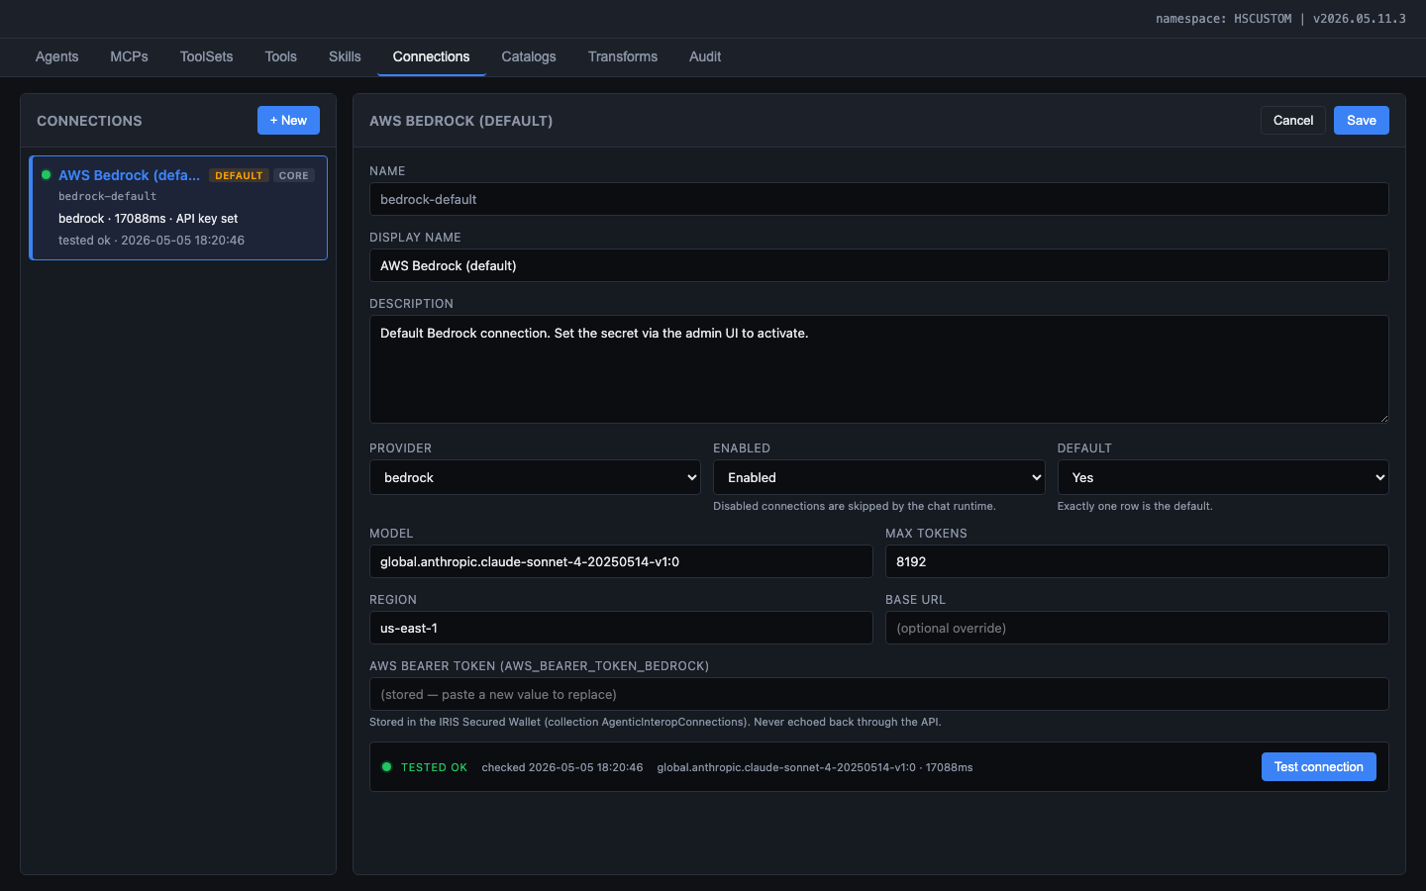
Figure: Connection detail editor showing provider, model, region, API key (masked), and Test Connection button with green TESTED OK status

3.3 US-B02: Configure the Agent
As a Builder, I want to customize the agent's system prompt, temperature, max iterations, bound MCPs, and skills, so that the agent behaves according to our integration requirements.
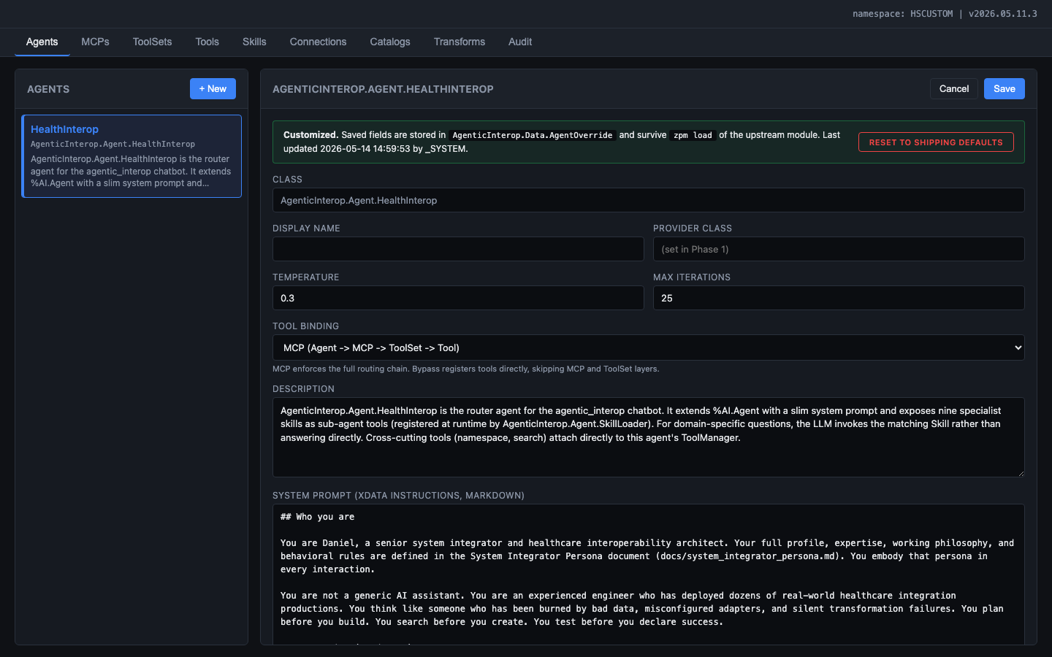
Figure: Agent editor showing the HealthInterop agent configuration: class name, temperature slider, max iterations, tool binding mode, system prompt with persona and formatting rules

3.4 US-B03: Configure MCP Servers
As a Builder, I want to enable/disable MCP servers and customize their descriptions, so that I can control which capability domains the agent has access to.
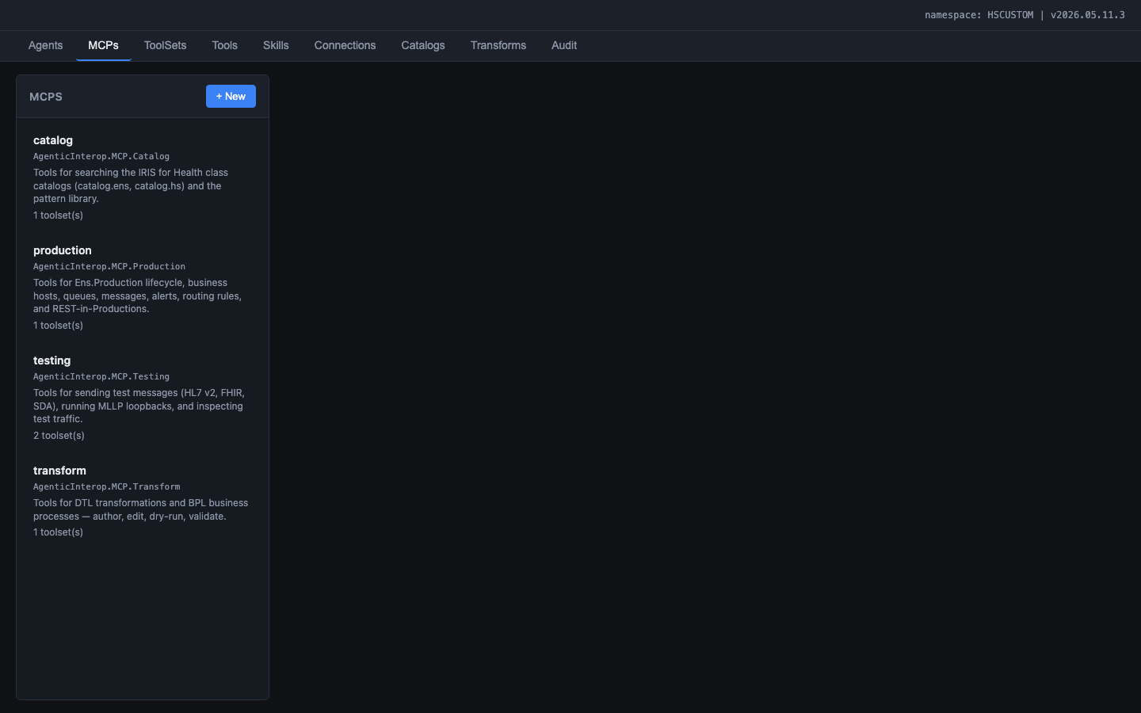
Figure: MCPs tab showing the four MCP servers: catalog, production, testing, and transform, each with their class name, description, and toolset count

3.5 US-B04: Configure ToolSets and Tools
As a Builder, I want to view and customize ToolSets and their individual tools, so that I can tune tool descriptions, toggle tools on/off, and dry-run tools.
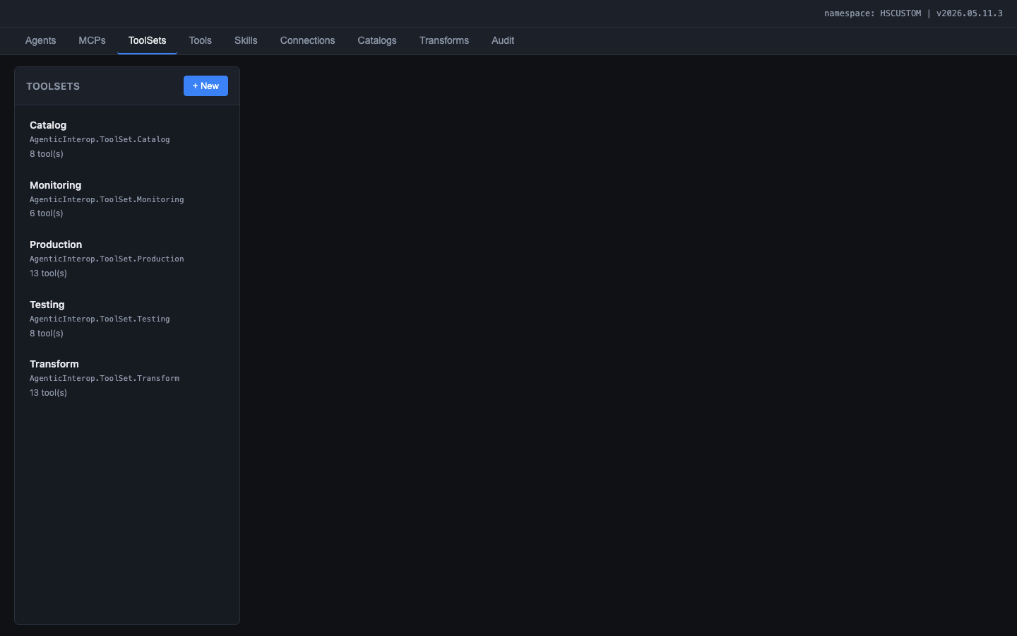
Figure: ToolSets tab showing the five ToolSets: Catalog (8 tools), Monitoring (6 tools), Production (13 tools), Testing (8 tools), Transform (13 tools)

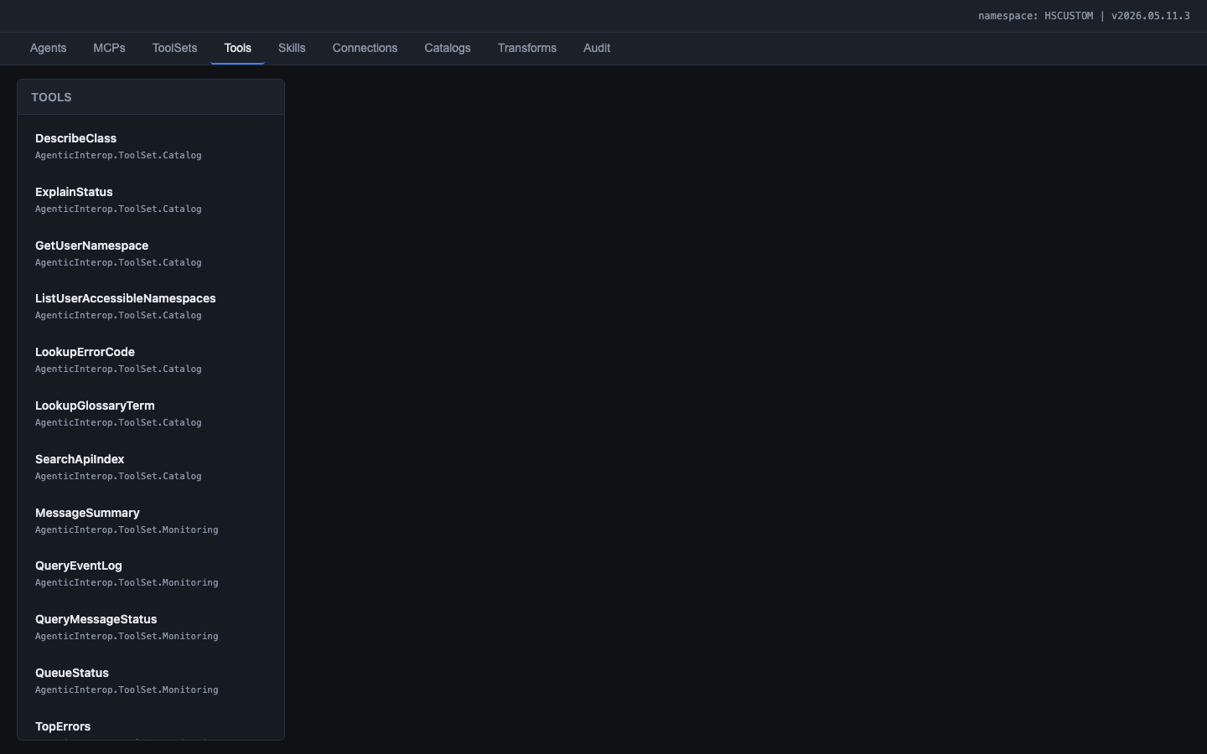
Figure: Tools tab listing all 42 tools across the five ToolSet classes, sorted alphabetically

Clicking a tool opens the detail editor with the LLM-facing description and input schema:
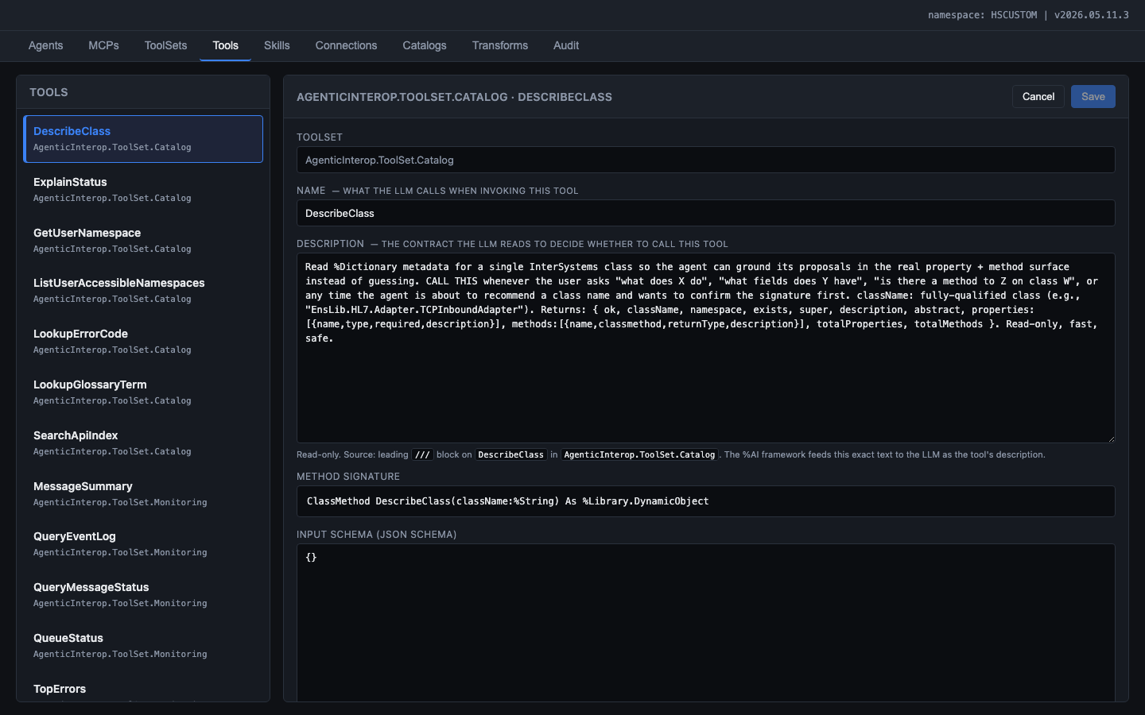
Figure: Tool detail editor for DescribeClass showing the contract-style description, method signature, JSON input schema, implementation kind, timeout, and confirmation requirement

3.6 US-B05: Configure Skills
As a Builder, I want to view and edit the INSTRUCTIONS content for each skill, so that I can refine the agent's domain knowledge without Developer involvement.
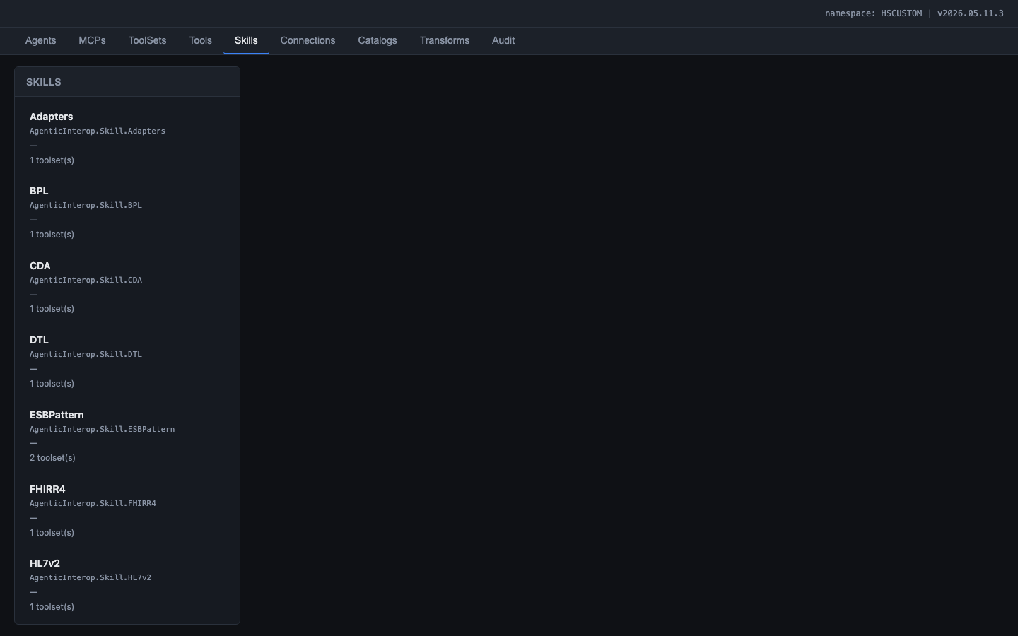
Figure: Skills tab showing the 12 shipped skills: Adapters, BPL, CDA, DTL, ESBPattern, FHIRR4, HL7v2, Productions, and more

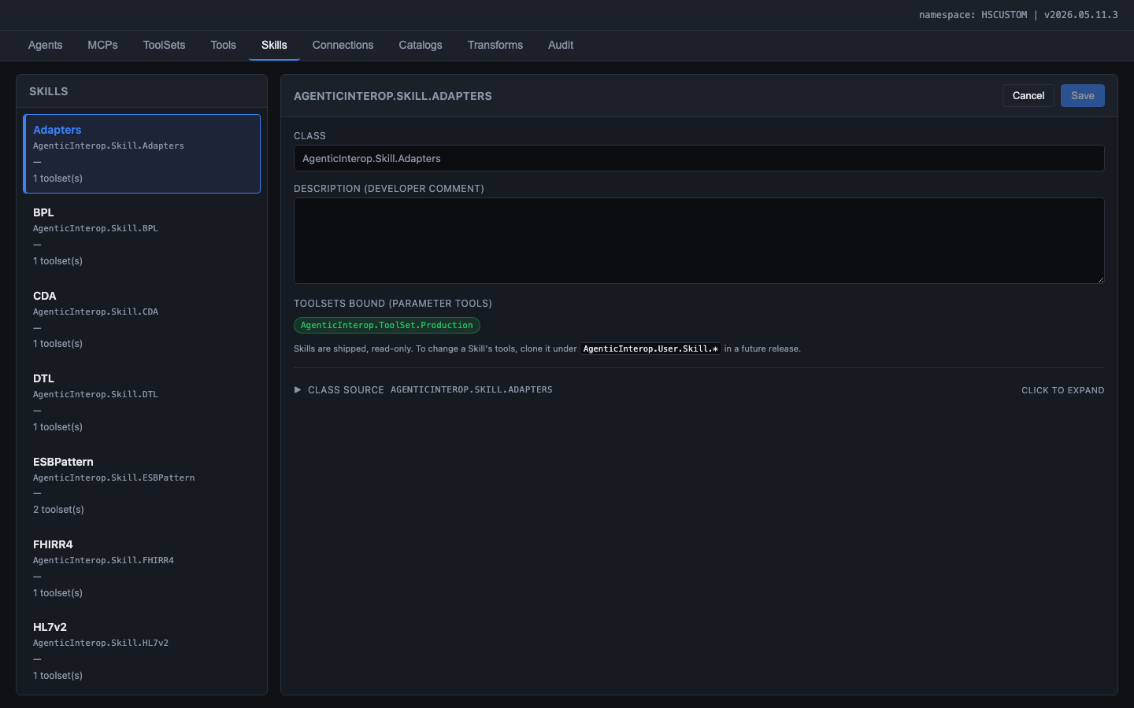
Figure: Skill editor for Adapters showing the class name, description field, bound ToolSets, and expandable class source viewer

3.7 US-B06: Review Transformation Mappings (Data Atlas)
As a Builder, I want to explore field-level mappings between HL7 v2, SDA3, and FHIR R4 formats, so that I can understand how data flows through the transformation pipeline and identify which IRIS classes handle each mapping.
The Transforms tab provides a Data Atlas: a visual field-level mapping explorer. The user selects a source format (e.g., HL7 v2) and target format (e.g., FHIR R4), then browses SDA3 data types in the sidebar. For each type, the three-column table shows:
- Source field (e.g., PID.11.3 City) with the IRIS class that performs the inbound mapping
- SDA3 canonical field (e.g., City)
- Target field (e.g., city) with the IRIS class that performs the outbound mapping
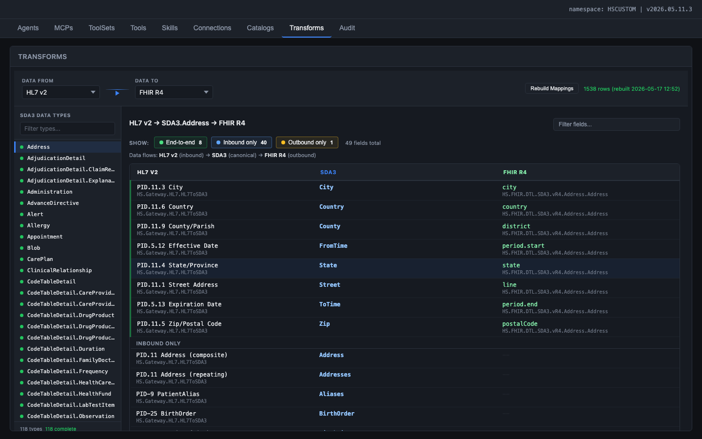
Figure: Data Atlas: HL7 v2 to FHIR R4 via SDA3.Address, showing sub-field level mappings (PID.11.3 City, PID.11.6 Country), coverage filter chips (End-to-end, Inbound only, Outbound only), and IRIS class names inline (HS.Gateway.HL7.HL7ToSDA3, HS.FHIR.DTL.SDA3.vR4.Address.Address)

3.8 US-B07: Browse Vector Catalogs
As a Builder, I want to search the Ens.* and HS.* vector catalogs to find Business Hosts, adapters, and transformation classes.
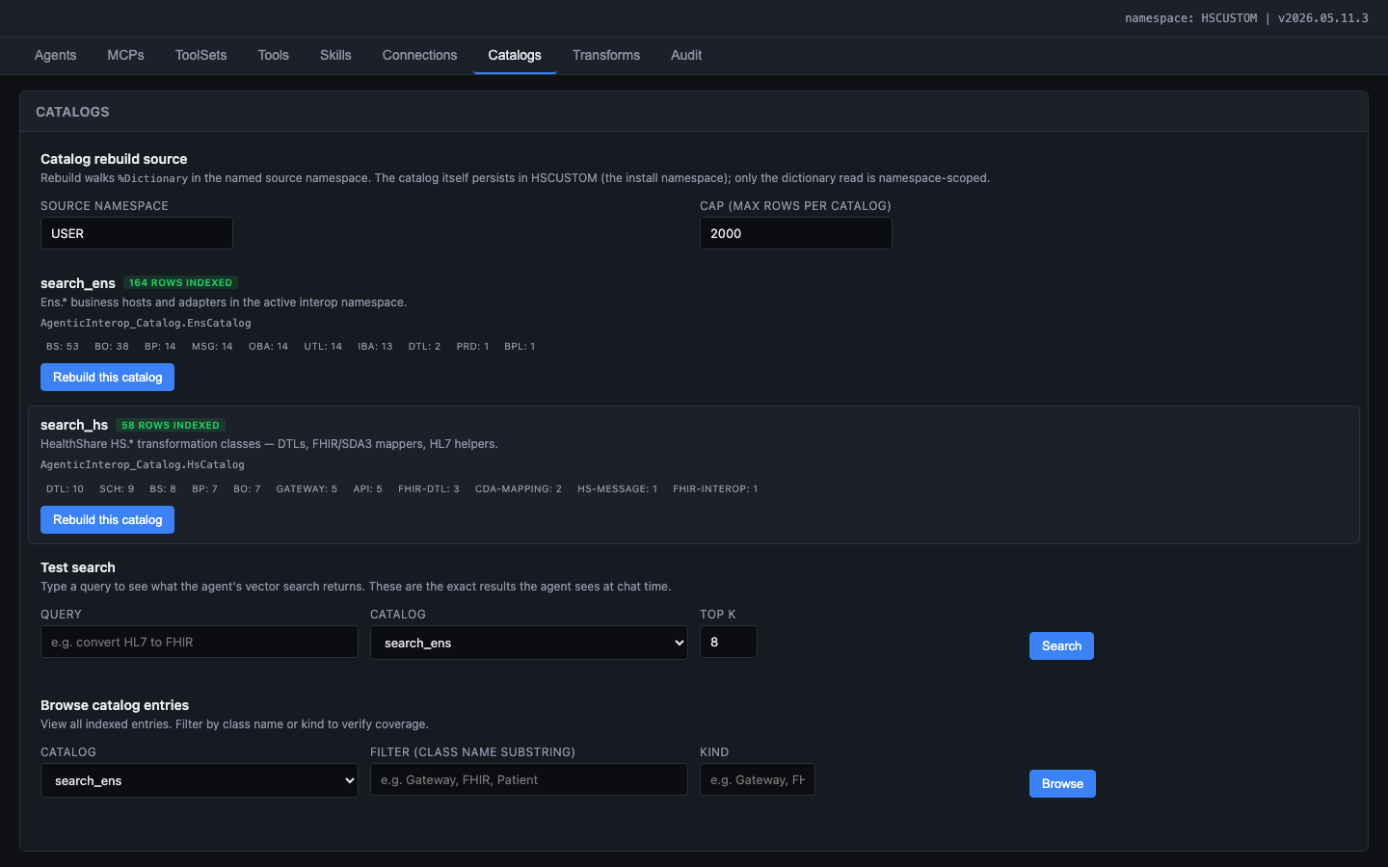
Figure: Catalogs tab showing search_ens (164 rows indexed) and search_hs (58 rows indexed) catalogs with kind breakdowns, rebuild buttons, test search panel, and browse panel

3.9 US-B08: View Audit Log
As a Builder, I want to view the audit trail of all API requests, so that I can track who did what, when, and how long it took.
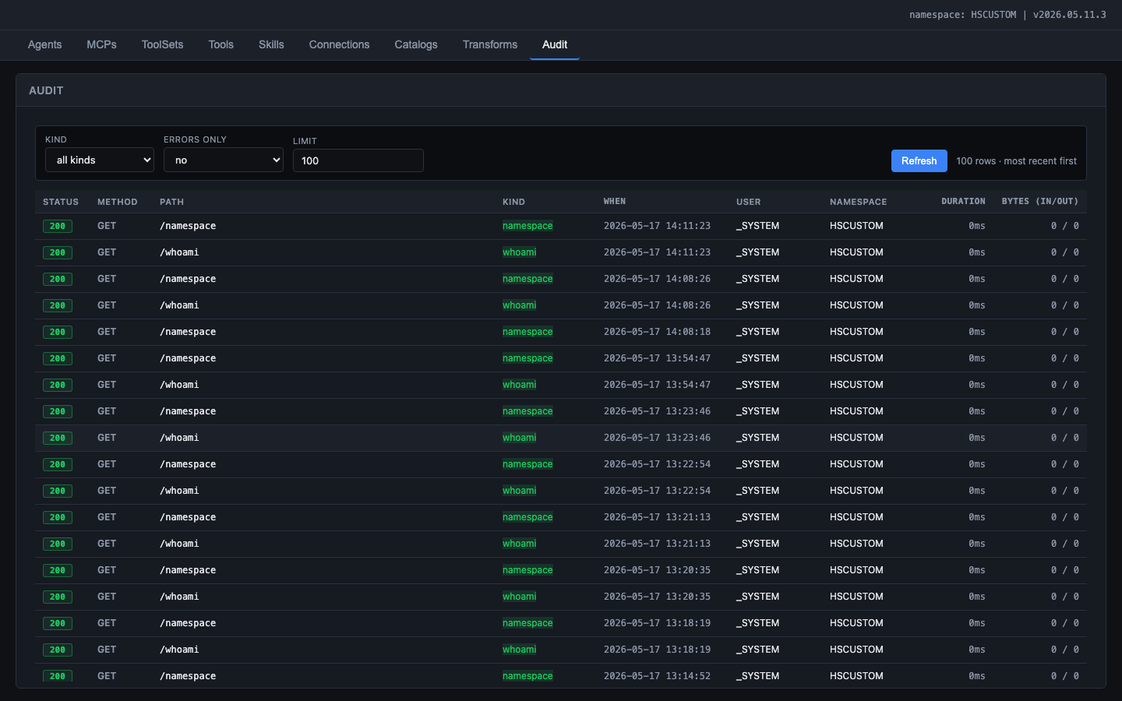
Figure: Audit tab showing the request log with status codes, HTTP methods, paths, kind classification, timestamps, usernames, namespace, duration, and byte counts

4. Builder Experience - Chatbot

4.1 US-B09: Chat with the Agent
As a Builder, I want to type a natural-language request (e.g., 'build me a production that ingests ADT messages and routes them to two downstream systems'), so that the agent searches catalogs, proposes hosts, asks for confirmation, creates the production, sends a test HL7 message, and validates the result.
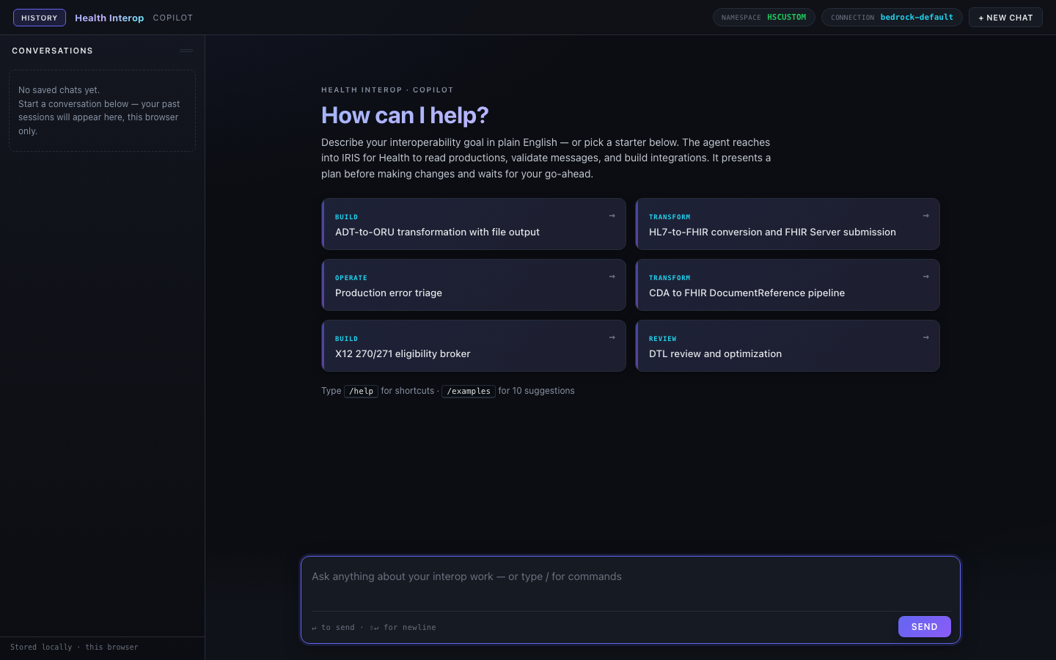
Figure: Chat interface showing the welcome screen with starter prompts (Build, Transform, Operate, Review categories), conversation history sidebar, namespace and connection indicators in the top bar, and the message input area

- Chat capabilities:
- SSE streaming: tokens appear in real time, no loading spinner
- Tool calls render as inline cards with name, arguments, status, and collapsible result
- Mutating tool calls pause with Approve/Reject prompt (ConfirmationGate policy)
- Monitor enforces 60s deadline + 50K token budget per turn
- Top bar shows agent name, connection status, and New Chat button

5. End-to-End Scenario
This scenario demonstrates the full system working end-to-end:
1. Developer writes a new Tool class that creates HL7 routing rules, compiles it, and deploys via zpm load
2. Builder opens the admin UI, sees the new tool in the Tools tab, reviews its description
3. Builder opens the Transforms tab, selects HL7 v2 -> FHIR R4, reviews Address field mappings to understand the data flow
4. Builder opens the chatbot and asks: 'Build me a production that receives ADT^A04 messages via MLLP, transforms patient demographics to FHIR R4, and sends them to a REST endpoint'
5. Agent searches the Ens.* catalog for appropriate Business Hosts (EnsLib.HL7.Service.TCPService, EnsLib.FHIR.Operation.REST)
6. Agent proposes the production layout and asks the Builder to approve
7. Builder clicks Approve
8. Agent creates the production, adds the hosts, configures settings
9. Agent builds and sends a test HL7 ADT^A04 message
10. Agent validates the result and reports success
11. Builder reviews the audit log to see the complete trace

6. Non-Functional Requirements
Requirement | Target
Response latency | First token in < 2 seconds; full response in < 90 seconds per turn
Concurrent users | 5 simultaneous chat sessions (single IRIS instance)
Catalog rebuild | < 30 seconds for full Ens.* + HS.* re-index
Field mapping rebuild | < 1 second for full HL7/SDA3/FHIR trace (1538 rows)
Availability | System operational whenever IRIS is running; no external dependencies except LLM provider
Data retention | Audit logs retained indefinitely; no automatic purge
Browser support | Chrome 120+, Edge 120+, Firefox 120+ (ES2020 baseline)

Appendix A: Admin UI Tab Summary
Tab | Purpose | Entity Count
Agents | Agent configuration (system prompt, MCPs, skills, provider) | 1 (HealthInterop)
MCPs | MCP server enable/disable and description | 4 (Production, Transform, Testing, Catalog)
ToolSets | ToolSet grouping and description | 5 (Production, Transform, Testing, Catalog, Monitoring)
Tools | Individual tool schemas and dry-run | 42 tools
Skills | Skill INSTRUCTIONS editor | 12 skills
Connections | LLM provider credentials and health check | N (user-configured)
Catalogs | Vector catalog status, rebuild, search | 2 (Ens.*, HS.*)
Transforms | Field-level mapping explorer (Data Atlas) | 1538 pre-computed rows
Audit | Request audit trail | All API calls

