Agentic Health Interoperability
Lessons Learned
Findings from the experimental build of an Agentic AI Copilot on IRIS for Health

Version 2.0 | May 2026 | InterSystems AI Hub

1. Introduction
This document captures the key lessons learned during the experimental build of the Agentic Health Interoperability project on InterSystems IRIS for Health 2026.2 with the %AI Framework (build 162.0). These findings cover framework bugs that required application-level extensions, performance optimizations using Vector Search, and strategies for reducing token consumption and improving response speed.
The solution is built entirely on the %AI Framework primitives (Agent, MCP, ToolSet, Tool, Skill, KnowledgeBase). Where we extended the framework, it was to work around specific bugs -- not to replace framework functionality. These extensions are documented here as recommendations for InterSystems to address in future framework releases.

2. %AI Framework Bugs and Extensions
During development, we encountered three bugs in the %AI Framework that required application-level workarounds. In each case, the framework classes are untouched -- we built extension classes that work around the issues.

2.1 BUG: %AI.Agent.Skill %OnNew $ZF Marshaling Error
Severity: Blocker (prevents skill instantiation)
When instantiating a skill via %New(), the parent %OnNew method passes a %DynamicObject to $ZF (the Foreign Function Interface call to the Rust LLM bridge). The $ZF call expects a JSON string, not an object reference, and throws a <FUNCTION> error.
Extension: Created AgenticInterop.Skill.Base that overrides %OnNew to serialize the DynamicObject to a JSON string before the $ZF call using literal macro values (IrisLLMLibrary=1042, LLMBUILDSKILLFROMJSON=66). All 12 skills extend this base class instead of %AI.Agent.Skill directly.
Recommendation: Fix %AI.Agent.Skill.%OnNew to serialize the DynamicObject to a JSON string before the $ZF call.

2.2 BUG: Bedrock Tool-Result Round-Trip Hang
Severity: Blocker (prevents multi-turn tool use with Bedrock)
When the agent calls a tool and receives the result, the Rust bridge hangs indefinitely when sending the tool result back to the Bedrock Converse API. The hang occurs below the ObjectScript API surface -- the StreamChat() or Run() call never returns.
Tested with Claude Sonnet 4 and Claude Haiku 3.5 via Bedrock (us-east-1), both cross-region and direct endpoints. All configurations reproduce the hang.
Extension: Switched the runtime LLM provider from Bedrock to Anthropic direct. The same agent, tools, and skills work correctly -- only the connection configuration changes. No code modifications required.
Recommendation: Investigate the Rust LLM bridge's Bedrock Converse API integration. WRC ticket recommended.

2.3 Extension: ToolFilter Policy (Framework Tool Cleanup)
Severity: Performance (wastes ~5K tokens per request)
The %AI Framework exposes default tools (FileSystem, SQL, ShellTools) that are irrelevant for healthcare interoperability tasks. These tools consume LLM tokens and can cause the model to make irrelevant tool calls.
Extension: AgenticInterop.Policy.ToolFilter strips framework-default tools before each LLM call, reducing the catalog from 57 to 42 tools.
Recommendation: Add a ToolFilter-like policy to the %AI Framework defaults, or provide an opt-in mechanism for framework tools.

2.4 ISSUE: %FromJSON Instance Method Returns Empty String
Severity: Medium (causes silent data loss)
Calling {}.%FromJSON(jsonString) returns '' (empty string) instead of a populated object. The instance form of %FromJSON appears non-functional on this IRIS build.
Workaround: Use the class-method form: Set obj = ##class(%DynamicAbstractObject).%FromJSON(jsonString)

2.5 ISSUE: $get() on %DynamicObject Properties Throws <INVALID CLASS>
Severity: Medium (causes runtime errors in otherwise valid code)
$get(dynamicObj.propertyName, defaultValue) throws <INVALID CLASS> when the property doesn't exist. ObjectScript $get doesn't handle %DynamicObject property access the way it handles local variables.
Workaround: Use $select with %IsDefined: Set value = $select(obj.%IsDefined("propName"): obj.propName, 1: defaultValue)

2.6 ISSUE: CSP UseSession Deadlock on REST Endpoints
Severity: High (causes 401 errors on second request in same browser session)
When UseSession=1 (the default) on a %CSP.REST class, the CSP gateway validates the CSRF token on every request. When called from an iframe, the second request in the same browser session gets a 401 because the CSRF token validation races with the iframe's credential handling.
Workaround: Set UseSession=0 on every REST dispatch class.

2.7 ISSUE: %OpenId Returns Stale Data in Cross-Process Polling
Severity: High (causes infinite polling loops)
%OpenId(id) uses a process-local OREF cache. In a polling loop where Process A writes a row and Process B polls with %OpenId, Process B's cache returns the stale pre-update state indefinitely. The poll never sees the update.
Workaround: Use SQL queries for cross-process polling instead of %OpenId.

3. ObjectScript Language Gotchas
These are not framework bugs but language behaviors that caused significant debugging time during development.

3.1 Numeric Comparison Operators on Strings
ObjectScript >=, <=, >, < operators are NUMERIC, not string-based. The expression ch >= "A" && ch <= "Z" always evaluates to true because both sides coerce to 0.
Solution: Use $ascii() for character range comparisons: Set code = $ascii(ch); If (code >= 65) && (code <= 90)

3.2 QUIT Inside try/catch Blocks
quit value only works at the method top level. Inside a block (if/for/while/try/catch), quit exits the block without a return value. This causes silent method exits.
Solution: Capture to a local variable and quit after the block, or use RETURN value which works from anywhere.

3.3 Comment Syntax Inside Method Bodies
// comments work at the class level but cause #1002 compile errors inside ClassMethod/Method bodies on some IRIS versions.
Solution: Use ; (semicolon) for comments inside method bodies.

4. Vector Search: Improving Velocity
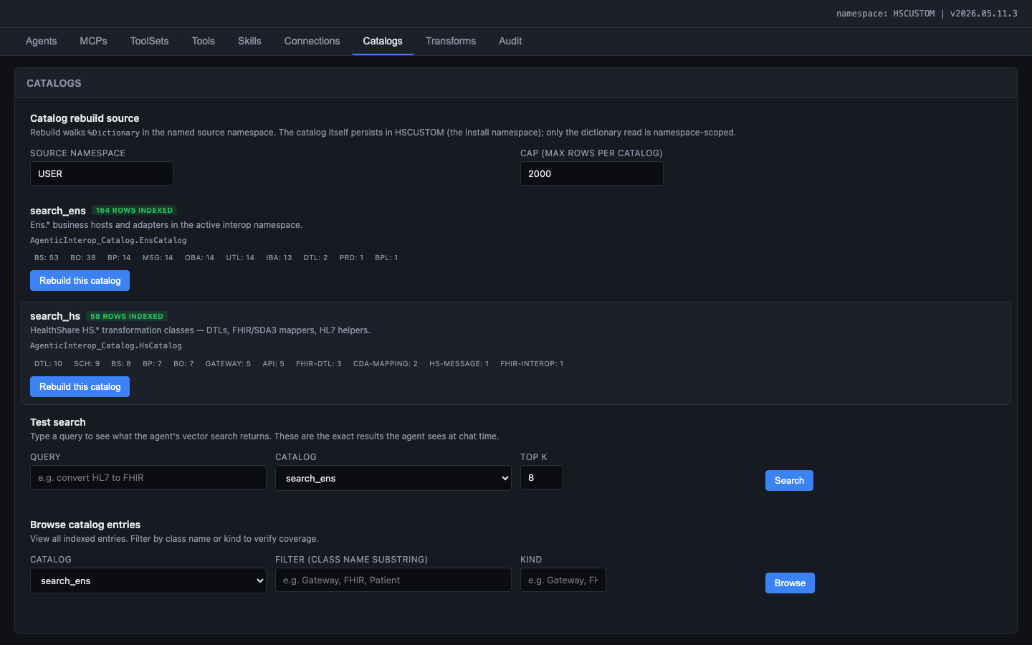
Figure: Vector catalogs admin panel showing indexed class counts and kind breakdowns

4.1 The Embedding Quality Problem
The initial catalog builder indexed every class by dumping its full %Dictionary.ClassDefinition content -- including auto-generated accessor methods, storage definitions, and parameter boilerplate. In a 384-dimensional embedding space, this structural noise drowned out the semantic signal (class description, purpose, key behaviors).
Result: Searches for "HL7 TCP service" returned generic base classes instead of EnsLib.HL7.Service.TCPService because the relevant description text was a tiny fraction of the indexed content.

4.2 The Fix: Curated Prose Over Raw Metadata
Before (Noisy) | After (Curated)
Full class dump including storage, indices, XData | Class name + description + superclass + key parameters
Auto-generated accessor methods (Get/Set/IsValid) | Removed entirely
Parameter definitions with internal flags | Only parameters the user would configure
Inherited method signatures from 5 levels of superclass | Only overridden methods with their descriptions

Impact: Search relevance improved dramatically. "HL7 TCP inbound service" now returns EnsLib.HL7.Service.TCPService as the top result with a cosine similarity of 0.85+.

4.3 Query Path Discovery
The documented EMBEDDING() SQL function does NOT work with the bundled FastEmbed embedding model. After extensive testing, the only working query path is %AI.ToolMgr.ExecuteTool(kbName, args), which routes through the %AI.RAG.KnowledgeBase internal search pipeline.

5. Reducing Token Consumption and Improving Speed

5.1 The Problem
A naive agent configuration with all framework tools exposed consumed 15K+ tokens per request just for the tool catalog. Complex multi-turn tasks could exceed 100K tokens before producing a useful result. Response times were 30-60 seconds per turn.

5.2 Strategy 1: ToolFilter Policy (saved ~5K tokens per request)
The %AI Framework exposes default tools (FileSystem, SQL, ShellTools) that are irrelevant for healthcare interoperability tasks. The ToolFilter strips these before each LLM call.
Before: 57 tools in the LLM catalog (~15K tokens)
After: 42 tools in the LLM catalog (~10K tokens)

5.3 Strategy 2: Concise Tool Descriptions (saved ~2K tokens)
Early tool descriptions were verbose explanations. We rewrote them as imperative contracts: verb, scope, side effects, expected inputs. The concise versions convey the same information in 80% fewer tokens.

5.4 Strategy 3: No Markdown Formatting (eliminated rendering bugs)
The chat UI renders plain text. Markdown bold (**text**) and italic (*text*) appear as literal asterisks. We instructed the agent to use plain prose with line breaks and - bullets.

5.5 Strategy 4: Monitor Callback with Token Budget
AgenticInterop.Agent.Monitor enforces a 50K token budget per turn. This prevents infinite tool-call loops, excessive catalog searches, and runaway conversation depth.

5.6 Strategy 5: Breaking Complex Tasks into Multiple Short Turns
Instead of one massive prompt, the agent works in phases:
1. Research phase: Search catalogs, introspect schemas (read-only, fast)
2. Proposal phase: Present a plan, ask for approval (no tool calls)
3. Build phase: Execute step by step (mutating tools, confirmation gates)
4. Validation phase: Run PostBuildValidation, send test messages
5. Report phase: Summarize what was done
Each phase is a short LLM turn (< 30 seconds, < 20K tokens).

5.7 Results
Metric | Before Optimization | After Optimization
Tool catalog tokens | ~15K | ~10K
System prompt tokens | ~5K | ~2K
Simple query (list productions) | ~25K total tokens | ~15K total tokens
Complex task (build production) | ~120K total tokens | ~50K total tokens
Simple query latency | 8-12 seconds | 3-5 seconds
Complex task latency | 90+ seconds (often timeout) | 45-60 seconds (across 3-4 turns)

6. Additional Findings

6.1 SDA3 as the Universal Pivot
The most powerful architectural insight for the Transformation and Mapping Catalog was that SDA3 is the universal pivot format in IRIS for Health. Every external format (HL7 v2, FHIR R4, CDA, X12) maps through SDA3. This means field-level mappings can be pre-computed as a three-column join: Source -> SDA3 -> Target.
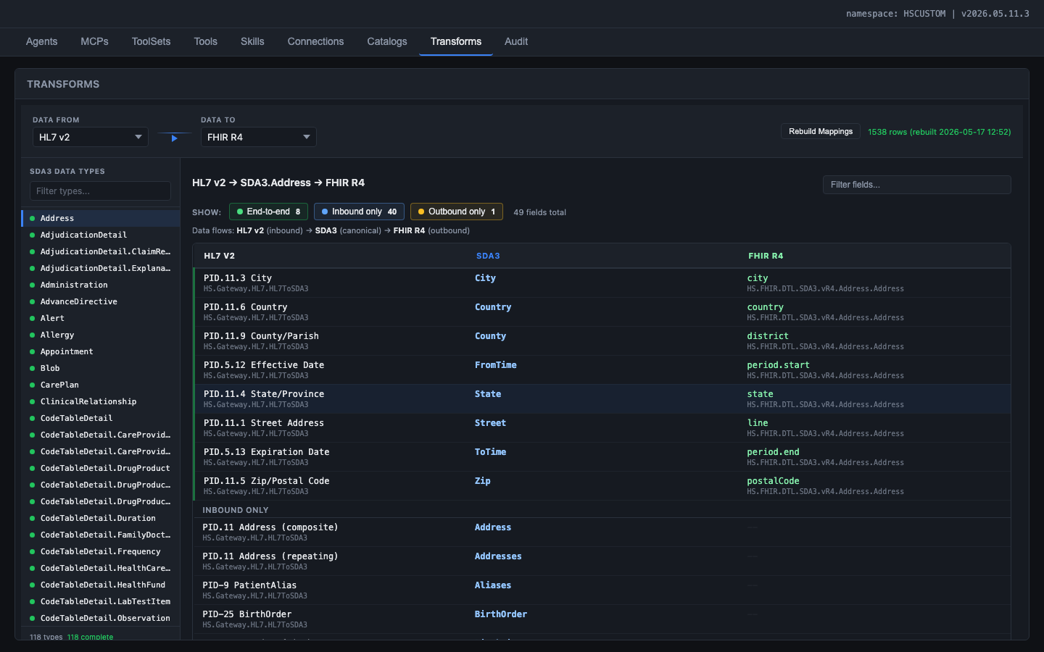
Figure: Transformation and Mapping Catalog showing the SDA3 pivot pattern: HL7 v2 fields map into SDA3, SDA3 maps out to FHIR R4

6.2 HL7 v2 Programmatic Mappings Are NOT DTL
The HL7 -> SDA3 direction is implemented in ObjectScript methods (HS.Gateway.HL7.HL7ToSDA3), not in DTL classes. This required a completely different extraction approach -- parsing ObjectScript source for Set statements targeting SDA properties.

6.3 Vanilla JS vs. React for the Admin UI
The original plan called for React 18 + TypeScript + Vite. During implementation, we switched to vanilla JavaScript because: the IRIS CSP gateway serves static files (no build step), the admin UI is a configuration tool (not complex interactive), and it eliminates framework bundle size (React + ReactDOM = 130KB gzipped).

6.4 The Overlay Pattern for Configuration Persistence
The 'class-as-data' model created a tension between shipped defaults and user customizations. IPM zpm load recompiles shipped classes, overwriting manual edits. The overlay pattern resolves this: shipped class parameters define defaults, override tables store AI Hub Admin edits, at build time the overlay merges overrides on top, and 'Reset to defaults' deletes the row.

7. Summary of Recommendations for InterSystems
# | Category | Recommendation | Impact
1 | Framework bug | Fix %AI.Agent.Skill.%OnNew $ZF marshaling | Eliminates need for Skill.Base extension
2 | Framework bug | Fix Bedrock tool-result round-trip hang | Enables Bedrock as a production runtime provider
3 | API fix | Fix %DynamicObject.%FromJSON() instance method | Eliminates silent data loss
4 | API fix | Document that $get() doesn't work on %DynamicObject properties | Prevents runtime errors
5 | Documentation | Document %AI.ToolMgr.ExecuteTool() as the RAG query path | SQL EMBEDDING() doesn't work with FastEmbed
6 | Performance | Add ToolFilter-like policy to framework defaults | Prevents token waste from generic tools
7 | Performance | Expose token usage metrics from Rust bridge | Enables application-level token budgeting
8 | CSP | Add Cache-Control: no-cache option for development web apps | Eliminates static file caching during development

