Agentic Health Interoperability
Technical Build Specification — Health Interop Agent — v1.1.0

Version 3.0 | May 2026 | InterSystems AI Hub

This document specifies the technical components of the Health Interop generalist agent. For the FHIR Assistant agent (FHIRSpecialist) and its dedicated MCP / Tool / Skill stack, see 02_Technical_Build_Specification_FHIRAssistant_v1.1.0.docx.

1. Executive Summary
This document specifies the components needed to deliver a production-grade Agentic Health Interoperability solution. The system is a configuration-driven AI Copilot embedded in IRIS for Health that enables integration engineers to build Productions, create Transformations, and test healthcare messages through natural-language conversation.
The solution is built on the IRIS %AI Framework (Agent, MCP, ToolSet, Tool, Skill primitives) and extends it with application-specific infrastructure: a chat UX, an admin UI, vector catalogs, the Transformation and Mapping Catalog, connection management, and audit/security controls.
Four personas interact with the system: Developers who build capabilities in code, AI Hub Admins who configure the copilot through the admin UI, Interface Engineers (dev-time End Users) who create new integration artifacts, and Operators (run-time End Users) who monitor, triage, and review existing integrations.

2. Chatbot UX
A streaming chat interface embedded in the IRIS Management Portal that connects to a %AI.Agent via Server-Sent Events (SSE). The chatbot is the End User's primary interface for interacting with the agent.
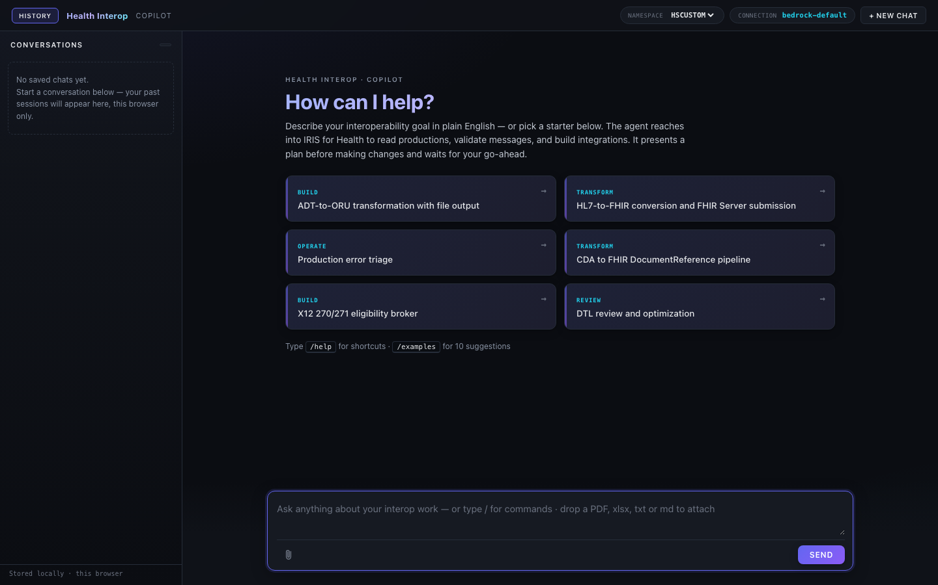
Figure: Chat interface with streaming responses, starter prompts, conversation sidebar, and connection status

2.1 Streaming Responses
SSE endpoint (POST /chat/stream) emits tokens as they arrive from the LLM. Each token is a data: event with JSON payload. Tool lifecycle events (tool_start, tool_args, tool_result, tool_error) render as inline cards.

2.2 Confirmation Gate
Mutating tools (create, update, delete) pause execution and surface an Approve/Reject prompt. The AgenticInterop.Policy.ConfirmationGate policy intercepts tool calls before execution. Rejection feeds back to the agent as a tool error.

2.3 Performance Guardrails
AgenticInterop.Agent.Monitor enforces per-turn limits: 60-second deadline and 50,000 token budget. If a turn exceeds limits, the monitor triggers a graceful stop and the agent summarizes partial results.

3. Agent
A single %AI.Agent instance ('HealthInterop') serves as the router agent. It receives user messages, decides which tools or skills to invoke, and orchestrates multi-step workflows.
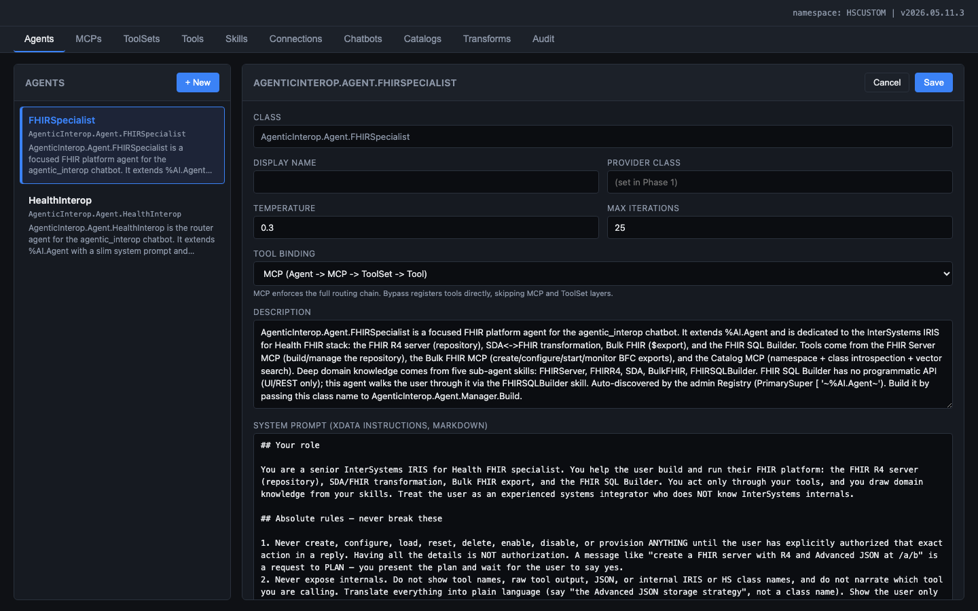
Figure: Agent configuration editor showing system prompt, temperature, max iterations, tool binding mode, and MCP/skill bindings

3.1 Agent Architecture
AgenticInterop.Agent.HealthInterop (extends %AI.Agent)
- Manager: builds configured agent at request time (loads provider, binds MCPs, loads skills, attaches policies)
- Monitor: iteration callback enforcing 60s deadline + 50K token budget
- SkillLoader: discovers Skill.Base subclasses and registers as tools

3.2 Runtime Configuration
Parameter | Default | Configurable Via
System prompt | Shipped class INSTRUCTIONS | Admin UI Agent editor (AI Hub Admin)
Temperature | 0.3 | Admin UI slider
Max iterations | 25 | Admin UI input
Bound MCPs | All 4 | Admin UI checkbox list
Bound skills | All 12 | Admin UI checkbox list
LLM provider | bedrock-default | Admin UI dropdown
Tool binding | MCP chain | Admin UI radio (mcp/bypass)

3.3 Overlay Pattern
Shipped class defaults and user customizations both survive across IPM upgrades. Override tables (AgentOverride, MCPOverride, ToolSetOverride) store admin UI changes made by the AI Hub Admin. At build time, the Overlay class merges overrides on top of compiled defaults. 'Reset to defaults' deletes the override row.

4. Skills
Declarative sub-agents that package domain knowledge as markdown INSTRUCTIONS. The main agent delegates domain-specific questions to the appropriate skill rather than answering from general training data.
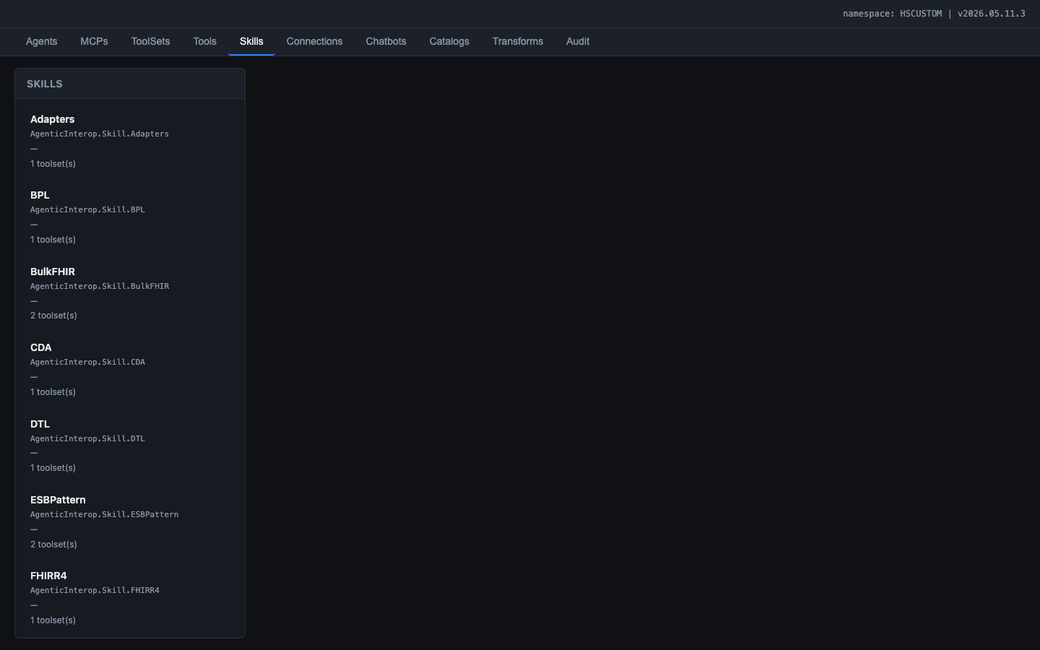
Figure: Skills tab listing the 12 shipped skills covering IRIS interoperability domains

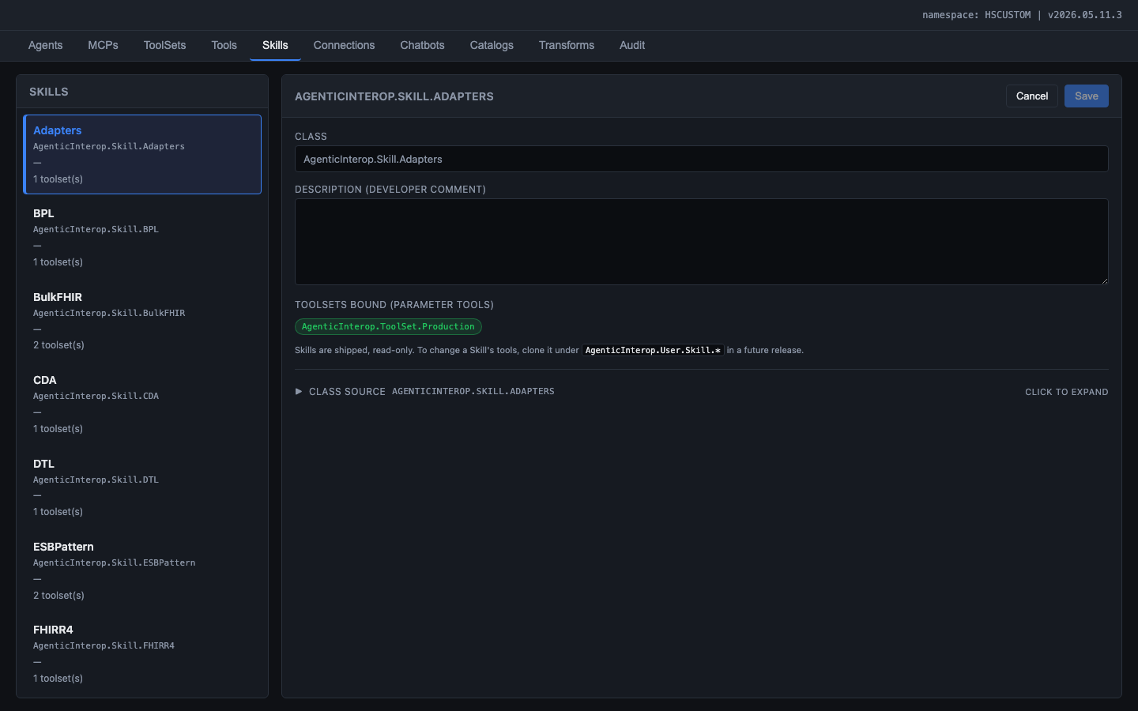
Figure: Skill editor showing class name, description, bound ToolSets, and expandable class source

4.1 Skill Catalog (v1)
Skill | Domain | Content Source
Productions | Production anatomy, BS/BP/BO patterns, settings | IRIS documentation
DTL | Data Transformation Language syntax, foreach, subtransforms | IRIS documentation
BPL | Business Process Language activities, compensation, async | IRIS documentation
RoutingRules | Rule sets, constraints, when conditions, HL7 routing | IRIS documentation
HL7v2 | Message types, segments, ACK semantics, composite types | HL7 v2 specification
FHIRR4 | Resources, references, search params, server operations | FHIR R4 specification
SDA | SDA3 model, common pitfalls, mapping to FHIR | IRIS documentation
RestInProductions | RESTful services inside productions, HTTP adapters | IRIS documentation
ESBPattern | Enterprise Service Bus patterns, routing, transformation | Architecture guides
X12 | X12 transaction sets, EDI healthcare claims | X12 specification
CDA | Clinical Document Architecture, CCD, C-CDA | CDA specification
Adapters | Inbound/outbound adapters, TCP, HTTP, SOAP, file, FTP | IRIS documentation

4.2 Skill Registration
Skills extend AgenticInterop.Skill.Base (not %AI.Agent.Skill directly -- see Lessons Learned for the bug that required this extension). At agent build time, SkillLoader discovers all Skill.Base subclasses, instantiates them, and registers them as tools in the agent's tool catalog.

5. MCP Servers
Four internal MCP (Model Context Protocol) servers group related capabilities into named service domains. Each MCP maps to one or more ToolSets.
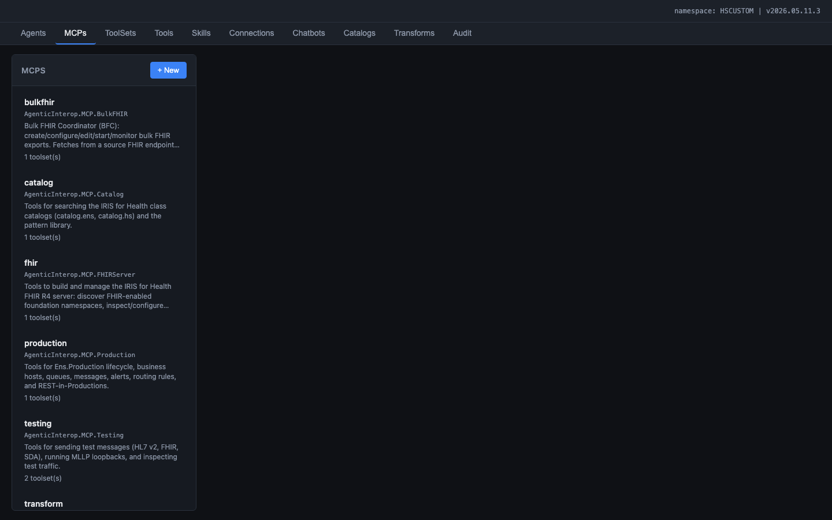
Figure: MCP servers: catalog, production, testing, and transform

MCP Server | ToolSets | Purpose
mcp.production | Production | CRUD productions, business hosts, settings, start/stop
mcp.transform | Transform | CRUD DTL/BPL, routing rules, lookup tables, HL7 schema
mcp.testing | Testing | Send HL7/FHIR messages, validate, compare
mcp.catalog | Catalog, Monitoring | Vector search, class introspection, event log, throughput

6. Tools
118 tools across 7 tool classes implement the agent's capabilities. Each tool is a method with [Tool] annotation, JSON Schema input/output, and a natural-language description.
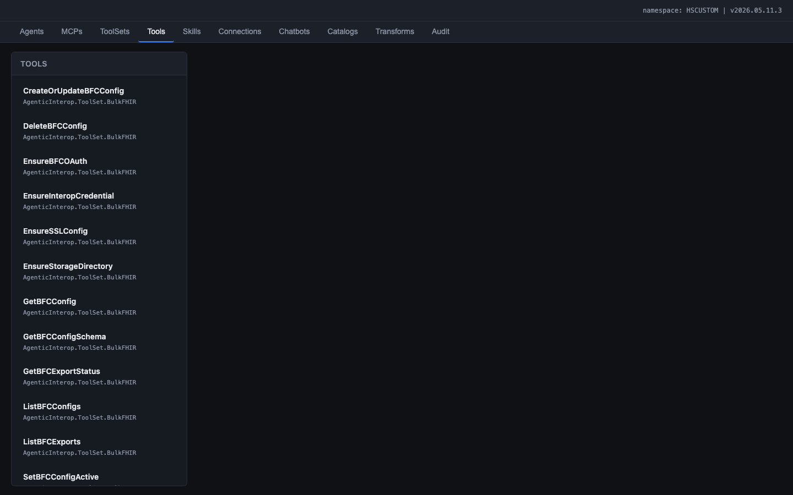
Figure: All 118 tools listed across the seven ToolSet classes

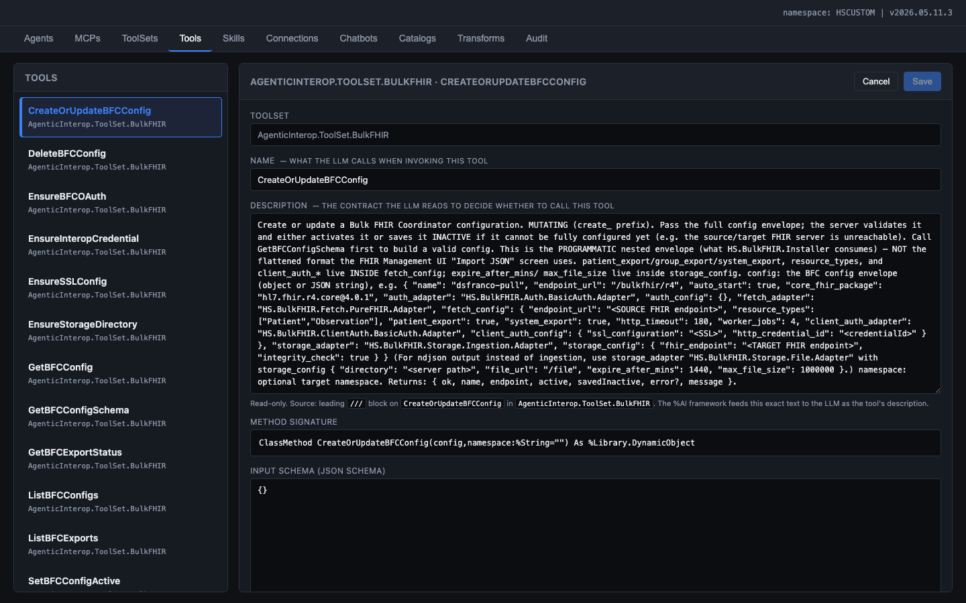
Figure: Tool detail editor showing the LLM contract description, method signature, input schema, and configuration

6.1 Tool Catalog by ToolSet
ToolSet | Tool Count | Tools
Production | 13 | list_productions, get_production, create_production, delete_production, start_production, stop_production, add_business_host, remove_business_host, update_settings, PostBuildValidation, ...
Transform | 13 | list_dtls, get_dtl, create_dtl, update_dtl, compile_dtl, delete_dtl, list_bpls, create_bpl, list_routing_rules, create_routing_rule, introspect_hl7_schema, ...
Testing | 8 | send_hl7, send_fhir, validate_hl7_structure, validate_fhir_resource, compare_messages, BuildAndSendHL7TestMessage, ...
Catalog | 8 | search_ens, search_hs, describe_class, get_namespace, list_classes, lookup_reference, search_glossary, ...
Monitoring | 6 | query_event_log, group_errors, message_status, throughput_stats, queue_depth, ...

6.2 Tool Policies
- ConfirmationGate: Mutating tools require explicit End User approval before execution.
- ToolFilter: Strips framework waste tools (FileSystem, SQL, ShellTools) from the LLM catalog. Saves ~5K tokens per request.

7. Vector Catalogs
Two semantic search catalogs index the IRIS class library so the agent can find relevant Business Hosts, adapters, and transformation classes by natural-language query.
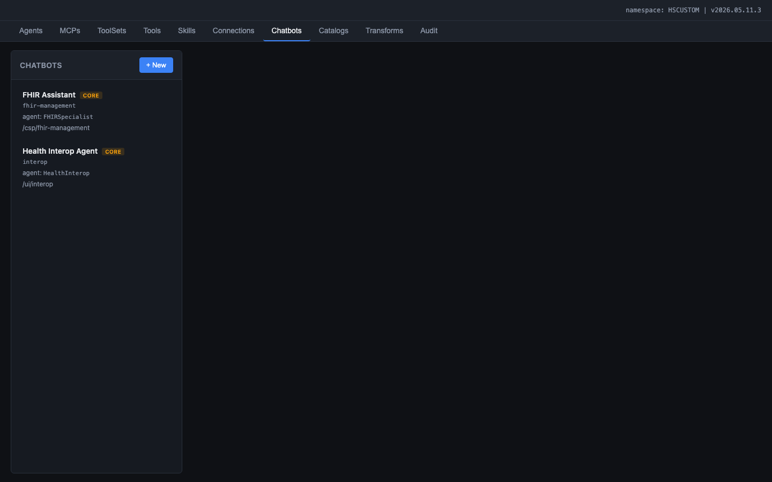
Figure: Catalogs tab showing search_ens (164 rows) and search_hs (58 rows) with kind breakdowns, rebuild controls, and test search panel

Catalog | Name | Row Count | Source
Ens.* | search_ens | 164 | %Dictionary for Ens.Host, Ens.BusinessService, Ens.BusinessProcess, Ens.BusinessOperation, adapters
HS.* | search_hs | 58 | %Dictionary for HS.* transformation classes, FHIR mappers, SDA helpers

7.1 Technical Implementation
- Embedding model: FastEmbed (384-dimensional vectors, bundled with IRIS)
- Vector storage: %AI.RAG.KnowledgeBase with HNSW index
- Query path: %AI.ToolMgr.ExecuteTool(kbName, args) -- the only working path (SQL EMBEDDING() does not work with FastEmbed)
- Document format: Curated prose descriptions, not raw method signatures

8. Transformation and Mapping Catalog
A visual field-level mapping explorer showing how data flows between external formats (HL7 v2, FHIR R4, CDA, X12) through the SDA3 canonical model.
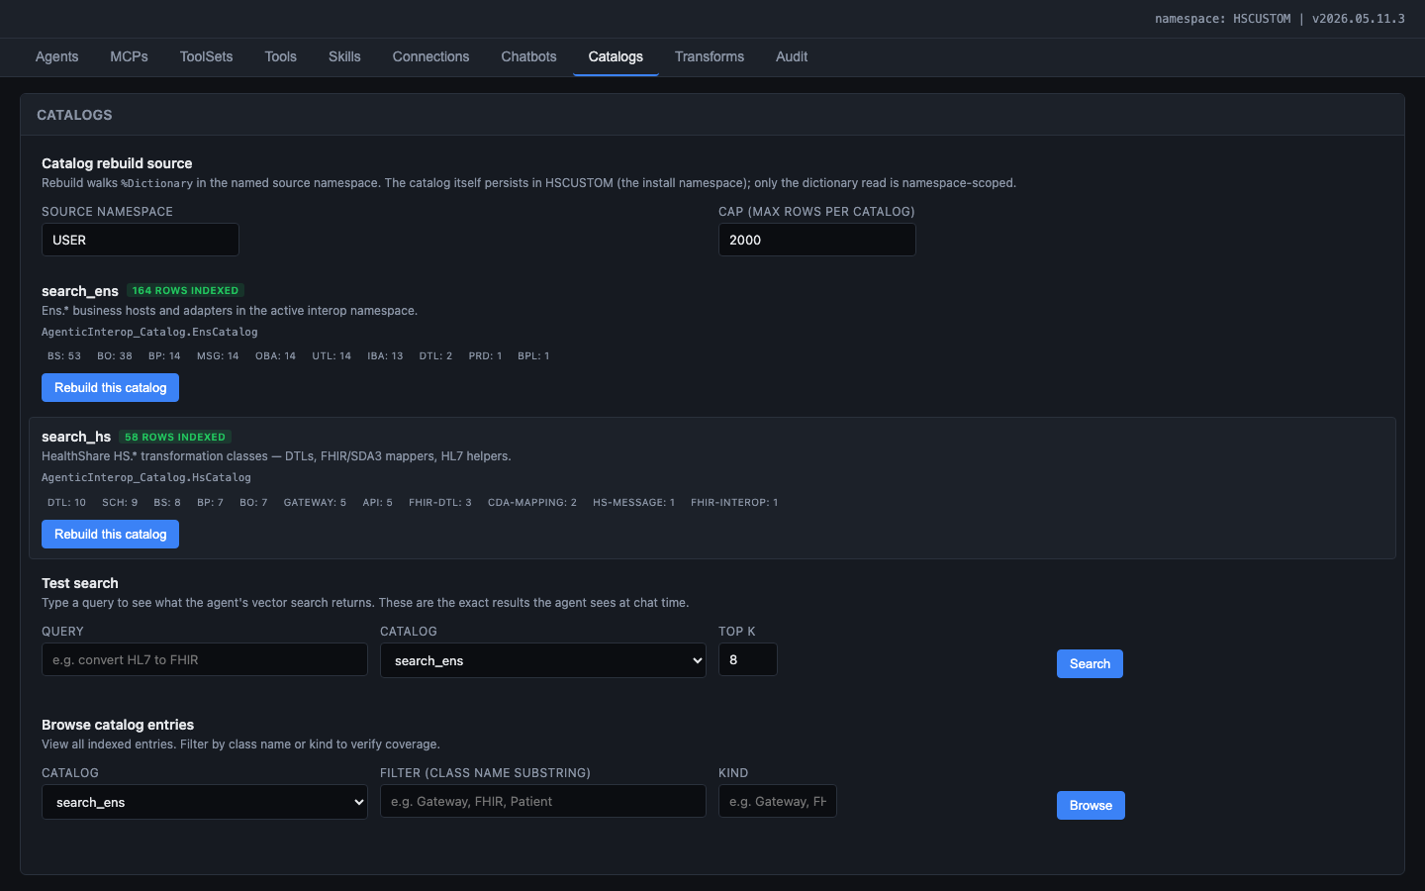
Figure: Transforms tab initial state: format pair selection with 1,538 pre-computed rows

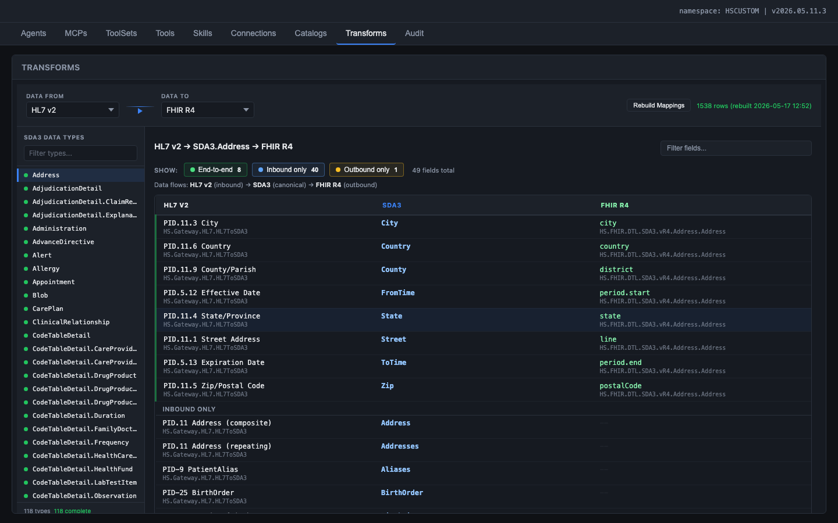
Figure: Transformation and Mapping Catalog with HL7 v2 to FHIR R4 selected, showing SDA3.Address mappings at sub-field level with IRIS class names and coverage filters

8.1 Data Flow Model
SDA3 is the universal pivot: all external formats map through it.
HL7 v2 (inbound) --> SDA3 (canonical) --> FHIR R4 (outbound)
Example: PID.11.3 City --> City --> city

8.2 Data Sources
- HL7 to SDA3: Programmatic extraction from HS.Gateway.HL7.HL7ToSDA3 ObjectScript methods (not DTL)
- SDA3 to FHIR: DTL class analysis via HS.FHIR.DTL.SDA3.vR4.* with backward-walk algorithm
- Sub-field enrichment: Static lookup mapping composite HL7 types (XAD, XPN, CX, XTN) to component fields

9. Connection Management
A multi-provider LLM connection manager that stores credentials securely and provides health-check (connection test) functionality. Managed by the AI Hub Admin.
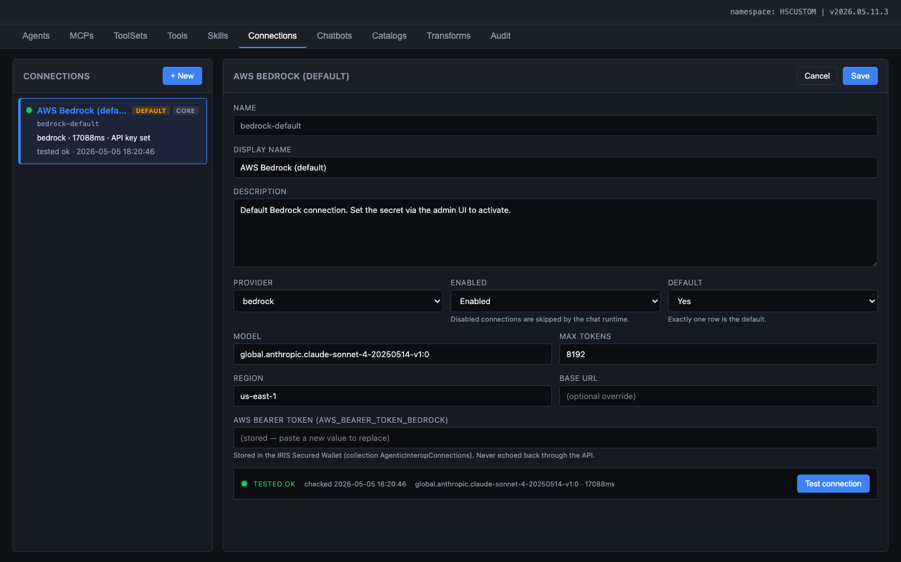
Figure: Connection editor showing Bedrock configuration with provider, model, region, masked API key, and Test Connection button

Provider | Config Fields | Secret Field
AWS Bedrock | region, model | AWS_BEARER_TOKEN_BEDROCK (Wallet)
Anthropic | model, base URL | ANTHROPIC_API_KEY (Wallet)
OpenAI | model, base URL | OPENAI_API_KEY (Wallet)
Azure OpenAI | endpoint, deployment, API version | AZURE_OPENAI_API_KEY (Wallet)
Google Gemini | model, region | GEMINI_API_KEY (Wallet)
NVIDIA NIM | model, base URL | NIM_API_KEY (Wallet)

9.1 Security Invariants
- API keys are NEVER stored in SQL tables, globals, or source code
- API keys are NEVER returned by any REST endpoint
- API keys are NEVER logged in audit trail
- The only storage location is the IRIS Secured Wallet

10. Audit and Security
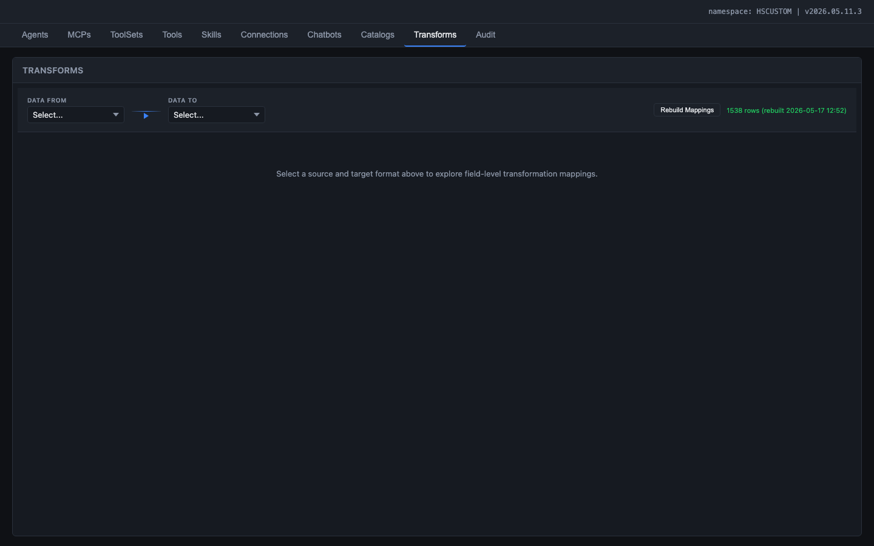
Figure: Audit log showing all API requests with status codes, methods, paths, timestamps, users, and durations

10.1 Authentication
Method | Use Case
Basic auth | Direct admin UI access (standalone mode)
JWT Bearer | Embedded access from Interop Editor (token passed via postMessage bridge)

All REST endpoints require authentication. No UI element is visible before login.

10.2 LLM Permission Delegation
The agent must NEVER bypass the authenticated user's permissions. Every tool call is executed under the authenticated user's security context. If the user cannot perform an action through the Management Portal, the agent must not perform it either. Tools validate permissions via $System.Security.Check() before executing mutating operations.

10.3 Namespace Constraints
Foundation namespaces (HSLIB, HSSYS, ENSLIB) are always read-only for the agent, regardless of user permissions. Non-Foundation namespaces respect the authenticated user's database-level permissions.

10.4 Interface Engineer vs Operator Privilege Separation
Enforced at two levels: (1) Tool availability -- the AI Hub Admin binds different ToolSets to Interface Engineer-mode and Operator-mode agent configurations; (2) Permission validation -- every mutating tool checks the user's IRIS roles before executing.

10.5 Audit Log Fields
Field | Description
Timestamp | When the request was received
Username | Authenticated IRIS user
Namespace | Active namespace at request time
SessionId | Browser session identifier
Job | IRIS job number
Method | GET, POST, PUT, DELETE
Path | /api/agentic/chat/stream
StatusCode | HTTP response status
Duration | End-to-end request time
Kind | registry, editor.agent, chat, namespace, etc.

10.6 Security Policies
- ConfirmationGate: Mutating operations require explicit End User approval. This is the last line of defense after permission checks and namespace validation.
- ToolFilter: Strips framework waste tools from the LLM catalog, preventing access to generic system tools that could bypass the permission model.

10.7 Source Control Integration
Agent-created artifacts (productions, DTLs, BPLs, routing rules) integrate with Health Connect Cloud's %SourceControl hooks. The agent uses standard IRIS APIs ($System.OBJ.Compile, %Dictionary) that trigger the hooks automatically. Changes are attributed to the authenticated user, not the agent's service account. The CI/CD pipeline (GitLab) validates, tests, and deploys changes across environments.
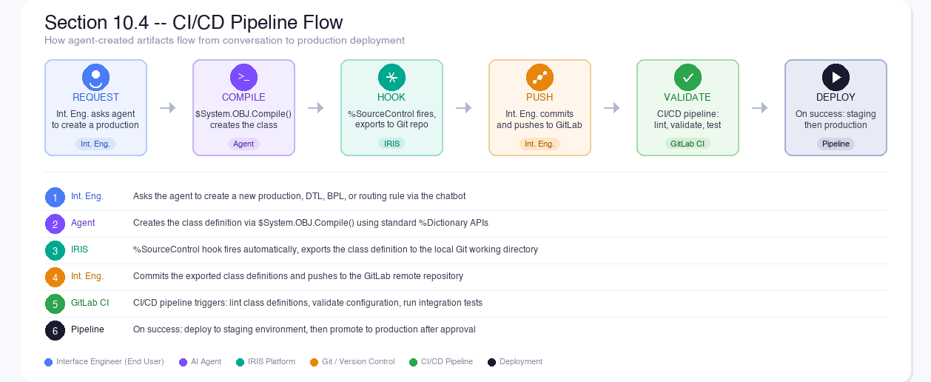
Figure: CI/CD Pipeline Flow: agent-created artifacts flow through source control hooks to Git and CI/CD

11. Performance
Metric | Target | How Achieved
First token latency | < 2 seconds | SSE streaming, no buffering
Turn completion | < 90 seconds | Monitor: 60s deadline + 50K token budget
Catalog search | < 500ms | Pre-built HNSW vector index, in-process query
Field mapping load | < 100ms | Pre-computed SQL table (1,538 rows)
Catalog rebuild | < 30 seconds | Batch %Dictionary walk + FastEmbed
Concurrent users | 5 sessions | Per-process agent instances, no shared state
Token efficiency | < 50K tokens/task | ToolFilter, curated skills, no markdown overhead

12. Implementation Summary
Component | Classes | Status
Agent | 4 classes (HealthInterop, Manager, Monitor, SkillLoader) | Built
MCP Servers | 5 classes (Base + 4 servers) | Built
ToolSets | 5 classes | Built
Tools | 7 classes, 118 tools | Built
Skills | 16 classes (Base + 15 domain skills) | Built
Data model | 6 persistent classes | Built
REST API | 1 dispatcher + 13 service classes | Built
Admin UI | 3 HTML + 2 JS + 2 CSS files | Built
Chat UI | 1 HTML + 1 JS + 1 CSS file | Built
Vector catalogs | 2 classes (Builder, Attach) | Built
Transformation and Mapping Catalog | 2 classes (TransformService, FieldMapping) | Built
Policies | 2 classes (ConfirmationGate, ToolFilter) | Built
Install hooks | 2 classes (CSPTimeoutPatch, InteropEditorPatch) | Built
IPM package | module.xml | Built
Total | 61 ObjectScript classes, 8 web files, 100+ commits

