Forward Feynman Gives Schrödinger, Reversible Feynman Gives QTSI
The postulates of quantum mechanics as theorems of a sum over histories on an invariant lattice
Alejandro Frank
August 2026
Instituto de Ciencias Nucleares and Centro de Ciencias de la Complejidad, Universidad Nacional Autónoma de México, Apartado Postal 70-543, 04510 Ciudad de México, Mexico
El Colegio Nacional, Ciudad de México, Mexico
afrank@nucleares.unam.mx

Abstract
Three postulates of quantum mechanics are obtained as theorems of a sum over histories, and a second theory is obtained by withdrawing the single geometric permission on which the three of them rest. Equating the gravitational self-energy Gm²/ℓ, the rest energy mc² and the quantum confinement energy ħc/ℓ fixes ℓ = √(ħG/c³) and m = √(ħc/G) with no further input. No probe resolves below that length. The bound is carried by the parameter that measures arc length along a worldline, which is a scalar, so the Lorentz group is left exact and no deformation of the transformation law is required. Feynman's sum over histories, placed on a lattice with that cell and with time advancing monotonically along every path, is equivalent to the Schrödinger equation, and the equivalence uses one geometric assumption, that each path crosses each instant once. First order in time, unitarity and the positive norm behind the Born rule are then not three independent axioms but one geometric fact read three times. Removing the assumption and allowing paths to fold in time removes all three at once and destroys the composition law at an instant. Reversibility, stated at the level of amplitudes, requires the elementary fold vertex to commute with the antiunitary operation that exchanges the two senses of traversal, which forces the fold amplitude real, the vertex into U(1,1) rather than SU(2), the generator to H = Eσ3 + iΔσ1, the algebra to su(1,1), the conserved bilinear to the indefinite Q = |ψ+|² − |ψ−|², and the interference time to τRC = ħ/√(E² − Δ²). The metric operator is not imposed either; it arrives with the signature conditions that make a square root linear. Elimination of one component returns a second-order equation of Klein-Gordon type, and the linearization of that equation in time alone reproduces the same generator by an independent route. Setting the cell to the Planck cell makes c the ratio of the two cells, caps the fold amplitude at Δ < Ep, compactifies the energy into a Brillouin zone, gives the interference time an exact floor of tp/π, and deforms the mass shell at relative order (Δ/Ep)². That deformation is second order in the inverse Planck energy and vanishes identically for massless modes, so it is not of κ-Poincaré type and no noncommuting coordinate algebra is inherited. Every step is verified against exact lattice transfer matrices. What is claimed is not that a time-symmetric reading dissolves the puzzles of measurement, which several existing programmes also deliver, but that the list of postulates is shorter at the end of the derivation than at its beginning.
Keywords: path integral; Planck length; discrete spacetime; doubly special relativity; time reversal; SU(1,1); pseudo-Hermiticity; exceptional point; quantum measurement.

1. The time-symmetric framework

1.1 The two branches
QTSI abbreviates the Quantum Time-Symmetric Interpretation. The two temporal orientations available to a segment of worldline carry independent amplitudes, ψ+ for the branch traversed toward increasing t and ψ− for the branch traversed toward decreasing t. The state of a mode is the doublet
Ψ = (ψ+, ψ−) (1.1)
and the dynamics of that pair is generated by a noncompact algebra rather than by a compact rotation.

1.2 Existing time-symmetric work
Time symmetry has a literature. Aharonov, Bergmann and Lebowitz showed that the formalism admits a description in which a state prepared in the past and a state selected in the future enter symmetrically [1], and the two-state vector formalism, with the weak values of Aharonov, Albert and Vaidman [29], developed that description into a calculus with measurable consequences. Cramer's transactional account [30] treats emission and absorption as one event. Wharton and Argaman [31] survey the locally mediated reformulations and set out what each requires.
Huw Price took the general case furthest. The temporal asymmetry ordinarily assumed of microscopic processes is an assumption and not a datum; it is inherited from the macroscopic thermodynamic asymmetry by an inference that has not been justified; and Bell's theorem constrains locality only if that inference is granted [32, 33]. Price also stated the question a position of that kind must answer, which is why a world admitting influence in both temporal directions permits no signal. The construction below was reached independently and by another route, from the absence of a consistent microscopic definition of the direction of time, and it arrives in territory Price had already mapped.
The difference from the two-state vector formalism lies in what is taken as given. No post-selected second state vector appears, no weak values are computed, and the symmetry at issue is a symmetry of local vertex weights on a lattice rather than a boundary condition imposed at two times. The axioms are outputs rather than inputs: Section 3 obtains first order in time, unitarity and the positive norm from the geometry of monotonic paths, and Sections 4 to 7 obtain the two components, the indefinite metric and su(1,1) from the geometry of folded ones.

1.3 The generator and its invariant
The generator of evolution in the worldline parameter is
H = E σ3 + i Δ σ1 = [[E, iΔ], [iΔ, −E]] (1.2)
with E and Δ real. The diagonal carries the energy of each branch with opposite sign, since the branches run in opposite temporal senses. The off-diagonal coupling is imaginary, and the imaginary character of that coupling is the entire departure from ordinary quantum mechanics.
The split of an amplitude into a forward and a backward part is not unique. Shifting it is a hyperbolic rotation of the doublet, an element of SU(1,1) and a Bogoliubov transformation. Under that rotation E and Δ change individually while
E² − Δ² = −det H (1.3)
remains fixed. The physical content is the single invariant, and the two parameters are not independent inputs. The freedom to trade E against Δ is the freedom that makes particle number observer-dependent for a quantum field.

1.4 The conserved branch charge
Conservation of Q = ⟨ψ|σ3|ψ⟩ requires
dQ/dτ = (i/ħ) ⟨ψ|(H†σ3 − σ3H)|ψ⟩ = 0 ⟺ σ3 H σ3⁻¹ = H† (1.4)
which is σ3-pseudo-Hermiticity [2, 3]. The generator (1.2) satisfies the condition identically, since σ3σ1σ3 = −σ1 while (iσ1)† = −iσ1. The contrast with the ordinary case is exact: Hermiticity requires the coupling to satisfy g = g*, pseudo-Hermiticity requires g = −g*.
Q is not a probability. Feshbach and Villars [4] made the structure explicit: in two-component form the theory carries both an indefinite σ3 bilinear and a positive bilinear, both well defined on the same space, and only the first is conserved by the free dynamics. Pauli and Weisskopf [5] identified the conserved indefinite quantity of the scalar theory as charge and showed that second quantization returns a positive-definite norm on Fock space. Q is accordingly a branch charge, the net imbalance between the two directions of time along a worldline, in exact analogy with the net imbalance between particles and antiparticles.
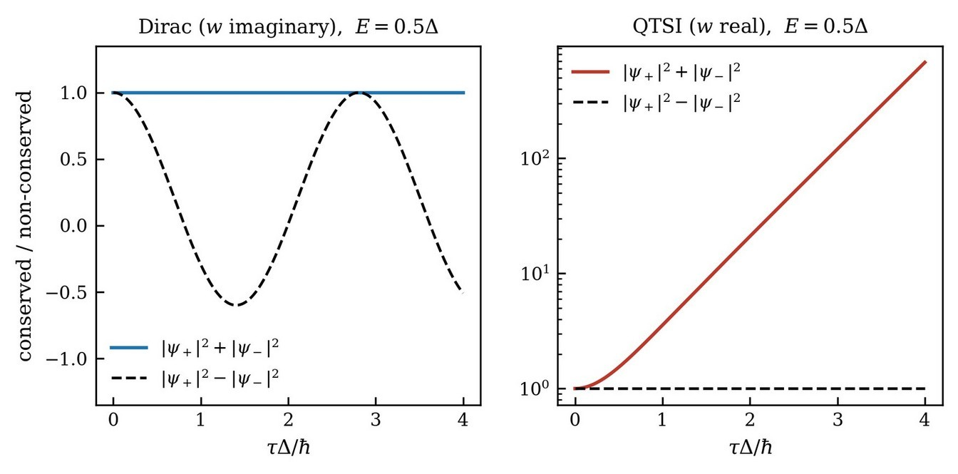
Figure 1. The conservation laws in the continuum, both panels at E = 0.5Δ, below threshold. On the left, Hermitian evolution keeps the norm flat while the pseudo-norm swings through the full range and changes sign. On the right, pseudo-Hermitian evolution on a logarithmic scale inverts the situation exactly: the norm climbs by three orders of magnitude while the branch charge holds throughout.

1.5 The algebra
The traceless matrices obeying (1.4) are the real span of {σ3, iσ1, iσ2}. Setting K3 = σ3/2, K1 = iσ1/2 and K2 = iσ2/2,
[K1, K2] = −i K3, [K2, K3] = i K1, [K3, K1] = i K2 (1.5)
which differs from su(2) by the single sign in the first line. That sign makes the group noncompact. Orbits are open and lie on the hyperboloid |ψ+|² − |ψ−|² = const rather than closed on the sphere |ψ+|² + |ψ−|² = const. Ordinary quantum evolution rotates a vector on a sphere, so it returns and nothing can grow. Time-symmetric evolution boosts a vector along a hyperboloid, so it runs outward while the invariant pins it to the surface.
The classification of linear symmetries preserving a fixed σ3 metric admits no third class. That statement fixes the signature and not the representative: a general Hermitian η may serve as metric, σ1 and σ2 are legitimate choices related to σ3 by similarity, and any η with one positive and one negative eigenvalue defines an equivalent pseudo-unitary structure. Antilinear symmetries fall outside the classification, and the PT-symmetric class of Bender and Boettcher [6] is the relevant example.
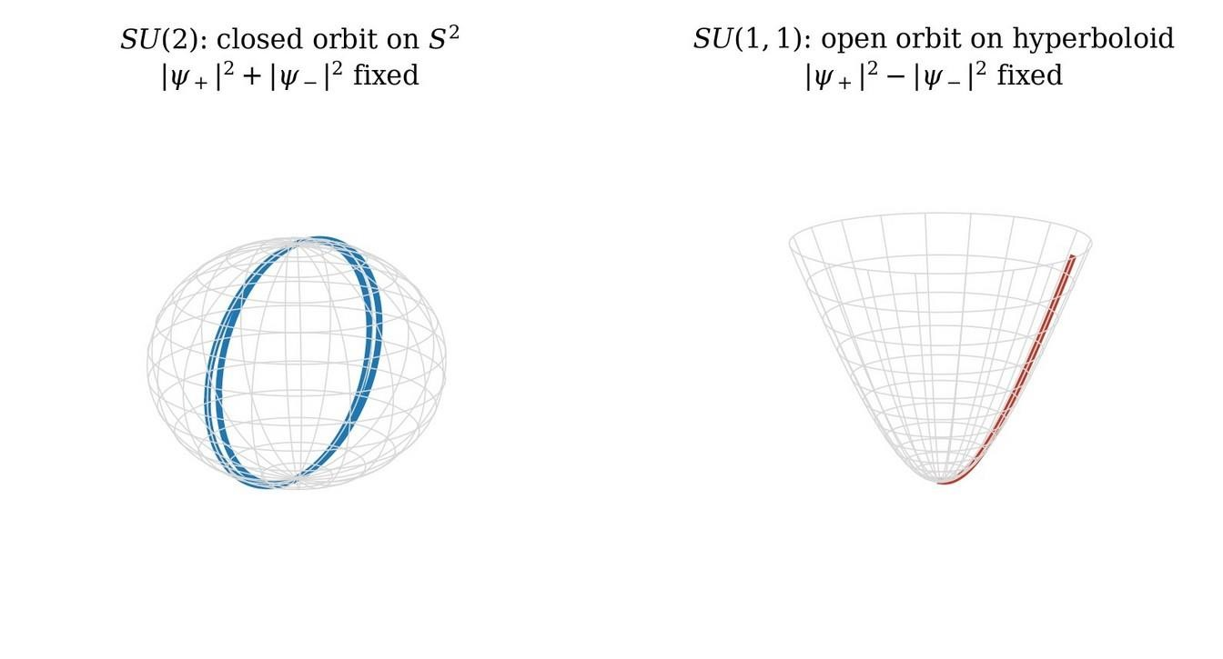
Figure 2. The same information read geometrically. On the left the SU(2) orbit, closed on the sphere, with the sum of the two branch weights fixed. On the right the SU(1,1) orbit, open on the hyperboloid, with the difference fixed while the individual components grow without bound.

1.6 The two timescales
Squaring (1.2) with σ3² = σ1² = I and σ3σ1 + σ1σ3 = 0,
H² = E²σ3² + (iΔ)²σ1² + iEΔ(σ3σ1 + σ1σ3) = (E² − Δ²) I (1.6)
so that
λ± = ± √(E² − Δ²). (1.7)
The cross terms cancel by anticommutation, and the minus sign under the radical appears because (iΔ)² = −Δ². Above threshold the eigenvalues are real and the evolution oscillates. Below threshold they are purely imaginary and the exponential becomes real. At E = Δ the eigenvalues collide, which is an exceptional point.
The spectral gap λ+ − λ− = 2√(E² − Δ²) sets the rate at which relative phase accumulates between the branches. Above threshold,
τRC = ħ / √(E² − Δ²) (E > Δ) (1.8)
is the shortest interval in which ψ+ and ψ− acquire relative phase of order unity, hence the shortest interval in which the two branches interfere at all. Below threshold the gap is imaginary, no relative phase accumulates, and the same expression measures the reciprocal growth rate,
τamp = ħ / √(Δ² − E²) (E < Δ) (1.9)
the interval in which the surviving branch grows by a factor e. One formula covers both regimes because the square root turns imaginary at threshold. The two quantities are physically distinct and are kept apart throughout.
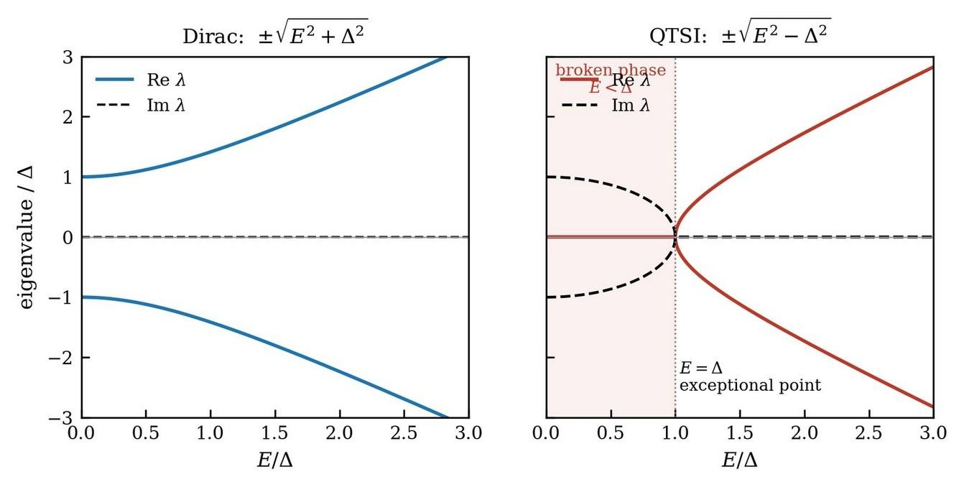
Figure 3. Compact and noncompact dispersion, real parts solid and imaginary parts dashed. On the left the Hermitian case, with two real branches separated by a gap that persists at all energies, so that the evolution can never do anything but oscillate. On the right the pseudo-Hermitian case, where the eigenvalues are purely imaginary in the shaded region E < Δ, collide at E = Δ, and become real only above threshold. The collision point is where the interference time τRC of (1.8) diverges, because the two branches no longer beat against one another.

1.7 Where growth is invariant and where it is a choice of metric
Amplification is not simply what a noncompact group does, and the counterexample is standard. The two-mode squeezing generator i(a†b† + ab) is Hermitian, its exponential is unitary on Fock space, and the norm of the state is preserved exactly; what grows is the occupation number. SU(1,1) acting on mode operators costs no unitarity [7]. No violation of unitarity is claimed anywhere.
The correct statement requires the theory of quasi-Hermitian operators. For any diagonalizable generator with real spectrum satisfying (1.4) there exists a positive-definite metric η+ in which the evolution is genuinely unitary, a result due to Scholtz, Geyer and Hahne [8] and developed systematically by Mostafazadeh [3]. Above threshold, E > Δ, the generator (1.2) is of that kind, and η+ may be constructed explicitly. For E = 2Δ the eigenvalues are ±√3 Δ, the intertwining η+H = H†η+ holds to machine precision, and η+ has eigenvalues 2/3 and 2, both positive. An observer equipped with η+ sees ordinary unitary evolution, and growth of the positive form in the unbroken phase is a statement about a choice of inner product rather than an invariant of the dynamics.
Below threshold the escape closes. For E < Δ the spectrum is imaginary, the pseudo-Hermiticity is spontaneously broken in the sense familiar from PT-symmetric quantum mechanics [6], no positive-definite η+ exists, and the exponential growth of the branch amplitudes cannot be transformed away by any change of metric. The same holds at the exceptional point, where H is not diagonalizable. The broken phase and its boundary are the only locations at which noncompactness carries invariant physical content, and any observable consequence of fold dynamics must be traceable to the neighbourhood of E = Δ or below.
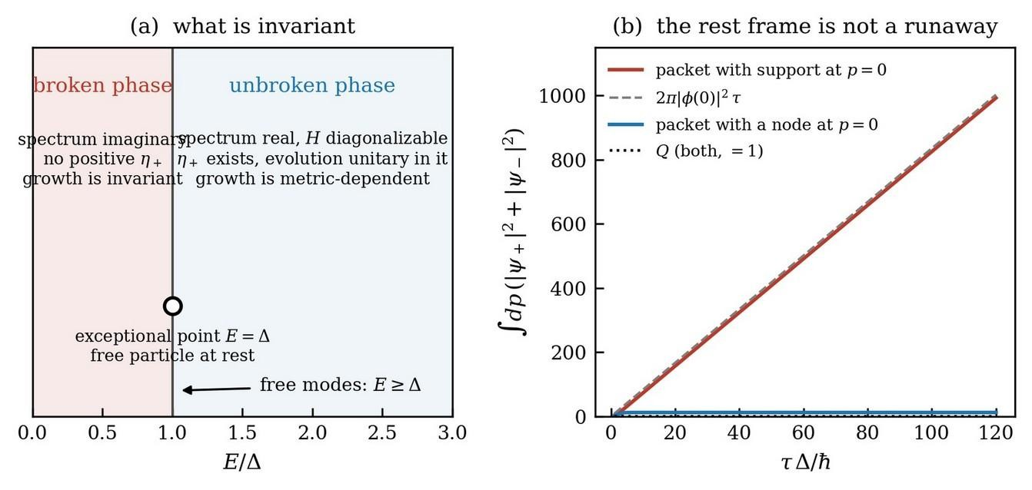
Figure 4. (a) The two phases and the status of growth in each. Above threshold the generator is quasi-Hermitian, a positive metric η+ exists, and amplification is metric-dependent; below threshold no such metric exists and the growth is invariant. Free modes with Δ = mc² satisfy E ≥ Δ, with equality only at rest, so free evolution never enters the broken phase. (b) The exceptional point at rest. A wavepacket with support at p = 0 shows growth of the positive form that is linear in the parameter, with slope 2π|φ(0)|², and a packet with a node at p = 0 shows no growth at all; the branch charge is conserved to machine precision in both.

1.8 Measurement as a driven crossing
A free mode with Δ = mc² satisfies E ≥ Δ for every momentum, with equality only at rest, so free evolution never enters the amplifying sector. Reaching Δ > E requires something to drive the mode across the band edge, and in the measurement context that something is the coupling to the apparatus. The division of labour is exact. The kinematics, meaning the two branches, the indefinite charge, the noncompact group and τRC, follows from closed reversible dynamics with no measurement in the argument. The breaking is dynamical and must be caused.
Tunnelling is the ordinary and already observed face of the same structure. Below the mass gap the solutions of a Klein-Gordon equation are evanescent, amplitudes grow and decay instead of oscillating, and the conserved current stays fixed while the density does not. The framework therefore sits inside established physics at one end and leaves the measurement claim as the extrapolation at the other.

1.9 Quantitative consequences
Two companion manuscripts take the two-branch structure as given and develop what follows from it [9, 10]: the visibility law V(φ) = (1 − φ²)ᵏ on the Bargmann disk, the coherence-rebuild time that reappears as (1.8), the Rydberg-scaled hydrogen deviation ΔEn/|En| = (Δ0²/2Ry²) n⁴, which is the most accessible falsifiable prediction of the scheme, and the recovery of Bell correlations by integration over SU(1,1) coherent states, saturating the Tsirelson bound. The derivation that follows supplies the structure those results presuppose.
The correlator saturates that bound rather than exceeding it, which is the value an ordinary quantum treatment returns and is the value compatible with the absence of signalling. Whether the absence of signalling is forced by conservation of Q in general, rather than confirmed case by case, is recorded in Section 11 among the open questions, since it is the fine-tuning question of Section 1.2 in its technical form.

1.10 Postulates as theorems
Three statements ordinarily supplied as axioms are supplied below as consequences, and one accounting collects them. That the equation of motion is first order in time follows from the requirement that a path cross each instant once, since only one earlier slice is then needed to construct the next. That the evolution is unitary follows from first order together with a self-adjoint generator. That the conserved quantity is positive, and therefore readable as a probability, follows from its being a sum of squares. Three axioms, one geometric fact, and Section 3.4 is where the three are collected.
Permitting folds withdraws the fact and the three consequences with it. What replaces them is not a vacancy but a second set of consequences: two components rather than one, by the arithmetic of a three-term recursion in Section 4.3; an indefinite conserved form rather than a positive one, because the vertex must be blind to the sense of traversal it exchanges, which is Section 5.3; and a noncompact algebra rather than a compact one, because a real off-diagonal generator admits no other invariant bilinear. The metric operator is not selected by hand either. It arrives as η = Γ1 in (7.6), fixed by the signature conditions that make a square root linear, and its indefiniteness is a consequence of the signature rather than a further postulate.
The claim is therefore narrow. A time-symmetric reading of the measurement puzzles is available from the programmes of Section 1.2 as well. What the derivation adds is that the list of postulates is shorter at the end of Section 7 than at the beginning of Section 3, and that Schrödinger's theory and the one obtained below are two branches of a single derivation, separated by whether a worldline may turn around.

2. The invariant cell

2.1 One length where three theories agree
Take a particle of mass m confined to a region of size ℓ. Gravitation gives the self-energy
Egrav ∼ Gm²/ℓ (2.1)
relativity gives the rest energy
Erel = mc² (2.2)
and quantum mechanics gives the confinement energy, since a particle localised in ℓ carries momentum of order ħ/ℓ and therefore, in the relativistic regime,
Equ ∼ ħc/ℓ. (2.3)
Setting the three equal, Erel = Equ gives m = ħ/(cℓ), which states that ℓ is the Compton wavelength, and Egrav = Erel gives m = c²ℓ/G, which states that ℓ is the gravitational radius. Equating the two expressions for m,
ħ/(cℓ) = c²ℓ/G ⟹ ℓp = √(ħG/c³) ≈ 1.6 × 10⁻³⁵ m (2.4)
and correspondingly mp = √(ħc/G) ≈ 2.2 × 10⁻⁸ kg, Ep = mp c² ≈ 1.2 × 10¹⁹ GeV, tp = ℓp/c ≈ 5.4 × 10⁻⁴⁴ s. No field equations enter the argument.
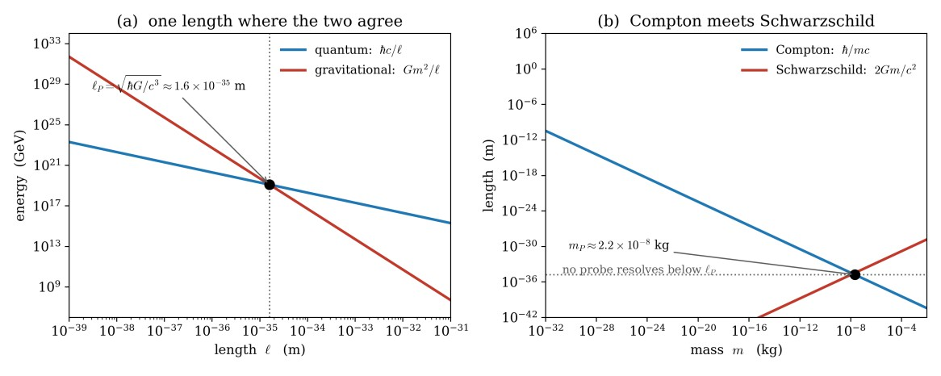
Figure 5. The coincidence that fixes the cell. Panel (a) takes the mass whose Compton length is ℓ, that is m = ħ/cℓ, and compares the quantum energy ħc/ℓ with the gravitational self-energy Gm²/ℓ. The two agree at exactly one length, ℓp = √(ħG/c³), where both equal Ep. Panel (b) is the same statement in the other variable: the Compton wavelength falls with mass while the Schwarzschild radius rises with it, and they cross at the Planck mass, below which the wavelength of a probe exceeds the region it is meant to resolve, and above which the probe is inside its own horizon.

2.2 Why that length cannot be contracted
Resolving a region of size ℓ requires a probe of wavelength no greater than ℓ, hence of mass at least ħ/(cℓ). A mass that large concentrated in that region has Schwarzschild radius 2Gm/c², and once that radius exceeds ℓ the region is behind a horizon and returns no information. The two requirements are compatible only for ℓ > ℓp. Below the Planck length there is no measurement, and a length that admits no measurement in any frame is not a length that a choice of frame can alter.
A bound imposed on a coordinate length nevertheless cannot survive a boost, since an exact boost contracts every length by the same factor, and restoring it would require deforming the transformation so that two quantities are invariant, the speed c and the length ℓp, equivalently the energy Ep. That is doubly special relativity [11, 12]. The construction below takes the other road. The quantity discretized is the parameter of Section 5.1, which is the arc length of the worldline and therefore a scalar, and ℓp enters only through the ratio c = ℓp/tp and through the mass-independent geometric mean of Section 8. The Lorentz group is left exact, and the deformation of the mass shell obtained in (8.4) is a derived property of the lattice dynamics rather than a modification of the transformation law. Section 9 carries out that argument and settles which of the two roads the construction is on.

2.3 Three consequences for a sum over histories
A shortest length and a shortest time make a path a finite sequence of steps rather than a continuous curve. The pathology of equation (3.5) below, where the dominant paths of the continuum sum have divergent speed, is removed, and the light cone that the nonrelativistic construction lacks is supplied.
A particle cannot be a point, since nothing is localisable below ℓp. An electron occupies at least one cell, so the classical self-energy divergence of a point charge is a statement about a continuum that does not exist.
A discrete reversible rule has no preferred direction of stepping. On a lattice the rule carrying the state from one cell to the next is either invertible or it is not, and if it is invertible then stepping backward is exactly as legitimate an operation as stepping forward. Discreteness and reversibility together make the folded path the natural object and the monotonic path a restriction requiring argument.

3. Forward Feynman gives Schrödinger

3.1 The rule implies the equation
The amplitude for passage between two events is obtained by adding exp(iS/ħ) over every path joining them, and amplitudes for successive intervals are composed by summing over the intermediate configuration. The weight must be a pure phase: were its magnitude to vary from path to path, the classical limit would select the route of largest weight, and no reason exists for that route to coincide with the route of extremal action.
Let ψ(x, t) be the amplitude at x at time t. Advancing by a short interval ε and summing over the single position y occupied at time t,
ψ(x, t + ε) = (1/A) ∫ exp(iS(x,y;ε)/ħ) ψ(y, t) dy, S = m(x − y)²/(2ε) − εV((x + y)/2) + O(ε²). (3.1)
Put y = x + η. The kinetic phase turns rapidly unless η² ≲ ħε/m, so the integral is controlled by
|η| ∼ √(ħε/m). (3.2)
Expand the smooth factors, ψ(x + η, t) = ψ + η∂xψ + ½η²∂x²ψ + …, and exp(−iεV/ħ) = 1 − (iε/ħ)V + …, and use, with a = m/2ħε, the three Gaussian integrals
∫ exp(iaη²) dη = √(iπ/a), ∫ η exp(iaη²) dη = 0, ∫ η² exp(iaη²) dη = (i/2a)√(iπ/a). (3.3)
The first is a Fresnel integral, defined by giving a a small positive imaginary part and letting it go to zero at the end. The second vanishes because the integrand is odd over a symmetric range, and its vanishing is why the resulting equation contains no first derivative in x. The ratio of the third to the first, namely iħε/m, is the origin of the diffusion-like second derivative. Fixing A = √(2πiħε/m) so that a constant ψ is unchanged when V = 0,
ψ + ε∂tψ = ψ + (iħε/2m)∂x²ψ − (iεV/ħ)ψ + O(ε²) (3.4)
so that, cancelling ψ, dividing by ε and multiplying by iħ,
iħ ∂tψ = −(ħ²/2m) ∂x²ψ + V(x)ψ. (3.5)
Adding phases over neighbouring paths becomes, in the limit, a second difference in space and a first difference in time.

3.2 The equation implies the rule
Write (3.5) as iħ∂tψ = Hψ with H = T + V, where T = −(ħ²/2m)∂x² is diagonal in momentum and V(x) is diagonal in position. Since [T, V] ≠ 0, the Baker-Campbell-Hausdorff expansion gives, over a short step,
exp(−iTε/ħ) exp(−iVε/ħ) = exp[ −(iε/ħ)(T + V) − (ε²/2ħ²)[T, V] + O(ε³) ] (3.6)
so the error per step is O(ε²) and the accumulated error over N = t/ε steps is O(t²/N). The limit is the Lie-Trotter product formula [13],
exp(−iHt/ħ) = limN→∞ ( exp(−iTε/ħ) exp(−iVε/ħ) )ᴺ. (3.7)
For unbounded T and V the exponentials are defined by the spectral theorem, the convergence is strong rather than in norm, and the result requires T and V self-adjoint with H essentially self-adjoint on the intersection of their domains, which is the Trotter-Kato theorem.
The symmetric ordering, exp(−iVε/2ħ) exp(−iTε/ħ) exp(−iVε/2ħ), improves the per-step error to O(ε³) and matches the path sum as written, since the adjacent half-potentials of neighbouring steps combine into the average of the potential at the two ends, differing from the midpoint value by ⅛V″(x)η², which is O(ε²) per step by (3.2).
The kinetic factor is evaluated by transforming to momentum and back,
⟨x| exp(−iTε/ħ) |y⟩ = ∫ (dp/2πħ) exp(ip(x−y)/ħ) exp(−iεp²/2mħ) = √(m/2πiħε) exp(im(x−y)²/2ħε) (3.8)
which is the free part of the short-time action with the normalisation fixed above. Inserting a resolution of the identity in position at each interior step turns the product into an integral over all intermediate positions of exp(i Σk Sk/ħ). The two formulations are one statement.

3.3 The assumption
Both directions used the same thing in the same place. In (3.1) the amplitude at t + ε was built from the amplitude at t with exactly one position per path. In (3.7) the propagator was cut at intermediate times, each cut contributing exactly one integration variable. Both presume that every path crosses every intermediate instant exactly once, that is, that each path is a graph x(t), single-valued in t.

3.4 Four names for one assumption
Because only one earlier slice is needed, the equation is first order in ∂t. Because it is first order with a self-adjoint generator, ∫|ψ|²dx is conserved. Because that quantity is a sum of squares it is positive, and can therefore be read as a probability. Monotonic time, first order, unitarity in the ordinary sense, and the positivity behind the Born rule are four names for one geometric assumption about the paths. Removing the assumption removes all four at once.
Three of the four are ordinarily postulated and are obtained here instead, at the cost of one statement about the shape of a path. Section 4 withdraws that statement.
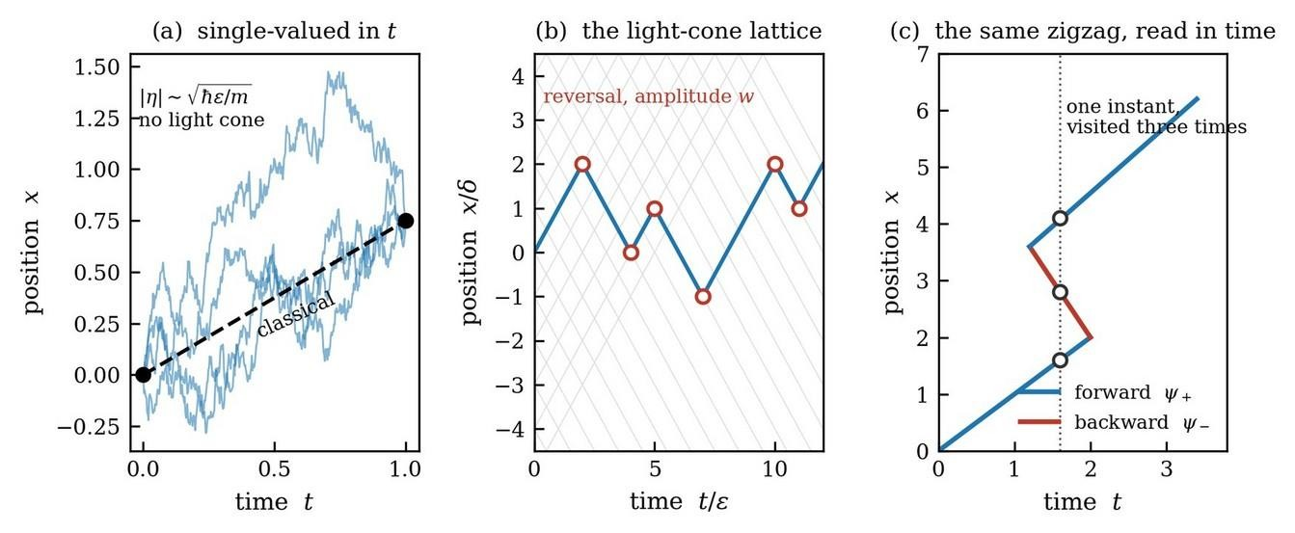
Figure 6. The three path pictures. (a) Feynman's paths are single-valued in t and, by equation (3.2), jagged at every scale with divergent speed, so there is no light cone and no chirality. (b) A cell of size ℓp in space and tp in time forces a light-cone lattice, since a path moves exactly one cell per tick: at each vertex it either continues or reverses, and its state is no longer a position alone but a position together with a direction of travel, which is the origin of the two-component amplitude. (c) The reading appropriate to the time-symmetric formalism, in which the same zigzag is a worldline folding back in time, so that a single instant is visited more than once. Blue segments carry the forward branch, red segments the backward branch, and each fold carries the amplitude that becomes the off-diagonal coupling of the generator.

4. Folds in time
On the lattice of Section 2 the rule carrying the amplitude from one cell to the next is reversible, and a reversible rule has no preferred direction of stepping. Paths are therefore permitted to reverse their sense of traversal of time.

4.1 The composition law fails
Equation (3.1) and the product (3.7) both rest on cutting a history at an instant and summing over the single crossing point. A folded path crosses that instant three times, or five, or any odd number. No single crossing point remains to integrate over, and
K(x″, t″; x, t) = ∫ dx′ K(x″, t″; x′, t′) K(x′, t′; x, t) (4.1)
no longer holds for t < t′ < t″. Equation (4.1) is the semigroup property, and being first order in t is what it means. Losing (4.1) is losing first order in time. The conclusion follows from the geometry of a folded line and requires no dynamical input.

4.2 What the counting settles, and what it does not
Cut a folded worldline with a time slice and count its crossings. Each crossing is either forward, meaning the line pierces the slice in the direction of increasing t, or backward. Insert a fold pair anywhere later than the slice, so that the line runs forward, turns back, and runs forward again. The total number of crossings increases by two. The signed number, forward minus backward, does not change, because the two new crossings carry opposite signs.
The signed count is therefore an invariant of the worldline, fixed by its endpoints and blind to how many times the line folds. The total count is not an invariant. On a lattice of folding paths the natural bilinear form is consequently
Q = |ψ+|² − |ψ−|² (4.2)
with ψ± the amplitudes carried by the forward and backward crossings.
The counting establishes that the positive form cannot be the density of a conserved quantity of a folded worldline, since the count it would weigh is not an invariant of the line. The counting does not establish that a fold vertex must preserve Q, and it fails to do so for two reasons.
A fold vertex does not change the signed crossing number whatever amplitude it is assigned. Folds enter in pairs and a pair contributes +1 − 1 = 0 to the count. Setting the fold amplitude to zero, to one, to i, or to any complex number leaves the signed count unchanged, because the count never depended on the amplitude. A quantity conserved for every possible vertex weight cannot select among vertex weights.
The second reason is a matter of type. The signed count is an integer attached to one geometric object and appears inside the specification of which configuration is being summed. Q is a real quadratic form on a two-dimensional complex amplitude space, built from the sums themselves. No canonical map carries the first into the second.
The contrast with the forward case is sharp. In Section 3 the conserved object was ψ†ψ, already a bilinear on amplitudes, so demanding its conservation produced a condition on the evolution immediately. Demanding conservation of the signed count produces nothing, because the count is conserved anyway. An independent reason is needed for the inner product on the two-branch space to be weighted by σ3, and Section 5.3 supplies it. The counting keeps the role it can support, which is to say what the conserved quantity means once it has been derived: Q is the imbalance between the two directions of time along the worldline.
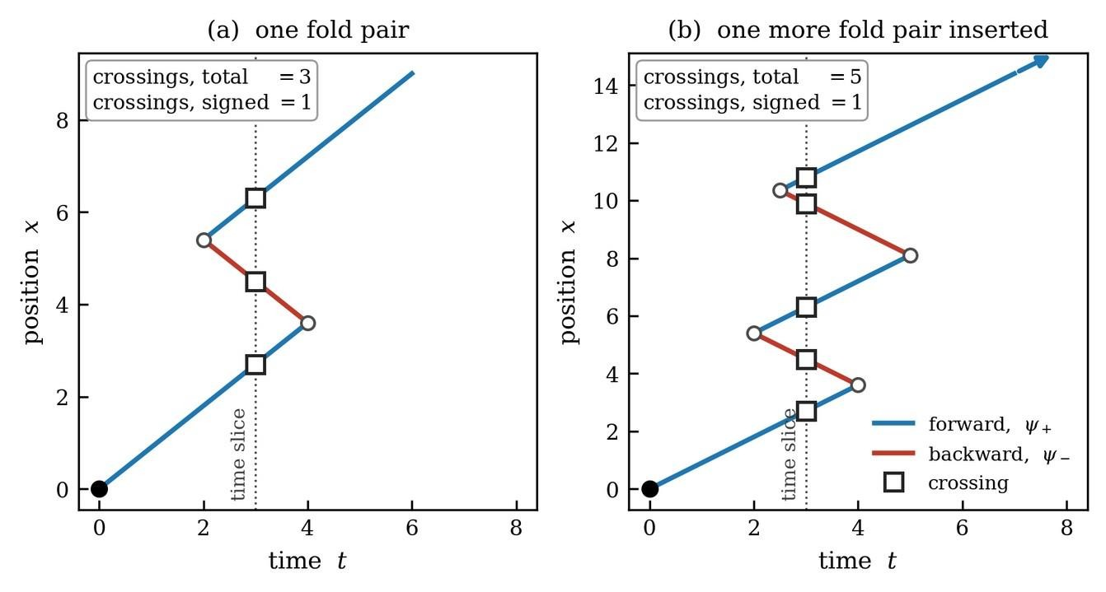
Figure 7. What a fold conserves. A time slice is cut through a folded worldline and its crossings are counted, forward in blue and backward in red. Inserting one more fold pair, in the passage from (a) to (b), raises the total number of crossings from three to five, while the signed number stays at one. The signed count is an invariant of the worldline and the total count is not, which is why the positive bilinear cannot be the density of anything conserved by folding. The count is unchanged whatever amplitude the fold vertex carries, so the geometry interprets the conserved form without fixing the vertex; the vertex is fixed in Section 5.3.

4.3 Two components, by arithmetic
At a given instant a folded path carries more than one sense of traversal, so the amplitude cannot be recorded as one number per instant. Two numbers are needed, one per sense.
The recursion gives the same conclusion. With folds allowed, amplitudes on cell n − 1 reach cell n + 1, so the update is a three-term relation rather than a two-term one, and a three-term relation requires two initial data, ψ0 and ψ1, or equivalently ψ and ∂tψ. Two data per mode require two components. The doubling is arithmetic and not interpretation.

5. The temporal checkerboard

5.1 The rules
Let time be a chain of cells of size ε, and let the path be indexed by its own step count n, which increases monotonically along the path even when t does not. The parameter τ = nε is the arc length of the worldline and plays the role Stueckelberg gave it [14]. At each step the path moves one cell in time, forward or backward, so its state is a time cell together with a sense of traversal, and the amplitude is the doublet of (1.1).
A segment traversing forward accumulates the phase exp(−iEε/ħ), and a segment traversing backward accumulates exp(+iEε/ħ), since the action accrued is −E dt and dt has changed sign. The propagation step is diagonal,
D = diag( exp(−iEε/ħ), exp(+iEε/ħ) ) = exp(−iEεσ3/ħ). (5.1)
At each vertex the path either continues in its current sense, with amplitude 1, or folds, with amplitude w. The vertex is
V = (1/N)[[1, w], [w, 1]] = (1/N)( I + w σ1 ) (5.2)
and w is the only new ingredient. Equality of the two off-diagonal entries states that the amplitude to fold from forward to backward equals the amplitude to fold from backward to forward.

5.2 Counting the folds
In the sector of zero net momentum the position bookkeeping decouples and only the fold count matters. A path of N steps with R folds carries weight wᴿ, and there are (N choose R) ways to place R folds among N vertices, so the sum over all paths is a binomial,
ΣR (N choose R) wᴿ = (1 + w)ᴺ. (5.3)
An even number of folds returns the path to its original branch and an odd number flips it, so splitting (5.3) by parity gives the two amplitudes exactly,
Asame = ½[(1 + w)ᴺ + (1 − w)ᴺ], Aflip = ½[(1 + w)ᴺ − (1 − w)ᴺ] (5.4)
and holding θ ≡ Nw fixed as N → ∞ gives
Asame → cosh θ, Aflip → sinh θ. (5.5)
Everything depends on the phase of w. If w is imaginary then cosh(iϑ) = cos ϑ, successive folds interfere destructively, and the amplitude stays bounded and passes through exact zeros. If w is real then cosh θ grows exponentially, successive folds interfere constructively, and turning around twice does not return the system to its starting point but adds.
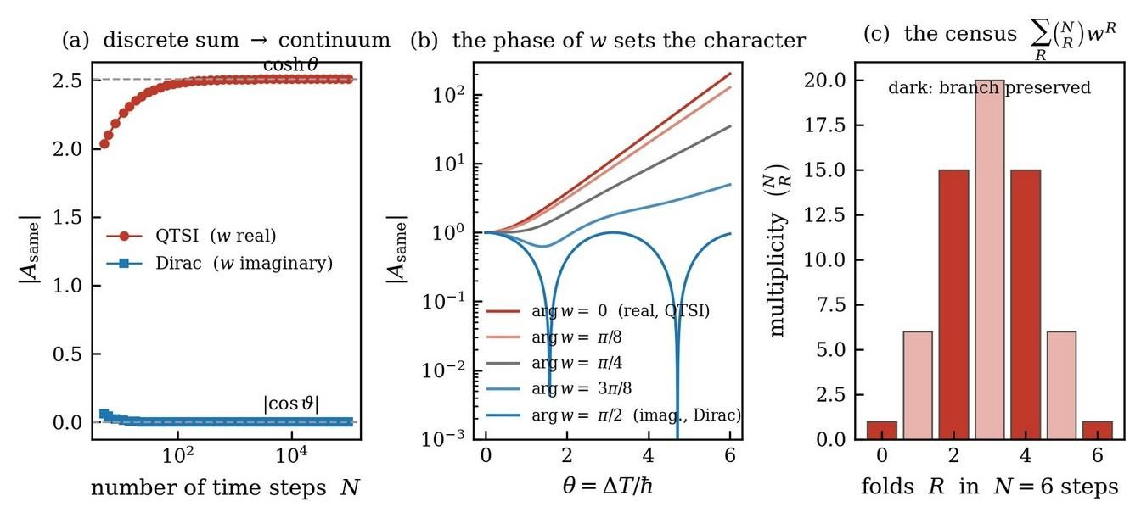
Figure 8. The sum verified by counting. Panel (a) plots the exact discrete amplitude of (5.4) against the number of steps with Nw = θ held fixed, converging to the continuum values of (5.5), real θ to cosh θ and imaginary θ to |cos ϑ|. Panel (b) rotates the phase of the fold amplitude continuously from one endpoint to the other, so that the two theories appear as the two ends of one continuous rotation: at arg w = 0 the amplitude grows, at arg w = π/2 it oscillates through exact zeros. Panel (c) is the census underlying everything, the multiplicities (N choose R) for N = 6, with dark bars keeping the branch and pale bars flipping it.

5.3 Reversibility fixes the vertex
The temporal construction parts company with the spatial one at this point, and the two cases are settled by different arguments living at the level of amplitudes.
In the spatial checkerboard the two components are directions of motion in space. At a fixed instant a path occupies exactly one cell on exactly one branch, so |ψ+|² + |ψ−|² at a cell is the entire probability content of that cell, and its conservation is the statement that the particle is somewhere, which the path sum already guarantees. Demanding V†V = I and writing V = I + wσ1 gives, to first order, V†V = I + (w + w*)σ1 + O(w²), so that
w + w* = 0, that is, w purely imaginary. (5.6)
The vertex lies in SU(2) and the group is compact.
For folds in time no such quantity is available in advance, and Section 4.2 gives the reason the counting cannot supply one. What is available is reversibility, which was the premise of the construction and which has a precise expression at the level of amplitudes.
The operation reversing the sense of traversal exchanges the two branches and conjugates amplitudes, since it reverses the sign of the phase accumulated along a segment. It is the antiunitary
Θ = σ1 K, Θ M Θ⁻¹ = σ1 M* σ1 for any matrix M (5.7)
with K complex conjugation. A rule that does not distinguish the two senses of traversal commutes with Θ. The propagation step commutes with it identically and for every E,
σ1 D* σ1 = σ1 diag( exp(+iEε/ħ), exp(−iEε/ħ) ) σ1 = D (5.8)
since conjugation swaps the two phases and σ1 swaps them back. Requiring the same of the vertex, σ1Vσ1 = V with V = I + wσ1, gives σ1(I + wσ1)σ1 = I + w*σ1, so that
w = w*, that is, w purely real (5.9)
and the full step T = VD is Θ-covariant if and only if the vertex is. Reversibility fixes the phase of w to the opposite of the spatial case. The same point is argued on general grounds by Price [32, 33]; here it is a condition on a matrix.
With the normalisation restored the two vertices are exactly a rotation and exactly a boost. Writing w = tan φ in the spatial case and w = tanh χ in the temporal case,
Vspace = cos φ · I + i sin φ · σ1 ∈ SU(2), Vtime = cosh χ · I + sinh χ · σ1 ∈ SU(1,1). (5.10)
The first satisfies V†V = I identically. The second satisfies
V†σ3V = (cosh²χ − sinh²χ) σ3 = σ3 (5.11)
identically, using σ1σ3σ1 = −σ3, while V†V = cosh 2χ · I + sinh 2χ · σ1 ≠ I. Both statements are exact rather than first order in w.
A fold in space preserves the sum because probability at a cell is a bilinear on amplitudes and must be conserved; its amplitude is therefore imaginary and the vertex lies in SU(2). A fold in time preserves the difference because reversibility forces its amplitude to be real; the invariant bilinear of a real off-diagonal generator is σ3 and nothing else, so the vertex lies in U(1,1). The phase of w is fixed by whether the vertex must conserve a probability or must be blind to the direction of time.
The signed crossing number then takes its place as the reading rather than the premise. Once Q is known to be the conserved bilinear, the geometry says what Q counts, and says that the alternative bilinear could not have counted anything invariant.

5.4 The generator
The evolution over one parameter step is the vertex followed by the propagation, T = Vtime D. Writing w = Δε/ħ with Δ real and expanding both factors to first order, and using cosh χ = 1 + O(w²) and sinh χ = w + O(w³),
T = I + (Δε/ħ)σ1 − (iEε/ħ)σ3 + O(ε²) = I − (iε/ħ)( Eσ3 + iΔσ1 ) + O(ε²) (5.12)
where the last step used −i·iΔ = Δ to absorb the real σ1 term into the standard form T = I − iHε/ħ. The generator is therefore H = Eσ3 + iΔσ1, which is (1.2), obtained by summing over folded paths.

6. The second-order equation, derived explicitly
The generator arrived first, so the second-order equation must now be extracted from it. Written out, the coupled pair is
iħ ∂τ ψ+ = E ψ+ + iΔ ψ−, iħ ∂τ ψ− = −E ψ− + iΔ ψ+. (6.1)
Solve the first equation for the backward component,
ψ− = ( iħ ∂τψ+ − E ψ+ ) / (iΔ) (6.2)
and differentiate,
iħ ∂τ ψ− = ( −ħ² ∂τ²ψ+ − iħE ∂τψ+ ) / (iΔ). (6.3)
Substitute (6.2) into the second equation of (6.1),
iħ ∂τ ψ− = −E ( iħ ∂τψ+ − E ψ+ ) / (iΔ) + iΔ ψ+. (6.4)
Equate (6.3) and (6.4) and multiply through by iΔ,
−ħ² ∂τ²ψ+ − iħE ∂τψ+ = −iħE ∂τψ+ + E² ψ+ + (iΔ)² ψ+. (6.5)
The terms in ∂τψ+ cancel between the two sides, and (iΔ)² = −Δ², leaving, with no approximation,
−ħ² ∂τ²ψ+ = ( E² − Δ² ) ψ+ (6.6)
a second-order equation of Klein-Gordon type [15, 16] whose mass term is the invariant of (1.3). The same elimination applied to ψ− returns the same equation, as it must, since the invariant is a property of H and not of a component.
The result is not an importation of relativity. It is the bookkeeping of folded paths, and it arrives whether or not the underlying problem is relativistic. The two-component first-order system and the one-component second-order equation carry the same content, which is why the doubling counted in Section 4.3 and the doubling built in Section 5.1 are the same doubling.

7. The linearization, done explicitly
Suppose now that (6.6) is all that is given, and a first-order equation is wanted. A first-order equation reads iħ∂τΨ = HΨ, so applying it twice gives −ħ²∂τ²Ψ = H²Ψ, and matching to (6.6) requires
H² = ( E² − Δ² ) I. (7.1)
If H were an ordinary number, (7.1) would force H = ±√(E² − Δ²), which is not linear in E and Δ, so the equation could not be local in either. The square root becomes linear only if H is allowed to be a matrix, because matrices can anticommute and anticommuting cross terms cancel.
Look for a generator linear in the two quantities,
H = E Γ1 + Δ Γ2 (7.2)
and square it,
H² = E² Γ1² + Δ² Γ2² + EΔ {Γ1, Γ2}. (7.3)
Equation (7.3) equals (E² − Δ²)I for all E and Δ if and only if
Γ1² = +I, Γ2² = −I, {Γ1, Γ2} = 0. (7.4)
Conditions (7.4) are the entire linearization procedure. They require two objects that anticommute, one squaring to plus the identity and the other to minus it. Numbers cannot satisfy them, since numbers commute. The smallest matrices that can are two by two:
Γ1 = σ3, Γ2 = iσ1, giving H = E σ3 + i Δ σ1 (7.5)
since (iσ1)² = −I and σ3 anticommutes with σ1. That is the generator (5.12), obtained a second time by an independent route, the first time by counting folded paths and this time by demanding that a square root be linear. The two derivations agree, which is the check that matters.
The metric comes with the algebra rather than being imposed. Because Γ1 squares to +I it may be chosen Hermitian, while Γ2 squares to −I and must therefore be anti-Hermitian. Conjugating H by Γ1 and using the anticommutation,
Γ1 H Γ1⁻¹ = E Γ1 − Δ Γ2 = E Γ1 + Δ Γ2† = H† (7.6)
so the metric operator is η = Γ1 = σ3 and the conserved bilinear form is ⟨ψ|Γ1|ψ⟩, which is indefinite precisely because Γ2 had to be anti-Hermitian. The pseudo-Hermiticity of (1.4) is a consequence of the signature and not an additional postulate. With that step the accounting of Section 1.10 is complete: neither the metric, nor the indefiniteness of the conserved form, nor the algebra generating the evolution has been assumed at any point.
The passage back is reduction of order. Given a solution φ of (6.6), set
ψ+ = φ, ψ− = ( iħ ∂τφ − E φ ) / (iΔ) (7.7)
and the pair satisfies iħ∂τΨ = HΨ with H of (7.5), as substitution confirms. The two components are the amplitude and its rate of change in disguise, which is the content of Section 4.3. The passage between the two forms is the Feshbach-Villars transformation [4], and the freedom in choosing which linear combinations to call ψ± is the SU(1,1) freedom of (1.3).
The size of the matrices is set by how many quantities are being linearized. Only two appear here, E and Δ, because the whole spatial dependence has already been packaged inside E. Two anticommuting generators need two by two matrices, in any number of spatial dimensions. Dirac linearized in space as well, writing H = α·p + βm so as to treat the three momentum components on the same footing as the time derivative [17]. Squaring that must give p² + m², so all four objects must square to +I and all six pairs must anticommute. Four mutually anticommuting objects of signature (4,0) do not fit into two by two matrices, and the smallest that hold them are four by four. The extra room is spin, together with the second pair of solutions later read as antiparticles. In one spatial dimension only α and β are needed, and Dirac's equation is two by two, which is why Feynman's spatial checkerboard has two components [18, 19].
The whole difference between the two constructions sits in the signature of (7.4). Dirac requires both generators to square to +I; the temporal linearization requires one of each sign. That single minus sign is what the reality of the fold amplitude delivered.
The comparison becomes exact in one spatial dimension. Both constructions are then a diagonal Eσ3 plus a single off-diagonal coupling, and the entire difference is whether that coupling is gσ1 with g real, giving λ = ±√(E² + g²) and a gap that never closes, or iΔσ1 with Δ real, giving λ = ±√(E² − Δ²) and a threshold at E = Δ. A fold in space redistributes among directions of motion at fixed temporal bookkeeping, and the quantity it must protect is a probability. A fold in time exchanges the two senses of traversal, and the requirement it must satisfy is that it not distinguish between them.
In second-quantised language the distinction is a distinction of devices. A Hermitian coupling σ1 corresponds to a†b + ab†, which transfers excitation from one mode to the other and back; it is what a beam splitter does, the number of quanta is conserved, and the group is SU(2). An anti-Hermitian coupling iσ1 corresponds to i(a†b† + ab), which creates and destroys pairs; it is what a parametric amplifier does, the number of quanta is not conserved, what is conserved is the difference, and the group is SU(1,1) with the transformation being the Bogoliubov one [7]. A fold between temporal branches is a pumping operation and not a transfer operation, which is the physical content of the statement that two folds do not return the system to its starting point but add.

8. The lattice at the Planck cell
Everything above holds for any cell size. Setting ε = tp and δ = ℓp adds four statements that a general lattice does not supply.
A path moves exactly one spatial cell per temporal cell, so the maximum speed is
c = δ/ε = ℓp/tp (8.1)
which is a definition rather than a postulate. The light cone that the continuum sum of Section 3.1 lacked is now automatic.
The vertex of (5.10) is a boost with tanh χ = w = Δε/ħ, and a boost parameter is finite only if |w| < 1. With ε = tp that reads
Δ < ħ/tp = Ep (8.2)
so a maximum energy emerges from the counting rather than from an additional assumption. Taking Δ = mc² gives w = Δ/Ep = m/mp = tp/τC with τC = ħ/(mc²), so the fold amplitude per tick is the ratio of the Planck time to the Compton time. For an electron, τC = 1.288 × 10⁻²¹ s against tp = 5.391 × 10⁻⁴⁴ s, giving w = 4.185 × 10⁻²³, one fold in roughly 10²² Planck ticks, that is, once per Compton time. The reduced Compton length is therefore not a size but the mean spacing between folds along the worldline, and it is independently the scale below which localising a particle costs more than its rest energy.
Two further identities fix the place of the three lengths. The product of the reduced Compton length and the Schwarzschild radius is mass-independent, λC rs = 2ħG/c³ = 2ℓp², so every particle has the same geometric mean of those two lengths and that mean is the Planck length. Their ratio is rs/λC = 2(m/mp)² = 2w², so the fold amplitude is the square root of the compactness of the particle, and the ceiling |w| < 1 reads rs < 2λC. The lattice refuses to fold at a rate that would collapse the object doing the folding.
Since θ = Eε/ħ = E/Ep enters only through cos θ, energy is an angle, bounded and periodic exactly as crystal momentum is on an ordinary lattice. Writing the eigenvalues of T as exp(∓iΩε) gives the exact lattice dispersion
cos(Ωε) = cosh χ · cos(Eε/ħ) (8.3)
verified against the transfer matrix to twelve digits. A propagating solution requires the right side to lie between −1 and 1, so there are two gaps rather than one: the familiar gap at E < Δ, where solutions are evanescent, and a second gap at the top of the zone. The band edges follow from cos θ = ±1/cosh χ. Expanding (8.3) for θ and χ small, and keeping every term of fourth order,
(ħΩ)² = E² − Δ² + Δ²E²/(3Ep²) − 2Δ⁴/(3Ep²) + … (8.4)
The leading correction is proportional to Δ², so a mode with Δ = 0 has an exactly undeformed dispersion and the deformation is a property of massive modes alone. Its relative size is (Δ/Ep)²/3, about 10⁻⁴⁵ for an electron with Δ = mc², far below anything measurable but nonzero in principle. The quartic term changes the sign of the whole correction below E² = 2Δ².
Since Ωε cannot exceed π, the interference time acquires a floor,
τRC = 1/Ω ≥ ε/π = tp/π (8.5)
exact rather than approximate and attained at the upper band edge, where cosh χ cos θ = −1. Scanning the band numerically returns max(Ωε) = 3.141593 for every value of Δ tested. There are accordingly two ways for a mode to leave the propagating band. At the lower edge, E = Δ, the particle is at rest and τRC diverges, so the branches never interfere because they never beat. At the upper edge the interference time has fallen to its floor and propagation ceases because no shorter interval is available. A collapse criterion phrased as the driving of τRC down to its minimum therefore selects the upper edge, and identifies measurement with the exhaustion of the available temporal resolution.
With Δ = mc² the invariant becomes the momentum, E² − Δ² = c²p², and τRC = ħ/(c|p|), the time light takes to cross a reduced de Broglie wavelength. A free particle at rest then sits exactly on the exceptional point, and three statements settle that case. The rest frame is the edge of the broken phase and not inside it, since E ≥ Δ for every momentum. The polynomial growth associated with the Jordan block at p = 0 does not survive superposition in dramatic form: for a normalised wavepacket the positive form evolves as ∫dp |φ(p)|²[cos²Ωτ + ((E² + Δ²)/(ħΩ)²) sin²Ωτ], whose small-p integrand is finite, and a Gaussian packet of width 0.3 mc gives growth asymptotically linear in τ with slope 2π|φ(0)|², reproduced to better than one percent at τΔ/ħ = 400, while the branch charge stays at unity to machine precision. The residual growth is controlled entirely by the weight the state places on exactly zero momentum, and a packet with a node at p = 0 shows no growth whatever, the positive form remaining constant to twelve digits over the same interval. The exceptional point at rest is a coordinate singularity of the metric operator at a single momentum and not a physical instability.
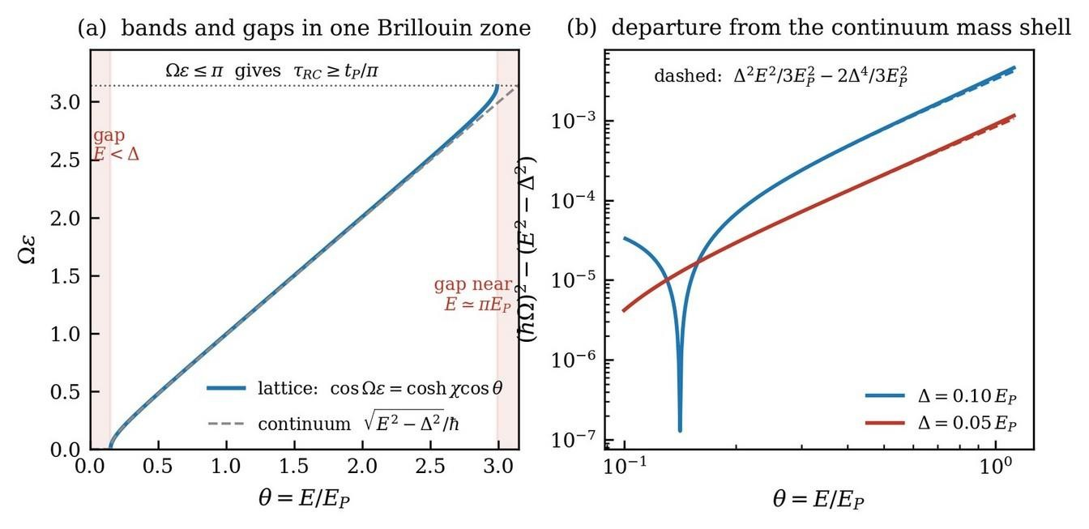
Figure 9. The lattice at the Planck cell, drawn for Δ = 0.15 Ep in panel (a). Panel (a) shows the exact dispersion (8.3) across one Brillouin zone in E, with the continuum √(E² − Δ²) dashed for comparison. Shading marks the two gaps, the familiar one below E = Δ and a second at the top of the zone, where no propagating solution exists; the ceiling Ωε ≤ π is the floor on the interference time of (8.5). Panel (b) isolates the departure from the continuum mass shell for two values of Δ and compares it with the analytic form of (8.4), shown dashed. The dip is the sign change at E² = 2Δ², which the two-term expansion predicts and the single-term one does not.

9. The status of the elementary interval

9.1 Two inequivalent discretizations
A fundamental interval enters a relativistic theory in one of two ways, and the two are not equivalent. One way lays a grid on the coordinates of a chosen frame, so that events occupy sites labelled by integer multiples of tp and ℓp. The other quantizes a scalar, so that an invariant carried along a worldline advances by units while the coordinates remain continuous. The first choice breaks Lorentz invariance explicitly and must then be repaired, either by deforming the transformation law or by declaring the breaking spontaneous. The second choice leaves the Lorentz group untouched and calls for no repair.
The construction of Section 5.1 is already of the second kind. The parameter carrying the step is τ = nε, the arc length of the worldline in the sense of Stueckelberg [14], and the coordinate time t is not the parameter of the lattice but a quantity that advances or retreats according to the sense of traversal. The lattice is a lattice in proper time, and the discreteness therefore attaches to a scalar from the outset.

9.2 Time dilation protects a lower bound, length contraction destroys one
Let two events lie on the worldline of a massive system and be separated by proper time τ. Every inertial observer assigns them the coordinate separation Δt = γτ with γ ≥ 1. A bound τ ≥ tp is therefore inherited by every observer in the form Δt ≥ tp, and a boost can only strengthen it. The bound is stable under the full Lorentz group, and no modification of that group is required to maintain it.
The corresponding statement for length fails, and it fails in the dangerous direction. A rod of rest length ℓ0 is assigned the length ℓ0/γ by a moving observer. A bound ℓ ≥ ℓp is therefore violated by any observer with γ > ℓ0/ℓp, and such observers always exist. Restoring the bound demands an upper cutoff on γ, which is a deformed boost, which is doubly special relativity [11, 12], which carries a noncommuting coordinate algebra with it as a consequence rather than as a free choice.
The asymmetry is structural. Proper time is the least coordinate separation that any observer assigns to a pair of timelike separated events, while proper length is the greatest spatial separation that any observer assigns to an extended body. A lower bound placed on a quantity that every other observer sees enlarged is inherited upward and survives. A lower bound placed on a quantity that every other observer sees reduced is broken downward and does not survive. Discreteness of time costs nothing and discreteness of length costs the Lorentz group. Panel (a) of Figure 10 is that statement drawn.

9.3 No proper length is attached to a worldline
Proper time is the arc length of a timelike curve. It is defined without reference to any simultaneity convention, it is monotone along the curve, and it is the parameter of the histories summed over in Section 5. Proper length possesses no such standing. It is either the arc length of a spacelike curve, which no physical system traverses, or the extension of an extended body evaluated on a surface of simultaneity, which presupposes a frame before it can be stated. A sum over worldlines never calls for it.
The intuition that a minimum time entails a minimum length rests on the substitution ℓ = c tp. That product is not the proper length of anything. It is a coordinate distance in whichever frame the substitution was performed, and it transforms as the spatial component of a four-vector, which is what a scalar bound must not do. The Planck length enters Section 8 in exactly two places, and neither is a coordinate bound: through the ratio c = ℓp/tp, which is the statement that a path advances one spatial cell per tick and which fixes an invariant speed, and through the mass-independent identity λC rs = 2ℓp², which is a relation among three lengths and not a floor on any one of them.

9.4 Discreteness is a statement about counting
Number is a scalar and four-volume is a scalar. A discrete substratum whose elements are distributed at fixed density with respect to four-volume therefore admits an exactly Lorentz invariant description, and the invariance is not approximate. A Poisson sprinkling into Minkowski space at fixed density is invariant under the volume preserving Lorentz group [22], and no preferred direction can be extracted from such a sprinkling by any covariant construction [23]. What breaks Lorentz invariance in a lattice is regularity, not discreteness, and the two are routinely conflated. The invariant content of a discrete substratum is the number of elements in a region together with their causal order, both of which are scalars and neither of which is a coordinate.

9.5 Scaffold and structure
In the forward construction of Section 3 the time slicing is a scaffold. The product formula converges as ε → 0, the limit reproduces the Schrödinger propagator, and the physical content survives the removal of the slicing intact. The histories that carry the measure in that limit are continuous and nowhere differentiable, with |Δx| ∼ (ħΔt/m)^(1/2) by (3.2) and Hausdorff dimension two, so the velocity along a contributing history is undefined and nevertheless no amplitude diverges. Discreteness in the forward theory is a regulator and is properly discarded at the end of the calculation.
In the reversible construction the slicing cannot be removed. A history is no longer a graph over the parameter and is instead specified by its sequence of segments together with the placement of its reversals, which is the content of (5.3). The number of admissible reversal placements in a fixed interval grows as the inverse of the step, while the amplitude assigned to a reversal is real by (5.9) and therefore adds rather than cancelling, so the sum (5.5) resums to cosh θ with θ = Nw held fixed. Holding θ fixed is what fixes the step: releasing ε → 0 at fixed physical Δ sends w → 0 and N → ∞ with the generator (5.12) unchanged, but the vertex ceases to be a boost of finite parameter once |w| is required to stay below unity by (8.2), and the trichotomy of Section 10 has no continuum counterpart at fixed E and Δ. The elementary interval survives as a parameter of the theory rather than as an artifact of its construction.
Time symmetry and temporal continuity are therefore not independent. A reversible sum over histories requires a discrete ordering parameter, and the forward sum admits a continuum limit precisely because it is not reversible.

9.6 A one dimensional parameter admits discreteness without further choice
To discretize a one dimensional parameter one fixes a spacing and nothing else. The residual symmetry of the resulting set consists of translations by integer multiples of that spacing together with reflection, and nothing further is broken, because a one dimensional parameter carries no rotation group. To discretize three dimensional space one must in addition select a lattice type, which reduces the rotation group to a finite point group and leaves a residual anisotropy to be argued away order by order in the spacing. No such selection arises here and no such residue is generated. The objection that discreteness in three dimensions demands additional qualification, whether through cubic cells, squared coordinates or a noncommuting algebra, is an objection to discretizing three coordinates, and it does not transfer to a parameter that has one dimension and is a scalar besides.

9.7 Compactness of the conjugate variable
Discrete spectra are not obtained by imposing grids. They are obtained when the conjugate variable is compact. Angular momentum takes values in units of ħ because the conjugate angle is periodic, and rotational invariance remains exact throughout, since the quantized object is a generator of the symmetry group and not a coordinate on a manifold. That mechanism is available for time whenever the energy variable is periodic or bounded, and (8.2) and (8.3) are exactly the statement that it is: the fold amplitude is capped at Ep and the energy enters only as an angle θ = E/Ep.
The same mechanism operates in the algebra already in use. The elliptic generator K3 of the positive discrete series of SU(1,1) has spectrum k, k+1, k+2, and so on [2], so the variable conjugate to it is an angle, and the transfer matrix of Section 10 advances the state by one unit of that angle in the elliptic case. The discreteness of the ordering parameter thereby has the same standing as the discreteness of angular momentum.
The mechanism is realized in gravity in a solvable setting. In two spatial dimensions the energy of a point source is a conical deficit angle bounded above by 2π, so the energy variable is compact, and quantization of the polygon representation yields a time coordinate quantized in units of the Planck time while space remains continuous [24]. That is the asymmetry required here, obtained from the same family of groups. A different choice of variables in the same theory yields instead a curved momentum space with the manifold of SL(2,R), a mass bounded from above and noncommuting coordinates [25], so the two presentations are not reconciled, and which of them survives in three spatial dimensions is open.

9.8 What is not assumed, and what the deformation turns out to be
The Snyder algebra [26],
[xμ, xν] = i ℓp² Mμν (9.1)
is not postulated and does not appear from nowhere. It is the price of demanding a discrete position spectrum together with an undeformed Lorentz algebra. Taking momentum space to be a hyperboloid of curvature 1/ℓp, whose isometry group SO(4,1) contains SO(3,1) as the stabilizer of a point, and defining the position operators as xμ = ℓp M4μ from the four remaining generators, (9.1) is read off from the SO(4,1) commutators and nothing further is assumed. Discretizing coordinates obliges one to accept it. Discretizing a scalar does not, and no coordinate algebra enters the construction.
Whether a deformed dispersion of κ-Poincaré type is nevertheless inherited is decided by comparison rather than by preference, and the comparison can be carried out because both objects are in hand. The κ-Poincaré Casimir [27] is
Cκ = (4/ℓ²) sinh²(ℓE/2) − p² eˡᴱ (9.2)
whose expansion in ℓ reads Cκ = E² − p² − ℓ E p² + O(ℓ²). The leading correction is first order in ℓ and survives at zero mass, so that a massless mode obeys p = E − ℓE²/2 and the photon velocity acquires a dependence on energy at first order in E/Ep. The lattice Casimir is (8.4). Its leading correction is second order in 1/Ep, it is proportional to Δ² and therefore vanishes identically for Δ = 0, and it saturates at the constant value Δ²/3Ep² for E ≫ Δ rather than growing with energy.
The two deformations therefore disagree in order, in mass dependence and in energy dependence. The lattice does not select a κ-Poincaré structure, so the bicrossproduct coproduct dual to κ-Minkowski is not inherited, and with it no noncommuting coordinate algebra is inherited either. The comparison is drawn in panel (b) of Figure 10. The result also removes the construction from the reach of the strongest existing constraint on Planck-scale kinematics, since the timing of gamma ray bursts bounds any first-order energy dependence of the photon velocity above the Planck energy [28], and the deformation obtained here has no first-order term and no massless term at all.
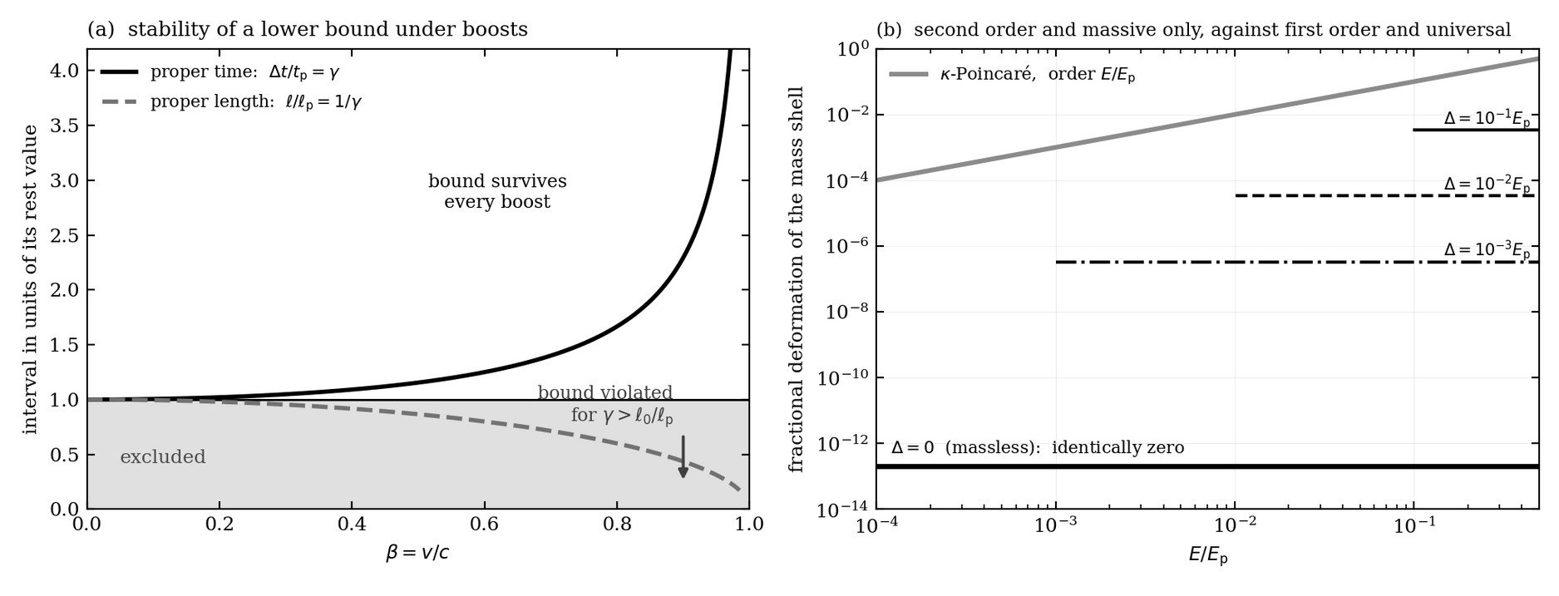
Figure 10. The status of the interval. Panel (a) follows the two candidate bounds under a boost. The proper time separation between two events on a worldline is assigned the value γtp by a moving observer and therefore rises away from the bound, while a rest length ℓ0 is assigned ℓ0/γ and falls through it at γ = ℓ0/ℓp; the shaded region is excluded by the bound and only one of the two curves stays out of it. Panel (b) compares the deformation of the mass shell obtained in (8.4) with the κ-Poincaré deformation of (9.2). The lattice correction is second order in 1/Ep, saturates at Δ²/3Ep² above threshold, and vanishes identically for a massless mode; the κ-Poincaré correction is first order in E/Ep and is independent of mass.

9.9 The null case
Proper time degenerates on null curves, so the parameter carrying the discreteness for massive systems vanishes for massless ones, and the gap is marked rather than smoothed over. Three completions are available. The tick may belong to the substrate and to its massive excitations, with the radiation field emergent and carrying no tick of its own, which is consistent with the vanishing of the deformation at Δ = 0. The affine parameter may replace proper time, at the cost that it transforms with a boost weight, so that the bound becomes frame dependent and the difficulty returns. Or the invariant that is discretized may be four-volume, which is defined for every region irrespective of causal character and which reduces to a count of ticks along a timelike worldline. The third is the completion retained here, since it is the only one that treats timelike and null structure on the same footing while keeping the discretized quantity a scalar. The choice is not required by the results reported, because the propagator, the deformed mass shell and the interference time are all derived on timelike histories.

10. Verification on the lattice
One parameter step is T = Vtime(χ)D(θ) with tanh χ = w and θ = Eε/ħ, so that
det T = 1, tr T = 2 cosh χ cos θ (10.1)
the trace being real, which places T in SU(1,1). A two by two matrix with det T = 1 has eigenvalues obeying λ+λ− = 1 and λ+ + λ− = tr T, so
λ± = [ tr T ± √( (tr T)² − 4 ) ] / 2. (10.2)
If |tr T| < 2 the eigenvalues are complex conjugates of unit modulus and repeated application rotates; this is the elliptic case. If |tr T| > 2 they are a real reciprocal pair and repeated application stretches along one direction while squeezing along the other; this is the hyperbolic case. At |tr T| = 2 the two coincide, the matrix is not diagonalisable, and the growth is polynomial; this is the parabolic case, the exceptional point seen on the lattice. Expanding tr T for small ε gives |tr T| − 2 ≃ −(E² − Δ²)ε²/ħ², verified to be −3.000 × 10⁻⁶ at E = 2Δ and +7.500 × 10⁻⁷ at E = 0.5Δ for εΔ/ħ = 10⁻³, so the lattice trichotomy reproduces the continuum threshold at E = Δ exactly.
The numerical results follow, with εΔ/ħ = 10⁻³ over a parameter interval τΔ/ħ = 10, starting from Ψ = (1, 0), and det T = 1 to 10⁻¹⁶ in every case. The vertex claims of (5.6) to (5.11) hold exactly: the vertex with real w preserves σ3 to 2 × 10⁻¹⁶ and is not unitary, while the vertex with imaginary w is unitary to 10⁻¹⁶ and does not preserve σ3. The Θ-covariance of (5.7) is likewise exact, since σ1M*σ1 − M vanishes identically for D and for the real-w vertex and does not vanish for the imaginary-w vertex.
For E = 2Δ the evolution is elliptic, the norm oscillates within a factor of 1.66, and Q is conserved to 2.6 × 10⁻¹². For E = Δ the evolution is parabolic, the norm grows polynomially by a factor of 197 over the interval, and Q is conserved to 3.2 × 10⁻¹². For E = 0.5Δ the evolution is hyperbolic, the norm grows by a factor of 1.87 × 10⁷, and Q is conserved to 1.6 × 10⁻⁸ throughout that growth, with a measured growth rate of 0.866026 against the predicted √(Δ² − E²)/ħ = 0.866025.
The last figure carries a qualification. Conserving Q while the norm reaches 10⁷ means holding a difference of order unity between two quantities of order 10⁷, so double precision cannot do better than about 10⁻⁹, and the observed 10⁻⁸ is at the arithmetic floor. Exponential growth of one quadratic form alongside constancy of another to the limit of the arithmetic remains the most stringent single test available, because it cannot happen by accident.
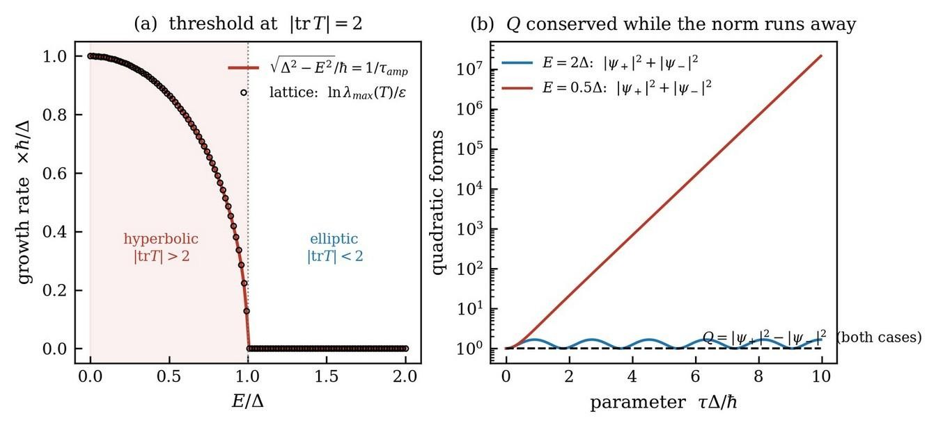
Figure 11. The temporal checkerboard on the lattice. Panel (a) compares the exact Lyapunov exponent of the transfer matrix, obtained from its spectral radius, with √(Δ² − E²)/ħ, which is the reciprocal amplification time of (1.9) and not the interference time; the threshold at E = Δ is where |tr T| crosses 2 and the evolution changes from elliptic to hyperbolic. Panel (b) follows the two quadratic forms along the parameter for one case on each side of the threshold. The norm oscillates in the elliptic case and runs away by seven orders of magnitude in the hyperbolic case, while the branch charge holds flat in both.

11. What is established, and what is not
Established. The coincidence of the three energies fixes one length, ℓp = √(ħG/c³), and the operational impossibility of resolving below it makes that length invariant. The bound is carried by the arc length of the worldline, which is a scalar, and a lower bound on a scalar that every observer sees dilated survives every boost, so the Lorentz group is left exact. Forward-time Feynman is equivalent to Schrödinger in both directions, resting on the single geometric assumption of Section 3.3, and first order in time, unitarity and the positive norm are consequences of that assumption rather than independent postulates. Permitting folds destroys the composition law at an instant and therefore first order in time. The signed crossing number is a topological invariant of a folded worldline while the total count is not, so the positive bilinear cannot be the density of anything the folding conserves. Requiring the fold vertex to be blind to the sense of traversal it exchanges forces the fold amplitude real, the vertex into U(1,1), the generator to Eσ3 + iΔσ1, the algebra to su(1,1), the conserved form to |ψ+|² − |ψ−|², and the timescale to ħ/√(E² − Δ²). The metric operator is fixed by the signature conditions (7.4) and is not an independent choice. Elimination returns the second-order equation (6.6) with no approximation, and linearizing that equation in time alone returns the same generator from those same conditions. On the Planck cell, c becomes the ratio of the cells, Δ is capped at Ep, energy is compactified into a zone with two band edges, the interference time acquires an exact floor of tp/π attained at the upper edge, and the mass shell is deformed at relative order (Δ/Ep)². That deformation is second order in the inverse Planck energy, proportional to Δ² and identically absent for massless modes, so it is not of κ-Poincaré type and no noncommuting coordinate algebra is inherited. The lattice numerics confirm each step.
Not established. Evolution generated by an imaginary coupling does not preserve the positive form, and no rephrasing conceals it; what is conserved is Q. Amplification is not simply what a noncompact group does: above threshold a positive-definite metric η+ exists in which the evolution is unitary, so the growth there is a choice of inner product, and at the level of the quantum field the corresponding squeezing dynamics is unitary outright. Invariant growth exists only in the broken phase E < Δ and at its boundary.
The conserved indefinite bilinear is not a probability. Following Feshbach and Villars and Pauli and Weisskopf, Q is a branch charge, the temporal analogue of electric charge in the scalar theory.
The absence of a third symmetry class holds only for linear symmetries and only given the σ3 metric. The signature is what is fixed, the representative is not, and antilinear symmetries fall outside the classification.
The series (5.5) diverges below threshold, which is the broken phase. The divergence is the signature of that phase rather than a defect, and cosh θ is the meaningful resummed object.
The identification Δ = mc² is a choice guided by the analogy with the spatial checkerboard and not a theorem. The lattice supplies the ceiling Δ < Ep and the invariant E² − Δ², and does not supply the value of Δ for a given system.
The absence of signalling is verified in the cases computed in [10] and is not derived. The objection is fine tuning, stated by Price: an influence running backward must conspire so exactly that no message travels, and a conspiracy of that precision asks to be explained rather than assumed. A framework whose conserved quantity is a branch charge carries material for a reply, since a quantity held at every vertex constrains what a distant setting can alter, and since the correlator of [10] saturates the Tsirelson bound rather than exceeding it. The reply has not been carried out. Producing it, or establishing that it cannot be produced, ranks with the null case of Section 9.9 among the open problems of the programme.
Proper time degenerates on null curves, so the scalar that carries the discreteness for a massive system has no massless counterpart. The covariant completion proposed in Section 9.9, in which the discretized invariant is four-volume rather than arc length and the count of ticks along a timelike worldline is recovered as a special case, has not been carried out, and it is the open technical problem of the programme.
Nothing above establishes that the formalism is correct as physics. What is established is what a sum over histories becomes on an invariant lattice when paths are allowed to fold in time, and that the alternative, Dirac's, is what the same sum becomes when a positive norm is insisted upon instead. Deciding between them is an empirical question, and the natural arena is SU(1,1) interferometry of the Yurke type [7], where the boost of (5.10) is the operation the apparatus performs.

12. Summary in three sentences
Gravitation, relativity and quantum mechanics assign the same energy at exactly one length, ℓp = √(ħG/c³), below which no measurement is possible, and the bound is carried by the arc length of a worldline, which is a scalar, so the sum over histories runs on a discrete parameter while the Lorentz group is left exact.
On such a lattice, Feynman with monotonic time gives Schrödinger, and gives with it first order in time, unitarity and the positive norm behind the Born rule, three postulates delivered as consequences of the single requirement that a path cross each instant exactly once.
Feynman with reversible time withdraws that requirement and delivers a second set of consequences in its place, because a vertex that exchanges the two senses of traversal cannot distinguish between them, which forces a real fold amplitude, a U(1,1) vertex, the generator Eσ3 + iΔσ1, the second-order equation whose linearization in time alone returns that same generator, the metric that comes with the signature, the conserved branch charge, the ceiling Δ < Ep, and τRC = ħ/√(E² − Δ²).

Acknowledgments
It is a pleasure to thank Laurence A. Jacobs for a detailed reading, and in particular for pressing the distinction between the counting and the vertex drawn in Sections 4.2 and 5.3, for the Pauli-Weisskopf reference, for the two-mode squeezing counterexample, and for questions about the exhaustiveness of the symmetry classification and about the exceptional point in the rest frame, and for pressing the question of what kind of object the elementary interval is, which Section 9 answers.

References
[1] Aharonov, Y., Bergmann, P. G., and Lebowitz, J. L. (1964). Time symmetry in the quantum process of measurement. Physical Review 134, B1410.
[2] Bargmann, V. (1947). Irreducible unitary representations of the Lorentz group. Annals of Mathematics 48, 568.
[3] Mostafazadeh, A. (2002). Pseudo-Hermiticity versus PT symmetry. Journal of Mathematical Physics 43, 205.
[4] Feshbach, H., and Villars, F. (1958). Elementary relativistic wave mechanics of spin 0 and spin 1/2 particles. Reviews of Modern Physics 30, 24.
[5] Pauli, W., and Weisskopf, V. (1934). Über die Quantisierung der skalaren relativistischen Wellengleichung. Helvetica Physica Acta 7, 709.
[6] Bender, C. M., and Boettcher, S. (1998). Real spectra in non-Hermitian Hamiltonians having PT symmetry. Physical Review Letters 80, 5243.
[7] Yurke, B., McCall, S. L., and Klauder, J. R. (1986). SU(2) and SU(1,1) interferometers. Physical Review A 33, 4033.
[8] Scholtz, F. G., Geyer, H. B., and Hahne, F. J. W. (1992). Quasi-Hermitian operators in quantum mechanics and the variational principle. Annals of Physics (N.Y.) 213, 74.
[9] Frank, A. (2026). Local Reality from Time Symmetry: Measurement as a Phase Transition in the Arrow of Time. Submitted to Physics Letters A, manuscript PHYLA-D-00469.
[10] Frank, A. (2026). Local Reality from Time Symmetry: Algebraic Derivations and Falsifiable Predictions. Submitted to Physics Letters A, companion to [9].
[11] Amelino-Camelia, G. (2002). Doubly special relativity. Nature 418, 34.
[12] Magueijo, J., and Smolin, L. (2002). Lorentz invariance with an invariant energy scale. Physical Review Letters 88, 190403.
[13] Trotter, H. F. (1959). On the product of semi-groups of operators. Proceedings of the American Mathematical Society 10, 545.
[14] Stueckelberg, E. C. G. (1941). La signification du temps propre en mécanique ondulatoire. Helvetica Physica Acta 14, 322.
[15] Klein, O. (1926). Quantentheorie und fünfdimensionale Relativitätstheorie. Zeitschrift für Physik 37, 895.
[16] Gordon, W. (1926). Der Comptoneffekt nach der Schrödingerschen Theorie. Zeitschrift für Physik 40, 117.
[17] Dirac, P. A. M. (1928). The quantum theory of the electron. Proceedings of the Royal Society A 117, 610.
[18] Feynman, R. P., and Hibbs, A. R. (1965). Quantum Mechanics and Path Integrals. McGraw-Hill. Problem 2-6.
[19] Jacobson, T., and Schulman, L. S. (1984). Quantum stochastics: the passage from a relativistic to a non-relativistic path integral. Journal of Physics A 17, 375.
[20] Feynman, R. P. (1948). Space-time approach to non-relativistic quantum mechanics. Reviews of Modern Physics 20, 367.
[21] Schrödinger, E. (1926). Quantisierung als Eigenwertproblem (Zweite Mitteilung). Annalen der Physik 79, 489.
[22] Bombelli, L., Lee, J., Meyer, D., and Sorkin, R. D. (1987). Space-time as a causal set. Physical Review Letters 59, 521.
[23] Bombelli, L., Henson, J., and Sorkin, R. D. (2009). Discreteness without symmetry breaking: a theorem. Modern Physics Letters A 24, 2579.
[24] 't Hooft, G. (1996). Quantization of point particles in (2+1)-dimensional gravity and spacetime discreteness. Classical and Quantum Gravity 13, 1023.
[25] Matschull, H.-J., and Welling, M. (1998). Quantum mechanics of a point particle in (2+1)-dimensional gravity. Classical and Quantum Gravity 15, 2981.
[26] Snyder, H. S. (1947). Quantized space-time. Physical Review 71, 38.
[27] Majid, S., and Ruegg, H. (1994). Bicrossproduct structure of κ-Poincaré group and non-commutative geometry. Physics Letters B 334, 348.
[28] Abdo, A. A., et al. (Fermi LAT and Fermi GBM Collaborations) (2009). A limit on the variation of the speed of light arising from quantum gravity effects. Nature 462, 331.
[29] Aharonov, Y., Albert, D. Z., and Vaidman, L. (1988). How the result of a measurement of a component of the spin of a spin-1/2 particle can turn out to be 100. Physical Review Letters 60, 1351.
[30] Cramer, J. G. (1986). The transactional interpretation of quantum mechanics. Reviews of Modern Physics 58, 647.
[31] Wharton, K. B., and Argaman, N. (2020). Colloquium: Bell's theorem and locally mediated reformulations of quantum mechanics. Reviews of Modern Physics 92, 021002.
[32] Price, H. (1996). Time's Arrow and Archimedes' Point: New Directions for the Physics of Time. Oxford University Press, New York.
[33] Price, H. (2012). Does time-symmetry imply retrocausality? How the quantum world says "Maybe". Studies in History and Philosophy of Modern Physics 43, 75.

