BEIHANG UNIVERSITY
Basketball Shot Clustering
Frederico Portugal Pinho Rocha (LJ1808408)
Computer Engineering
FEUP
Porto, Portugal
fred.p.p.r@gmail.com
Abstract—This project gathers data from NBA regular seasons spanning from 2015 to 2018, using data scraping methods, and analyses the empirical success rate of the three types of distance shots using k-means clustering algorithms, proving the hypothesis that 3-point shots have become the key to victory.

Keywords—NBA, basketball, shots, k-means clustering, scraping, python, paint, midrange, three pointers

Introduction
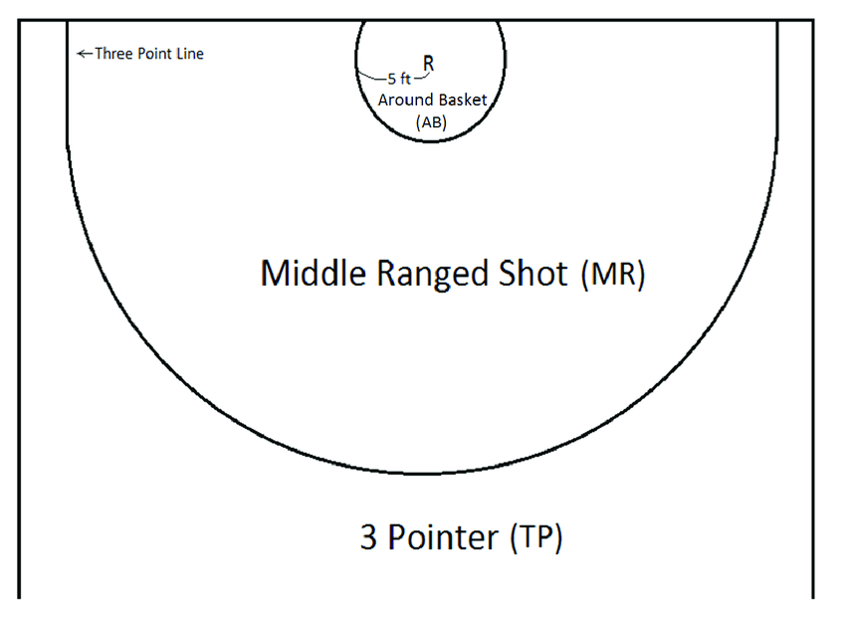
Starting in the year 2015, a transformation in the way that basketball was being played in the NBA happened, due to the dominant champions shooting an enormous amount of 3-point shots when compared to its competition. In basketball, the three different types of distance shots are: the ones around the basket, also known as paint, worth 2 points; midrange shots, farther but also worth 2 points; and 3-point shots, which happen from behind the perimeter line. The 3-pointers have, thus, become highly valued ever since 2015, however, their importance isn’t yet truly understood. As such, I’ve collected individual player data, from the 2015 season until the latest, regarding their shot choice and each team’s winning numbers for each season. Seeing as each team plays 82 games every season, a winning team would end the season with over 50 wins. This data was collected from the website www.basketball-reference.com, using data scraping methods. Data scraping is a common data mining technique used to automatically extract only desired data from websites into datasets.
After having extracted the data, various attempts were made at extracting meaningful conclusions from the information gathered, using k-means graph clustering algorithms. Both the data scraping and clustering algorithms were manually coded using the Python language.

Design and Implementation

Data Scraping
When creating the scraping script, the first step was choosing the website to scrape. BasketballReference has a simple design, full of tables containing a plethora of data based for each team and year.
Using the BeautifulSoup¹ python library, all 120 pages containing the 30 NBA teams throughout 4 years were iterated and had their html parsed, providing a total of 120 individual data points. Afterwards, the desired tables were accessed and had their data extracted. For each iteration, a list was appended containing an entry for each team, with the extracted information. Each entry had the team’s name formatted as its three initials + the season’s year in question, the amount of wins during said season, the average shot distance and the percentage of attempts for each of the three types of shots. After having all entries stored in the list, the list was then iterated as every entry was written into a row in a csv file, which is an excel filetype. This csv file was to be used as input for the clustering algorithms.

Clustering
When coding the clustering algorithms, certain python specific libraries were used to handle the data. Pandas² was used to read the csv file into a format compatible with Numpy³, which organized the data into a dataset. This dataset was accessed by Matplotlib⁴ for plotting purposes, and by Sklearn’s⁵ KMeans clustering functions.
Sklearn’s k-means clustering algorithm accepts first the desired number of clusters to be made, then provides the cluster labels as an array. The dataset points are then to be iterated and stored into a separate list of clusters, according to their cluster label. For optimization purposes, the graph plotting happens while the dataset points are being iterated. Due to the nature of the Sklearn algorithm, every time the script is ran, the clusters are always created in a different order, thus as a way to identify each cluster the console prints useful information to differentiate them, using their colour codes.
In order to find the optimal number of clusters for a given dataset, the Elbow Method⁶ was used. The Elbow method finds the average distortion for all the clusters created and plots it along different numbers of clusters. The average distortion is calculated by measuring the distance between each point in a cluster to its given centroid. Once plotted, the optimal K number of clusters is the point where the function’s derivative changed the most, meaning, the point from which the average distortion stops decreasing at such an abrupt rate.

Testing
The hypothesis testing was first done using the average shot distance team data along with average cluster wins. After not drawing conclusive results, the graph clustering was used with shots attempted from the paint along with shots attempted from outside the perimeter, which drew more relevant results.

Shot Distance x Wins
Initially, I attempted to see a connection between how far teams averaged their shots and their win rate. Creating a plot with three clusters, where there would be teams that shot from close, far, and inbetween, unfortunately didn’t yield conclusive results, most likely due to the imprecise nature of averages.
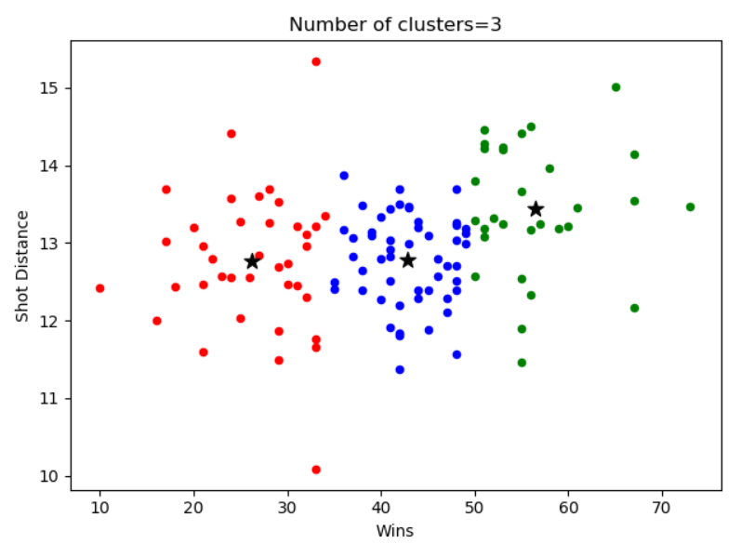

3-pointers x paint attempts
In order to find more specific correlations between shot types, and avoiding average data when clustering, the k-means algorithm was applied to the percentage of attempted shots from the paint and from outside the perimeter for each team. Afterwards, each cluster would have their win rate analysed, in order to correlate shot preference with victories. Furthermore, this approach also allowed to consider midrange shots, as it is the only remaining shot type and as such any horizontal variance between clusters would mean a change in midrange attempts.
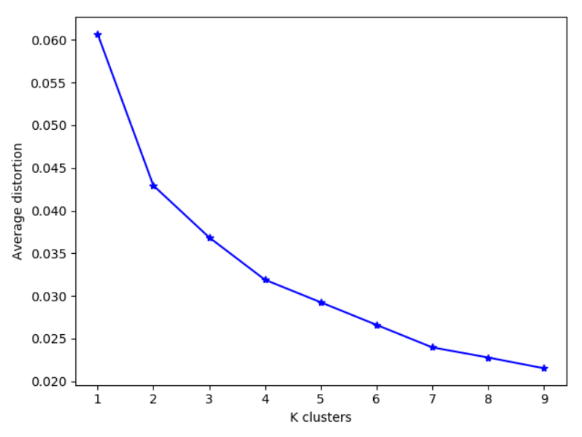
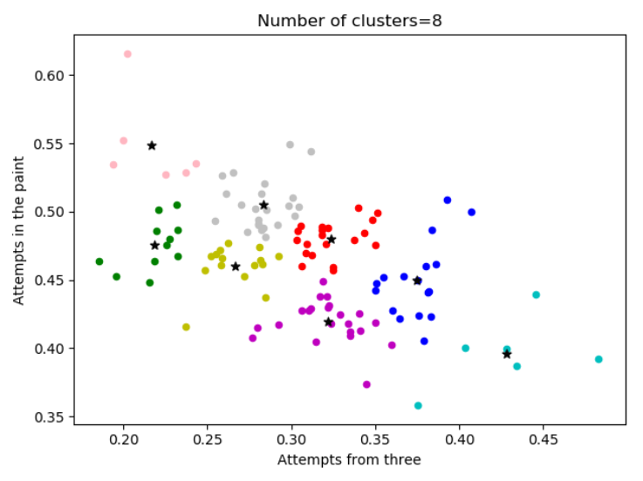
Following the Elbow Method, the number of clusters was decided to be 8, as that was the point where the average distortion seemed to follow a more horizontal trend.
This approach provided a more interesting graph shape, as it showed clusters with vastly differing plot points, such as the cyan edge cluster with heavy focus on three point attempts, and the other edge cluster in pink with heavy focus on attempts from the paint. The clusters in the middle of the plot give more preference to midrange shots when compared to the two edge clusters.When calculating every cluster’s average win rate, the pink and cyan ones had 54 and 49 average wins per team, while every other cluster averaged around 40. However, due to the small size of the edge clusters, a different analysis method had to be used in order to draw better conclusions.
As such, the percentage of teams with over 50 wins, which is considered a good record for a season, was calculated for each cluster.
In this new scenario, the cyan cluster, which focused on three attempts, had a stunning 66% of teams over 50, while the pink which focused on paint attempts only had 50%.
Next to the cyan cluster, sharing around the same amount of paint attempts, the blue cluster had 41% over50 teams while the purple one only had 18%. The main difference between both clusters is that the blue one shoots comparatively more from outside the perimeter and less from the midrange.
Again, analysing the clusters next to the pink cluster, the grey one has 30% over50 teams while the green one only has a staggering 9%. The main difference between both is again how the grey one shoots comparatively more from three and less from midrange.
The four clusters which shot the most from midrange, the green, yellow, red, and purple all had by far the lowest scores of the bunch, with little significant variance between each.

Conclusions
This study proved correct the hypothesis that teams that focus their efforts on three point attempts are more victorious. However, it also showed that teams that completely forego the three point attempts and focus entirely on shots under the basket are also due for some success.
The strongest conclusion taken from this work, unrelated to the initial hypothesis of three point prevalence, is that teams that neither focus on paint attempts nor three point attempts, and instead give more importance to the midrange and take a hybrid of shots, are by far the least victorious ones

References
- https://www.crummy.com/software/BeautifulSoup
- https://pandas.pydata.org/
- http://www.numpy.org/
- https://matplotlib.org/
- https://scikit-learn.org/
- https://en.wikipedia.org/wiki/Elbow_method_(clustering)

Scraping
- https://gist.github.com/ryanvmenezes/4779d017010a9e3c6b75
- http://savvastjortjoglou.com/nba-shot-sharts.html

K-means Clustering
- https://bigdatascienc.wordpress.com/2017/12/29/k-means-clustering-in-python/
- https://www.cmusportsanalytics.com/clustering-nba-teams-by-shot-selection/
- https://www.learndatasci.com/tutorials/k-means-clustering-algorithms-python-intro/

