LABORATORY EXERCISE 8

REAL-TIME NOTIFICATIONS WITH JQUERY

Learning Objectives
By the end of this laboratory exercise, students should be able to:
- Implement AJAX functionality using jQuery to fetch data from the server without refreshing the page.
- Create a dynamic notification system that displays real-time updates to the user.
- Update the user interface (UI) based on server-side data, specifically by managing a notification badge.
- Utilize Bootstrap components for styling interactive alerts and badges.
- Manage application state by marking notifications as "read" via an AJAX call.

Prerequisite student experiences and knowledge
Before starting this exercise, students should have:
- Completed Laboratory Exercise 7 (File Uploads for Course Materials).
- A solid understanding of the CodeIgniter MVC structure and database operations.
- Proficiency in writing basic jQuery and JavaScript code.
- Experience with handling jQuery AJAX requests (GET, POST).
- Familiarity with manipulating the DOM with jQuery (e.g., showing/hiding elements, updating text).
- Knowledge of Bootstrap classes for badges and alerts.

Background
A key feature of modern, interactive web applications is the ability to provide real-time feedback and updates to users. Notifications inform users of important events, such as new course enrollments or available materials, without requiring a page reload. jQuery's AJAX methods allow the client-side browser to asynchronously communicate with the server, fetching new data in the background. This data can then be dynamically inserted into the webpage, creating a seamless user experience. This exercise will guide you in building a notification system that displays a badge count in the navigation bar and a dropdown list of alerts, all styled with Bootstrap.

Materials/Resources
- Personal Computer with Internet Access
- XAMPP/WAMP/LAMP server installed
- CodeIgniter Framework (latest version)
- Visual Studio Code or any code editor
- Git and GitHub Account
- Web Browser (Chrome, Firefox, etc.)
Laboratory Activity
Step 1: Database Setup for Notifications
- Create a new migration file for a notifications table.
Run: php spark make: migration CreateNotificationsTable
- Open the new migration file in app/Database/Migrations/.
  - In the up() method, define the table with the following fields:
    - id (primary key, auto-increment)
    - user_id (int, foreign key to users table)
    - message (varchar, e.g., "You have been enrolled in [Course Name]")
    - is_read (tinyint, default 0)
    - created_at (datetime)
- In the down() method, drop the notifications table.
- Run the migration: php spark migrate

Step 2: Create a Notification Model
- Navigate to app/Models/ and create a file named NotificationModel.php.
- Create methods for:
  - getUnreadCount($userId)
    - Fetches the count of unread notifications for a user.
  - getNotificationsForUser($userId)
    - Fetches the latest notifications (e.g., limit 5) for a user.
  - markAsRead($notificationId)
    - Updates a specific notification's is_read field to 1.

Step 3: Update the Base Controller/Layout
- To display the notification badge on all pages, we need to fetch the unread count for the logged-in user and make it available to the main layout.
- In your base controller (or a custom controller that others extend), add logic to load the unread notification count and pass it to the view. Alternatively, you can create a view fragment that uses an AJAX call to get the count (more complex but more efficient).
- For simplicity, modify your main layout file (e.g., app/Views/templates/header.php) to include a placeholder for the notification badge..

Step 4: Create a Notifications Controller and API Endpoints
- Create a controller named Notifications.php in app/Controllers/.
- Add the following methods:
  - get()
    - A method that returns a JSON response containing the current user's unread notification count and list of notifications. This will be called via AJAX.
  - mark_as_read($id)
    - A method that accepts a notification ID via POST and marks it as read. Returns a success/failure JSON response.
- Ensure these routes are added to app/Config/Routes.php:
  - \$routes-\>get('/notifications', 'Notifications::get');
  - \$routes-\>post('/notifications/mark_read/(:num)', 'Notifications::mark_as_read/$1');.

Step 5: Build the Notification UI with jQuery and Bootstrap
- In your main layout file (e.g., header.php), add the Bootstrap-styled notification dropdown to the navigation bar.
- Include a badge (`<span class="badge bg-danger">...</span>`) to show the unread count. Initially, it can be hidden or show 0.
- Create the dropdown menu structure to list notifications. It can initially be empty.
- Write a jQuery function (in a separate .js file or within a `<script>` tag) that uses `$.get()` to call your /notifications endpoint.
- In the AJAX success callback, update the badge count with the returned data. If the count is 0, hide the badge; otherwise, show it.
- Populate the dropdown menu with the list of notifications. Use Bootstrap's alert classes (e.g., `alert alert-info`) for each notification item to improve styling.
- For each notification, add a Mark as Read button/link that triggers another jQuery function.
  - This function should use $.post() to call the /notifications/mark_read/[id] endpoint and, upon success, remove the notification from the list and update the badge count.

Step 6: Trigger Notification Updates
- Call your jQuery notification-fetching function when the page loads (`$(document).ready()`).
- To simulate real-time updates, you can set an interval to fetch notifications every 60 seconds (optional advanced task).

Step 7: Generate Test Notifications
- Temporarily modify your course enrollment logic (from a previous lab) to create a new notification in the notifications table for the student when they enroll in a course.

Step 8: Test the Functionality
- Log in as a student and enroll in a new course (or create a notification manually in the database).
- Refresh the page and verify that the notification badge appears with the correct count.
- Click the notification dropdown and verify the list is populated correctly.
- Click the Mark as Read button on a notification and verify that it disappears from the list and the badge count decreases.

Step 9: Push to GitHub
- Commit and push your completed notification system code to your GitHub repository.

Output / Results
- Screenshot of the `notifications` table schema from your database (phpMyAdmin or equivalent).
- Screenshot of the browser's Developer Tools "Network" tab showing the successful AJAX call to the `/notifications` endpoint and its JSON response.
- Screenshots of the navigation bar:
- With the notification badge visible (showing a count > 0).
- With the dropdown open, showing the list of notifications styled with Bootstrap alerts.
- After marking a notification as read, showing the updated badge and list.

QUESTIONS:
- What are the benefits of using AJAX to load notifications compared to loading them directly with the initial page load in PHP?

- a. Real-time updates:
AJAX allows notifications to be fetched dynamically from the server without refreshing the entire page, giving users instant updates.
- b. Reduced server load:
Only the notification data is requested, not the entire webpage. This saves bandwidth and reduces unnecessary server processing.
- c. Better user experience (UX):
Users can continue interacting with the page while new notifications appear automatically in the background.
- d. Faster performance:
Since AJAX loads only a small portion of data (like notifications), pages load faster initially.
- e. Modular design:
Notifications can be managed independently from the main page logic, making the code cleaner and easier to maintain.

- Explain the role of the JSON format in the communication between your jQuery code and the CodeIgniter controller.

- a. Data exchange format:
JSON (JavaScript Object Notation) acts as a lightweight data format used to send and receive information between the frontend (jQuery) and backend (CodeIgniter controller).
- b. Easy parsing in JavaScript:
When the controller returns data as JSON, jQuery can easily parse it using JSON.parse() or automatically handle it with dataType: 'json' in AJAX calls.
- c. Consistency and flexibility:
JSON structures (key-value pairs) make it easy to send multiple pieces of information (e.g., message, timestamp, read status) in one response.

- In a production environment, what are more scalable alternatives to using a simple database query and page polling (intervals) for real-time notifications?

- a. WebSockets:
Provides a persistent two-way connection between client and server.
Notifications are pushed instantly from the server to the browser (no need for repeated requests).
🔹 Example: Using Ratchet (PHP), Socket.IO, or Pusher.
- b. Server-Sent Events (SSE):
A one-way push mechanism where the server continuously sends updates to the client as they happen.
- c. Message Queues + Push Services:
Tools like Redis, RabbitMQ, or Kafka can handle high-volume real-time message delivery efficiently.
- d. Cloud-based Notification Systems:
Services like Firebase Cloud Messaging (FCM) or AWS SNS handle real-time push notifications across devices and web apps.

Output / Results
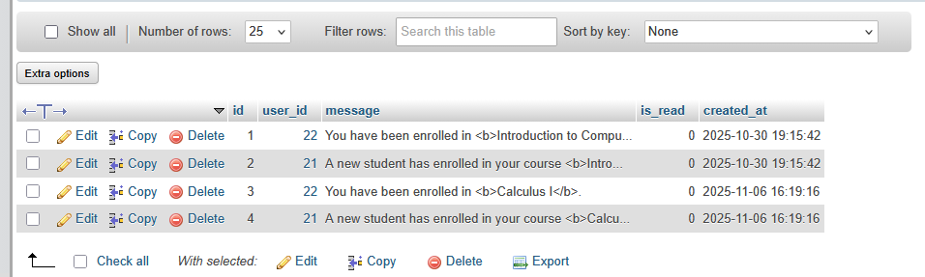

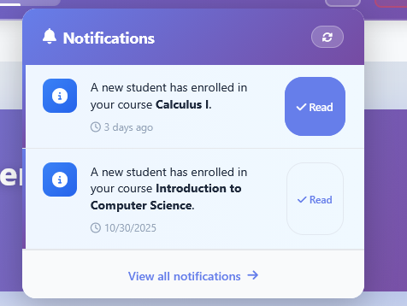

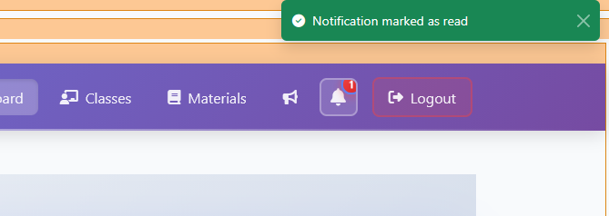

Conclusion
Using AJAX to load notifications provides a faster, smoother, and more interactive user experience by updating data dynamically without reloading the page. The JSON format plays a vital role in this process as it enables seamless data exchange between the frontend (jQuery) and the backend (CodeIgniter) in a lightweight and structured way. However, while AJAX with database polling works well for small applications, larger or real-time systems should adopt more scalable technologies such as WebSockets, Server-Sent Events (SSE), or cloud-based push notification services to ensure efficient, instant, and reliable notification delivery.

