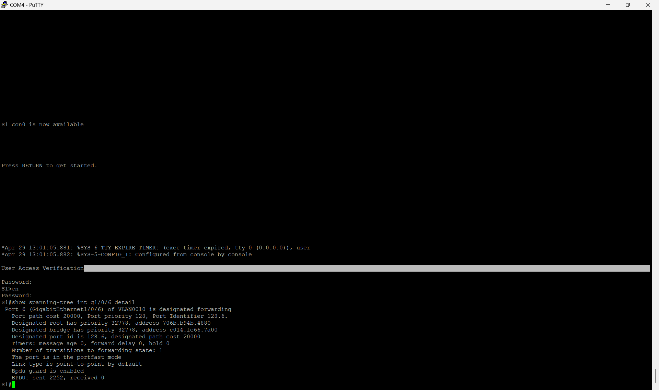
Confirmation that the spanning-tree protocol was set up correctly
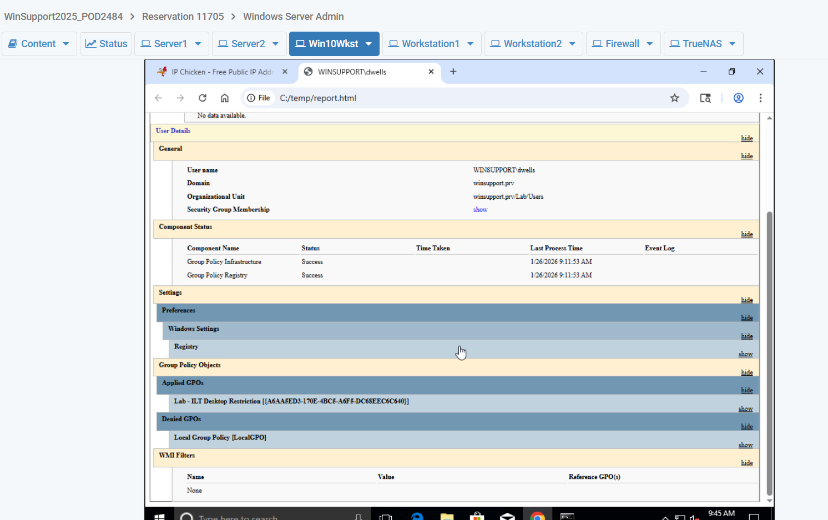
This screenshot is confirming a group policy that makes a new tab into this page
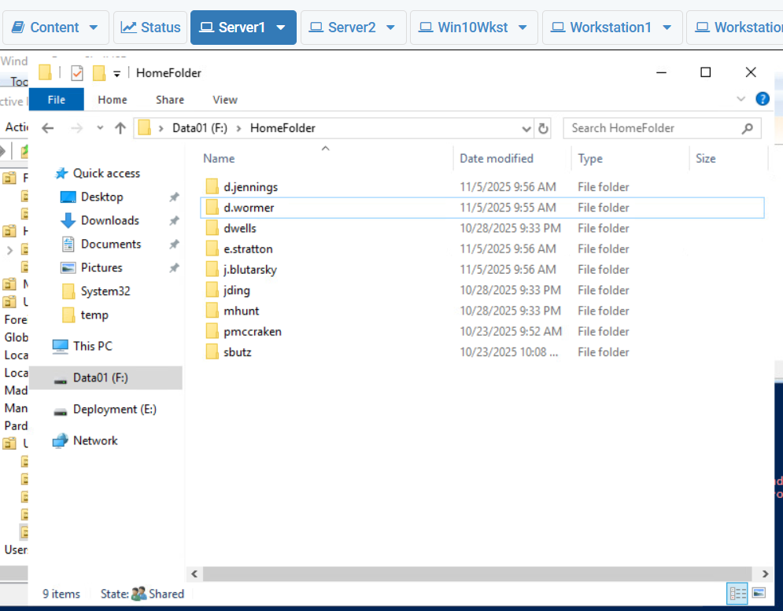Confirmation that created users have home folders on the server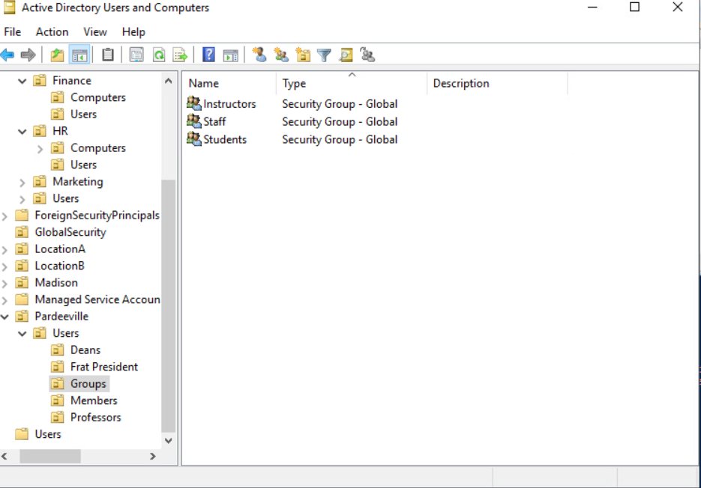
Confirmation of groups made in Active Directory
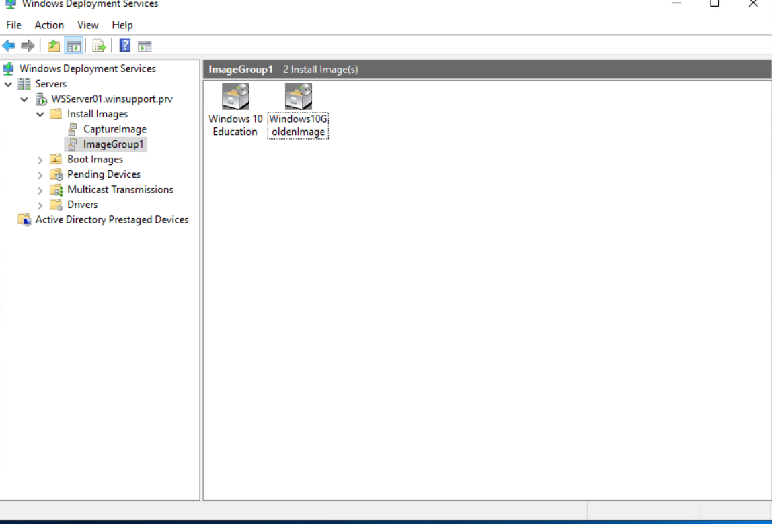
The boot images that were created and used to reimage workstations using PXE boot
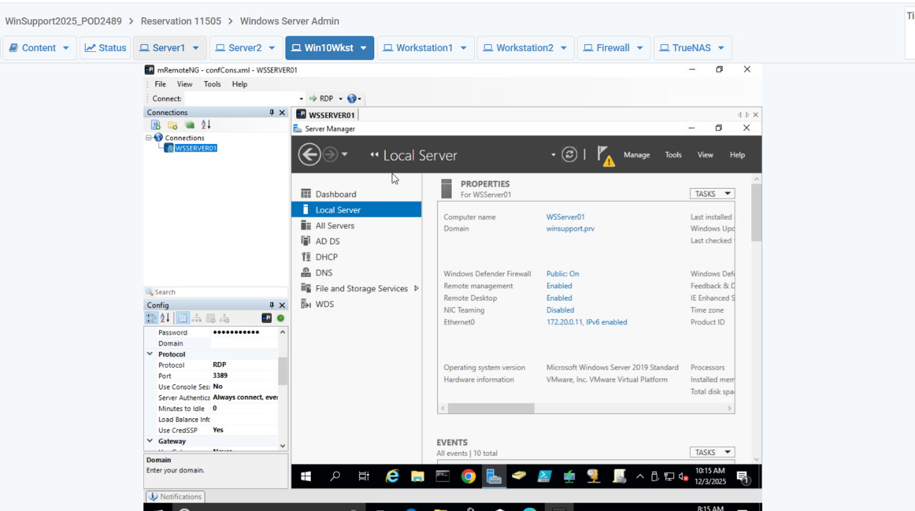
Confirmation that I could remotely access the server using SSH from a workstation

