Create a GNU Autotools C/C++ Project
From Existing C/C++ Code or From Scratch

- Create a project directory (myproj in this guide) containing src, build, and m4 directories, and any additional desired directories such as debug, test, etc.:
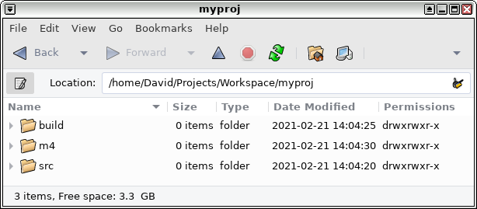
- Copy source code files into (or create them in) src:
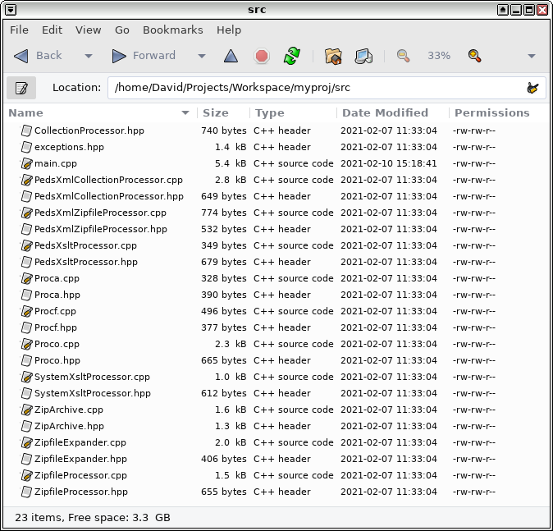
- Create a Makefile.am file listing source files in the project directory:
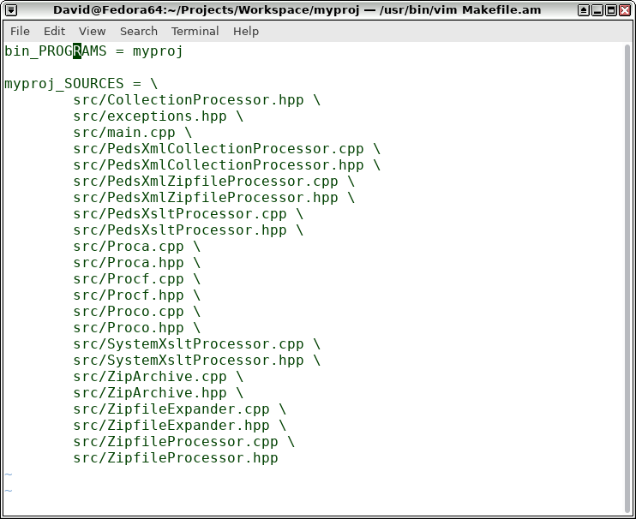
- Add preprocessor and library loading flags to Makefile.am as needed:
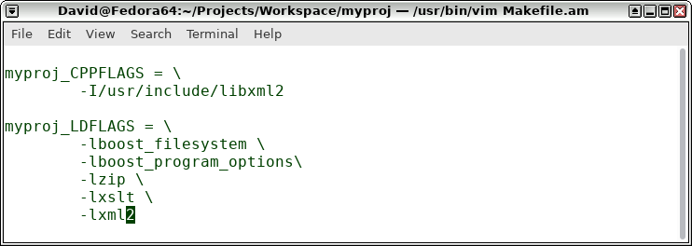
  - Use pkg-check command, where possible, to get the necessary flags.
  - Where libraries (e.g. Boost libraries) don't support pkg-check, manual determination of the flags is required.
  - Variables defined in configure.ac or elsewhere to the extent possible may be used to provide values for x_CPPFLAGS and x_LDFLAGS. See Bibliography items 2 and 3.
- Add nonstandard directories and object installation directives to Makefile.am and (create any directories or objects within the project directory) as necessary. See Bibliography item 4.
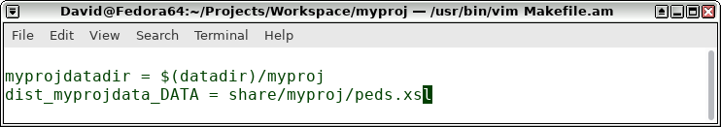
- Run autoscan in the project directory (i.e. myproj) to create a configure.scan configure script template (log file autoscan.log, also created, isn't necessary and can be deleted):
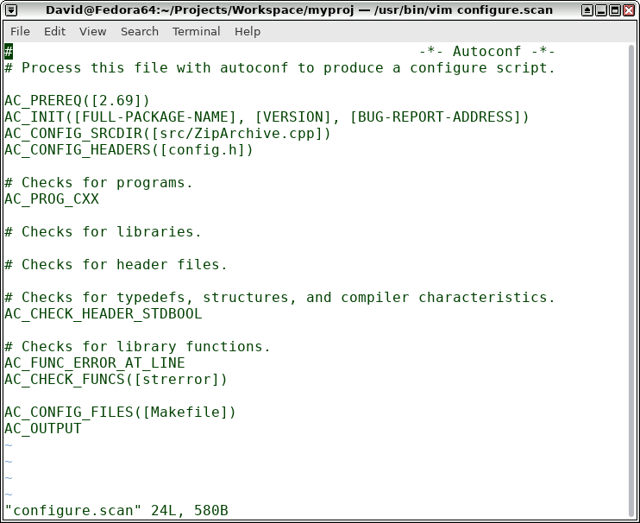
- Rename configure.scan to configure.ac (i.e. execute `mv configure.scan configure.ac`).
- Customize configure.ac as needed:
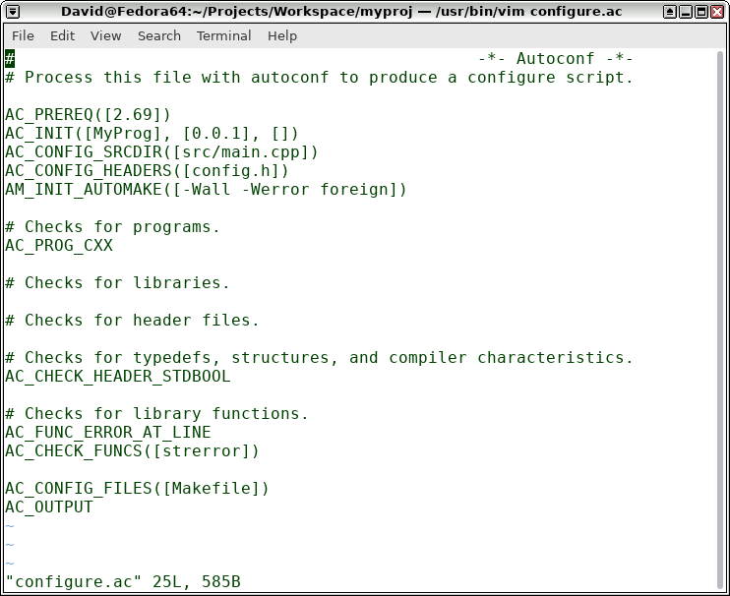
- Add checks for libraries and header files to configure.ac where desired:
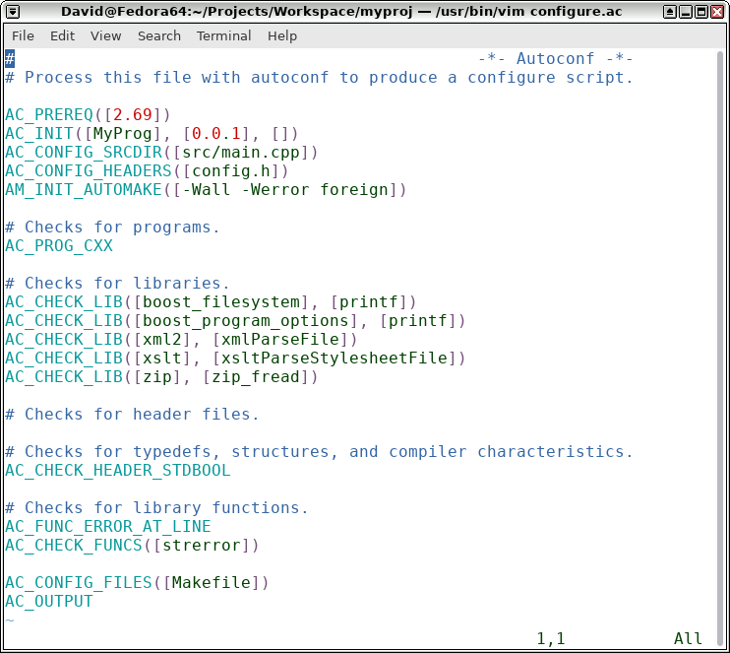
- Run autoreconf -vi to generate a configure file.
  - If a warning is generated indicating that a source file "is in a subdirectory, but option 'subdir-objects' is disabled", add the following line at the top of Makefile.am:
AUTOMAKE_OPTIONS = subdir-objects
- To build the project and thereby create a Makefile, run configure from the build directory (so that files generated during the build are kept separate from the project directory, just to keep things neat):
$ cd build
$ ../configure
- To create an executable, run make in the build directory.
$ make
- Run autoreconf -vi again after subsequent modification of Makefile.am and/or configure.ac.

Bibliography
- "Creating a simple Autotools based project", https://www.youtube.com/watch?v=dc1kEJvS248
- "Adding GTK to an Autotools Project", https://www.youtube.com/watch?v=TDGwgz1e710
- "PKG_CHECK_MODULES considered harmful?", https://stackoverflow.com/questions/10220946/pkg-check-modules-considered-harmful
- Automake Manual (for GNU Automake version 1.16.3, 19 November 2020), "2.2.3 Standard Directory Variables" and "3.3 The Uniform Naming Scheme", Copyright © 1995–2020 Free Software Foundation, Inc., https://www.gnu.org/software/automake/manual/automake.html#Uniform
- "Detecting C++ Libraries with Autotools", https://nerdland.net/2009/07/detecting-c-libraries-with-autotools/
- Autoconf Manual (for GNU Autoconf version 2.67, 21 July 2010), Copyright © 1992, 1993, 1994, 1995, 1996, 1998, 1999, 2000, 2001, 2002, 2003, 2004, 2005, 2006, 2007, 2008, 2009, 2010 Free Software Foundation, Inc., https://www.gnu.org/software/autoconf/manual/autoconf-2.67/html_node/index.html

Create a GNU Autotools C/C++ Project – Copyright © 2021 David Yockey

