Claim Tree Constructor - Quick Reference Guide
April 2002 - Created by David Yockey - Guide Version 1.0 for CTC 1.02
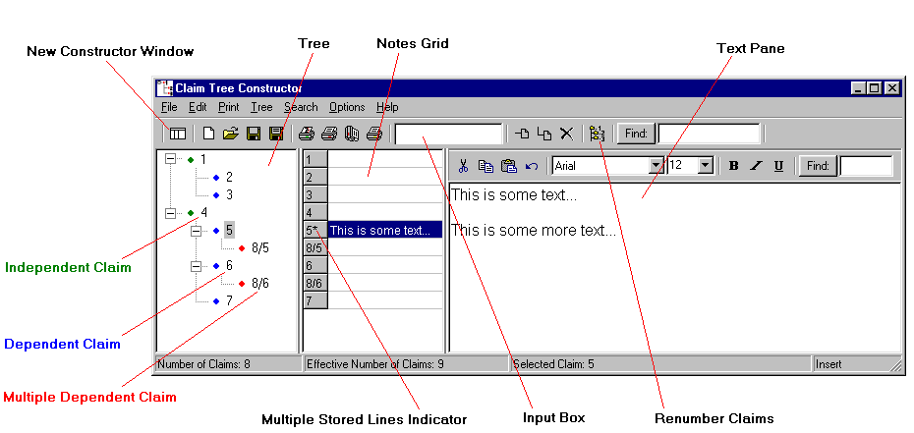

Adding Claims:
Independent Claim:
1) Type new claim number in Input Box
2) Hit Enter while holding the Shift key or click
Dependent Claim:

1) Select a claim in the Tree OR 1) Type new claim number / claim on which the
2) Type a new claim number in Input Box new claim depends in Input Box (e.g. 7/4)
3) Hit Enter or click 2) Hit Enter or click

Multiple Dependent Claim (MDC):
1) Type the new claim number in Input Box followed by a / character
2) After the / character, type the list of claims on which the MDC depends
- Separate series of claims by commas, e.g. 8/2,4
- Enter a range of claims separated by a hyphen, e.g. 9/2-4
- Series and ranges can be combined, e.g. 10/2,4,6-7
3) hit Enter or click

Renumbering Claims:
Click - click again to remove renumbering.

Text Editing:
- Notes: Each box the Notes Grid corresponding to a claim can be edited by clicking on the box and typing text. This text is identical to the first line in the Text Pane.
- Multiple Lines of Text: The Text Pane corresponds to the selected claim in the Tree. Multiple lines of text can be typed or cut & pasted into the Text Pane as desired.

Printing:
- Print Tree: click - if renumbered, a suitable-for-mailing form including the Tree with renumbering is printed; otherwise, the Tree is printed without renumbering.
- Print Tree with Notes: click - prints notes in Notes Grid adjacent claims in the tree.
- Print Tree with Notes in Landscape: click
- Print Text Pane: click - prints text in the Text Pane for the currently selected claim.

For Additional Information:
- Select Show Help File in the Options menu.

