Claim Tree Constructor - Help File

Claim Tree Constructor (CTC) allows for rapid construction of a claim tree with error checking during construction, multiple dependent claim generation with proper claim references for each dependency, and claim renumbering as necessary when allowing an application. CTC also provides storage space associated with each claim where any desired information about the particular claim may be stored (such as references to be applied, location of corresponding information in the specification, description of claimed subject matter, possible search areas, cut & pasted information from an EAST or WEST text search, etc.).

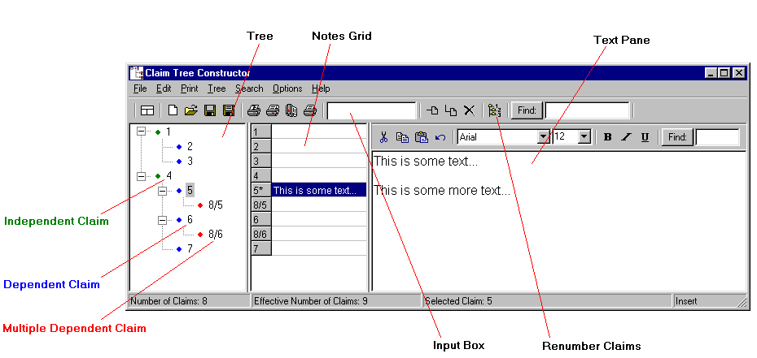

To construct a Claim Tree:

To add an Independent Claim:
- Type the number of claim to add in the Input Box.
- Hold down the Shift key and hit Enter or click the Add Independent Claim button.

To add a Dependent Claim:
- Select the claim on which the added claim will depend (click on a claim already in the tree or move to a particular claim using the up and down arrow buttons).
- Type the number of claim to add in the Input Box.
- Hit Enter or click the Add Independent Claim button.

Alternate method to add a Dependant Claim:
- Type the number of the claim to add in the Input Box, followed by a / character, followed by the claim on which the added claim will depend, and hit Enter (for example: 5/2 adds a claim 5 dependent on claim 2).

To add a Multiple Dependent Claim:
- Type the number of the claim to add in the Input Box, followed by a / character, followed by the claims on which the added claim will depend, and hit Enter (for example: 10/2,4-6,7,9 will add a claim 10 dependent on each of claims 2, 4, 5, 6, 7 and 9).

For more information on claim addition formats:
- Click in the Input Box and hit Enter with nothing in the Input Box – an error window will appear providing format information.

To Renumber a Claim Tree:

- Click the Renumber Claims button. Numbers will be added to the tree with an arrow separating each original and renumbered claim number. Clicking the Print Tree button will provide a suitable-for-mailing copy of the renumbered claim tree.

Searching:

Global Searching:
- In the right-most box on the main toolbar (the bar with buttons on it extending from the left of the window), typing text and hitting Enter will search through all text stored for each of the claims. However, if the text begins with a number, the text is assumed to be a claim number and the tree will be searched for the claim instead.

Global Searching (continued...):
- To search a number in the stored text or for a bit more advanced text searching, click the "Find:" button instead of hitting Enter, select options as desired, and then hit the "Find Next" button in the box that appears.

Local Searching:
- In the right-most box on the Text Pane toolbar (below the main toolbar), typing text and hitting Enter will search through all text stored in the Text Pane for the selected claim.
- For a bit more advanced text searching, click the "Find:" button instead of hitting Enter, select options as desired, and then hit the "Find Next" button in the box that appears.

Options (in the options menu):

Enable Claim Checking:
- Unchecking this option will allow entry of any desired text into the tree to allow for uses such as creating a classification hierarchy. Unchecking of this option is not recommended for normal use. This option is reset to being checked each time CTC is run.

Always Show Buttons:
- This option is provided to reduce visual clutter. Unchecking this option turns on labeled covers for main toolbar buttons and hides the Text Pane toolbar when the Text Pane is not being edited. This option is stored and remains in the state selected by the user each time CTC is run.

Show Claim Color Codes:
- This option selected whether or not to show a colored dot next to each claim indicating whether it is independent, dependent or multiple dependent. This option is stored and remains in the state selected by the user each time CTC is run. (Note: the colored dots are not printed when printing a Tree).

Increase Font Size:
- Each selection of this option incrementally increases the size of font displayed in the Tree and Notes Grid (i.e. repeated selection of this option will gradually increase the font size). The selected font size is stored and remains in at the size selected by the user each time CTC is run.

Decrease Font Size:
- Similar to the Increase Font Size option, but decreases rather than increases font size.

Additional Functions:
- Standard file operations (new, open, save, save as, etc.)
- Standard editing operations (undo, cut, copy, paste, delete, and select all) for text in the Text Pane.
- Tree sort, expand, and collapse functions in a right-click menu provided for the Tree.
- Various print functions for printing the Tree (if renumbered, a header is included to provide a suitable-for-mailing print), the Tree including the notes in the Notes Grid, A Landscape version of the Tree including the notes in the Notes Grid, and the selected Text Pane.
- A New Constructor Window function to start another CTC window to work on another Claim Tree while the first is still open.

A Few Definitions:

Note – The first line of the text stored in the Text Pane, displayed in the Notes Grid.

* next to claim number in Notes Grid – Multiple Stored Line Indicator. Indicates that
more than one line of text is stored in the Text Pane corresponding to the selected claim. For example, where the first line of stored text, shown in the Notes Grid, indicates references used in a rejection and additional lines include explanation of the rejection, the Multiple Stored Line Indicator indicates the presence of the additional lines of explanation without need to select the claim and look at the text.

Number of Claims – The number of claims entered into CTC. When a Tree is completed, the Number of Claims should equal the actual number of claims in the application.

Effective Number of Claims – The number of claims where each multiple dependency is considered as a separate claim. In an application having no multiple dependent claims, the Number of Claims and Effective Number of Claims is equal.

A Few Advisories:

CTC assumes all multiple dependencies entered are in alternative format – CTC has no way of knowing if claim dependencies are properly recited in the claim; e.g. if a claim 2 is improperly recited as dependent on "claims 3, 4 and 5" instead of "claims 3, 4 or 5" and the user enters "2/3,4,5" or "2/3-5", CTC assumes the meaning to be "claims 3, 4 or 5."

Don't Rename the Claims in the Tree – While this is possible by standard means in the Tree and is provided for use as desired, it is highly discouraged unless you have a really good reason because claim checking is not performed when renaming.

A Claim Dependent upon a Cancelled Claim cannot be added – A claim must be present for a claim dependent thereon to be added to the Tree.

A new dependency of a Multiple Dependent Claim cannot be added – In the event that a new dependency of this type is added (e.g. a claim 10 was dependent upon claims 3 or 4, but is amended to be dependent upon claims 3, 4 or 5), the previous Multiple Dependent Claim must be deleted and the entire newly amended Multiple Dependent Claim added after the deletion. Support for addition of new multiple dependencies may be provided in a future version of CTC.

Claim Tree Constructor – Help File — Copyright © 2002 David Yockey

