Deep Learning with PyTorch

L3: Introduction to Neural Networks

Maximum likelihood: The product of the classification probabilities of every point in a dataset. This gives the likehood of the effectiveness of the entire model. Thus, we can calculate the likehood of different models and pick the one that is the most likely to give accurate predictions.
Cross-entropy: Taking the negative log of the maximum likelihood equation for a model gives us the cross-entropy. Since taking porducts of probabilities generate very small numbers for large datasets, it is better to take the logarithms so that we can use the sum of the individual probabilities using Information Threory concepts. The numbers are also bigger.
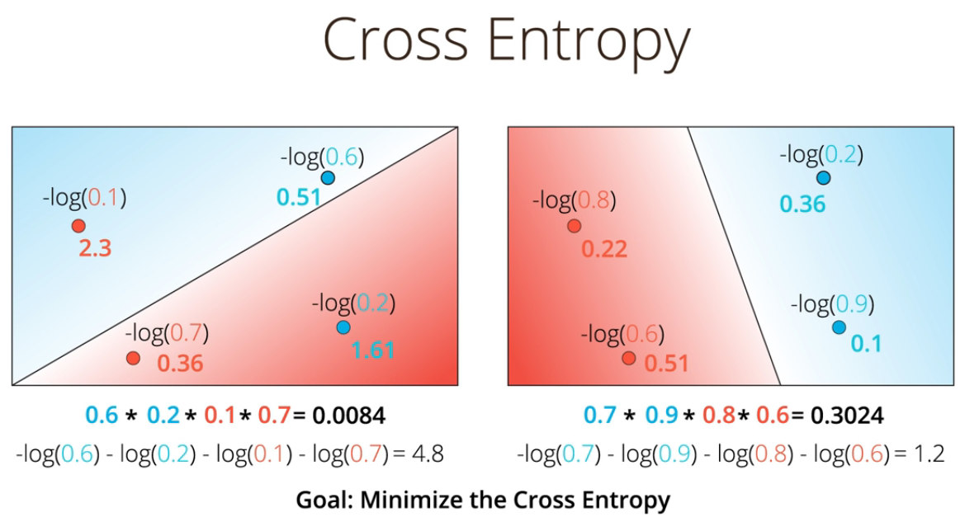
From the lecturer: If we have a number of events and their probabilities, then how likely is it that each of those events happened based on their probabilities? If it’s very likely, then we have a small cross-entropy. If it’s unlikely, then we have a large cross-entropy.

