R1 – 47 Ohm
R2 – 22 k
R3 – 220 k
R4 – 22 k
R5 – 220 k
R6 – 220 k
R7 – 82 k

C1 – 47 n
C2 – 4u7
C3 – 4u7
C4 – 100 p
C5 – 4u7
C6 – 47 n

Soldering Point Description Connection in TRX

X1 RX signal from discriminator Demod-IC / Pin 5
X2 FSK RX out to Modem, DSUB Pin 7 e.g. D652 cathode
X2A – AC-coupled
X2B – DC-coupled
X3 Combined signal / to modulator L602
X4 NF audio from microphone U601 / Pin 4
X5 FSK TX sig. from Modem, DSUB Pin 9 e.g. D651 cathode
X6 9.6 V e.g. U801 / Pin 11
X7 4.8 V e.g. U601 / Pin 9
X8 GND e.g. U601 / Pin 7

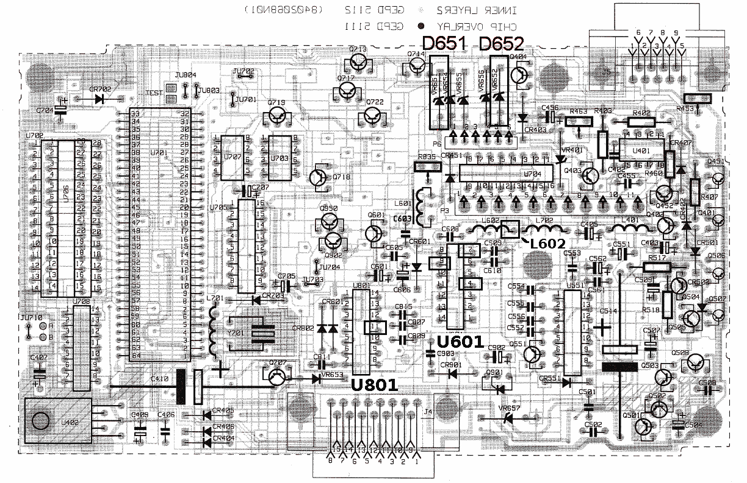Command Board

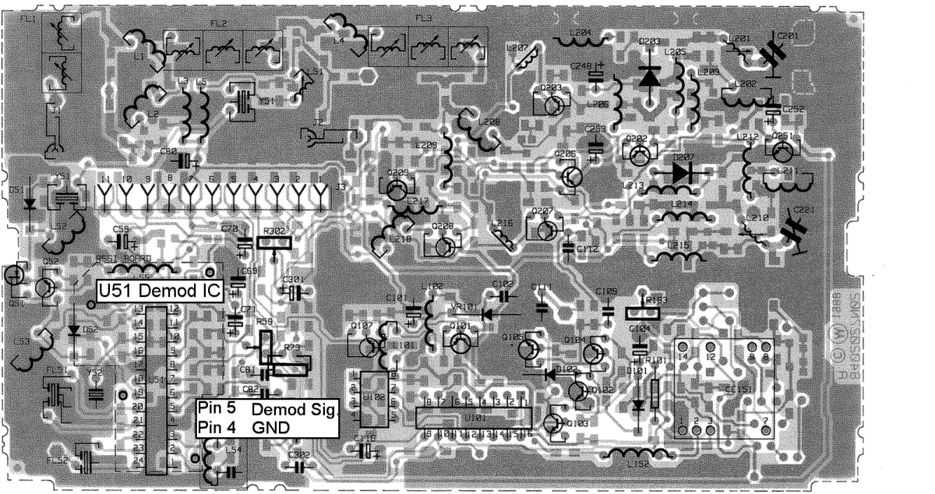
RF Board

