Red Dog Mine — Bottom-Up Climate-Risk Read
One ~100-day window carries the whole year's fuel in and the whole year's revenue out — and the Arctic is closing it.
For: InfraSure team (internal) · As of 2026-06-14 · Re-grounded 2026-06-15 · Draft v1 (for review before any external use)
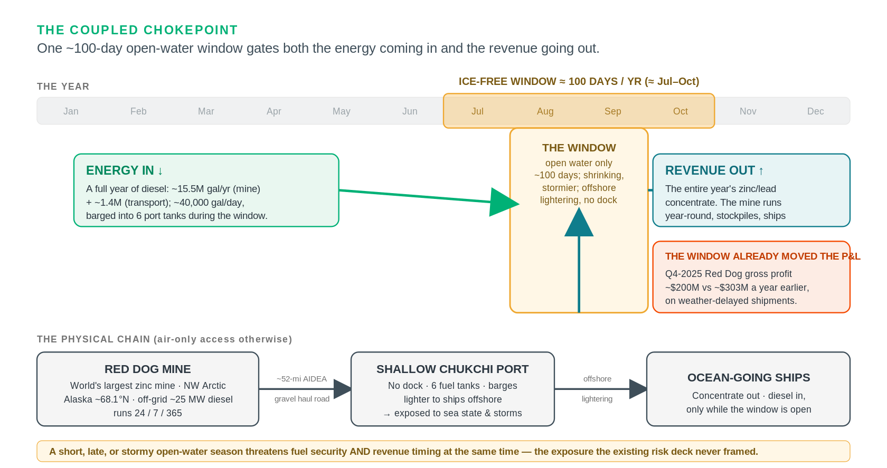
The coupled energy-and-logistics chokepoint — the central thesis in one screen (schematic). Sources: AIDEA; Teck FY2025 production; Alaska DNR. As of 2026-06-15.
TL;DR
Red Dog is a single-point-of-failure energy-and-logistics asset in the fastest-warming region on Earth. Everything the mine needs (a year of diesel) and everything it sells (its entire zinc/lead concentrate) moves through one gravel road to one shallow Chukchi-Sea port that is ice-free only ~100 days a year — so the same shrinking-and-stormier open-water window gates both energy-in and revenue-out. That coupling is the climate exposure the existing risk deck never framed, and it is squarely InfraSure's lane. Layered on top is a permafrost-driven water-balance crisis that a US regulator has formally conceded cannot be fixed (a 10-year compliance runway to ~2036), pushing a ~$279M adaptation capex onto a mine with only ~6 years of ore left, an escalating royalty, and an owner mid-merger into a copper-focused major. The decision-relevant tail risk — a diesel-tank or tailings-dam failure on thawing ground — is exactly the geometry that destroyed Norilsk in 2020 (~$2B), and the asset-level numbers that would price it (fuel autonomy, dam factor-of-safety, foundation engineering) are not disclosed — a finding in itself.
Posture: a research-grounded, directional read — the decision-relevant numbers are undisclosed, and that is itself the finding. Driver: the Arctic warms ~4× the global average and models under-state it (Rantanen 2022).

Re-ground (2026-06-15): the moving facts were re-verified against live public sources. Updated: the Anglo–Teck merger (Canada + South Korea now cleared; only China remains). Confirmed: the ADEC permit (reissuance public-noticed, ~2036 runway) and the forward production decline. Base check (held the line): the company-total 2025 zinc figure is ~565 kt, but that is Teck-total (Red Dog + Antamina) — Red Dog's own ~462,700 t below is the right base and is unchanged; the two must not be conflated. Candidate to verify before external use: Teck reportedly cites wetter weather limiting reserve access among the decline drivers — a direct confirmation of §3 if matched to Teck's exact wording.

What this is: a worked, bottom-up climate-risk read on a single off-substrate asset — Teck/NANA's Red Dog Mine, NW Arctic Alaska — produced by the reverse-engineering method (research + the model + our methodology), not the InfraSure platform. It is the proof case for handling outliers that fall outside our energy-infrastructure substrate.

Grounding honesty (read first): this is research-grounded — public sources (primary regulatory filings, Teck disclosures, peer-reviewed science, reporting) disciplined by our claim/confidence/gate rules. It uses no InfraSure MCP data and no model-gpr output. The value here is rigor + currency + the energy-infrastructure framing, not proprietary data. It deliberately does not re-do the existing LT-Risk deck; it adds what the deck lacks.
1 · The asset in one screen
Operator / owner | World's largest zinc mine · Teck Resources operates · NANA Regional Corp. (Iñupiat) owns the land
Location & type | NW Arctic Alaska, ~68.1°N (170 km N of the Arctic Circle) · open-pit zinc/lead · runs 24/7/365 · air-only access
Power | OFF-GRID: ~25 MW typical demand on diesel gensets (installed capacity contested 24.5–40+ MW)
Logistics | ~52-mi state-owned (AIDEA) gravel haul road → one shallow Chukchi port (no dock; barges lighter to ships offshore)
Production | FY2025: 462,700 t contained zinc (↓~17% from 555,600 t in 2024, on falling grades) · ore life ~2032

Sources: Alaska DNR; NS Energy; AIDEA; FindAPort; Teck FY2025 production (Feb 2026). Confidence: high (the contested item — generator nameplate — is flagged in §6).
2 · The lead exposure — a coupled energy-and-logistics chokepoint
This is the framing the LT-Risk deck missed, and it's the most decision-relevant climate linkage at the asset. The hero schematic above captures it; in plain terms:
ONE ~100-day ice-free window (≈ July–October) carries BOTH:
Energy-in — the year's diesel: ~15.5M gal/yr (mine) + ~1.4M (transport); ~40,000 gal/day; barged into 6 port tanks.
Revenue-out — the entire annual concentrate export; the mine produces year-round, stockpiles, and ships only in the window.
→ a short, late, or stormy open-water season threatens fuel security AND revenue timing simultaneously.

This is not hypothetical. In late 2025, "weather and sea conditions" delayed shipments into early 2026, and Q4-2025 Red Dog gross profit fell to ~$200M (from ~$303M a year earlier) on the timing — climate variability already moving the P&L through the logistics window. (Teck Q4-2025 results, Feb 2026 — fact/high.)
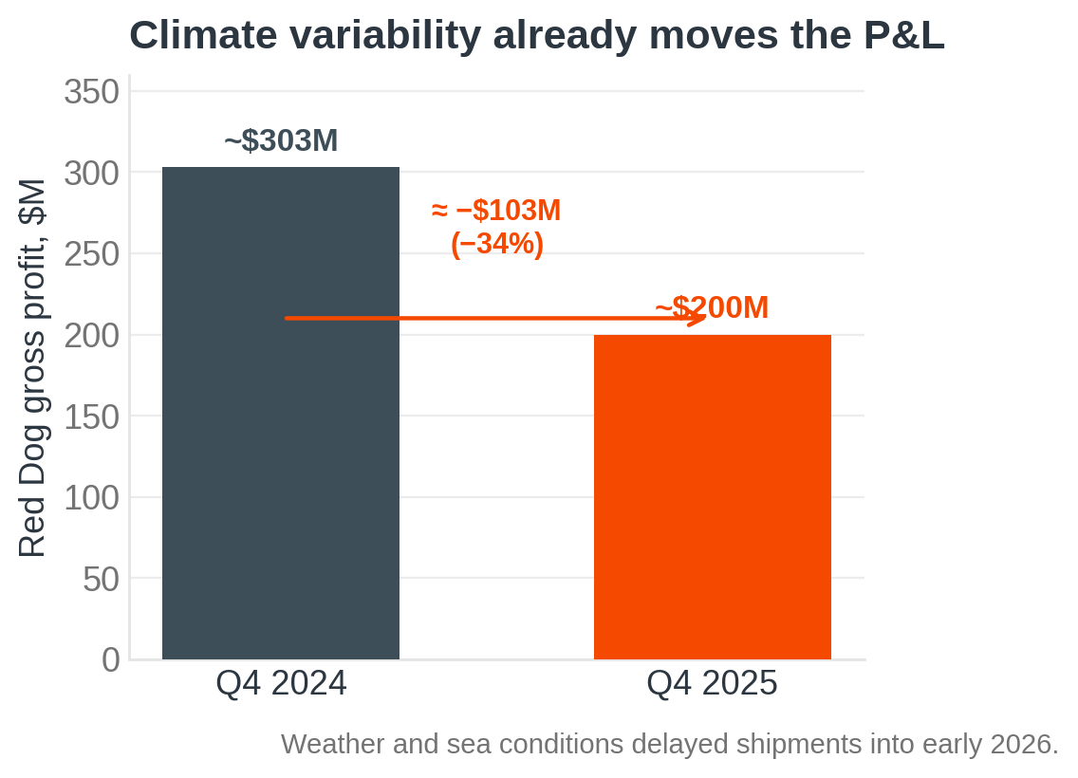
Q4 Red Dog gross profit, 2024 vs 2025. Source: Teck Q4-2025 results (Feb 2026). As of 2026-06-15. fact/high.
Two structural amplifiers:
- Sea-ice retreat cuts both ways: it can lengthen the shipping window (operational upside) but removes the landfast-ice buffer that protected the coast — the same coastal cell is eroding fast at nearby Kivalina. The port relies on offshore lightering, so it is exposed to sea state and storms, not just ice. (AIDEA; Ground Truth Alaska — fact/medium.)
- The single-window dependency is undisclosed at the point that matters: how many days of fuel the site can run if a resupply season is missed or cut short is not public (see §6). An 8.8 MW solar array (Tugliq, ~2 MW summer-effective, tax-credit-timed to start mid-2026) dents diesel but does not change the resupply dependency. (Alaska Beacon, Mar 2026 — fact/high; the "dents not displaces" read is ours.)
3 · Permafrost → a water-balance crisis the regulator calls unfixable
The second pillar is documented in primary regulatory text, not just press:
permafrost thaw → naturally elevated TDS in receiving waters → lost mixing-zone capacity → discharge blocked
+ a wetter Arctic → tailings/contact water +60% (3.3B → 5.3B gallons, 2017–2021) → encroaches on dam freeboard

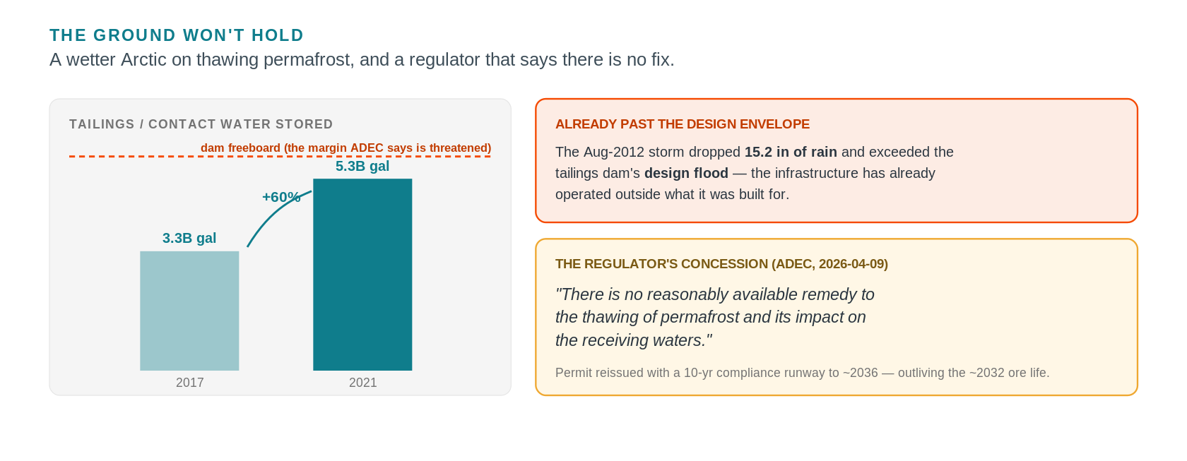
The ground won't hold — rising contact water against the dam-freeboard margin, a storm past the design flood, and the regulator's concession (schematic). Source: Alaska DEC APDES AK0038652 Statement of Basis (2026-04-09). As of 2026-06-15. fact/high.
- Alaska DEC is reissuing the discharge permit (APDES AK0038652) with a 10-year compliance-schedule extension (public-noticed; effective after May 19, 2026, to ~2036), stating in its own Statement of Basis (2026-04-09) that "there is no reasonably available remedy to the thawing of permafrost and its impact on the receiving waters." A US regulator formally conceding a Clean-Water-Act limit can't be met because of permafrost is decision-relevant and unusual. (ADEC SOB — fact/high.) Note: this corrects the deck's "permit expiring 2026" — it was extended, and the runway now outlives the ~2032 ore life, shifting the binding constraint toward closure-phase water treatment.
- ADEC states stored water "threatens the safety of the tailings impoundment dams," with a tail risk of "dam failure" / untreated-drainage release. The Aug-2012 storm (15.2 in rain) exceeded the tailings dam's design flood — the infrastructure has already operated outside its design envelope. (ADEC SOB — fact/high; this is the single strongest data point that the asset is past-envelope.)
- The mitigation under evaluation is a ~$279M, ~50-mile pipeline to the Chukchi Sea — "more than half of Red Dog's annual gross profit" — one of four options, not committed. ~$19M was already spent on thaw-driven wastewater in 2020 alone. (Northern Journal Dec 2025; Alaska Public Media 2020; ADEC SOB — fact/high; the pipeline is an estimate under evaluation — projection.)
- The regional driver is real and independent of the mine: "river rusting" — thaw-exposed sulfide weathering turning 75+ (200+) Brooks Range streams orange — with on-site seeps measured at pH 3.2 and TDS to 11,300 mg/L. (O'Donnell 2024 / NOAA Arctic Report Card 2025; ADEC SOB — fact/high.)
Context for the rate: the Arctic has warmed ~4× the global average since 1979, and climate models under-state it — so the signal arrives faster than scenario planning assumes, compressing adaptation lead-time. (Rantanen 2022, Nature Comms — fact/high.)
4 · The decision frame — a fading asset asked to fund a costly adaptation
What makes this a genuine decision (not just a hazard list) is the collision of climate capex with late-life economics:
A fading asset | ore ~2032; Red Dog zinc guided DOWN 2026 375–415 kt → 2027 330–370 → 2028 230–270 kt; extension (Aktigiruq/Anarraaq) only pre-feasibility
A rising cost base | NANA royalty ratchets 40% (2022) → 45% (Oct 2027) → 50% max, as grades/tonnage fall
Ownership in flux | Anglo–Teck merger announced Sept 2025, shareholder-approved Dec 2025; Canada + S. Korea cleared, ONLY CHINA remains (as of Jun 2026), close ~Q3-2026–Q1-2027 → Red Dog a non-core zinc slice of a >70%-COPPER major
A long-tail liability | state closure assurance ~$558M + PERPETUAL post-closure water treatment (outlives the revenue)

Sources: Teck production guidance + MD&A; North of 60 Mining News; Teck/Anglo merger releases; Alaska DNR. Confidence: high (figures), with mine-life ~2032 and the extension as projections.
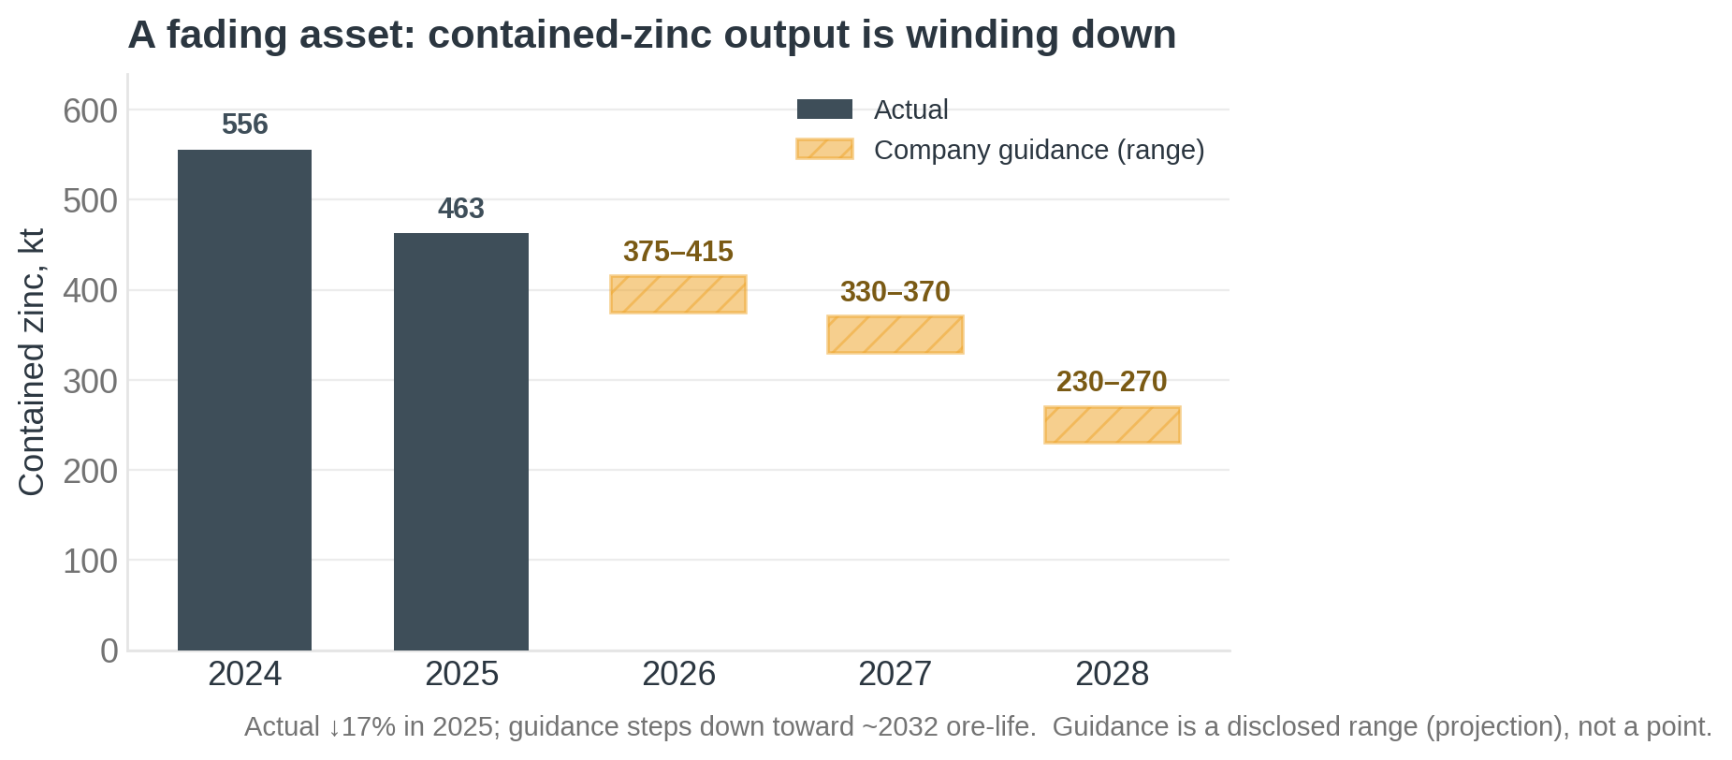
Contained-zinc output: actual (2024–25) then company guidance (2026–28). Sources: Teck FY2025 production (Feb 2026); production guidance + MD&A. As of 2026-06-15. Guidance is a disclosed range (projection).
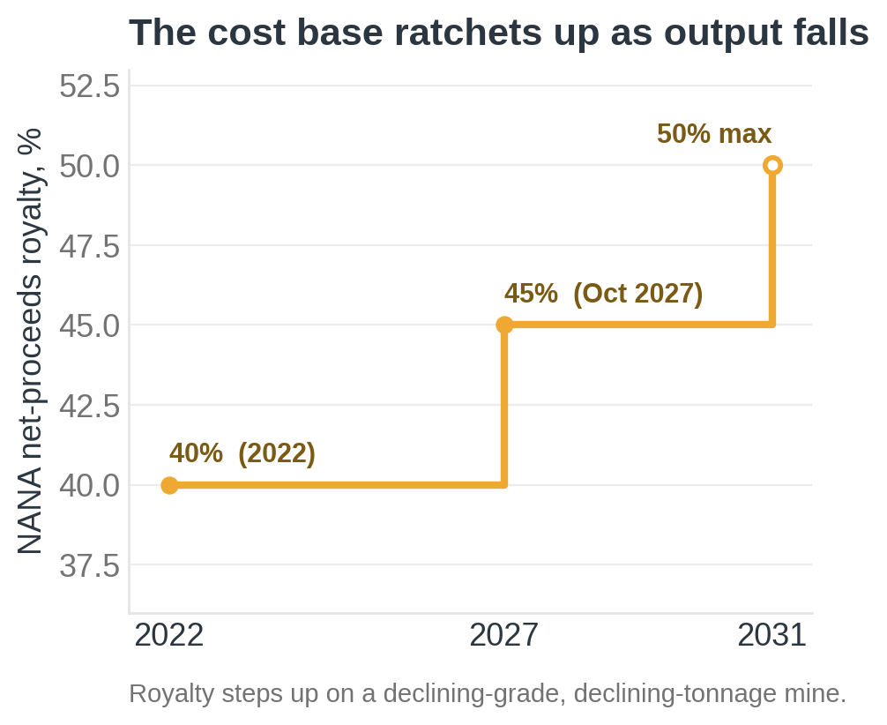
NANA net-proceeds royalty schedule. Sources: Alaska DNR; North of 60 Mining News. As of 2026-06-15. fact/high (2031 step = 50% cap).
The sharp frame, from the Arctic-infrastructure literature: near-term permafrost risk is largely mitigation-insensitive — for an existing asset, adaptation, not decarbonization, is the only lever (Hjort et al. 2018, Nature Comms). So the question Red Dog's owner actually faces is how much adaptation capex to sink into a depleting, soon-to-change-hands asset — a ~$279M pipeline (and "hundreds of millions over a decade" for a permanent fix) against ~6 years of declining ore. That tension — not a generic risk rating — is the read a decision-maker needs.
5 · Why this generalizes — the outlier class + a realized precedent
Red Dog instantiates a class InfraSure will meet again: the remote, off-grid, cold-region industrial asset — islanded on a diesel microgrid + dependent on a single climate-sensitive logistics window + built on degrading permafrost. The method transfers to the next one (another mine, a port, a remote data center).
- The realized precedent — Norilsk, 2020: a diesel storage tank on thaw-weakened permafrost piles collapsed → ~21,000 t spill, ~$2B in damages — the exact Red Dog risk geometry, realized. (ERM / press — fact/high.) This is why the fuel-farm foundation engineering (§6) is the most important number we don't have.
- The mirror precedent — winter ice roads (Tibbitt–Contwoyto, serving NWT diamond mines): the same narrowing-seasonal-window risk, opposite sign (they need ice present; Red Dog needs it absent) — showing the "single climate-sensitive window" is the portable risk concept. (Reuters — fact/high.)
Frameworks that anchor the class: IPCC AR6 WG2 CCP6 ("warming and wetting"; most Arctic infrastructure impacted by mid-century, high confidence); Hjort 2018 (33–69% of pan-Arctic infrastructure on thawing permafrost by 2050); AMAP/SWIPA.
6 · What we can't know — and why that's a finding
A disciplined read names its blind spots rather than guessing. For Red Dog, the most decision-relevant numbers are not public:
Days of fuel autonomy | if an open-water window is missed/short — undisclosed (the latent single-point-of-failure)
Tailings-dam factor-of-safety | current freeboard margin — undisclosed (ADEC says it's threatened; the margin isn't public)
Fuel-farm foundation engineering | piles to bedrock? thermosyphons? — undisclosed (this is exactly the Norilsk failure mode)
Asset-level financials | Red Dog has no standalone public P&L (reported inside Teck's zinc segment; ~CAD $846M of the segment's $1,143M FY2025 gross-profit-before-D&A is the closest anchor) — so margin-at-risk can't be priced precisely

These gaps are the honest boundary of a research-grounded read — and the precise questions a pilot/data-exchange would close.
7 · What InfraSure would actually add here
Honest version, for the team: a generic consultant or a vanilla LLM can produce a Red Dog climate narrative. What this read demonstrates that they don't is (1) the energy-infrastructure framing (the coupled diesel-in/revenue-out chokepoint — our lane, the deck's blind spot), (2) discipline (every claim sourced, dated, and confidence-rated; the deck's stale points corrected; nothing over-quantified), and (3) gap-honesty (we name the undisclosed numbers a pilot would resolve). The platform/MCP and model-gpr do not reach this asset — and we say so. That combination is the capability worth showing Teck: not "we already have your data," but "here is how rigorously and quickly we reason about an asset we've never been given data for."

What's still resolving — and the forward door
The Arctic is warming ~4× the global average and faster than models assume, so the open-water window and the permafrost water balance keep moving; this is a directional read that firms as the Anglo–Teck merger, the production guidance, and the ADEC permit resolve. That uncertainty is the world's, not a gap in the work.
This is the rigor on public data. The per-asset quantified layer — fuel-autonomy modeling, tailings-dam factor-of-safety, the priced tail risk — is where InfraSure goes deeper; §6 names exactly the undisclosed numbers a pilot or data-exchange would close. Talk to the team to take it there.
Sources & provenance
Primary / regulatory | Alaska DEC APDES AK0038652 Statement of Basis (2026-04-09) · Alaska DNR Large Mines (Red Dog) · AIDEA (DMTS)
Company | Teck Q4/FY2025 results (Feb 2026) · Teck production guidance + MD&A · Teck–Anglo merger releases (Sept/Dec 2025)
Peer-reviewed | Rantanen 2022 (Arctic ~4× warming) · Hjort 2018 (pan-Arctic infra exposure) · O'Donnell 2024 (river rusting) · IPCC AR6 WG2 CCP6
Reporting | Northern Journal / Alaska Beacon / Anchorage Daily News (permafrost, solar, fuel) · Fastmarkets · North of 60 Mining News · Ground Truth Alaska (critical-stakeholder)
Precedent | Norilsk 2020 diesel-tank collapse (ERM / press) · Tibbitt–Contwoyto winter ice road (Reuters)
Re-ground 2026-06-15 | Teck 2025 Production & Sales Update (teck.com, 2026-02) · merger: Canada + S. Korea cleared, China pending (MLex; mining.com, 2026) · ADEC AK0038652 reissuance public notice + SOB (2026-04-09)

*Full per-claim provenance (named source · URL · date · confidence · fact-vs-projection) is in the research record behind `docs/discussion/2026-06-14_outlier_method_red_dog.md`. Research-grounded; not InfraSure MCP / model-gpr data.*

