One Window In, One Window Out — on Ground That Won't Hold
One ~100-day window carries the whole year's fuel in and the whole year's revenue out — and the Arctic is closing it.
Red Dog Mine · Teck operates, NANA Regional Corp. owns the land · NW Arctic Alaska · Research-grounded (public sources + our methodology; not InfraSure MCP / model-gpr) · As of 2026-06-14, re-grounded 2026-06-15 · Internal draft
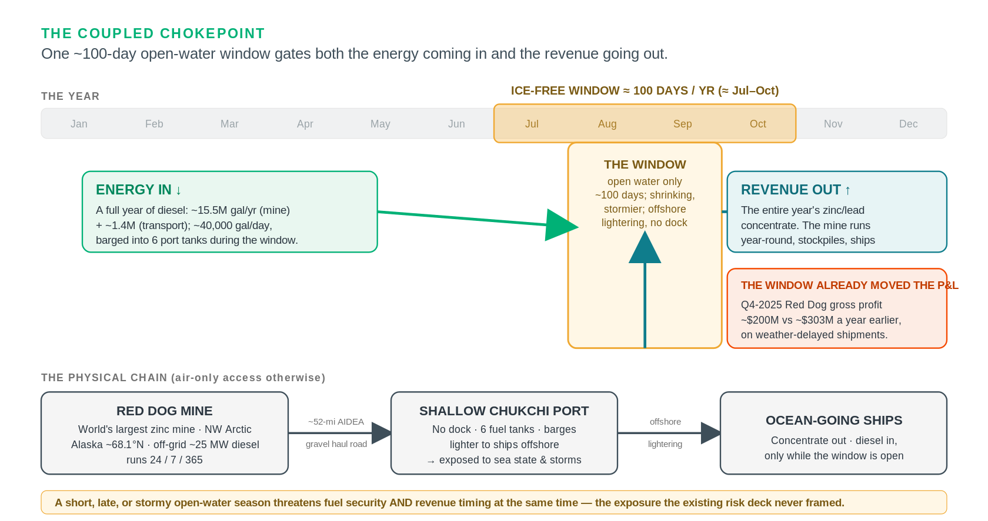
The coupled chokepoint — one ice-free window gates diesel-in and concentrate-out, and it has already moved the P&L (schematic). Sources: AIDEA; Teck FY2025 production + Q4-2025 results. As of 2026-06-15.
The claim
Red Dog is a single-point-of-failure energy-and-logistics asset in the fastest-warming region on Earth: one ~100-day ice-free window (≈ Jul–Oct) carries both the year's diesel in (~15.5M gal) and the entire concentrate export out, so a short, late, or stormy season threatens fuel security and revenue timing at once — already proven (Q4-2025 Red Dog gross profit ~$200M vs ~$303M a year earlier, on shipping delays). Layered on it: a permafrost water-balance crisis a US regulator has formally conceded is unfixable (ADEC's 10-year schedule to ~2036; "no reasonably available remedy to the thawing of permafrost"), pushing a ~$279M adaptation capex onto a mine with ~6 years of ore left, an escalating royalty, and an owner mid-merger into a copper major. The tail risk — a diesel-tank or tailings-dam failure on thawing ground — is the realized Norilsk-2020 geometry (~$2B).
Posture: a research-grounded, directional read — the decision-relevant numbers are undisclosed, and that is itself the finding. Driver: the Arctic warms ~4× the global average and models under-state it (Rantanen 2022).
1 · The coupled chokepoint — the framing the risk deck missed
The most decision-relevant climate linkage at Red Dog is not a single hazard, it is a coupling. One short open-water season carries the whole year in both directions, and the same Arctic trend is squeezing it from both ends:
ONE ~100-day ice-free window (≈ July–October) carries BOTH:
Energy-in — the year's diesel: ~15.5M gal/yr (mine) + ~1.4M (transport); ~40,000 gal/day; barged into 6 port tanks.
Revenue-out — the entire annual concentrate export; the mine produces year-round, stockpiles, and ships only in the window.
→ a short, late, or stormy open-water season threatens fuel security AND revenue timing simultaneously.

This is not hypothetical. In late 2025, "weather and sea conditions" delayed shipments into early 2026, and Q4-2025 Red Dog gross profit fell to ~$200M (from ~$303M a year earlier) on the timing — climate variability already moving the P&L through the logistics window. (Teck Q4-2025 results, Feb 2026 — fact/high.)
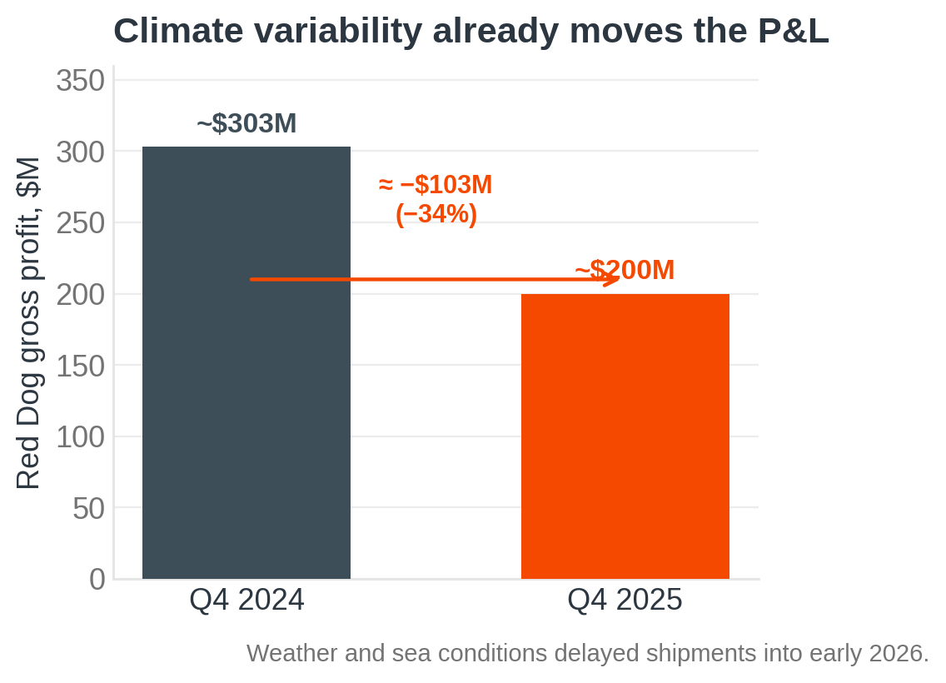
Q4 Red Dog gross profit, 2024 vs 2025. Source: Teck Q4-2025 results (Feb 2026). As of 2026-06-15. fact/high.
- Sea-ice retreat cuts both ways: it can lengthen the shipping window (operational upside) but removes the landfast-ice buffer that protected the coast — the same coastal cell is eroding fast at nearby Kivalina. The port relies on offshore lightering, so it is exposed to sea state and storms, not just ice. (AIDEA; Ground Truth Alaska — fact/medium.)
- The single-window dependency is undisclosed at the point that matters: how many days of fuel the site can run if a resupply season is missed or cut short is not public (see §5). An 8.8 MW solar array (Tugliq, ~2 MW summer-effective, tax-credit-timed to start mid-2026) dents diesel but does not change the resupply dependency. (Alaska Beacon, Mar 2026 — fact/high; the "dents not displaces" read is ours.)
2 · The ground won't hold — a water-balance crisis the regulator calls unfixable
The second pillar is documented in primary regulatory text, not press. A wetter Arctic on thawing permafrost has pushed the mine's water balance past what its infrastructure was built for, and the regulator has said so on the record:
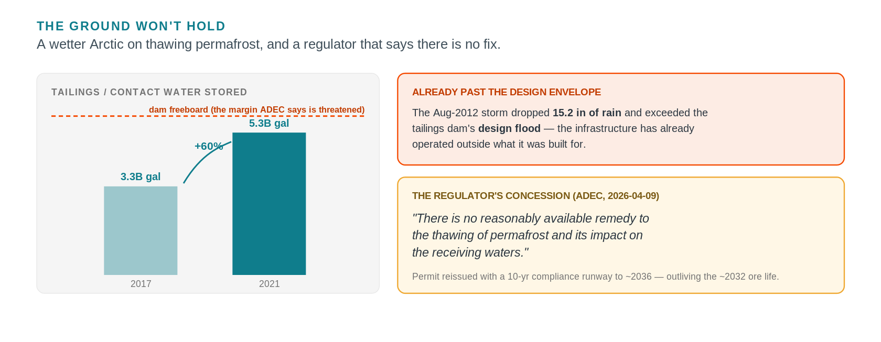
The ground won't hold — rising contact water against the dam-freeboard margin, a storm past the design flood, and the regulator's concession (schematic). Source: Alaska DEC APDES AK0038652 Statement of Basis (2026-04-09). As of 2026-06-15. fact/high.
- Alaska DEC is reissuing the discharge permit (APDES AK0038652) with a 10-year compliance-schedule extension (public-noticed; effective after May 19, 2026, to ~2036), stating in its own Statement of Basis (2026-04-09) that "there is no reasonably available remedy to the thawing of permafrost and its impact on the receiving waters." A US regulator formally conceding a Clean-Water-Act limit can't be met because of permafrost is decision-relevant and unusual. The runway now outlives the ~2032 ore life, shifting the binding constraint toward closure-phase water treatment. (ADEC SOB — fact/high.)
- ADEC states stored water "threatens the safety of the tailings impoundment dams," with a tail risk of "dam failure" / untreated-drainage release. The Aug-2012 storm (15.2 in rain) exceeded the tailings dam's design flood — the infrastructure has already operated outside its design envelope. (ADEC SOB — fact/high; the single strongest data point that the asset is past-envelope.)
- The mitigation under evaluation is a ~$279M, ~50-mile pipeline to the Chukchi Sea — "more than half of Red Dog's annual gross profit" — one of four options, not committed. ~$19M was already spent on thaw-driven wastewater in 2020 alone. (Northern Journal Dec 2025; Alaska Public Media 2020; ADEC SOB — fact/high; the pipeline is an estimate under evaluation — projection.)
- The regional driver is real and independent of the mine: "river rusting" — thaw-exposed sulfide weathering turning 75+ (200+) Brooks Range streams orange — with on-site seeps measured at pH 3.2 and TDS to 11,300 mg/L. (O'Donnell 2024 / NOAA Arctic Report Card 2025; ADEC SOB — fact/high.)
3 · The decision frame — a fading asset asked to fund a costly adaptation
What makes this a genuine decision, not a hazard list, is the collision of climate capex with late-life economics: output is falling, the cost base is rising, ownership is changing hands, and the liability outlives the revenue.
A fading asset | FY2025 462,700 t contained zinc (↓~17% from 555,600 t in 2024, on falling grades); ore ~2032; guided DOWN 2026 375–415 kt → 2027 330–370 → 2028 230–270 kt; extension (Aktigiruq/Anarraaq) only pre-feasibility
A rising cost base | NANA royalty ratchets 40% (2022) → 45% (Oct 2027) → 50% max, as grades/tonnage fall
Ownership in flux | Anglo–Teck merger announced Sept 2025, shareholder-approved Dec 2025; Canada + S. Korea cleared, ONLY CHINA remains (as of Jun 2026), close ~Q3-2026–Q1-2027 → Red Dog a non-core zinc slice of a >70%-COPPER major
A long-tail liability | state closure assurance ~$558M + PERPETUAL post-closure water treatment (outlives the revenue)

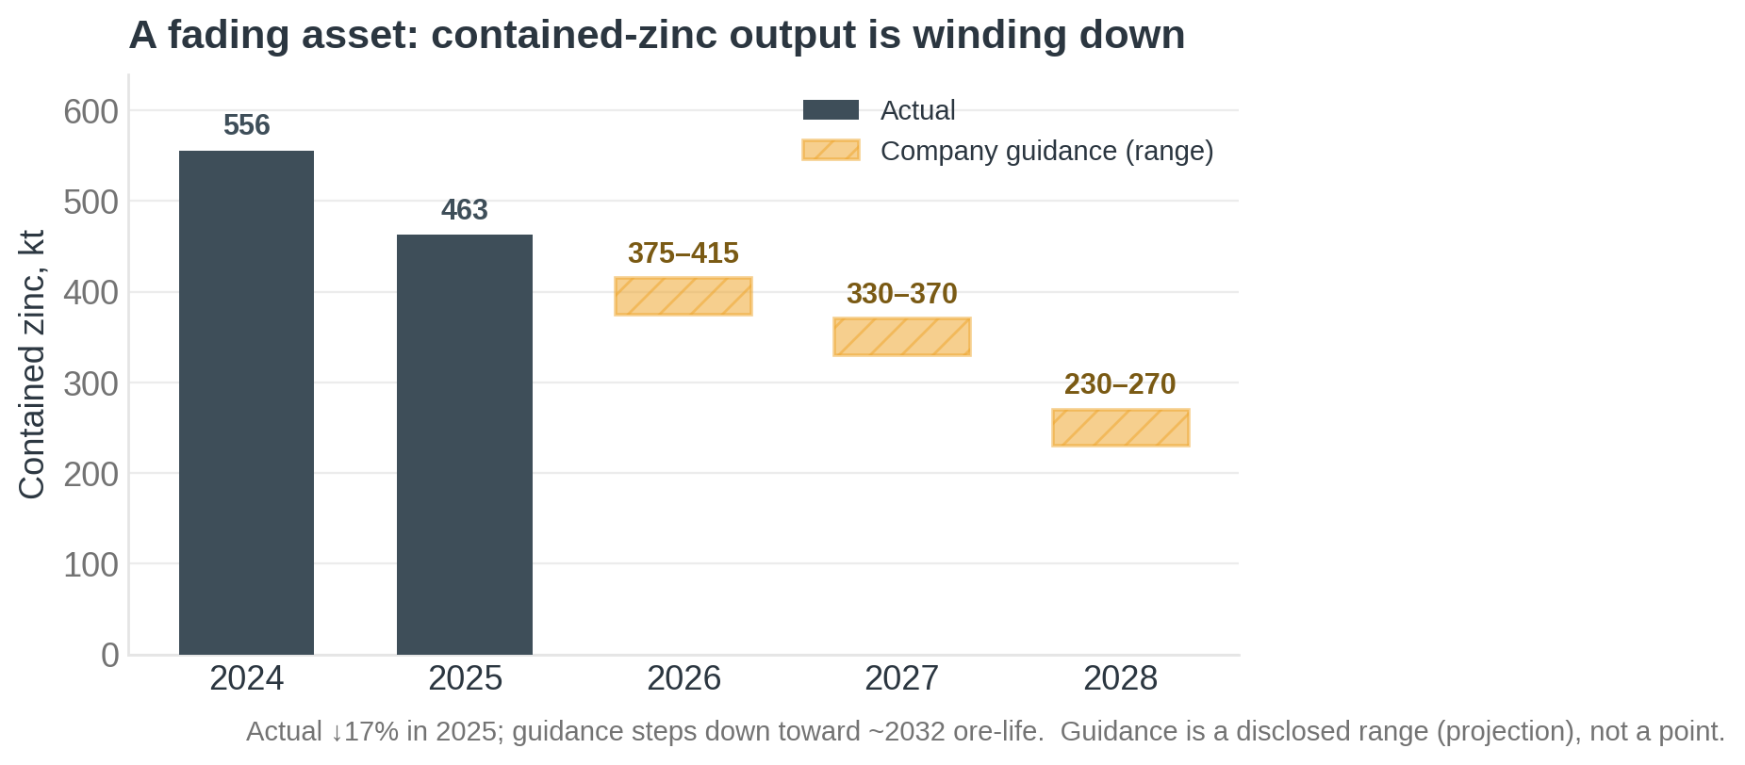
Contained-zinc output: actual (2024–25) then company guidance (2026–28). Sources: Teck FY2025 production (Feb 2026); production guidance + MD&A. As of 2026-06-15. Guidance is a disclosed range (projection).
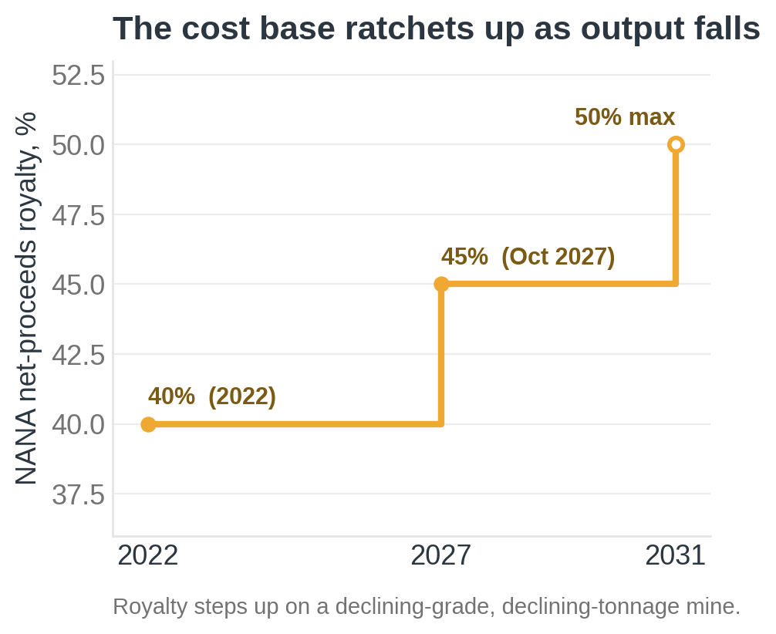
NANA net-proceeds royalty schedule. Sources: Alaska DNR; North of 60 Mining News. As of 2026-06-15. fact/high (2031 step = 50% cap).
The sharp frame, from the Arctic-infrastructure literature: near-term permafrost risk is largely mitigation-insensitive — for an existing asset, adaptation, not decarbonization, is the only lever (Hjort et al. 2018, Nature Comms). So the question Red Dog's owner actually faces is how much adaptation capex to sink into a depleting, soon-to-change-hands asset — a ~$279M pipeline (and "hundreds of millions over a decade" for a permanent fix) against ~6 years of declining ore. That tension — not a generic risk rating — is the read a decision-maker needs.
4 · The realized precedent — and the outlier class it opens
The hook is not a peer ranking (Red Dog is off-substrate, there is no fleet to rank); it is a realized precedent. The exact failure geometry has already happened, and it priced out at billions:
Norilsk, 2020. A diesel storage tank on thaw-weakened permafrost piles collapsed → ~21,000 t spill, ~$2B in damages — the exact Red Dog risk geometry, already realized. Norilsk already showed the bill. The one number that prices Red Dog's version — the fuel-farm foundation engineering — is the number that isn't public. (ERM / press — fact/high.)

Red Dog instantiates a class InfraSure will meet again: the remote, off-grid, cold-region industrial asset — islanded on a diesel microgrid + dependent on a single climate-sensitive logistics window + built on degrading permafrost. The method transfers to the next one (another mine, a port, a remote data center). The mirror precedent is the winter ice road (Tibbitt–Contwoyto, serving NWT diamond mines): the same narrowing-seasonal-window risk, opposite sign — they need ice present; Red Dog needs it absent. That symmetry is what makes "the single climate-sensitive window" a portable concept. (Reuters — fact/high.) Frameworks that anchor the class: IPCC AR6 WG2 CCP6 ("warming and wetting"; most Arctic infrastructure impacted by mid-century, high confidence); Hjort 2018 (33–69% of pan-Arctic infrastructure on thawing permafrost by 2050); AMAP/SWIPA.
5 · What we can't know — and why that's the finding
A disciplined read names its blind spots rather than guessing. For Red Dog, the most decision-relevant numbers are not public — and naming them precisely is exactly what a pilot or data-exchange would resolve:
Days of fuel autonomy | if an open-water window is missed/short — undisclosed (the latent single-point-of-failure)
Tailings-dam factor-of-safety | current freeboard margin — undisclosed (ADEC says it's threatened; the margin isn't public)
Fuel-farm foundation engineering | piles to bedrock? thermosyphons? — undisclosed (this is exactly the Norilsk failure mode)
Asset-level financials | Red Dog has no standalone public P&L (reported inside Teck's zinc segment; ~CAD $846M of the segment's $1,143M FY2025 gross-profit-before-D&A is the closest anchor) — so margin-at-risk can't be priced precisely

What's still resolving — and the forward door
The Arctic is warming ~4× the global average and faster than models assume, so the open-water window and the permafrost water balance keep moving; this is a directional read that firms as the Anglo–Teck merger, the production guidance, and the ADEC permit resolve. That uncertainty is the world's, not a gap in the work.
This is the rigor on public data. The per-asset quantified layer — fuel-autonomy modeling, tailings-dam factor-of-safety, the priced tail risk — is where InfraSure goes deeper; §5 names exactly the undisclosed numbers a pilot or data-exchange would close. Talk to the team to take it there.
Sources & provenance
Primary / regulatory | Alaska DEC APDES AK0038652 Statement of Basis (2026-04-09) · Alaska DNR Large Mines (Red Dog) · AIDEA (DMTS)
Company | Teck Q4/FY2025 results (Feb 2026) · Teck production guidance + MD&A · Teck–Anglo merger releases (Sept/Dec 2025)
Peer-reviewed | Rantanen 2022 (Arctic ~4× warming) · Hjort 2018 (pan-Arctic infra exposure) · O'Donnell 2024 (river rusting) · IPCC AR6 WG2 CCP6
Reporting | Northern Journal / Alaska Beacon / Anchorage Daily News (permafrost, solar, fuel) · Fastmarkets · North of 60 Mining News · Ground Truth Alaska (critical-stakeholder)
Precedent | Norilsk 2020 diesel-tank collapse (ERM / press) · Tibbitt–Contwoyto winter ice road (Reuters)
Re-ground 2026-06-15 | Teck 2025 Production & Sales Update (teck.com, 2026-02) · merger: Canada + S. Korea cleared, China pending (MLex; mining.com, 2026) · ADEC AK0038652 reissuance public notice + SOB (2026-04-09)

*This report renders the gated studio brief `studio/red_dog_mine/arctic_climate_risk.md`; full per-claim provenance is in the research record behind `docs/discussion/2026-06-14_outlier_method_red_dog.md`. Research-grounded; not InfraSure MCP / model-gpr data.*

