ENSO
El Niño Is Coming for California's Winter Sun
NOAA now calls El Niño near-certain for the 2026-27 winter. Using InfraSure's directory of 15,000 plants, we map where California's solar fleet sits, which owners carry the most exposure, and why winter is the season the fleet can least afford a cloudier sky.
12 June 2026 · California solar ≥50 MW · about a 6 minute read · data as_of 2026-06-12
THE TAKEAWAY
- California runs 36.8 GW of solar, the second-largest state fleet in the country. 153 plants clear 50 MW.
- Exposure is concentrated: NextEra, Intersect, Clearway and Terra-Gen together hold roughly half of it.
- El Niño winters run cloudier across the Southwest, and winter is already the fleet's seasonal low. The season the signal touches is the season output is thinnest.
- A forward, directional read on the season ahead: the geography and ownership are firm; the size of any effect tracks an El Niño strength that is still resolving.

The signal
The El Niño-Southern Oscillation is the largest year-to-year swing in the climate system. In its warm phase, a warmer equatorial Pacific pushes the winter storm track south, and Southern California tends to sit under more cloud. As of its early-June discussion, NOAA's Climate Prediction Center holds an El Niño Watch, with roughly a 96% chance of El Niño through the December to February window. One detail is worth keeping in view: the event's strength is not yet set, with no single intensity category carrying much more than a third of the model spread. Occurrence is near-certain. Magnitude is the open question.
Where it lands, and who holds it
California is not the country's largest solar fleet. Texas is. But Texas is not where the El Niño winter signal arrives. California is, and it carries 36.8 GW, second nationally, across 153 plants at or above 50 MW. A top-tier fleet sitting directly under the teleconnection is what makes the state the one to watch this winter.
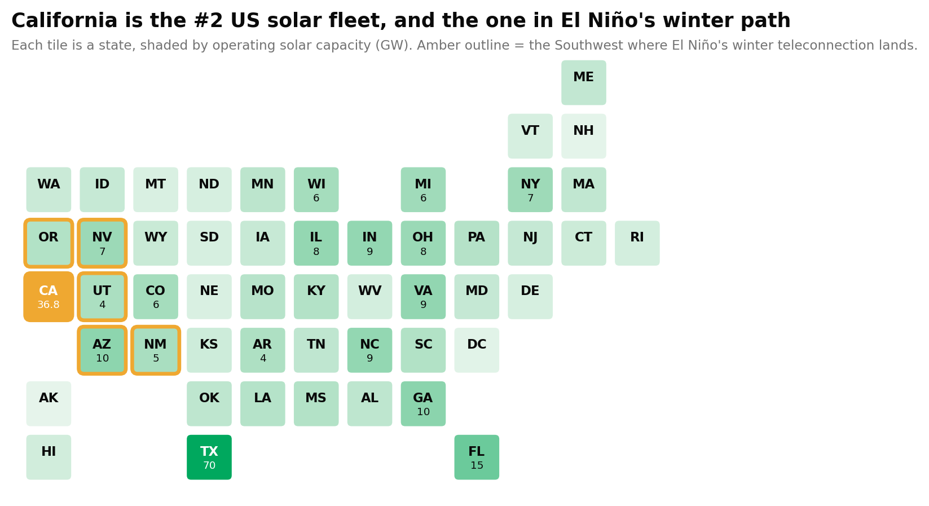
Operating solar capacity by state, GW, each tile one state. California (amber) trails only Texas, and sits in the Southwest zone (amber outline) where El Niño's winter teleconnection lands. Source: InfraSure directory, as_of 2026-06-12.
The exposure is not evenly held. Four owners carry roughly half of the ≥50 MW fleet between them, so this is a small set of books, not a diffuse market.
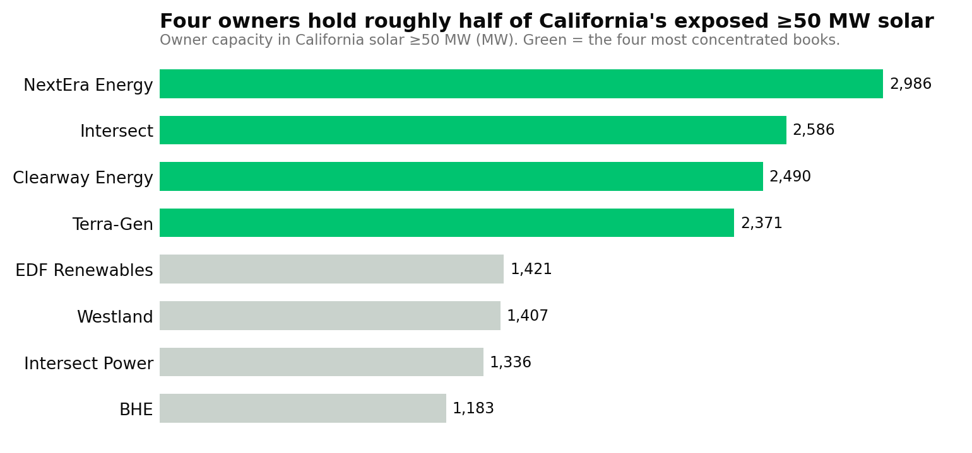
Owner capacity within California solar ≥50 MW, MW. Source: InfraSure directory, as_of 2026-06-12.
The flagship sites trace the desert and valley geography where the winter signal is strongest:
Flagship site | Plant ID | MW | County
Pelicans Jaw Hybrid | 68607 | 678.5 | Kern
Darden I–IV | 69661–69664 | 646.4 ea. | Fresno
Topaz Solar Farm | 57695 | 585.9 | San Luis Obispo
Sanborn Hybrid 3 | 69956 | 578.0 | Kern
To see a detailed modeling result for this plants visit: infraSure.ai
Why winter, of all seasons
The physics is short. More winter cloud means less of the sunlight a panel turns into power, and a California solar plant already makes far less in winter than in summer, when the sun rides low and the days are short. So El Niño presses on the thinnest stretch of the year, not the peak. That is why a modest change in the winter sky matters more than its size suggests. It arrives exactly where the fleet has the least to give.
It has happened before
This is not a first. Across past El Niño winters, the Southwest has tended toward wetter, cloudier conditions, and California has more often than not landed in the below-normal sunshine column for the season. The link is well established in the climate record. What varies, event to event, is how hard it bites, which is the same uncertainty the strength forecast carries now.
The honest caveat
Two things decide how much this matters, and both resolve over the months ahead. First, El Niño's strength: a near-certain event is not a near-certain magnitude, and the intensity probabilities sharpen through summer and fall. Second, the teleconnection is noisy: a given winter can run wetter or drier than the phase alone implies. This is a read on the season's setup, written before the season turns. It will firm as the forecast does.

What to watch
For anyone holding California solar, the map is the useful part. The fleet is known, the owners are known, and the counties under the strongest winter signal are known today, before the first storm. The thing to watch next is not a price. It is NOAA's strength call as the year turns. That is what moves this from a setup to a season.
Sources and as-of register
• InfraSure directory: California solar capacity, owner ranking, the 153-plant count at or above 50 MW, and the named flagship sites. as_of 2026-06-12
• NOAA CPC ENSO Diagnostic Discussion and strength probabilities (external state). as_of 2026-06-05

A forward, directional read, grounded in observed fleet data and calibrated to a still-resolving forecast.

