ENSO
El Niño is strengthening. Most of Standard Solar’s book won’t feel it.
A directional winter-generation read on the Brookfield / Standard Solar US solar fleet, on a likely-strong El Niño into winter 2026-27.
15 June 2026 · 3 min read · Standard Solar US solar book (129 plants · 362.3 MW) · data as of 2026-06-15
THE TAKEAWAY
- Only about a quarter of the book (the 83.8 MW Southwest belt) sits where El Niño has a real winter-irradiance signal. The other roughly three-quarters does not.
- That exposed slice is itself spread across 25 small sites in four states, so even within it a single-winter shock averages out.
- The mechanism acts on the December-February floor, where these assets already run their lowest capacity factor. Direction down, magnitude unmodeled.
- Practical step: weather-normalize the 2026-27 winter solar budget for the Southwest belt to the firmer-El-Niño end of the historical band. The rest needs no special adjustment.
CONFIDENCE: LOW · DIRECTIONAL, NOT A FORECAST
The condition
NOAA’s Climate Prediction Center carries an El Niño Advisory: El Niño conditions are present and expected to strengthen into Northern Hemisphere winter 2026-27, with roughly a 96% chance of El Niño across December to February and a meaningful chance the event ranks among the stronger ones since 1950. Strength matters here because the California and Southwest winter-precipitation teleconnection is one of ENSO’s more reliable fingerprints, and it firms up in stronger events. That holds this read at the firmer end of its low-confidence band without ever leaving it.
Who is exposed
Standard Solar, a Brookfield Renewable distributed-generation and community-solar developer-owner, runs a US book of 129 plants totalling 362.3 MW, averaging 2.81 MW per plant. That per-plant size is the signature of a DG and community-solar fleet, not utility-scale. It splits by ENSO region like this:
REGION BUCKET | PLANTS | MW | SHARE | ENSO WINTER SIGNAL
Southwest belt (CA · NM · AZ · NV · CO · UT) | 25 | 83.8 | ~23% | moderate-high: the one slice with a real El Niño winter-irradiance signal
PNW / Mountain West (ID · OR · WA) | 3 | 23.5 | ~6% | secondary; dominated by Mt. Home 1 (ID)
Upper Midwest / Mid-Atlantic / Northeast | 101 | 255.0 | ~70% | low / noisy: not a clean solar lever
Largest single assets: Mt. Home Solar 1 (EIA 59695, 20 MW, Elmore Co. ID), Kieffer Funk (69570, 12 MW, MD), Wheeler Gulch Solar (69287, 9.9 MW, CO), City of Gallup Solar (62406, 8 MW, NM).
The mechanism
El Niño strengthens the subtropical jet, which steers wetter, cloudier winters across California and the Southwest. Cloudier winters mean lower plane-of-array irradiance, which means a lower winter solar capacity factor. The catch is that it lands on a baseline that is already the seasonal trough. Mt. Home 1 runs a December capacity factor near 0.07 to 0.15 against a June peak near 0.35 to 0.46. The El Niño signal nudges that thin winter floor a little lower. It does not move the summer.
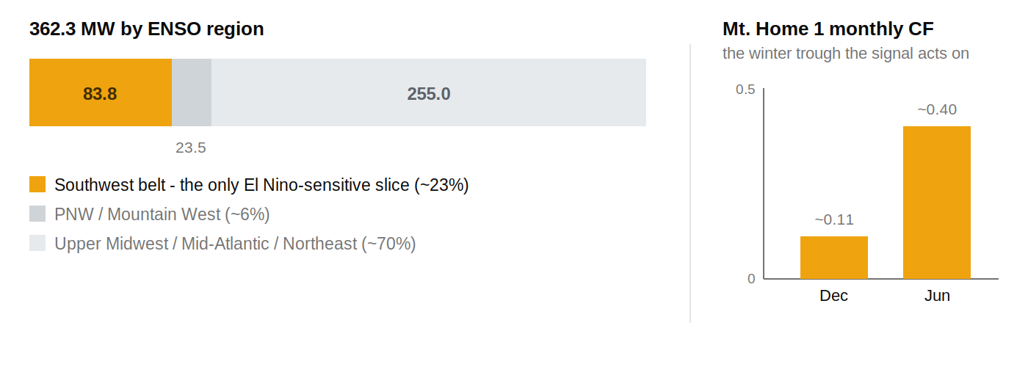
Exposure concentration, not a loss figure: where the book’s MW sit by ENSO region, beside the winter trough the signal perturbs. source: InfraSure plants_by_owner + get_plant(59695) · as of 2026-06-15

What it means for the book
About a quarter of the megawatts carry a directional, low-confidence downside to winter capacity factor under a strengthening El Niño, concentrated in December through February. The other roughly three-quarters sits in regions where ENSO’s winter signal is weak or noisy, so the aggregate weather-normalized solar budget is only modestly El Niño-sensitive. For an owner-operator, that means one action: shade the 2026-27 winter budget for the 83.8 MW Southwest belt toward the firmer-El-Niño end of the historical band, and leave the rest alone. For an investor, the concentration risk here is low by design. For a lender, a book this diversified is a weaker weather-driven DSCR story than a concentrated California utility-scale book would be. The shape of the fleet is the reassurance, and it is a real count: 129 plants averaging 2.8 MW means weather cannot concentrate where it hurts.
WHAT’S STILL RESOLVING
This is an odds shift, not an outcome. Event strength is a forecast, not a settled number, and a single winter can defy the composite: winter 2022-23 was a La Niña that ran wet in California. We run no production or price model here, so no per-plant MWh or revenue figure is asserted, only direction. Revenue translation also depends on each site’s offtake structure (mostly fixed-price community-solar subscriber contracts), which we have not resolved per asset.
Watch next
Re-pull the ENSO forecast as event strength resolves through summer and fall 2026. If a very strong event firms up, hold the Southwest-belt budget at the lower end of the band. If the signal softens toward a moderate event, relax it.

