Red Dog
One Window In, One Window Out, on Ground That Won’t Hold
A climate-exposure read on Red Dog (Teck operates, NANA owns the land): the coupled fuel-in, revenue-out chokepoint that gates the whole year, and a permafrost water crisis the regulator has formally conceded is unfixable.
Red Dog Mine, NW Arctic Alaska · As of 2026-06-15
THE READ IN FOUR LINES
One ~100-day ice-free window carries the entire year’s diesel in and the entire concentrate export out, so a short or stormy season threatens fuel security and revenue timing at once. It already has: a late 2025 window cut Red Dog’s Q4 gross profit to about $200M, from about $303M a year earlier.
Layered on the logistics is a permafrost water-balance crisis a US regulator has formally conceded cannot be fixed, pushing roughly $279M of adaptation capex onto a mine with about six years of ore left.
The decision-relevant tail risk, a fuel-tank or tailings-dam failure on thawing ground, is the realized Norilsk-2020 geometry (about $2B). The numbers that would price it are not public, which is a finding in its own right.
Posture: a forward, directional read. The Arctic is warming about 4× the global average, and the logistics window is already moving the P&L.
The asset in one screen
Red Dog is the world’s largest zinc mine, in northwest Arctic Alaska at about 68.1°N, 170 km north of the Arctic Circle. It runs 24/7/365 with air-only personnel access. It is off-grid: roughly 25 MW of typical demand on diesel gensets. Everything moves over one ~52-mile state-owned gravel haul road to one shallow Chukchi-Sea port with no dock, where barges lighter concentrate to ships offshore. FY2025 output was 462,700 t of contained zinc, down about 17% from 2024 on falling grades, with ore life to roughly 2032.
Sources: Alaska DNR; NS Energy; AIDEA; Teck FY2025 production (Feb 2026).
1 · The lead exposure: a coupled energy-and-logistics chokepoint
The most decision-relevant climate linkage at Red Dog is a coupling that is easy to treat as two separate risks. One ice-free window of about 100 days (roughly July to October) carries both flows. The energy in: the year’s diesel, about 15.5M gallons for the mine plus about 1.4M for transport, barged into six port tanks. The revenue out: the entire annual concentrate export, because the mine produces year-round, stockpiles, and ships only in the window. A short, late, or stormy open-water season therefore threatens fuel security and revenue timing at the same time.
This is not hypothetical. In late 2025, weather and sea conditions delayed shipments into early 2026, and Red Dog’s Q4-2025 gross profit fell to about $200M, from about $303M a year earlier, on the timing alone (Teck Q4-2025 results, Feb 2026). Two structural amplifiers sit underneath. Sea-ice retreat cuts both ways: it can lengthen the shipping window, but it removes the landfast-ice buffer that protected the coast, and the port relies on offshore lightering, so it is exposed to sea state and storms, not just ice. And the single-window dependency is undisclosed at the point that matters: how many days the site can run if a resupply season is missed is not public. A new 8.8 MW solar array (about 2 MW summer-effective) dents diesel use but does not change the resupply dependency.
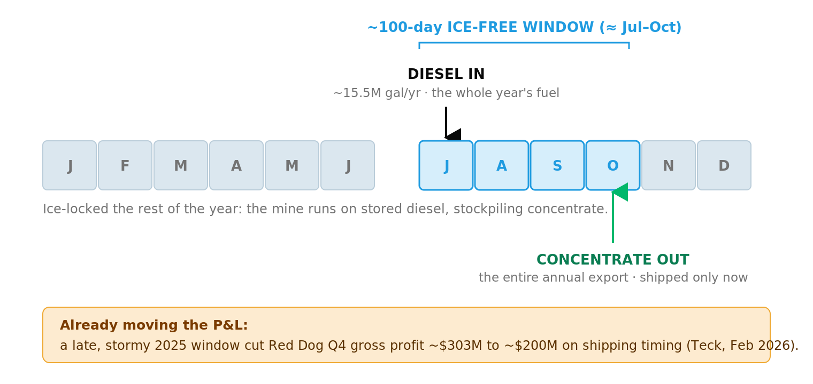
The coupled energy-and-logistics chokepoint. One ~100-day ice-free window carries both the year’s diesel resupply (~15.5M gal) and the entire concentrate export; the rest of the year the mine is ice-locked. Sources: AIDEA / Teck (diesel, window); Teck Q4-2025 results, Feb 2026 (the profit timing). As of 2026-06-15. The figure shows the coupling, not a modeled loss.
2 · Permafrost: a water-balance crisis the regulator calls unfixable
The second pillar is documented in primary regulatory text, not just press. Permafrost thaw raises total dissolved solids in receiving waters, which erodes mixing-zone capacity and blocks discharge; meanwhile a wetter Arctic has pushed stored contact water up about 60%, from 3.3 to 5.3 billion gallons between 2017 and 2021, encroaching on dam freeboard. Alaska DEC is reissuing the discharge permit (APDES AK0038652) with a 10-year compliance schedule to about 2036, stating in its own Statement of Basis (2026-04-09) that there is “no reasonably available remedy to the thawing of permafrost and its impact on the receiving waters.” A US regulator conceding that a Clean-Water-Act limit cannot be met because of permafrost is unusual and decision-relevant. The 10-year runway now outlives the ore life, shifting the binding constraint toward closure-phase water treatment.
ADEC further states the stored water “threatens the safety of the tailings impoundment dams,” with a tail risk of dam failure or untreated release. The August 2012 storm (15.2 inches of rain) already exceeded the tailings dam’s design flood, so the infrastructure has operated outside its design envelope. The mitigation under evaluation is a roughly $279M, ~50-mile pipeline to the Chukchi Sea, described as more than half of Red Dog’s annual gross profit, and it is one of four options, not committed. The regional driver is real and independent of the mine: thaw-exposed sulfide weathering is turning 75-plus Brooks Range streams orange, with on-site seeps measured at pH 3.2 and TDS to 11,300 mg/L.
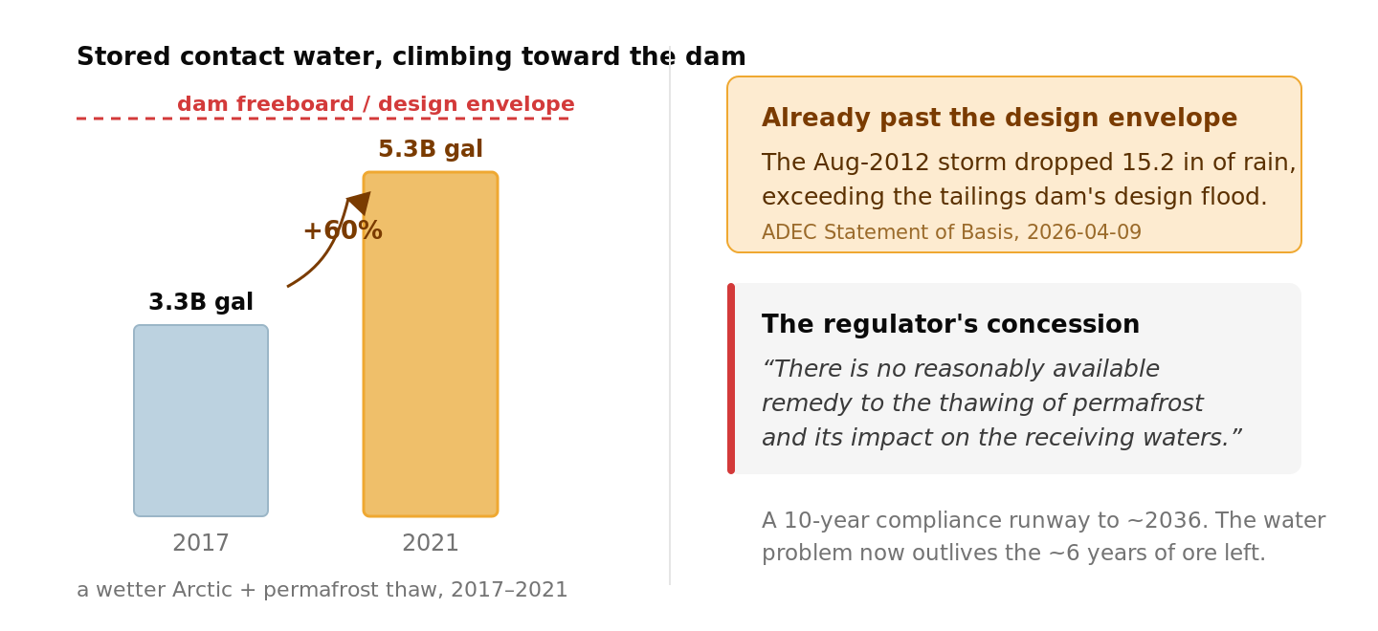
The ground won’t hold. Stored contact water rose about 60% (2017 to 2021) toward dam freeboard; the Aug-2012 storm exceeded the dam’s design flood; the regulator concedes no available remedy. Sources: ADEC Statement of Basis, 2026-04-09. As of 2026-06-15. The figure shows the documented trajectory, not a modeled probability of failure.
3 · The decision frame: a fading asset asked to fund a costly adaptation
What makes this a genuine decision, not a hazard list, is the collision of climate capex with late-life economics. The near-term permafrost risk is largely mitigation-insensitive, so for an existing asset adaptation, not decarbonization, is the only lever (Hjort 2018). The question the owner faces is how much adaptation capex to sink into a depleting, soon-to-change-hands asset: a ~$279M pipeline, and “hundreds of millions over a decade” for a permanent fix, against about six years of declining ore.
Pressure | What it means for the decision
A fading asset | Ore to ~2032; Red Dog zinc guided down 2026 (375-415 kt) to 2028 (230-270 kt); the extension is only pre-feasibility.
A rising cost base | The NANA royalty ratchets 40% (2022) to 45% (Oct 2027) to a 50% cap, as grades and tonnage fall.
Ownership in flux | The Anglo-Teck merger is shareholder-approved; Canada and South Korea cleared, only China remains as of Jun 2026. Red Dog becomes a non-core zinc slice of a copper-focused major.
A long-tail liability | State closure assurance is about $558M, plus perpetual post-closure water treatment that outlives the revenue.
Sources: Teck production guidance and MD&A; North of 60 Mining News; Teck / Anglo merger releases; Alaska DNR. Mine-life ~2032 and the extension are projections.
4 · The pattern, and a realized precedent
Red Dog is one of a class of assets where the same three vulnerabilities compound: the remote, off-grid, cold-region industrial site, islanded on a diesel microgrid, dependent on a single climate-sensitive logistics window, and built on degrading permafrost.
The realized precedent is Norilsk, 2020: a diesel storage tank on thaw-weakened permafrost piles collapsed, spilling about 21,000 t and causing roughly $2B in damages. That is the exact Red Dog risk geometry, already realized, which is why the fuel-farm foundation engineering is the single most important number that is not public. A mirror case, the winter ice roads serving NWT diamond mines, shows the same narrowing-window risk with the opposite sign: they need ice present, Red Dog needs it absent. The shared concept, a single climate-sensitive window, is the portable risk. Frameworks anchoring the class include IPCC AR6 WG2 CCP6 and Hjort 2018 (33 to 69% of pan-Arctic infrastructure on thawing permafrost by 2050).
5 · What is not yet public
Several of the most decision-relevant numbers are not in the public record: the days of fuel autonomy if a window is missed, the tailings-dam factor-of-safety and current freeboard margin, the fuel-farm foundation engineering (whether piles to bedrock or thermosyphons, the exact Norilsk failure mode), and asset-level financials, since Red Dog has no standalone public P&L. These are the inputs that would convert this directional read into a quantified, per-asset one.
WHAT IS STILL RESOLVING
Three facts are moving and are worth re-checking before any decision: the Anglo-Teck merger (Canada and South Korea cleared, China pending), forward production guidance, and the ADEC permit reissuance. The physical trajectory is not in doubt: the Arctic is warming about 4× the global average, and the logistics window is already moving the P&L.
The per-asset quantified layer (fuel-autonomy modeling, dam factor-of-safety, the priced tail) is where this read goes deeper. To take it there for your portfolio, talk to the InfraSure team.
Sources
PRIMARY Alaska DEC APDES AK0038652 Statement of Basis (2026-04-09); Alaska DNR Large Mines (Red Dog); AIDEA (DMTS).
COMPANY Teck Q4/FY2025 results (Feb 2026); production guidance and MD&A; Teck-Anglo merger releases (Sept/Dec 2025).
SCIENCE Rantanen 2022 (Arctic ~4× warming); Hjort 2018 (pan-Arctic infrastructure); O’Donnell 2024 (river rusting); IPCC AR6 WG2 CCP6.
PRECEDENT Norilsk 2020 diesel-tank collapse (ERM / press); Tibbitt-Contwoyto winter ice road (Reuters).
Every figure traces to the source cited with it, dated as shown. infrasure.ai

