STANDARD SOLAR · WEATHER & HAZARD EXPOSURE
Three Perils, One Diversified Solar Book
How severe hail, a strengthening El Niño, and extreme heat reach Standard Solar's 355 MW distributed-solar portfolio, and why the book's spread is the defense.
Report · Brookfield Renewable / Standard Solar · 17 June 2026 · substrate as_of 2026-06-17
The screen in four lines
Standard Solar operates 127 solar plants totaling 355.3 MW, averaging 2.8 MW per site across roughly 19 states. The book is diversified by construction, and that spread is its main structural defense: no single driver can concentrate on it.
Severe hail is solar's costliest physical peril, and close to half the book's capacity sits in genuine hail country: about 6% on the Colorado Front Range (itself a hail maximum) and about 41% across the Minnesota, Illinois, and New Mexico convective belt. The reassuring part is concentration, not absence of risk: none of it sits in the Plains hail maximum, and the exposure is spread across many small sites.
A strong El Niño is favored for winter 2026-27, but only about a quarter of the book (83.8 MW) sits in the El Niño-sensitive Southwest belt. The rest is where the winter signal is weak.
Extreme heat is real physics but the least material of the three: a modest intra-day shave, muted by the book's fixed-price contracts.
Calibration: a forward, directional screen. Event signals are sourced to NOAA and dated; this read places the book in or out of each hazard's geography, it does not forecast a magnitude.
About the figures: capacity factors and shares are reported or estimated values shown as an approximate, directional screen, not a site-level or portfolio model. For asset-specific and portfolio-level analysis, contact the InfraSure team.

The book at a glance
Standard Solar, a Brookfield Renewable distributed-generation and community-solar developer-owner, runs 127 operating solar plants totaling 355.3 MW (InfraSure, as_of 2026-06-17). The average site is 2.8 MW. That number is the whole story in miniature: this is a many-small-plants book spread across roughly 19 states, not a handful of utility-scale sites. Where a concentrated owner stacks its megawatts in a few large plants, often in one climate zone, Standard Solar's capacity is scattered. Every read below comes back the same way, real exposure, but diversified rather than concentrated.
The largest assets anchor the book without dominating it:
Plant | EIA ID | State | MW | Note
Mt. Home Solar 1 | 59695 | ID | 20.0 | single-axis c-Si
Kieffer Funk | 69570 | MD | 12.0 | Mid-Atlantic
Wheeler Gulch Solar | 69287 | CO | 9.9 | largest CO site
City of Gallup Solar | 62406 | NM | 8.0 | single-axis, fixed $44.08/MWh PPA
Top states by capacity: Illinois 59.1 MW, Minnesota 44.4 MW, New Mexico 43.0 MW, Virginia 39.2 MW, Maryland 28.1 MW, Colorado and California 20.4 MW each, Idaho 20.0 MW. Source: InfraSure plants_by_owner, as_of 2026-06-17.

Severe hail: solar's costliest peril, and where the book is genuinely exposed
Severe hail (golf-ball-plus) is the single largest cause of catastrophic insurance loss to utility-scale solar. Impact energy past a module's front-glass tolerance cracks cells and shatters glass, dropping array availability for weeks to months. NOAA SPC climatology puts the US hail maximum in the southern Great Plains and Texas, a stable geography rather than a dated forecast.
Standard Solar carries real, spread hail exposure. The Colorado Front Range, itself a recognized hail maximum, holds 8 plants and 20.4 MW (about 6% of the book), and the Minnesota, Illinois, and New Mexico convective belt holds 66 plants and 146.5 MW (about 41%), so close to half the book's capacity sits in genuine hail country. What the book does not have is concentration in the worst zone: zero plants and zero megawatts in the Plains maximum (Texas, Oklahoma, Kansas, Nebraska, South Dakota). The rest sits in lower-hail geography, and even the exposed share is spread across many small sites.
That placement is a starting point, not a per-site verdict: county-level hail cells vary within a state, and being outside the Plains maximum lowers concentration, it does not remove the risk on the Front Range or across the convective belt.
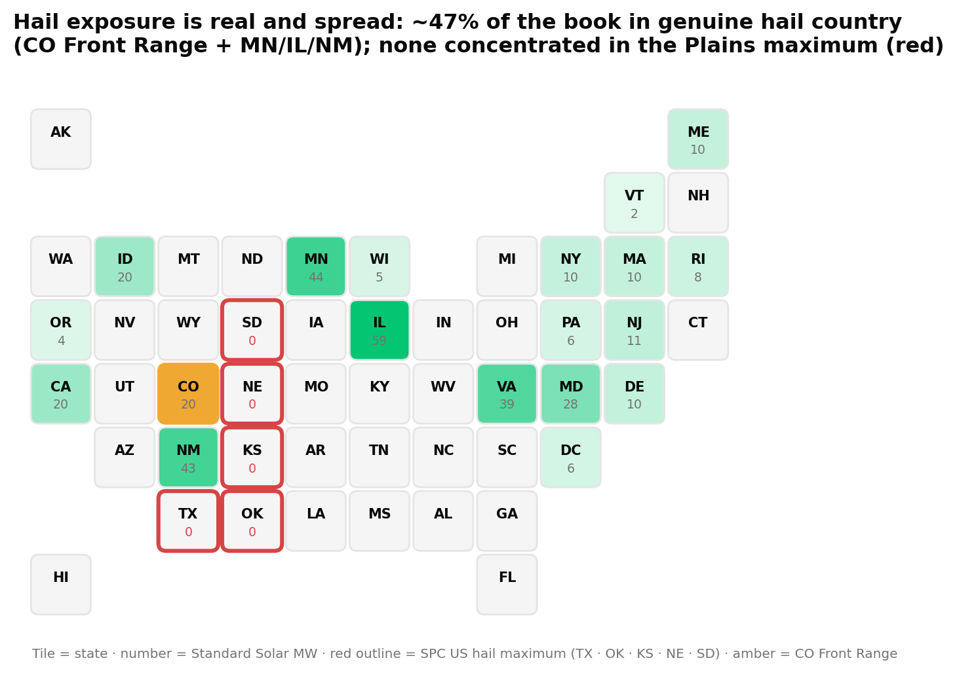
Standard Solar plant capacity by state against the NOAA SPC severe-hail geography. Close to half the book's capacity sits in genuine hail country (Colorado, in amber, plus the Minnesota, Illinois, and New Mexico belt, in green); none sits in the Plains maximum (red outline). Source: InfraSure plants_by_owner, as_of 2026-06-17, with NOAA SPC hail climatology.
The single biggest controllable factor is module exposure angle: single-axis trackers can hail-stow, rotating to deflect hail, while fixed-tilt arrays take it face-on. Construction is mixed across the book (Gallup is single-axis, the Nachtigall site in CA is fixed-tilt), so confirming tracker status and hail-stow protocols on the Colorado and Minnesota and Illinois sites is the practical next step. Hail is also often carried under a separate insurance sub-limit or deductible, worth checking on the Front Range assets.
How settled this is. A forward, directional read. Hail is sudden-onset and climatologically concentrated, so this places the book in or out of the hail geography, it does not predict a hail season or a dollar loss. The exposure geography itself is robust.

El Niño: a strong winter is favored, but most of this book won't feel it
As of NOAA CPC's diagnostic discussion issued 11 June 2026, an El Niño Advisory is in effect: El Niño conditions are present (Niño-3.4 anomaly +0.7 degrees C) and expected to strengthen, with a stated 63% chance of a very strong El Niño during November to January. The California and Southwest winter-precipitation teleconnection is one of ENSO's more reliable fingerprints and is stronger in strong events.
Roughly a quarter of the book, the 83.8 MW Southwest belt (25 plants across California, New Mexico, and Colorado), carries a directional downside to winter solar capacity factor under a strengthening El Niño. The mechanism is clean: El Niño strengthens the subtropical jet, which makes California and Southwest winters wetter and cloudier, which lowers winter plane-of-array irradiance, which lowers winter capacity factor, on a baseline that is already the seasonal trough. The other roughly 76% of the book sits where ENSO's winter signal is weak or noisy.
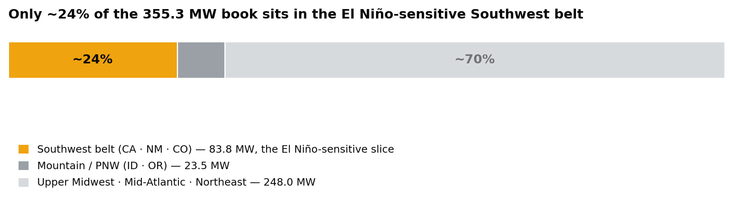
Standard Solar's 355.3 MW split by ENSO-relevant region. Only the Southwest belt carries a meaningful El Niño winter-irradiance signal. Source: InfraSure plants_by_owner, as_of 2026-06-17. Shown as an approximate, directional guide.
The winter trough the signal acts on is visible in the book's own data. Mt. Home 1 (EIA 59695) runs a December capacity factor near 0.11 against a June peak near 0.39. A strong El Niño nudges that already-thin winter floor a little lower; it does not touch the summer peak that drives the year.
A quarter of the book in the path is a real, directional exposure, not a rounding error. The worthwhile questions are the winter-budget number the Southwest belt actually carries under a strong El Niño, and how each site's contract turns that into revenue.
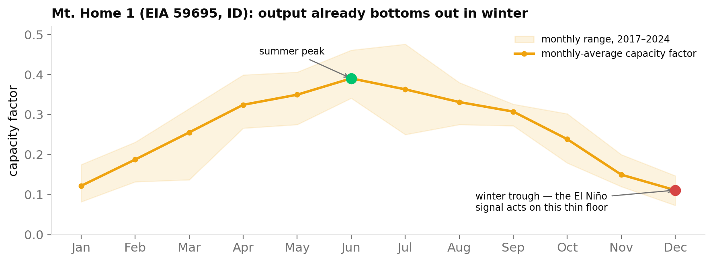
Mt. Home 1 (EIA 59695), monthly capacity factor, 2017 to 2024. Output already bottoms out in December and January, the window a strong El Niño would nudge lower. Source: InfraSure get_plant(59695), as_of 2026-06-17. Shown as an approximate, directional guide.
How settled this is. A forward, directional read; most of this book won't feel it. Event likelihood: NOAA CPC puts a 63% chance on a very strong El Niño for November to January (issued 11 June 2026). Settledness ▰▰▰▱▱, firms as the 2026-27 winter resolves.

Extreme heat: solar's most over-weighted peril, right-sized
Extreme heat lowers PV output through the temperature coefficient of power: every degree C above the 25 degrees C rating costs roughly 0.3% to 0.45% of efficiency. NOAA CPC's summer outlook leans above-normal with the highest confidence in the West, where the book's hot-climate plants sit. The exposed slice is the hot, low-elevation interior, concentrated in California's Kern County and New Mexico, about 18% of the book's megawatts.
The discipline matters here, because the intuition is backwards. The heat de-rate is a second-order, intra-day, peak-hour effect, and it is invisible at monthly resolution. Summer monthly capacity factor is high, driven by irradiance, not low. City of Gallup (EIA 62406) proves it: summer capacity factor peaks near 0.31 against a winter trough near 0.12. Reading a heat signal off high summer output is the common error this screen avoids.
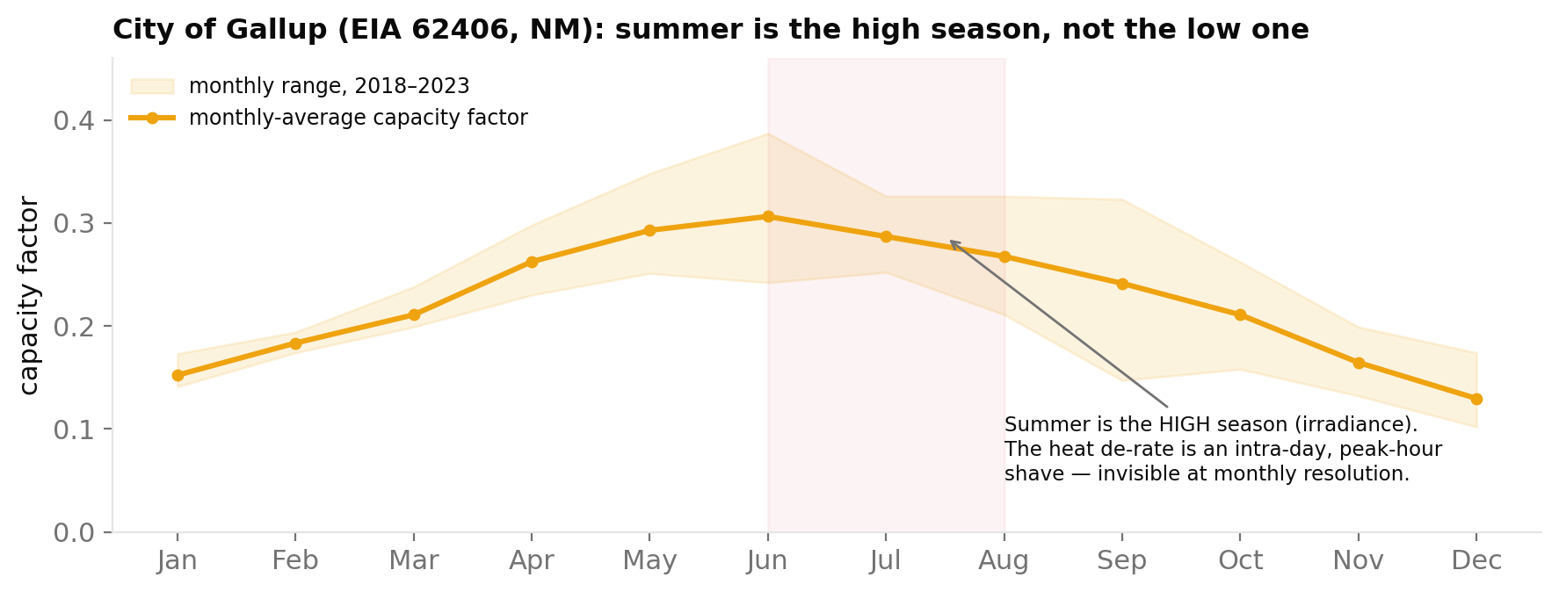
City of Gallup (EIA 62406), monthly capacity factor, 2018 to 2023. Summer is the high season; the heat de-rate is an intra-day, peak-hour effect not visible at monthly resolution. Source: InfraSure get_plant(62406), as_of 2026-06-17. Shown as an approximate, directional guide.
Heat matters more than its size only where it lands on a peak price window the asset actually captures, which means a merchant or shaped contract. For this book that amplifier is muted: Gallup sells under a fixed $44.08/MWh PPA, the community-solar signature, which does not capture peak-hour scarcity value. A fixed-price community-solar book in the West feels heat as a quiet efficiency factor, not a revenue event. It is a thermal-aware design and O&M item on the California and New Mexico sites, not a portfolio risk.
How settled this is. A forward, directional read. Event signal: NOAA CPC's summer outlook leans above-normal in the West. The de-rate is modest and second-order; no per-asset magnitude is modeled here.

What this means for the book
Three different perils, one recurring answer: the exposure is real, and the book's spread keeps any single driver from concentrating, but spread is not the same as safe. Nearly half the book's capacity sits in genuine hail country, a quarter is in El Niño's winter path, and the hot-interior sites carry a real thermal de-rate. The diversification is a strength to quantify, not a reason to look away.
At a glance
Peril | Exposed slice (grounded) | The read
Severe hail | ~47% in genuine hail country (~6% CO Front Range + ~41% MN, IL, NM); none in the Plains maximum | Lower concentration, not low risk: ~47% sits in real hail country, worth a mitigation-cost look
El Niño | ~24% of MW in the Southwest belt (CA, NM, CO) | A real, directional winter exposure on a quarter of the book; worth a per-asset budget translation
Extreme heat | ~18% in the hot interior (CA Kern, NM) | Real physics, muted by fixed-price contracts; confirm any merchant or shaped sites

What is still resolving, and where this goes deeper
The NOAA ENSO and summer outlooks are dated snapshots that update monthly; the El Niño odds firm as winter approaches. Hail and heat are placed at the state level here, and tracker-versus-fixed-tilt construction is confirmed on only a few sites. The commercial overlay, who buys each plant's output, is partly visible (a fixed PPA price surfaces on Gallup) but not fully resolved across the book.
This is a fast, fleet-wide screen, and it surfaces the questions worth answering next. What does the Colorado and convective-belt hail exposure cost per site once hail-stow and deductibles are priced in? What winter-budget haircut does the Southwest belt actually carry under a strong El Niño, and how does each contract translate it into revenue? Which assets, if any, sit on merchant or shaped contracts that would feel heat at the afternoon peak? The per-asset layer, production, revenue, offtake, hail-stow status, mitigation cost, and loss-and-recovery, is where InfraSure answers each. For the book at that depth, see infrasure.ai or talk to the team.

Sources
· InfraSure substrate: plants_by_owner("Standard Solar"), get_plant(59695), get_plant(62406). As of 2026-06-17.
· NOAA CPC ENSO Diagnostic Discussion, issued 11 June 2026: El Niño Advisory, Niño-3.4 +0.7 C, 63% very strong Nov-Jan.
· NOAA SPC severe-hail climatology and storm reports: US hail maximum in the southern Great Plains and Texas.
· NOAA CPC seasonal temperature outlook (JJA 2026): above-normal lean, highest confidence in the West.
· PV temperature-coefficient references (PVEducation; NREL / Sandia): roughly 0.3 to 0.45 %/C, 25 C STC rating.

