Database used: Oracle SQL

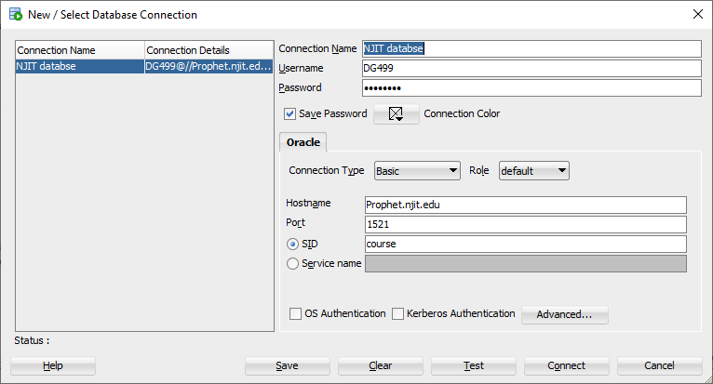

Schema:

[](https://github.com/dg499/CS631-Solutions/blob/master/orderitemschema.sql)

Solutions :

[](https://github.com/dg499/CS631-Solutions/blob/master/NJIT%20databse.sql)

1. List the customers who ordered computers

SELECT DISTINCT C.NAME FROM CUSTOMER C,"ORDER" O,PRODUCT P,LINEITEM L WHERE C.CID=O.CID AND O.OID=L.OID AND L.PID=P.PID AND P.PRODUCTNAME='Computer';

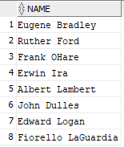

2. List the other products bought by customers who bought computers

SELECT DISTINCT P.PRODUCTNAME FROM PRODUCT P ,LINEITEM L,"ORDER" O,CUSTOMER C WHERE C.CID IN

(SELECT C.CID FROM CUSTOMER C,"ORDER" O,PRODUCT P,LINEITEM L WHERE C.CID=O.CID AND O.OID=L.OID AND L.PID=P.PID AND P.PRODUCTNAME='Computer')AND C.CID=O.CID AND

P.PID=L.PID AND L.OID=O.OID AND P.PRODUCTNAME!='Computer';

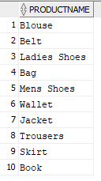

1. List the customers who did not place any order since January 1 2014

SELECT C.CID,C.NAME FROM CUSTOMER C,"ORDER" O WHERE C.CID=O.CID AND O."DATE" < TO_DATE('01-Jan-2014','DD-MON-YYYY');



1. List the products bought by at least one customer of Newark

SELECT DISTINCT P.PRODUCTNAME FROM PRODUCT P,"ORDER" O,LINEITEM L,CUSTOMER C WHERE P.PID=L.PID AND L.OID=O.OID AND O.CID=C.CID AND C.CITY='Newark';

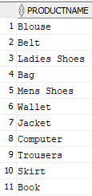

1. List the products bought by all the customers of Newark

SELECT DISTINCT L.pid, P.productname FROM lineitem L,product P WHERE P.pid=L.pid AND L.pid NOT IN

(SELECT l1.pid FROM "ORDER" o,customer C,lineitem l1 WHERE o.OID=l1.OID AND C.cid=o.cid AND C.city='Newark' AND l1.pid NOT IN

(SELECT l2.pid FROM lineitem l2 WHERE l2.OID=l1.OID));

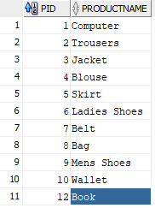

1. List the products ordered only by the customers of Newark

Query1:

select p.PID,p.productname from product p where p.PID NOT IN

(select distinct p1.PID from product p1,"ORDER" o,lineitem l,customer c where p1.PID=l.PID and l.OID=o.OID and o.CID=c.CID and c.city<>'Newark');



Query2:

select p.productname from product p minus select p.productname from product p,"ORDER" o,lineitem l,customer c where p.PID=l.PID and l.OID=o.OID and o.CID=c.CID and c.city!='Newark';



1. List the products never ordered by customers of New Jersey

SELECT DISTINCT P.productname FROM product P,lineitem L WHERE P.pid=L.pid AND L.pid NOT IN

(SELECT DISTINCT L.PID FROM LINEITEM L, "ORDER" O,PRODUCT P, CUSTOMER C WHERE

L.PID=P.PID AND L.OID=O.OID AND O.CID=C.CID AND C.state='NJ' ) ;

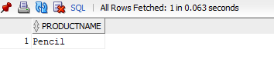

**Views and SQL Queries**

1. Create a view ProductMonth (PID, ProductName, Month, QuantitySold, NumberCustomer, Revenue) that gives for each the product and each month, the quantity sold, the number of distinct customers who bought the product and amount of money the sale corresponds to for the month.

drop view productmonth;

create view productmonth as

select p.pid, p.productname,to_char("DATE",'yyyy/mm') as "year/month",sum("NUMBER") as "quantitysold", count(distinct c.cid) as numberofcustomer, sum(l."totalprice") as revenue from customer c,"ORDER" o,product p,lineitem l where c.CID=o.CID and o.OID=l.OID and l.PID=p.PID group by p.pid, p.productname,to_char("DATE",'yyyy/mm')

order by to_char("DATE",'yyyy/mm');

select * from productmonth where "year/month"='2019/02';

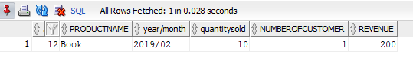

1. Which product is the most popular (in term of number of distinct customers it)? Answer this query with and without the view)

select p.pid, p.productname , count(distinct c.cid) as numberofcustomer from customer c,"ORDER" o,product p,lineitem l where c.CID=o.CID and o.OID=l.OID and l.PID=p.PID group by p.pid, p.productname order by count(distinct c.cid) desc fetch first 1 rows only;

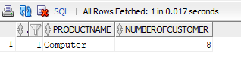

drop view mostpopularproduct;

create view mostpopularproduct as

select pid,productname,numberofcustomer from

(select p.pid, p.productname , count(distinct c.cid) as numberofcustomer from customer c,"ORDER" o,product p,lineitem l where c.CID=o.CID and o.OID=l.OID and l.PID=p.PID group by p.pid, p.productname order by count(distinct c.cid) desc ) fetch first 1 rows only;

select * from mostpopularproduct;

