SSBM Geneva

Bachelor BBS01

Business Strategy

Starbucks strategy to enter the Italian Market

Student: Domenico Galizia

ID: 81545

**Table of Contents**

1 Introduction 3

1.1 The Company 3

1.2 The Mission Statement 3

2 Analysis 4

2.1 The Growth Strategy 4

3 Discussion 6

4 Reference List 7

# Introduction

In this essay I am going to analyze the strategy adopted by Starbucks to enter the Italian Market. In particular, I will try to understand why the first attempt to enter the Italian Market by Starbucks was a failure, and how Starbucks changed its strategy to become accepted in a country with such a strong culture about coffe.

## The Company[1]

Starbucks was founded in 1971 in Seattle; in its first store, fresh-roasted coffee bean were sold to customers. After then years, Howard Schultz joined the company and introduced a radical transformation in the company after his trip in Milan in 1983.

Schulz was impressed by the Italian ritual of drinking coffee at bars, were customers were talking friendly with each other and with the barista as well, who often knew and addressed his customers by name. This experience inspired Schulz to introduce this kind of culture in the US, through Starbucks.

In 1992, Starbucks goes public; at that time it had already 165 stores spread out across the US. In 1996, there is the first opening of stores outside US, in Japan and Singapore, here the multinational adventure of Starbucks beings; from this point the growth of Starbucks seems to be unstoppable; they open stores in Asia, South America, Middle Asia, Africa and Europe; the Italian market was approached in 2018. As of 1st January 2022, Starbucks owns 36160 stores.

## The Mission Statement

The mission statement of Starbucks states: “Our Mission: With every cup, with every conversation, with every community - we nurture the limitless possibilities of human connection”; this statement is meant to reflect Italian spirit of seeing coffee drinking as a way to connect and socialize.

In addition to that, the corporate site of Starbucks report its commitment about preserving the environment and the people, positioning itself as a Social Enterprise that operates according the 3Ps principle (People, Planet, Profit).

# 

# Analysis

## The Growth Strategy

The mission statement mentioned in the above section is the basis for the constitution of the decision framework of the company, alias the corporate strategy; from that statement we can see that for Starbucks each person is a potential customer and that they put no boundaries to their growth (“every community”, “limitless possibilities”).

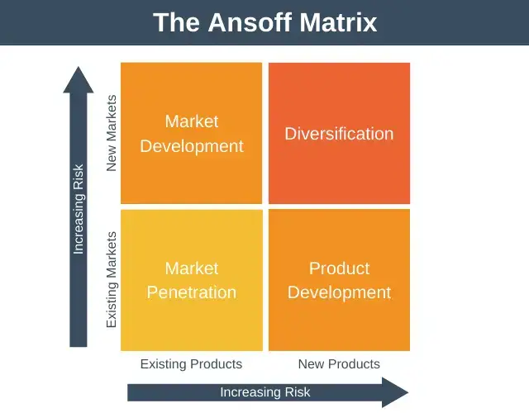Figure 1: Ansoff Matrix - https://expertprogrammanagement.com/2022/01/the-ansoff-matrix/

If we have to use the Ansoff Matrix (Figure 1) to express the growth strategy of Starbucks, we can say that from its foundation in 1971, up to 1995, the company pursued a strategy of market penetration, aiming to increase its market share in the US market; starting from 1996, Starbucks entering foreign markets, moved to Market development, selling the same products to other markets, thus capitalizing and its strategic capabilities accumulated and consolidated in 25 years of activity in the US market.

## Strategic Capabilities

https://www.copperproject.com/2022/07/lessons-business-can-learn-from-proper-management-strategies-in-starbucks/

## Value Chain

https://research-methodology.net/starbucks-value-chain-analysis/

<https://research-methodology.net/starbucks-value-chain-analysis/>

<https://www.investopedia.com/articles/investing/103114/starbucks-example-value-chain-model.asp>

## Porter’s Five Forces Analysis

https://thetakeout.com/starbucks-milan-italy-roastery-locations-dominos-fail-1849678898

https://studycorgi.com/starbucks-corporations-global-marketing-in-italy/

https://www.supplychain247.com/article/starbucks_as_an_example_of_the_value_chain_model

https://iimskills.com/marketing-strategy-of-starbucks/

# Discussion

http://www.napolinvespa.it/en/blog/11/why-starbucks-is-not-present-in-italy_25.html

https://www.forbes.com/sites/jennawang/2018/09/13/why-it-took-starbucks-47-years-to-open-a-store-in-italy/?sh=517ededffc00

# Reference List

1. Starbucks Corporation. (2023, February 16). *Company timeline - Starbucks Stories*. Starbucks Stories. https://stories.starbucks.com/press/2019/company-timeline/
2. G, D. (2022, November 23). *The Ansoff Matrix - Strategy Training from EPM*. Expert. https://expertprogrammanagement.com/2022/01/the-ansoff-matrix/

1. Starbucks Corporation. (2023, February 16). *Company timeline - Starbucks Stories*. Starbucks Stories. https://stories.starbucks.com/press/2019/company-timeline/