RHEL/CENTOS 7, GNOME3 Screen Saver Settings

GNOME3 has excluded screen savers. If you want to use a screen saver with GNOME3 you can use the X screen saver:

# yum remove gnome-screensave
# yum install xscreensaver* libgnome

To setup for all users:

# vi /etc/xdg/autostart/screensaver.desktop

[Desktop Entry]
Name=Screensaver
Type=Applicaton
Exec=xscreensaver -nosplash

To setup for single users:

$ vi ~/.config/autostart/xcreensaver.desktop

[Desktop Entry]
Name=Screensaver
Type=Applicaton
Exec=xscreensaver -nosplash

To set the screen saver options, from your user account:

$ xscreensaver-demo
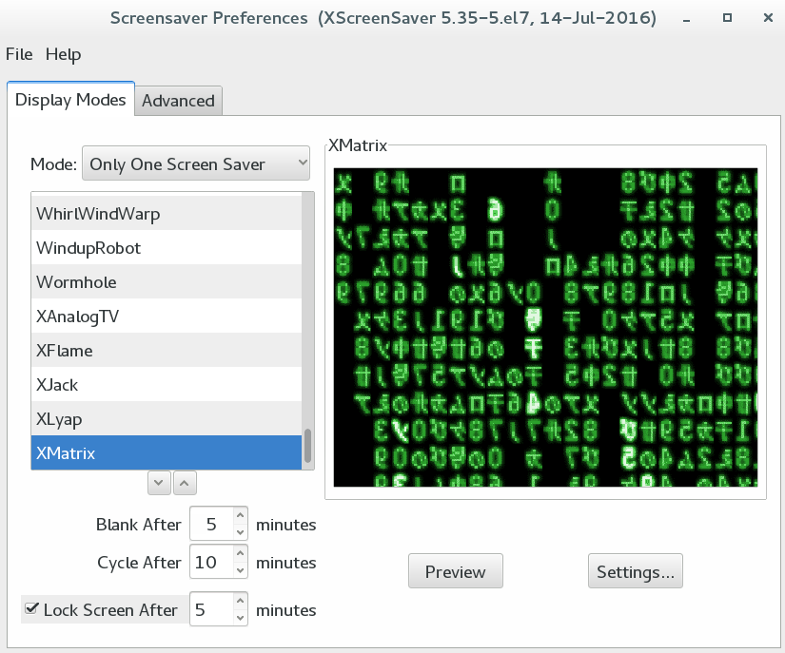

Disable the GNOME3 lock screen: Applications→System Tools→ Settings → Privacy
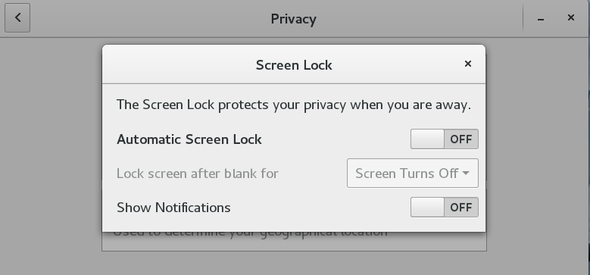

X screen saver config file: ~/.xscreensaver

