Single User Boot For RHEL/CENTOS 7
Original Author: Douglas.Gaer@noaa.gov
Last Modified: 04/23/2017

Booting into single user mode allows you to reset root's password, perform file system recovery, and fix configuration issues preventing the system from booting. Booting into single user mode will require console access. For virtual machines you will need to use the virt-manager GUI or a virsh console connection.

Reboot your system, select the kernel version you wish to boot into:

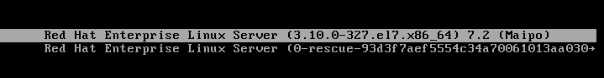

Press 'e' to edit the kernel settings. Using the down arrow key scroll down to the “linux16” line:

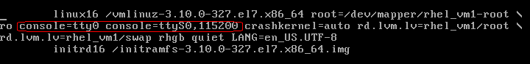

NOTE: On virtual machine look for console redirect entries as depicted in the above screen capture. If you are using the virt-manager GUI remove the console redirect entries. When console redirection is set the console will only be available to a virsh console session.

Next, set SE Linux enforcing to off and add “rd.break” to the end of the “linux16” line.
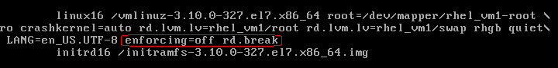

Press “Ctrl x” to boot the system. When the system boots you will need to remount /sysroot with read/write permissions, change the system root to /sysroot, and tell SE Linux to relabel file contexts:

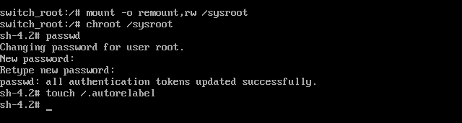

Enter “exit” to end the “chroot” session and enter “reboot” to restart the system.

