Single User Boot For RHEL/CENTOS 6
Original Author: Douglas.Gaer@noaa.gov
Last Modified: 04/26/2017

Booting into single user mode allows you to reset root's password, perform file system recovery, and fix configuration issues preventing the system from booting. Booting into single user mode will require console access. For virtual machines you will need to use the virt-manager GUI or a virsh console connection.

Reboot your system and press any key when the GRUB splash screen appears. Select the kernel version you wish to boot into:

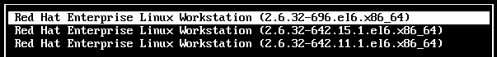

Press enter to edit the boot settings.
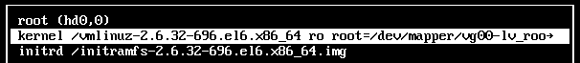

Arrow down to the kernel line and press 'e' to edit the kernel settings.
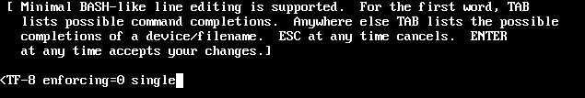

At the end of the kernel line disable SE Linux and add single

NOTE: On virtual machine look for console redirect entries, for example:

console=tty0 console=ttyS0,115200

If you are using the virt-manager GUI remove the console redirect entries. When console redirection is set the console will only be available to a virsh console session.

NOTE: In RHEL 6 there is no “emergency” mode to bypass file system checking. To boot into emergency mode replace the word single with init=/bin/bash:

Press enter to accept the changes. Press ‘b’ to boot the system. When the system boots you will drop into a root shell. From there you can reset the root password, fix file systems and configurations. Once complete, reboot or use the init command to go to runlevel 3 or runlevel 5.

