RHEL/CENTOS 7, GNOME3 Advanced Settings

The 2 primary GUI tools used to configure advanced GNOME3 settings are the dconf editor and the GNOME tweak tool. To access the dconf editor, from the Application pull down menu select System Tools, dconf Editor:
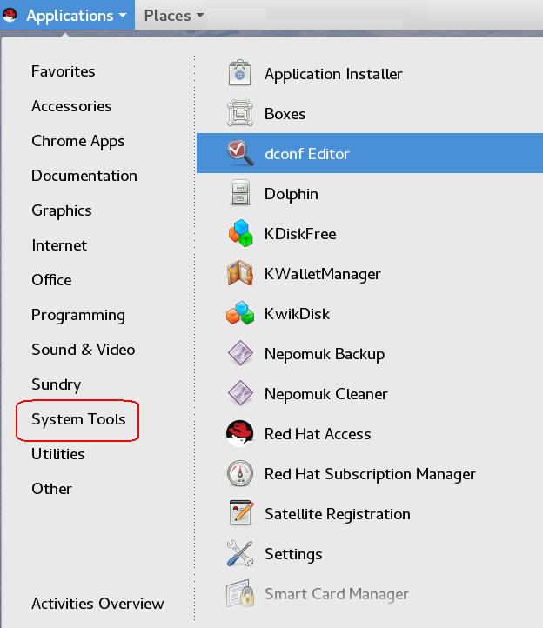
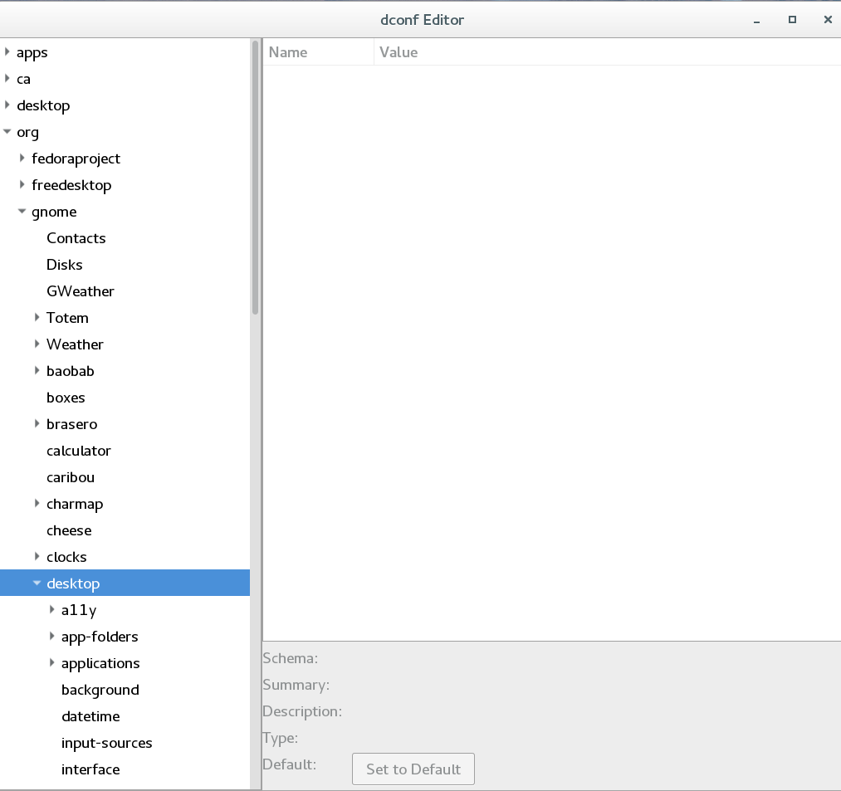

To access the GNOME tweak tool, from the Application pull down menu select Utilities, Tweak Tool:
