RHEL/CENTOS 7, GNOME3 User Settings

To access all user settings, click on the pull down menu arrow in the upper right hand corner on your primary desktop.

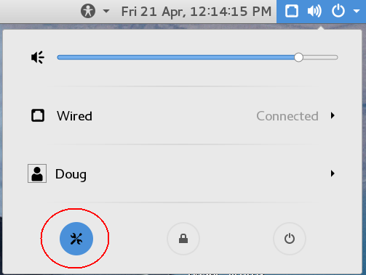

Next click on the settings icon to display the all settings dialog box, depicted below:

